**Aneesh Pavan Prodduturu**

**Q: What are the keyboard shortcuts used in Houdini sideFX?**

**A:** There is a wide range of keyboard shortcuts used in Houdini sideFX. Here are some of the shortcuts that are discussed in class.

* The keyboard letter “**H**” is used as Home All or Focus - Pans and Centers in the network pane.

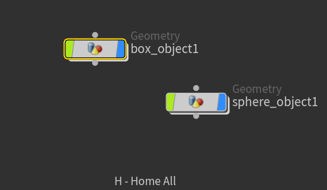

* The keyboard letter “**G**” is used as Home Selected or Focus or Home in Large in the network pane.

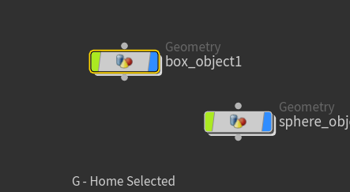

* The keyboard letter “**A**” is used to select all.
* The keyboard letter “**U**” is used as "jump up" or "jump up out of the network." It helps us move from **geometry to object**. And for turning an **object into** **geometry**, there are two ways of doing it. One way is to double click on the node and the object becomes geometry. The other way of doing it is to right-click in the network pane and add geometry to the pane, and everything from that added to the network pane is geometry.

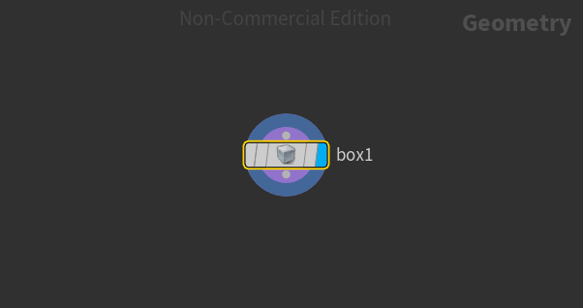

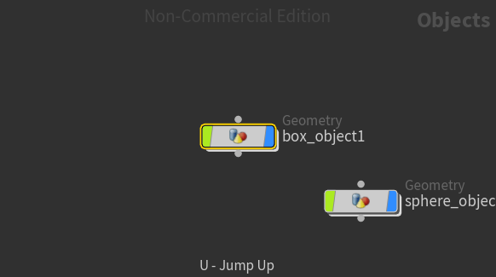

Everything is called a **node**. The top part of the node is used to **receive input** from others, and the bottom part of the node is used to **give output**.