**Aneesh Pavan Prodduturu**

**Q: How do I create a simple table in Houdini SideFX?**

**A:**

Firstly, open The Houdini Apprentice.



This interface consists of three panes: the Viewers pane, the Parameters pane, and the Network pane.

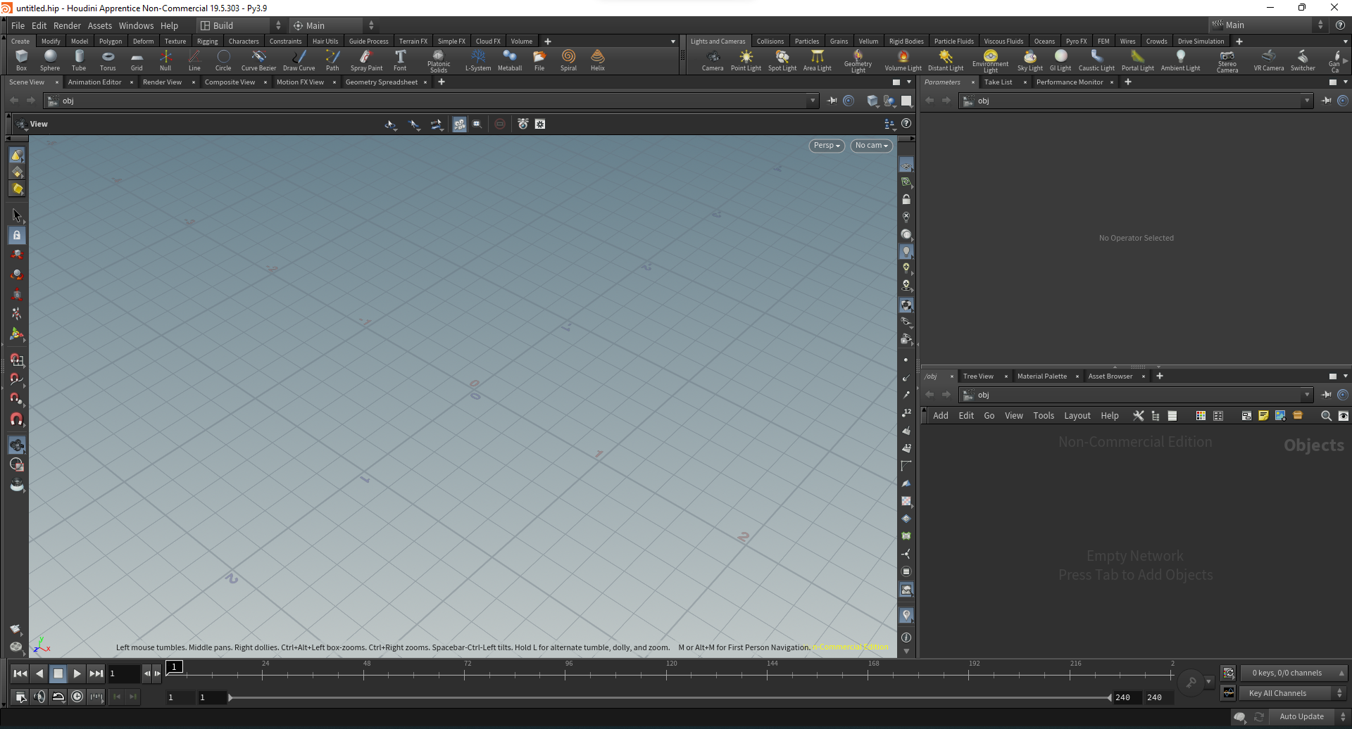

To get started, we first need to change the network pane from objects to geometry by right-clicking, adding geometry in the pane, and double-clicking on the node to turn the pane into geometry.

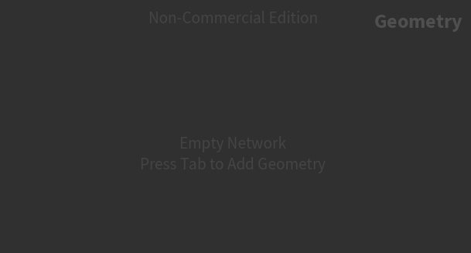

Add a grid in the network pane

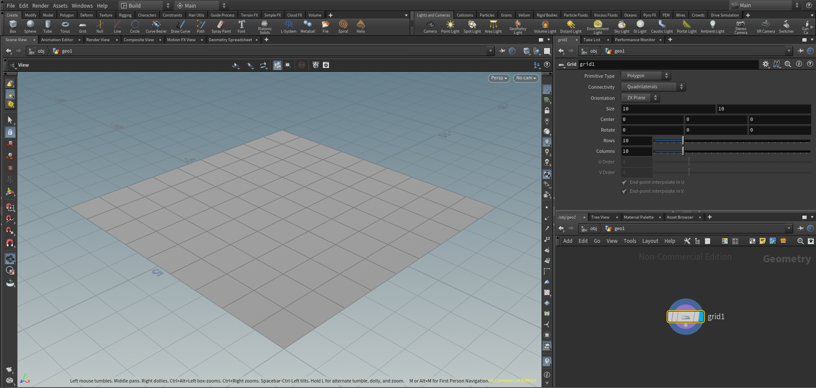

For the legs of the table, add transform and polyextrude.

.

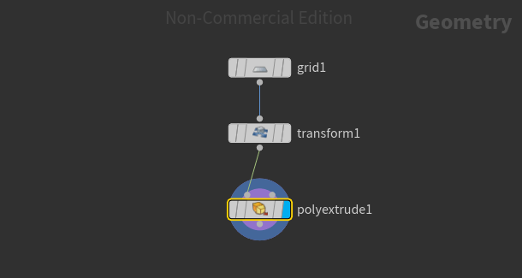

In the parameters pane for polyextrude, select a group number from the grid with the corner blocks to make their legs, increase the distance for it, and check the “output back” option to cover up the legs.

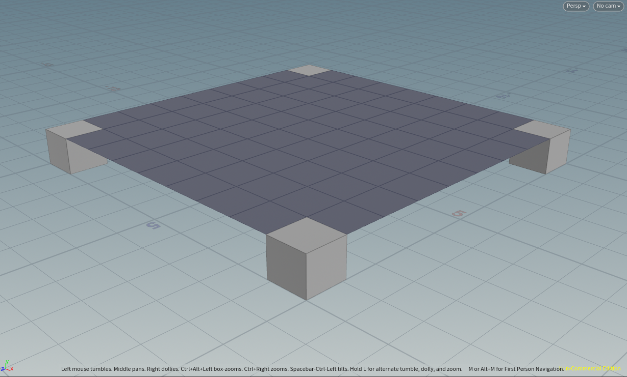

This is how a simple table is made.