**Aneesh Pavan Prodduturu**

**Q: How do I create a twisted building in Houdini SideFX?**

**A:** Firstly, open The Houdini Apprentice.



This interface consists of three panes: the Viewers pane, the Parameters pane, and the Network pane.

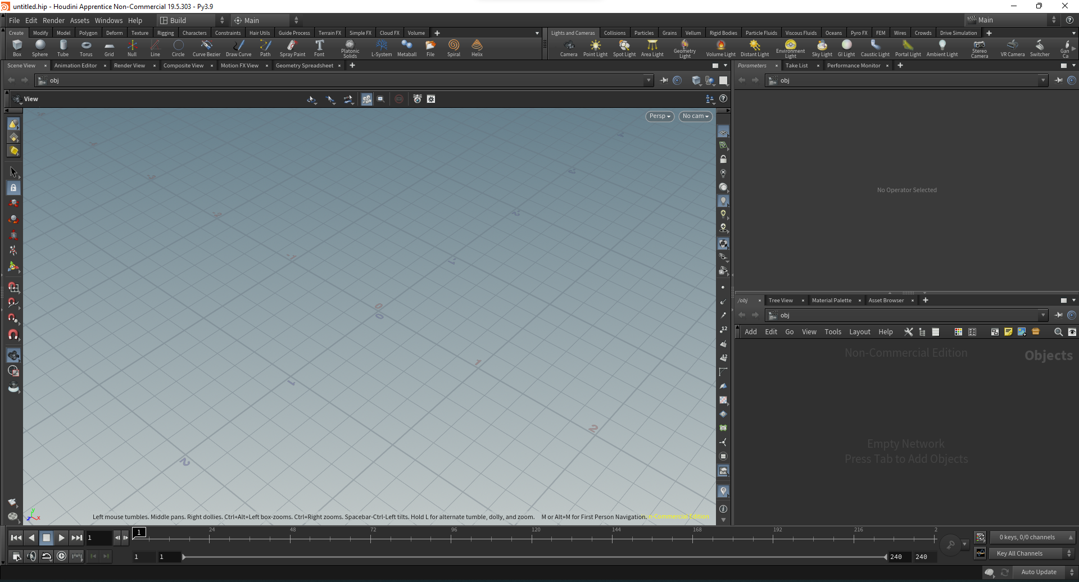

To get started, we first need to change the network pane from objects to geometry by right-clicking, adding geometry in the pane, and double-clicking on the node to turn the pane into geometry.



Add a grid in the network pane

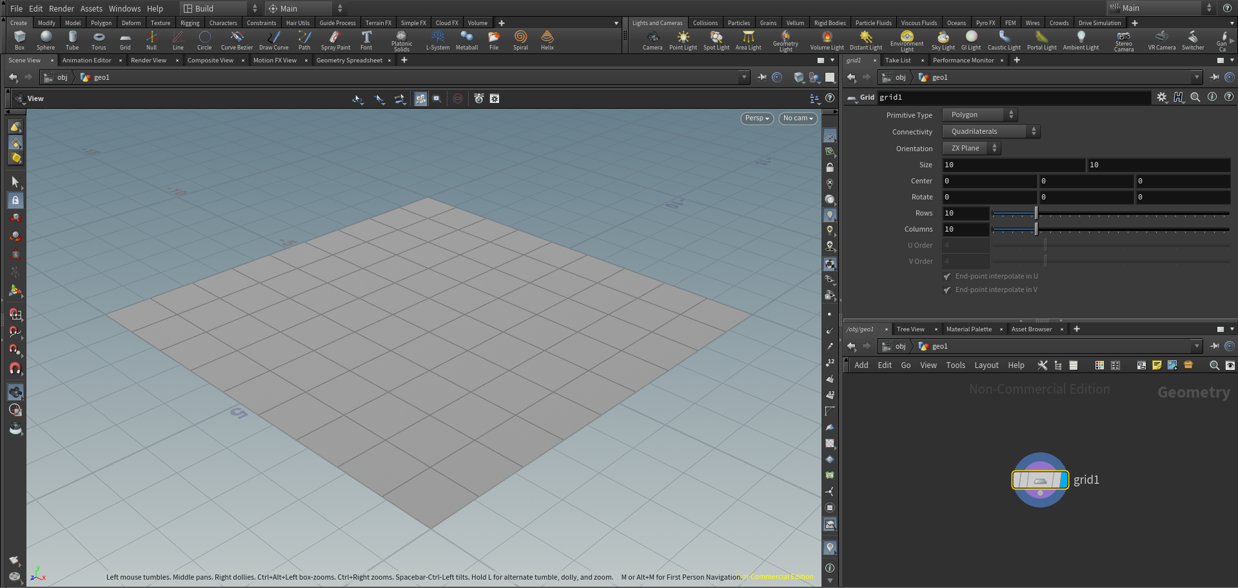

Add polyextrude to add the height of the building and for the twist

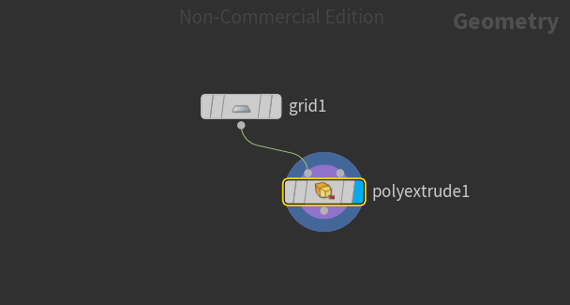

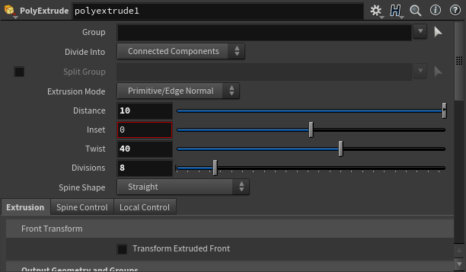

Make the distance 10 to increase the height of the building, the division 8 to make it as many floors as the building, and the twist 40 to twist the whole building.

