**Aneesh Pavan Prodduturu**

**Q: How do I use a bend node and what are the uses?**

**A:**

To use a bend node, we can start by making the network pane geometry from objects, and then add a line node for example and connect the output of the line node to the input of the bend node and enable deformation. Make changes to the Bend option in the bend section to bend the line in the viewer's pane. Further, we can also enable sections like twist, length scale, and taper. We can also alter the capture section to change the capture origin, capture direction and capture length.

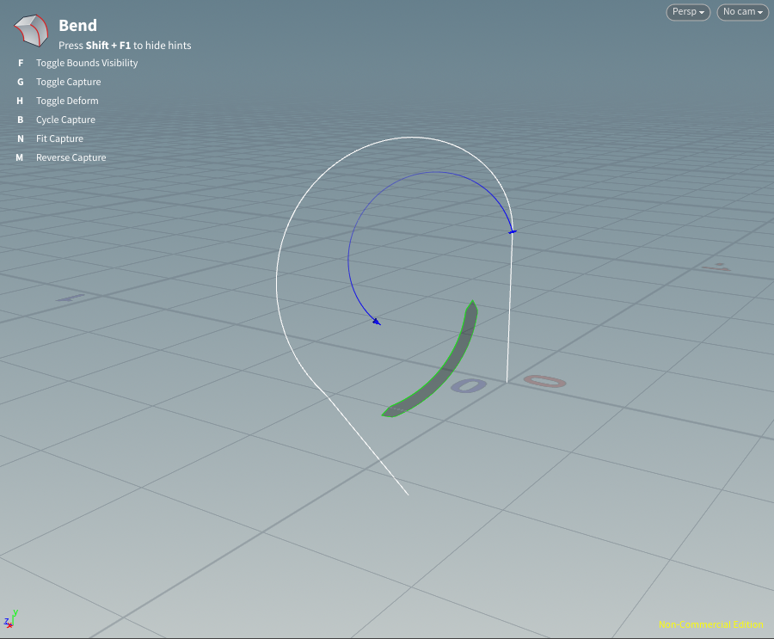

The bend node is used to construct a capture region around a model-like line node and modify the geometry node within the capture region. The bend node can execute bend, twist, length scale, and linear and smooth taper deformations.