**Screen Shot**

1. **Home Page** : Home page lists camera items

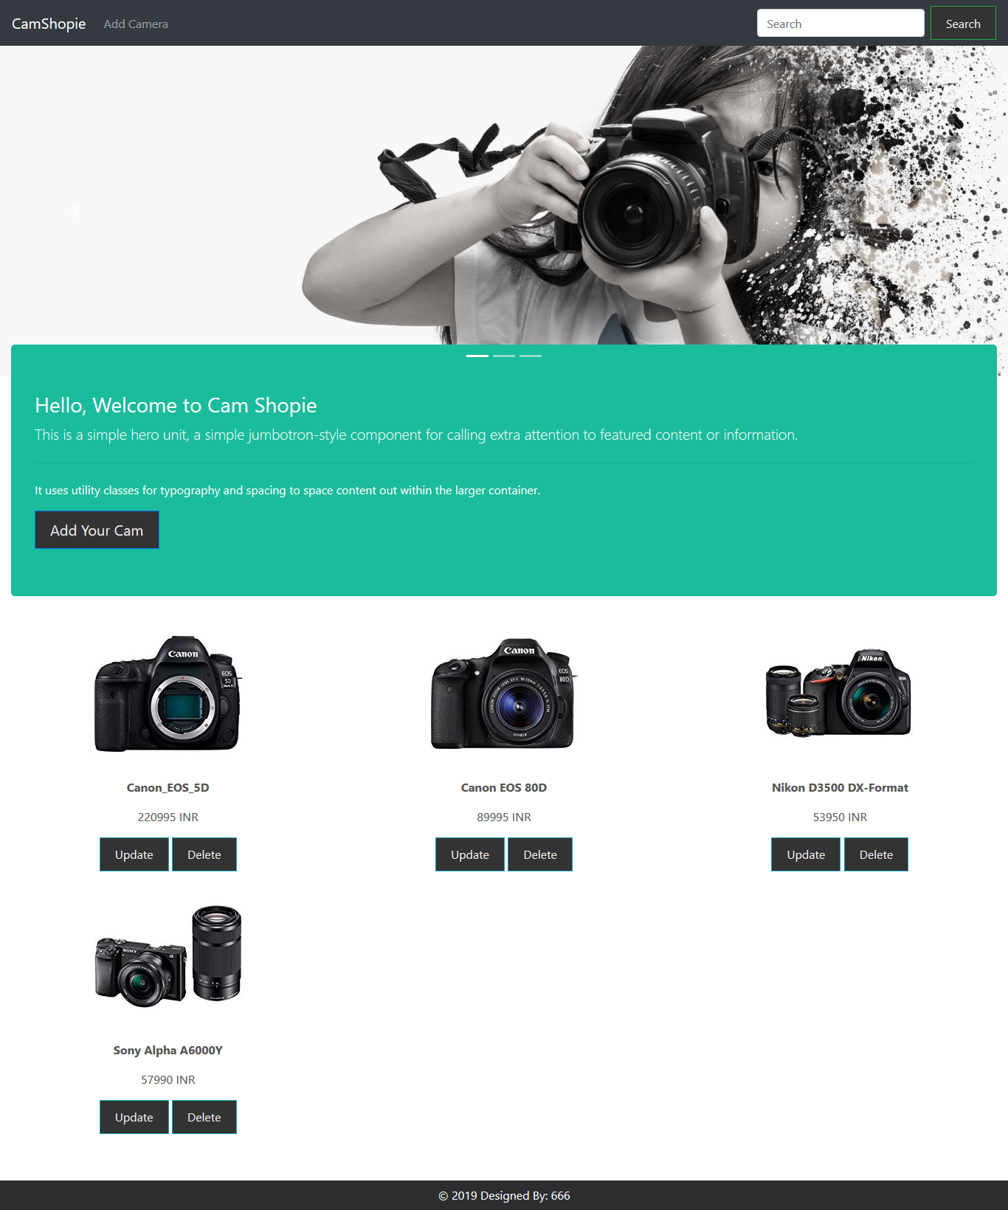

1. **Add Camera** : Page to add camera details

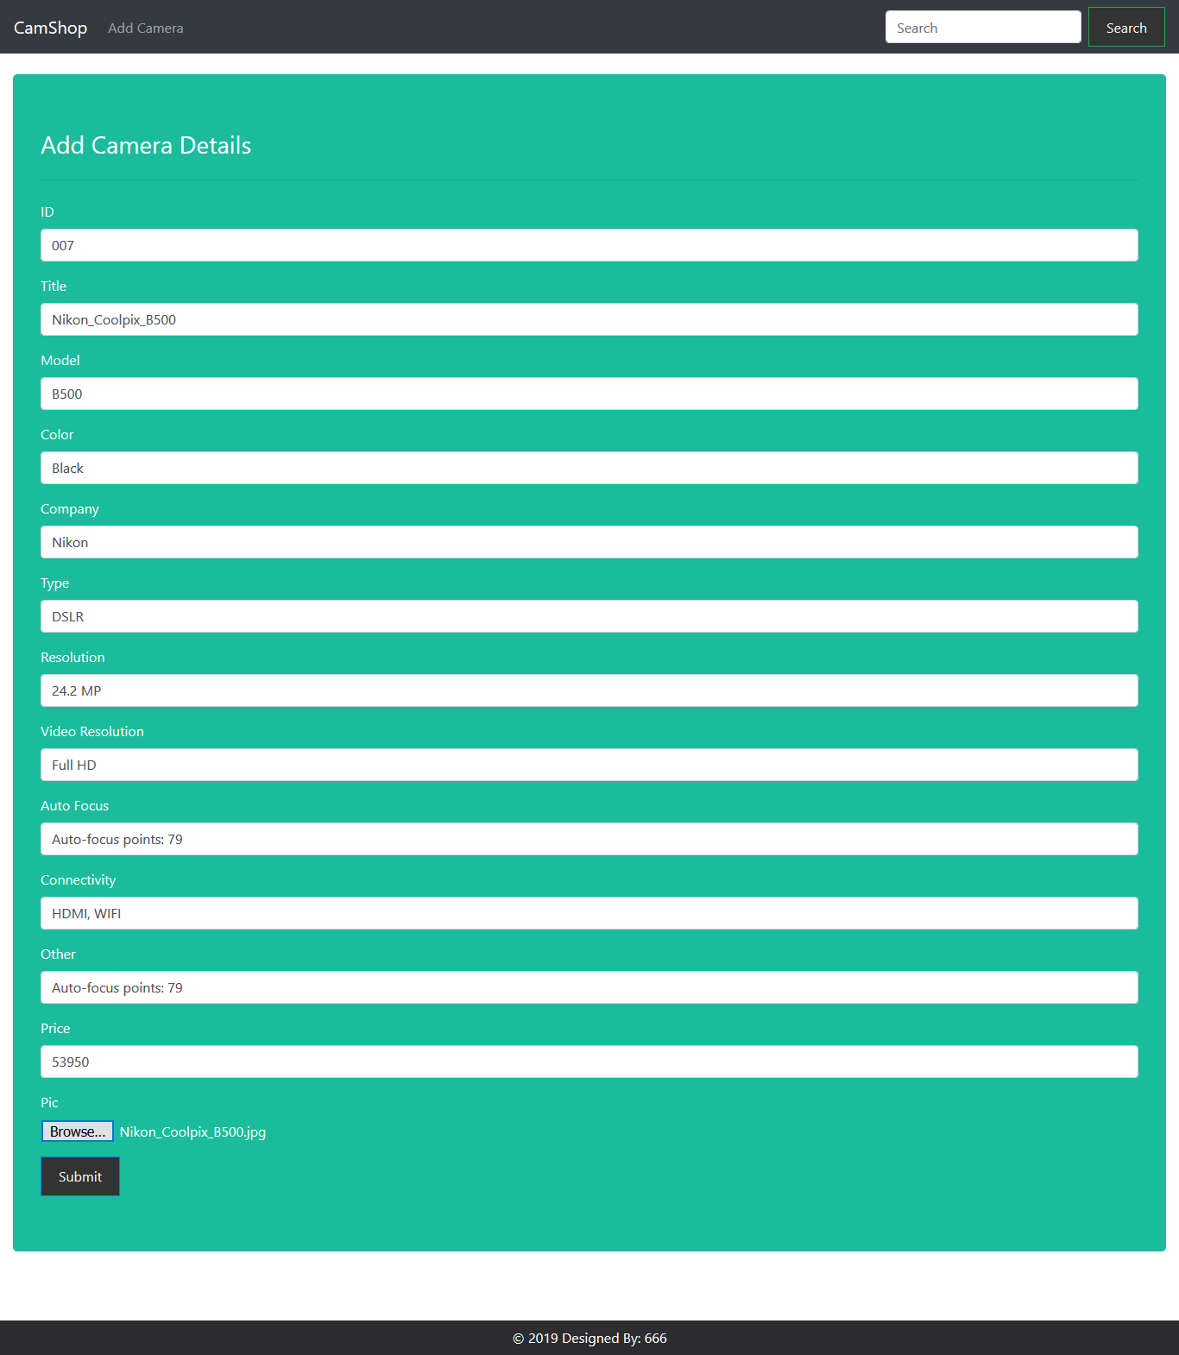

Then it redirects to home page showing newly added item (**Nikon_Coolpix_B500**)

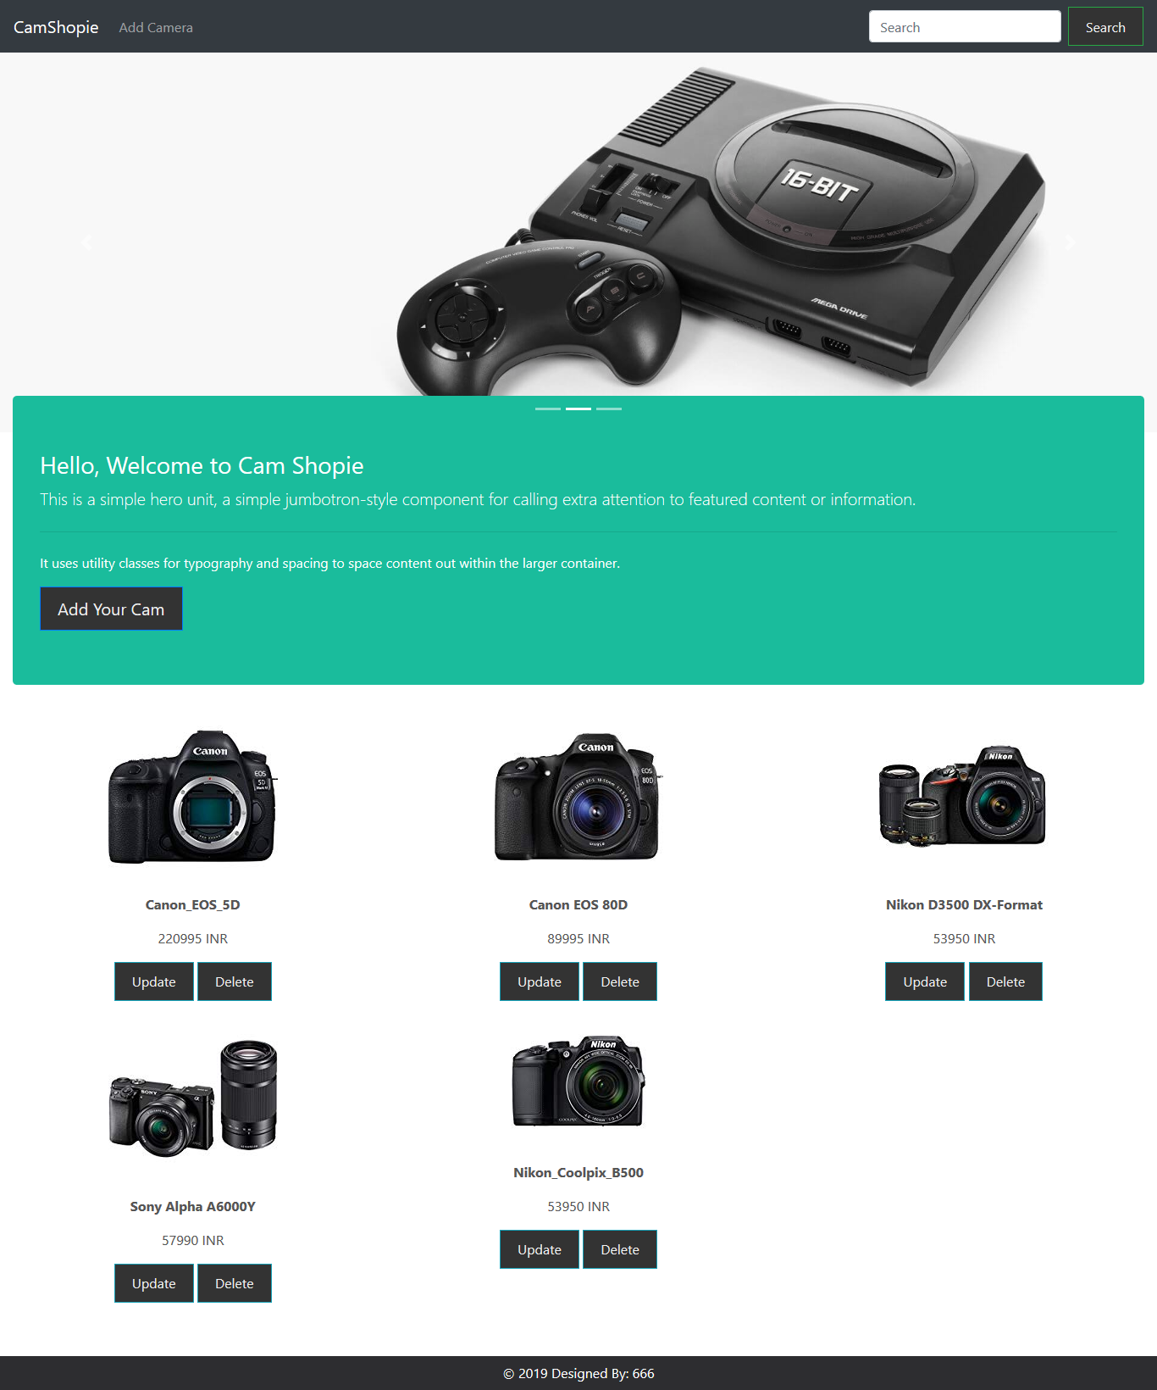

1. **Update Camera** : Updates existing camera item

Selected Item: **Test Cam1**

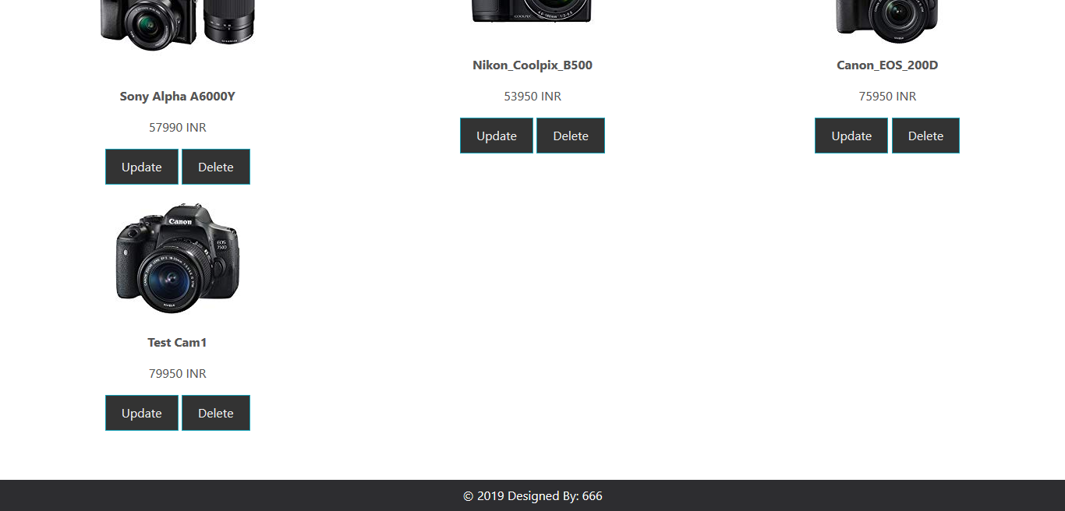

Redirects to update page

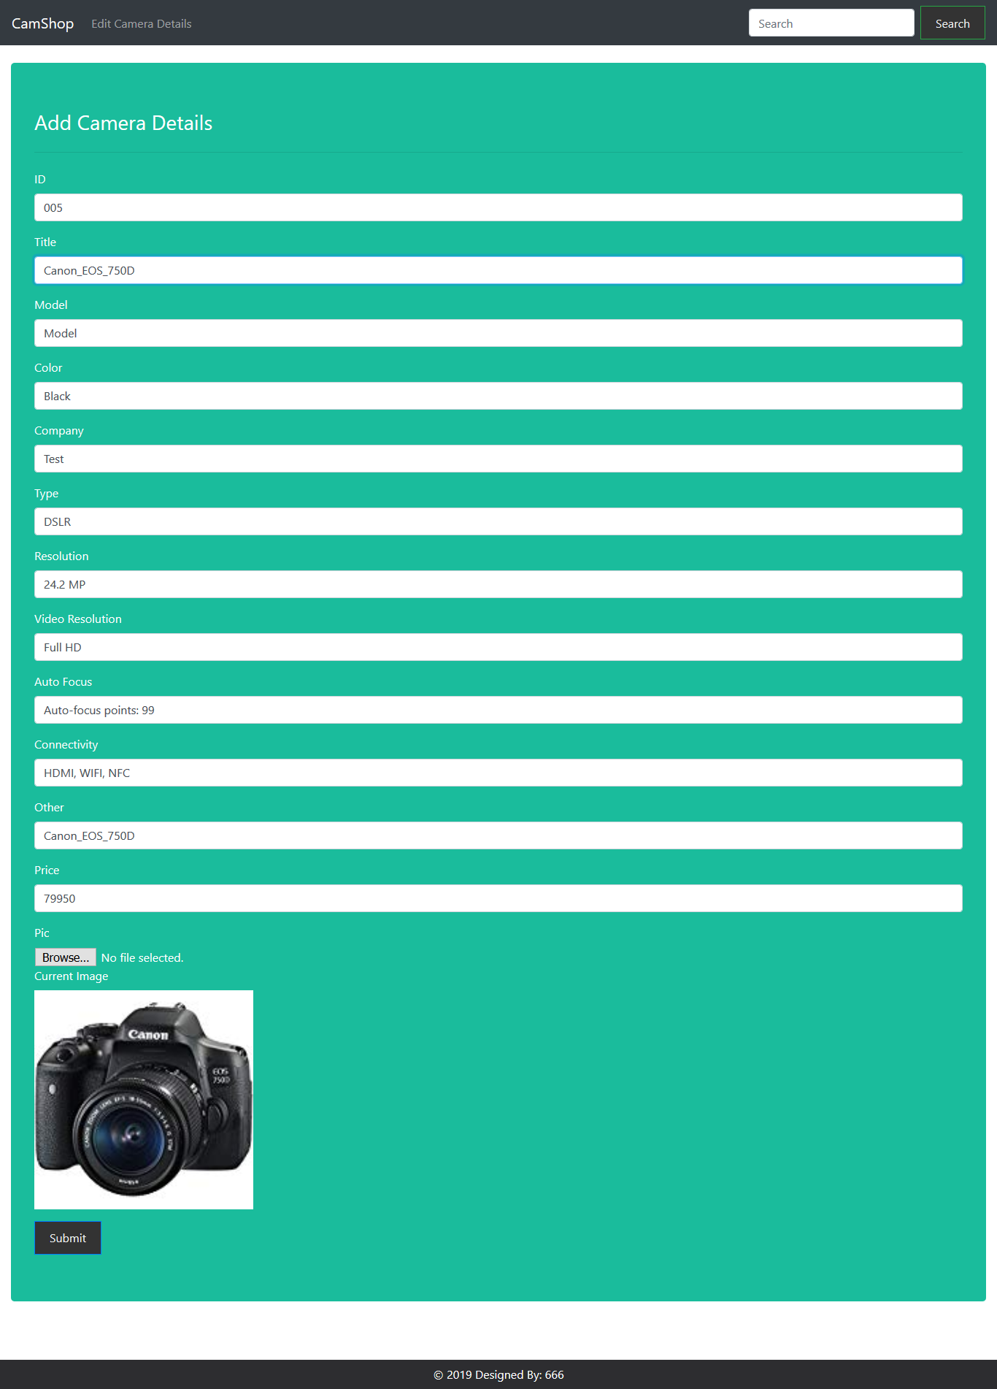

After updating, redirects to the home page. **Test Cam1** to **Cannon_EOS_750D**

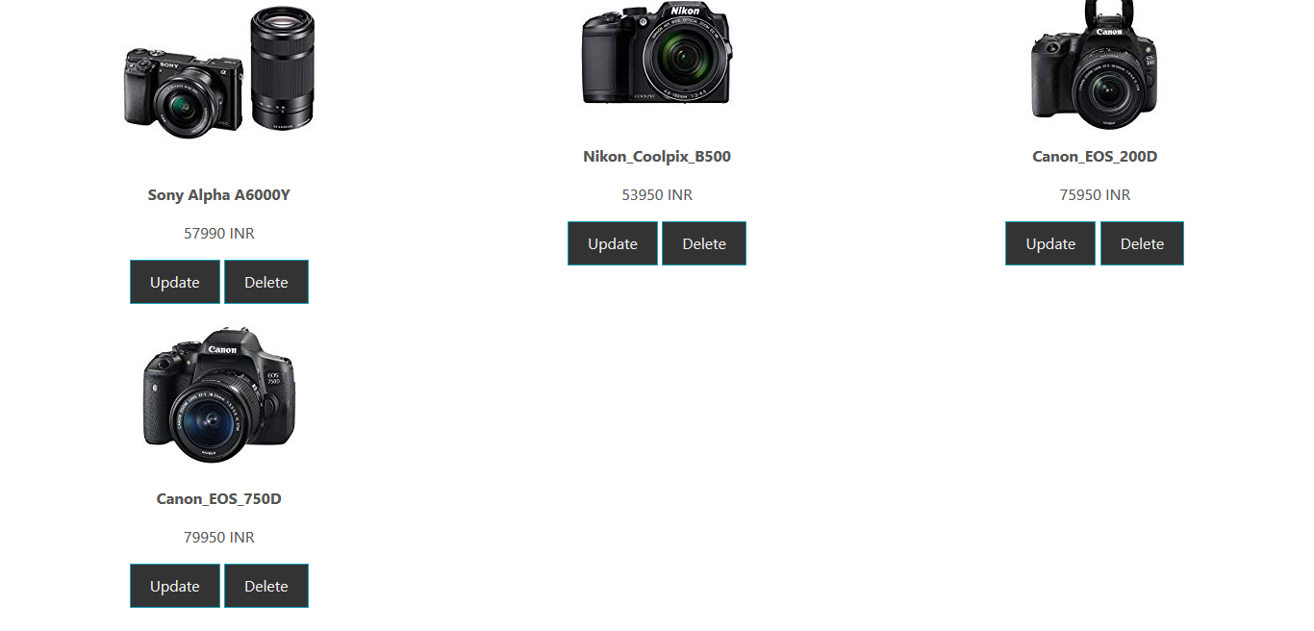

1. **Delete Camera** : Removes selected item **Cannon_EOS_750D**

