## **Strings**

A string   in python is a sequence of characters and can contain letters, numbers, symbols and even spaces . Strings are surrounded by either single quotation marks, or double quotation marks.

Eg ‘hello’

“hello”

## **Assign String to a Variable**

Assigning a string to a variable is done with the variable name followed by an equal sign and the string:

a=”hello”

print(a)

## **Multiline Strings**

You can assign a multiline string to a variable by using three quotes:

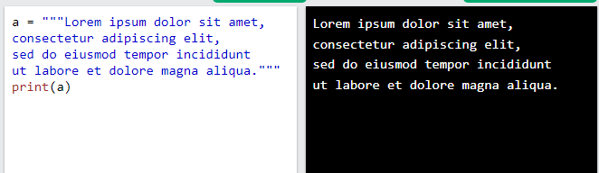

## **Python - Modify Strings**

Python has a set of built-in methods that you can use on strings.