PFA screenshot for reference

Login:

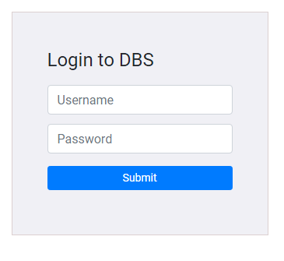

Login – Validation

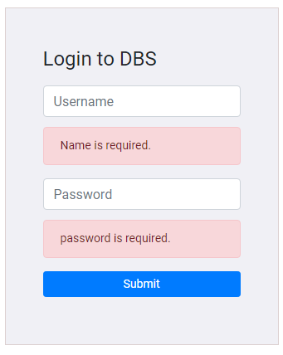

Home screen: Desktop View – for role ‘user’

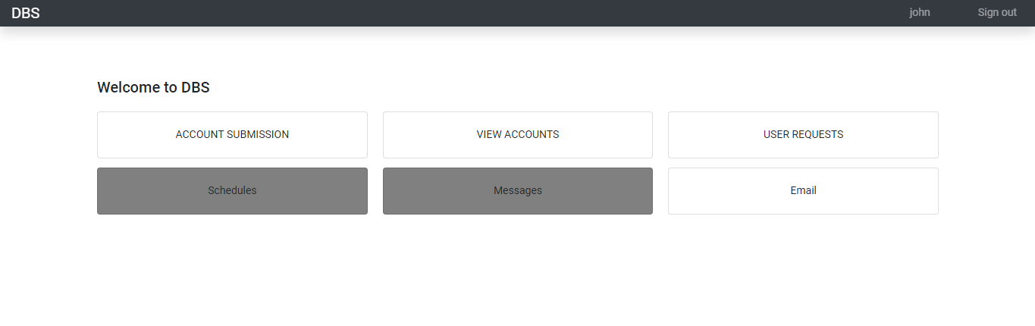

Home screen: for role ‘admin’ who has no access to account submission

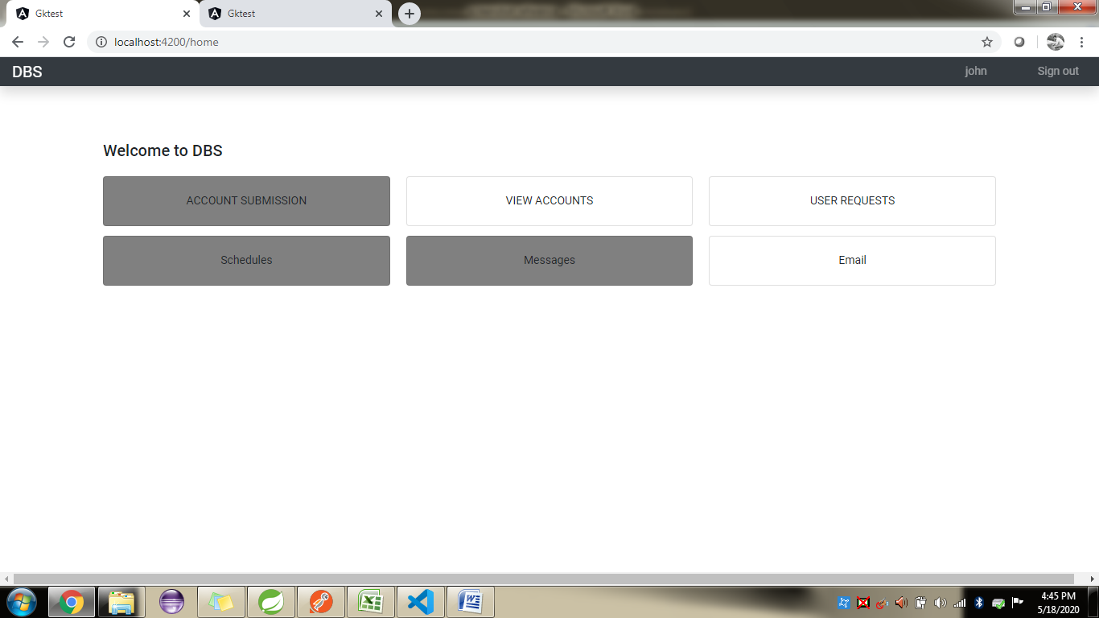

Homescreen : Mobile view example

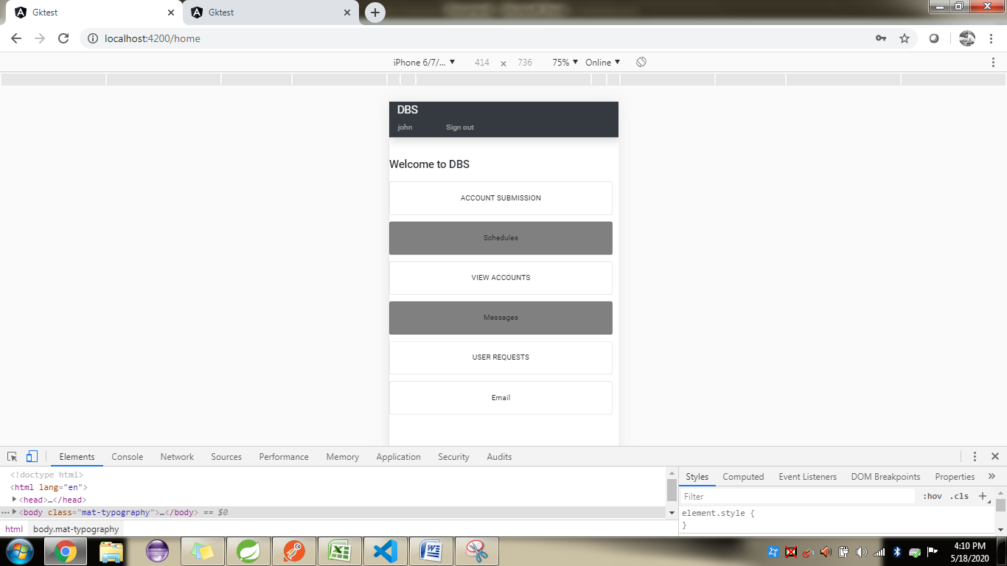

Account submission

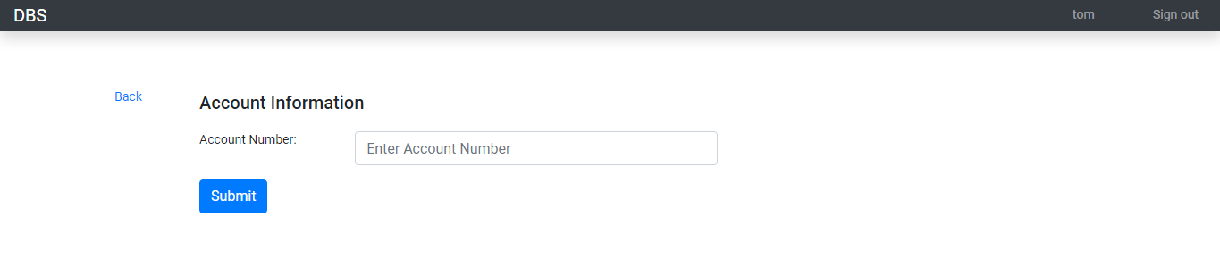

Exclusion Account

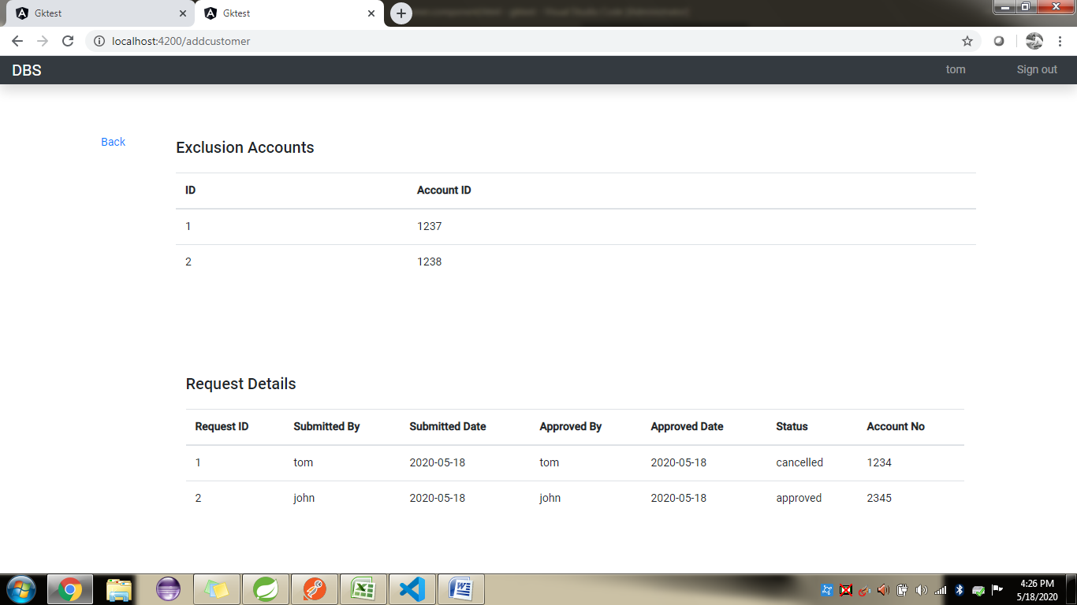

Approval screen for Admin user

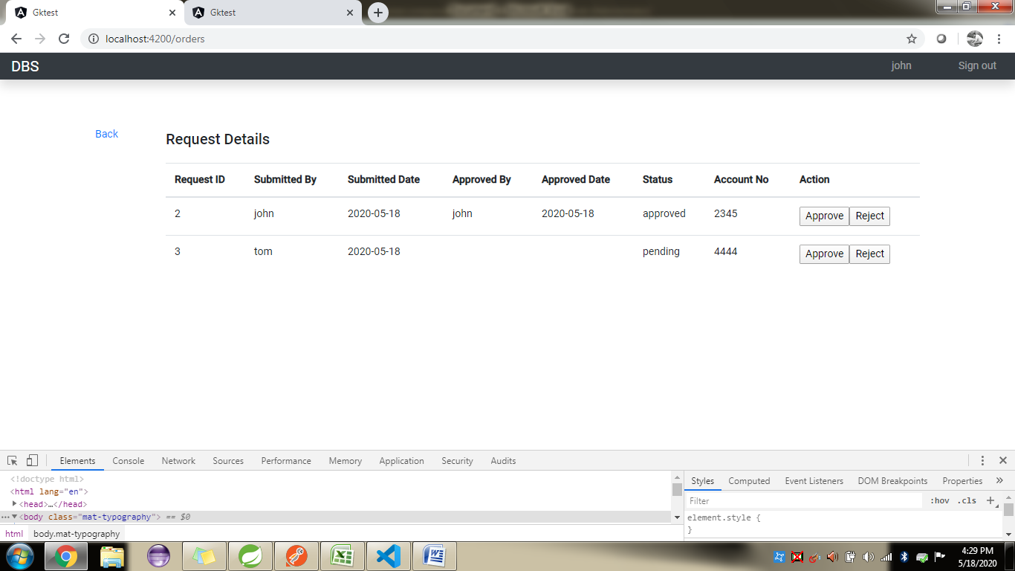

Approval screen for User role

