Workbook 2
KV Cache Optimization for Long Context LLM Inference
Team 6 | DATA 298A MSDA Project I | San José State University
November 11 2026
Samruddhi Chitnis; Anees Saheba Guddi; Manjot Kaur; Charvee Pragnesh Saraiya; Vedant Vilas Vartak.
Compiled by Vedant Vilas Vartak. Technical contributions follow repository ownership: Samruddhi—data engineering and TriAttention; Anees—shared harness, full-cache reference and RestoreKV; Manjot—RDKV; Charvee—ResidualKV; Vedant—TurboQuant and its analysis.
We have established a reproducible long-context evaluation pipeline, prepared a fixed 800-record development benchmark, and implemented five complementary KV-cache compression approaches around Llama-3.1-8B-Instruct. The current evidence includes full-cache and RestoreKV runs, nine complete TurboQuant configurations and a real-query adaptive study. This workbook presents the data engineering, model designs, platform support, comparison rationale and evaluation protocol that make those experiments interpretable. It distinguishes completed runs from integrated code and subsequent evaluation work. [10–12]
Evidence snapshot: team main commit 39a1097; TurboQuant results commit 9dc0d48 on vedant/turboquant-workbook2-results (PR 5). Experiments retain their own original source commits. Sections 1 and 2 remain in Workbook 1; changes are recorded in the carry-forward table. [10–14]
3 Data Engineering
3.1 Data Process
Section contributors: Samruddhi Chitnis; Anees Saheba Guddi; Vedant Vilas Vartak
Our primary data source is LongBench v1, accessed through the public zai-org/LongBench archive and standardized with the benchmark’s official prompt templates. The selected English and code-completion scope contains 3,750 records across 16 tasks and six categories. The ingestion notebook identifies each source task and retains benchmark IDs so that every cleaning operation can be traced to the original record. We preserve the source archive and its checksum separately from the Git repository. [1,8,12]
The pipeline applies field normalization, required-field validation and duplicate detection before constructing model-ready prompts. Nineteen repeated task–document–question pairs are removed, producing 3,731 unique pairs. We then apply the Llama tokenizer, retain both ends of over-length prompts under a 32,000-token cap, and select 50 records per task with seed 42. Prepared prompts, answers, token counts, task metadata and stable IDs are exported as JSONL. The complete cleaned export is the benchmark pool; the 800-record file is the shared development evaluation set, not a separate training dataset. [12]
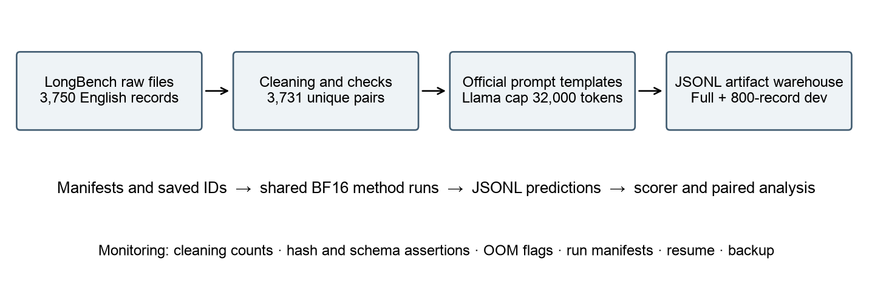
Figure 1. Data lineage and experiment artifact flow. Generator: report/workbook2/make_figures.py; sources: preprocessing notebook, manifest and independently verified exports. The warehouse is a file-based analytical artifact store, not a claimed cloud database deployment.
Collection, cleaning, transformation and validation are implemented in Data_pipeline/Scripts/01_LongBench_EDA.ipynb and 02_LongBench_Data_Preprocessing.ipynb. The processed files are distributed outside Git because of size; the repository stores manifests, saved development IDs, cleaning logs and aggregate statistics. During inference, the shared loader separates the compressible document from the protected question and instruction. Methods therefore operate on a common input while changing cache representation or selection. [10,12]
This project studies pretrained model inference. We do not fit the Llama backbone or invent a training split to satisfy a generic machine-learning template. Methods that use released learned adapters load those checkpoints without team fine-tuning. Calibration data, where required, is distinguished from development evaluation; the TurboQuant calibration-pool exclusions and overlap checks appear in Section 3.5.
3.2 Data Collection
Section contributors: Samruddhi Chitnis; Anees Saheba Guddi; Charvee Pragnesh Saraiya
The LongBench raw archive was available and read successfully. Our collection audit confirmed 3,750 selected records, zero duplicate benchmark IDs and zero missing required context fields. A source record has eight benchmark fields: _id, dataset, language, input, context, answers, all_classes and length. The loader adds task and source-file lineage. Raw records can contain a full scientific article, meeting transcript, narrative, collection of passages or code prefix; answers remain lists because multiple valid references are possible. [1,8,12]
Task | Raw | Cleaned | Development
2wikimqa | 200 | 200 | 50
gov_report | 200 | 200 | 50
hotpotqa | 200 | 200 | 50
lcc | 500 | 500 | 50
multi_news | 200 | 200 | 50
multifieldqa_en | 150 | 149 | 50
musique | 200 | 200 | 50
narrativeqa | 200 | 182 | 50
passage_count | 200 | 200 | 50
passage_retrieval_en | 200 | 200 | 50
qasper | 200 | 200 | 50
qmsum | 200 | 200 | 50
repobench-p | 500 | 500 | 50
samsum | 200 | 200 | 50
trec | 200 | 200 | 50
triviaqa | 200 | 200 | 50
Table 1. Independently verified task counts from the raw archive and supplied cleaned exports. The raw code tasks contribute 500 records each; the fixed development sample is task-balanced at 50 each.
RULER provides a complementary synthetic stress benchmark with 13 task types, including retrieval, multi-hop tracing, aggregation and question answering. The committed RestoreKV experiments cover 4K inputs and 650 examples per method (50 per task); longer-length sweeps remain a separate experiment. These synthetic inputs are not mixed into the LongBench development score. [2,10]
The LongBench software repository uses the MIT license; its constituent source corpora retain their applicable terms. Repository licensing is not a blanket relicensing of every underlying document. RULER’s source repository uses Apache 2.0. Llama weights require the Meta Llama community license and gated access; weights and credentials are not stored in Git. Our report includes only short representative excerpts and identifiers. [8–10]
Raw sample qasper
Record ID: 91dd7b7a6ead4025763812d70dc51c6674b0acf31bd5a5f0
Field | Original benchmark value
Context excerpt | Introduction Since humans amass more and more generally …
Input | How does their ensemble method work? …
Reference answer | simply averaging the predictions from …
This is a genuine source record matched by its benchmark ID to the prepared export; the document excerpt is abbreviated for readability. The original answers list is retained during evaluation.
Raw sample trec
Record ID: e55a65ad534b2649ceccf41cdcba863db7774efbd1408eed
Field | Original benchmark value
Context excerpt | Question: What botanical marvel did Nebuchadnezzar build ? …
Input | Question: What is the effect of volcanoes on the climate …
Reference answer | Description of something …
This is a genuine source record matched by its benchmark ID to the prepared export; the document excerpt is abbreviated for readability. The original answers list is retained during evaluation.
Raw sample lcc
Record ID: 28ce5cf5e0beeb47248c6cba20ae17fa71d60d402770d464
Field | Original benchmark value
Context excerpt | using System; using System.Collections; using System.Collections.Generic; using Server.Commands; …
Input | (empty input is valid for code completion)
Reference answer | Participant p = (Participant)m_Participants[i]; …
This is a genuine source record matched by its benchmark ID to the prepared export; the document excerpt is abbreviated for readability. The original answers list is retained during evaluation.
3.3 Data Pre-processing
Section contributors: Samruddhi Chitnis; validation review by Vedant Vilas Vartak
We normalize null/empty values consistently, remove NUL characters, convert CRLF/CR line endings to LF, trim outer whitespace, normalize language labels and convert answers to a nonempty list of strings. Required context, record ID and answers must exist; task names must belong to the selected registry. Empty question text is allowed for code-completion tasks because the code prefix itself supplies the input. Internal content is not paraphrased or augmented. [12]
Rule | Before | Removed | After
Required ID/context/answers | 3750 | 0 | 3750
Language scope and known task | 3750 | 0 | 3750
Duplicate benchmark ID | 3750 | 0 | 3750
Duplicate task/context/input | 3750 | 19 | 3731
Table 2. Cleaning rules and row reconciliation. Source: Data_pipeline/processed_longbench/cleaning_log.csv; the independent source/export audit confirms 19 removed IDs and no remaining duplicate task–context–input pairs.
A same-record normalization example is NarrativeQA ID f9cfda8abcc78f9e2f492d4f58ee4996430e9a8911e29726: the raw context begins with six tab characters before “Ghostbusters II”; the cleaned context begins directly with that title. Interior screenplay formatting is preserved. For the lcc sample above, the target begins with four tabs in the raw record and with Participant after cleaning; the code-completion scorer compares the first generated code line under the shared formatting convention. These examples demonstrate actual normalization rather than a hypothetical cleaning rule.
Sample | Raw value | Cleaned value
NarrativeQA context prefix | \t\t\t\t\t\tGhostbusters II | Ghostbusters II
lcc target prefix | \t\t\t\tParticipant p = … | Participant p = …
qasper question | How does their ensemble method work? | Unchanged; valid content is preserved
The project-defined Data Quality Index in the preprocessing export rises from 99.4347 to 99.8861 out of 100. Completeness and consistency remain 1.0; uniqueness rises from 0.994933 to 1.0. These are pipeline diagnostics, not model quality metrics. The earlier EDA scorecard uses a different scoring definition and approximate token counter; its 92.4/100 should not be presented as the directly comparable “before” value. [12]
The release is identified by the final manifest, 3,731-row export and 800 saved IDs. Earlier notebook outputs include a 12-task intermediate execution; refreshing them in a clean-kernel rerun will align the full notebook presentation with the final validated artifacts.
3.4 Data Transformation
Section contributors: Samruddhi Chitnis; shared prompt integration by Anees Saheba Guddi and method owners
After cleaning, we map each task to its category and metric, rename _id to record_id, and construct the official task prompt from context and input. We retain all_classes for classification scoring. The actual JSONL export has 21 fields, including context_words, input_words and prompt_words in addition to the schema summary in the older manifest. Those counts provide validation and EDA features; they are not features used to train a new predictive model. [12]
Transformation | Reason | Stored evidence
_id → record_id | Stable pairing across every method | record_id; dev_ids.json
Task → category and metric | Apply the appropriate scorer | task, category, metric
Context + task template + input | Control model input formatting | prompt, input, context
Llama tokenization and middle truncation | Bound inference input while retaining both ends | prompt_tokens_before/after; truncated
Deterministic task sampling | Keep common paired development inputs | split, seed 42; 800 IDs
Source schema → JSONL | Portable artifact store and streaming loader | 21 fields; pipeline_version
Table 3. Transformations that turn benchmark records into controlled evaluation inputs. No data augmentation or paraphrasing is applied; synthetic RULER inputs belong to a separately identified benchmark.
Exact Llama-tokenizer accounting finds 88 truncated prompts in the complete cleaned pool: 79 NarrativeQA, three GovReport and six RepoBench-P records. Twenty-one of the 800 development prompts are truncated. Every prepared prompt contains at most 32,000 tokens. Earlier tiktoken-based EDA length estimates are useful for screening but are not substituted for these exact model-token counts. [12]
Prepared sample | Before → after tokens | Truncated | Transformation evidence
qasper | 5321 → 5321 | False | You are given a scientific article and a question. Answer the question as concisely as you can, using …
trec | 3452 → 3452 | False | Please determine the type of the question below. Here are some examples of questions. Question: What botanical marvel …
lcc | 11436 → 11436 | False | Please complete the code given below. using System; using System.Collections; using System.Collections.Generic; using Server.Commands; using Server.Engines.PartySystem; using Server.Factions; …
The shared harness further separates each stored prompt into document and question/instruction while preserving the text. Only document K/V may be compressed. Few-shot and code tasks trec, triviaqa, samsum, lcc and repobench-p use the task-specific no-chat convention; the answer cue is handled separately where required. This formatting policy is shared across the registered methods rather than independently re-created for each comparison. [10,11]
Pipeline demonstration and monitoring. A demonstrator opens the raw record by ID, shows its normalized counterpart and prepared prompt, confirms token and split fields, then loads a saved result with the same ID. Cleaning logs reconcile counts; schema/ID/hash assertions reject bad data; result rows retain OOM flags; manifests and saved IDs support reproducible resumption and back-up. The analytical warehouse is the versioned metadata plus JSONL result store on lab storage and team backups. This is a manually invoked research pipeline, not a claimed scheduled production warehouse service.
3.5 Data Preparation
Section contributors: Samruddhi Chitnis; adaptive split design and checks by Vedant Vilas Vartak
We froze the 800-record development set before the reported method comparisons. Each of 16 tasks contributes 50 records sampled with seed 42; the repository stores all IDs, and the prepared file is verified by SHA256. It is a subset of the 3,731-record cleaned benchmark, not a newly collected independent test corpus. All fixed-rate comparisons pair by record ID and task; arbitrary random resampling is not performed per method. [10–12]
Split | Rows | % of 3,731 | Stratified on | Leakage check and result
Train | 0 | 0% | Not applicable | No team fitting or fine-tuning of the backbone
Validation / development | 800 | 21.44% | 50 per task; seed 42 | 800 unique IDs; exact frozen file hash
Independent test | 0 | 0% | Not yet designated | No untouched, document-disjoint test claim
Remaining benchmark pool | 2,931 | 78.56% | Original task distribution | Reference pool; document overlap with dev exists
Table 4. Preparation roles. “Full” and “dev” are the actual export labels. A training set is unnecessary for inference-only methods; the remaining pool is not relabelled as an independent test set.
The development SHA256 is fc9d8649f535619c6b3dbe31ad158b112131d85230f92cd253c2e32bb1b7a47c. The complete cleaned-file SHA256 is 106bb65a4111a14993dfc728b8e59798a595e16f6c39bba7e0e1e7a5e3cd1ed6. Their stable IDs and checksums identify the data used by the stored predictions. The development selection is a task-balanced diagnostic sample, not proof of coverage of every deployment population.
For TurboQuant’s layer allocator, a second deterministic seed (20260) selects a 32-record calibration pool, two examples per task. Sixteen examples, one per task, are actually profiled; all 32 pool IDs are excluded from evaluation even though half are unused. The held-out comparison therefore contains 768 records, 48 per task. This nested study does not change the shared 800-record fixed-rate benchmark. [11]
Adaptive role | Rows | Share of development | Preparation and sample
Calibration pool | 32 | 4% | Two IDs per task; adaptive_excluded_ids.json
Actually profiled | 16 | 2% (inside the pool) | Every second pool record; one per task
Held-out evaluation | 768 | 96% | All other development IDs; 48 per task
Leakage results. ID intersection between the 32 calibration records and 768 evaluation records is zero. Exact normalized-context hashing nevertheless finds 4 shared document contexts, affecting 4 calibration and 8 evaluation records. Between the 800-record development set and the remaining cleaned pool, 78 contexts overlap. LongBench legitimately contains multiple questions about the same document, so removal of duplicate document–question pairs does not produce document-disjoint partitions. We report record-held-out rather than document-held-out results; a grouped-by-document split is required before claiming independence for a learned compressor.
Prepared sample roles are directly inspectable in the saved files. The qasper ID 91dd7b7a6ead4025763812d70dc51c6674b0acf31bd5a5f0 appears in the development evaluation and is outside the adaptive calibration pool. Each retained calibration metadata file identifies the actual source ID of its profiled record. The authoritative membership is the versioned ID manifest, not the order of a screenshot.
3.6 Data Statistics
Section contributors: Samruddhi Chitnis; workbook audit and visualizations by Vedant Vilas Vartak
Stage | Rows | Columns | Notes
Raw | 3,750 | 8 source + lineage | 16 selected tasks; original archive preserved
Pre-processed | 3,731 | Source fields + derived checks | 19 duplicate pairs removed; no required-field removals
Transformed | 3,731 | 21 export fields | Llama templates; 32,000-token cap; 88 truncated
Prepared development | 800 | 21 | 50 per task; 21 truncated
Adaptive held-out | 768 | 21 + prediction fields | 32 calibration-pool IDs excluded
Table 5. Final stage reconciliation. Columns are actual exported fields where a persisted schema exists; intermediate dataframe columns are not presented as a fixed external schema.
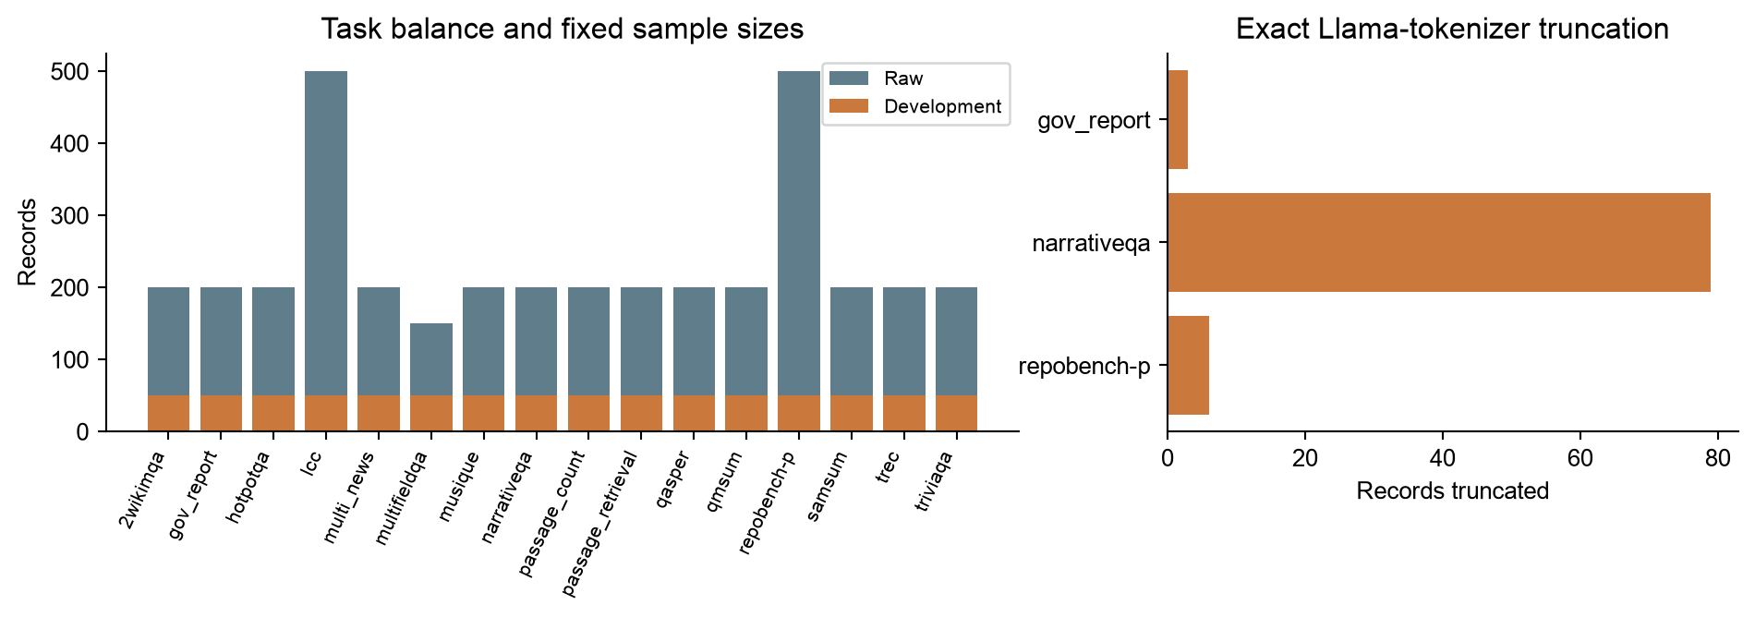
Figure 2. Raw task imbalance, balanced development sampling and exact tokenizer truncation. Generator: report/workbook2/make_figures.py; source: report/workbook2/data_audit.json, independently checked against raw and prepared files.
The raw source over-represents code completion (500 records for each of lcc and repobench-p), while multifieldqa_en contributes 150 and most other tasks 200. Equal 50-per-task sampling prevents those source counts from directly dominating the macro evaluation. Prepared development prompts average 10,355.84 tokens with median 9,474.5; the maximum is 32,000. The distribution spans short code and few-shot inputs through long narratives and retrieval passages.
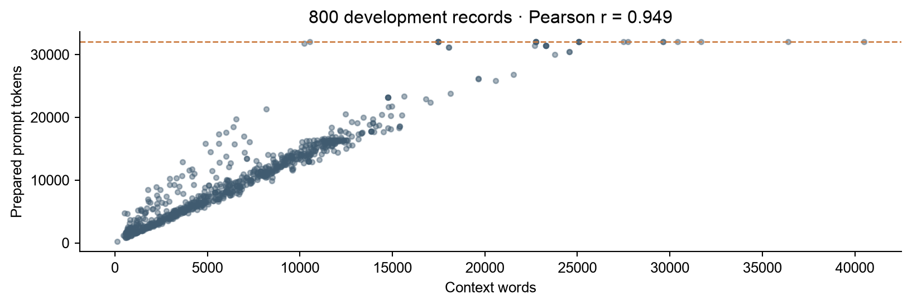
Figure 3. Context-word count versus prepared prompt tokens; Pearson r = 0.949. Generator: report/workbook2/make_figures.py. The cap and task-specific templates mean that word count is not interchangeable with tokenizer length.
Coverage limits matter for deployment. The selected scope excludes Chinese LongBench tasks and does not represent multilingual service traffic, confidential enterprise corpora, live conversation drift or the full 128K model context. A per-task balanced sample is not a natural request-frequency distribution. Applying these findings directly to non-English users or applications requiring exact retrieval from very long documents could understate risk. Shared documents also limit independence; grouped split evaluation and longer synthetic context sweeps are retained as follow-up work. [1,2]
4 Model Development
4.1 Model Proposals
Section contributors: Anees Saheba Guddi; Vedant Vilas Vartak; Samruddhi Chitnis; Charvee Pragnesh Saraiya; Manjot Kaur
The common backbone is pretrained Llama-3.1-8B-Instruct. Our five proposed systems apply distinct cache methods to this same model; they are not five independently trained LLMs. The full-cache run is a separate experimental reference and is not counted as one of the five. Relative to Workbook 1’s broad candidate list, the team selected implementable representatives of learned restoration, low-bit quantization, geometry-based eviction, residual coding and joint rate-distortion allocation. Each has committed code; the extent of completed GPU evidence varies. [3–7,10,11]
# | Model | Concept / architecture | Built in | Owner
1 | RestoreKV | KVzip eviction + 8 learned restore tokens; released adapter | 298A core; 298B extensions | Anees
2 | TurboQuant | Rotation + scalar codes; QJL or MSE keys; mixed rates | 298A evaluated; 298B integration | Vedant
3 | TriAttention | Calibrated pre-RoPE centres; trigonometric token scoring | 298A prototype; 298B full validation | Samruddhi
4 | ResidualKV | Reference states + quantized residual reconstruction | 298A integration; 298B full validation | Charvee
5 | RDKV | Joint eviction and per-unit bit allocation | 298A reimplementation; 298B validation | Manjot
— | Full-cache reference | Separate control; 47.72 on team development set | 298A | Anees / team
Table 6. Five method proposals and their roles. The latest plan advances several prototypes earlier than the template’s minimum one-model fall schedule; prototype availability is not represented as completed validation of all five.
RestoreKV
RestoreKV augments query-agnostic KVzip eviction with a compact learned representation of information lost through eviction. A one-time LoRA-adapted pass generates eight restore tokens; those tokens occupy slots inside the total cache budget. Our integration loads the released Llama adapter rather than training a new one. This is the current first-model system because the shared press, adapter and paired baseline are executable. Four 800-record development runs and three 650-record RULER-4K runs are committed. [4,10]
TurboQuant
TurboQuant rotates vectors and assigns scalar quantization codes to reduce reconstruction error; its product form adds a one-bit QJL residual to keys. Values use MSE quantization, and keys can use QJL or MSE-only coding. Our reference integrates the algorithm into the shared BF16 document-only protocol and records metadata costs. Mixed 2.5/3.5-bit configurations use independent high/low-rate subgroups, with half the original channels selected by per-head document energy; this is an explicit allocation interpretation, not a claim of exact reproduction of an ambiguous printed example. Nine fixed settings are evaluated on all 800 records. [3,11]
TriAttention
TriAttention uses calibrated query/key structure in pre-RoPE space to estimate which cached keys remain important across future query positions. The press calculates a trigonometric importance score and retains high-scoring keys together with sink and recent tokens. The implementation includes saved calibration statistics and chunked scoring to bound temporary memory. Committed headline outputs contain 260 short-prompt examples across 12 represented tasks; their macro score cannot be directly ranked against the 16-task, 800-record tables. Further full-length runs and OOM claims require their corresponding result files before quantitative comparison. [5,10]
ResidualKV
ResidualKV, formerly DeltaKV, represents historical states through sparse reference tokens and compressed residuals, reconstructing selected information rather than permanently discarding every unselected token. The repository vendors the authors’ implementation and supplies the released Llama compressor. The shared-data runner is present, including protected-layer, sink/recent-token and residual accounting. Five designated layers remain uncompressed by the residual mechanism, although their cache uses 4-bit coding; a nominal 0.9 compression ratio is consequently not a 10% total-cache budget. No completed shared 800-record result file was found in the audited snapshot. [6,10]
RDKV
RDKV treats token eviction and quantization as a joint bit-allocation problem. The project reimplementation assigns values per token and keys per channel from {0, 2, 4, 8, 16} bits using an importance-weighted rate-distortion objective, Lagrangian relaxation and bisection. Zero bits represents eviction. The current code estimates per-unit quantization error online rather than using the paper’s offline table, protects recent value tokens, and simulates quantization without the authors’ fused packing kernels. The shared press, CPU tests and Colab/Kaggle notebooks are committed; a completed shared 800-record outcome is not included in this snapshot. [7,10]
Project improvement hypothesis
We investigate whether adapting precision or restoration to the remaining cache can improve quality at a fixed total byte budget. Two concrete project extensions are implemented: TurboQuant’s layer-wise normalized-error allocator and RestoreKV followed by KIVI-style grouped 2/4-bit quantization. The former has completed calibration and evaluation but selected the uniform 3-bit setting in every layer, so it did not demonstrate adaptive improvement. The latter has correctness/smoke code and budget accounting, but its full matched-budget experiment is pending. These are testable improvement proposals, not claims of a newly proven algorithm or reproduced paper speedup. [10,11]
4.2 Model Supports
Section contributors: Anees Saheba Guddi; infrastructure contributions from all method owners
The primary real-model platform is the lab’s GeForce RTX 5090 with about 32 GB GPU memory, accessed through a Linux Docker container on the Windows host. Verified TurboQuant/RestoreKV execution uses Python 3.11.13, Torch 2.7.1+cu128, Transformers 5.2.0, kvpress 0.5.5 and BF16; relevant released adapters use PEFT. A system-site-packages virtual environment preserves the tested accelerator runtime. Mac/CPU fixtures establish algorithmic and API behavior but are not substitutes for full 8B GPU execution. [9–11]
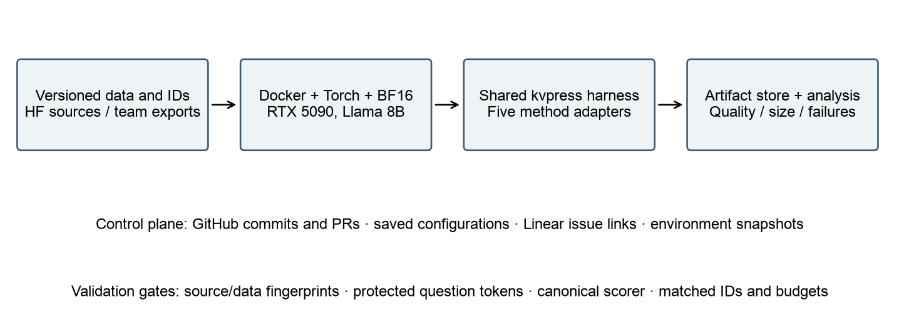
Figure 4. Supporting platform and ML data flow. Generator: report/workbook2/make_figures.py; source: shared harness, per-member integration files and archived runtime metadata.
Method | Entry point / dependency | Environment and evidence
RestoreKV | harness/run_longbench.py; kvpress + released LoRA adapter | Lab BF16; 4 × 800 LongBench + RULER-4K results
TurboQuant | members/vedant/turboquant_press.py; shared harness | Pinned source 82d40f7; 9 × 800 fixed + 800 adaptive
TriAttention | members/samruddhi/triattention_press.py; saved calibration | 260-record CSV study; chunked scoring code
ResidualKV | members/charvee/run_residualkv.py; vendored DeltaKV | Released compressor required; run outputs not committed
RDKV | members/manjot/rdkv_press.py; shared harness | Colab A100 notebook; T4 FP16 is a side-check, not the BF16 main table
GitHub records code history and pull requests; per-member directories isolate integrations. Linear is the task-management record, while run JSONL/manifests and environment snapshots provide experiment-level provenance. The workbook cites artifacts rather than inferring issue closure from code presence. Authentication tokens, model weights and large prepared datasets remain outside Git. Backups preserve the data and lab outputs before the shared machine is cleaned. [10,11]
The harness writes stable record IDs, method settings, predictions, task scores, elapsed example time, computed cache size and measured peak allocation. TurboQuant additionally fingerprints data, scorer, source implementation, model revision and runtime to reject incompatible resumes. Runs do not become comparable merely by sharing a filename: model precision, sample IDs, prompt policy, scorer version and memory definition must also agree.
4.3 Model Comparison and Justification
Section contributors: All method owners; paired analysis by Anees Saheba Guddi and Vedant Vilas Vartak
The comparison targets a practical question: how much useful information survives a smaller cache under the same language model and evaluation input? Full cache supplies the no-compression control. Eviction removes states; quantization retains approximate versions; residual coding reconstructs deviations; restoration creates a compact complement to dropped states. Each strategy has a different failure mode, so the preferred method is conditional on memory budget, question reuse and retrieval risk. [3–7]
Method / approach | Strength and rationale | Limit or losing condition
RestoreKV / learned restoration | Recover information after query-agnostic eviction; released adapter reduces fitting effort | Adapter/backbone dependence; additional construction cost; unseen budgets may lose facts
TurboQuant / statistical quantization | Predictable low-bit representation; no task-specific training; clean rate/QJL ablations | Very low bits can destroy quality; BF16 reconstruction path does not reduce actual cache allocation
TriAttention / attention-based selection | Calibrated geometry rather than a few recent post-RoPE queries | Evidence-specific tokens can be lost; long-input temporary memory and subset bias matter
ResidualKV / learned residual coding | Preserves token-specific residual information and cross-token similarity | Full-layer floor, compressor overhead and implementation compatibility; no committed shared result yet
RDKV / constrained optimization | Selects eviction and precision jointly rather than independently | Online distortion cost; metadata overhead; reference differs from the published fused implementation
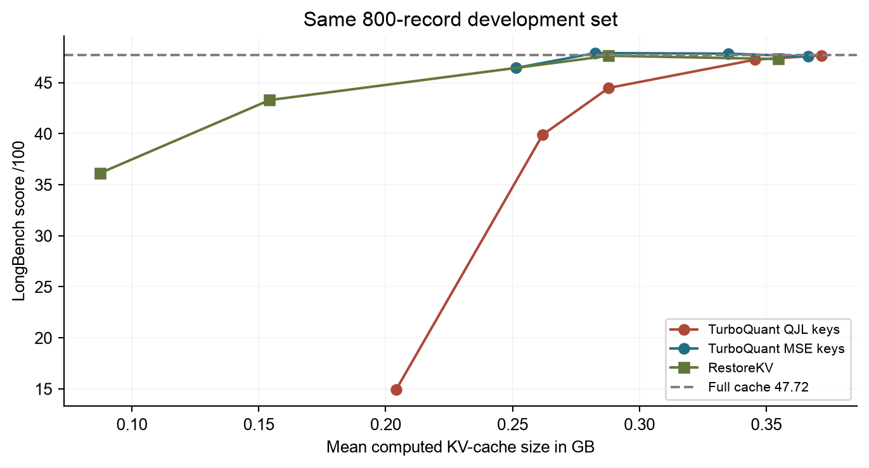
Figure 5. Scope-matched development comparison from committed RestoreKV results and TurboQuant PR 5. Generator: report/workbook2/make_figures.py. The x-axis is actual computed cache size; points are not asserted to have exactly equal budgets.
At broadly comparable computed storage, RestoreKV retaining 20% of document cache scores 47.63 with mean computed KV size 0.288 GB; TurboQuant MSE-key 3-bit scores 47.90 at 0.283 GB, against the common full-cache 47.72 and 1.357 GB. These small differences do not establish a winner: budget accounting, method variability and paired intervals must be considered. At stronger compression RestoreKV’s 5% setting falls to 36.13; TurboQuant QJL 2-bit falls to 14.94 at a different, larger actual logical budget. The latter is a real negative result, not a point to omit. [10,11]
TriAttention’s short-prompt baseline is 45.24 across the 12 represented tasks, and its 50% eviction result is 43.185. These are within-study comparisons only. They are not evidence that TriAttention is 4 points worse than a method run on all 800 examples. Likewise, RDKV and ResidualKV are compared here by design and available integration evidence, not assigned invented scores. [10]
When our preferred approach loses. Quantization is a poor choice if the chosen low precision erases a decisive key or if decoded reconstruction buffers eliminate the intended physical-memory benefit. Eviction can lose when a second question needs a token removed for the first, or when evidence lies in a low-ranked isolated passage. RestoreKV may lose when its released adapter does not transfer to a backbone or compression regime. Residual coding may lose its advantage when similarities are weak or protected layers set a high storage floor. RDKV may lose when allocation and metadata cost exceed the gain from finer precision choices. We will select methods at achieved byte budgets, not by the smallest nominal ratio.
4.4 Model Evaluation Methods
Section contributors: Anees Saheba Guddi; Vedant Vilas Vartak; all method owners
We retain the task-specific quality measures already described in Workbook 1 and Progress Report 2, and implemented in shared harness commit 0063a42 on October 22. The November 6 first-line scorer correction is explicitly versioned rather than hidden as a method improvement. We do not claim a retrospective preregistration certificate: the historical documents and Git commits establish which metrics preceded the reported full GPU runs. [10,13,14]
Metric | Why this metric | Benchmark or split | Committed on
QA token F1 | Compare supported answers with references | NarrativeQA, Qasper, MultiFieldQA, HotpotQA, 2WikiMQA, MuSiQue | Workbook 1; harness Oct 22
ROUGE-L | Measure sequence overlap for summaries | GovReport, QMSum, MultiNews, SAMSum | Workbook 1; harness Oct 22
Classification / retrieval / count score | Task-specific correctness, not one generic accuracy | TREC; passage retrieval/count | Workbook 1; harness Oct 22
Code edit similarity | Evaluate first-line code completion | lcc, RepoBench-P; rapidfuzz scorer | Harness Oct 22; policy fixes versioned
Task macro average | Give each represented task equal weight | 800-record/16-task shared development set | Progress Report 2 Oct 22
Computed bytes; GPU peak; elapsed time | Separate representation size, allocation and execution cost | Same records / hardware; no mixed definitions | Workbook 1; shared harness Oct 22
RULER string-match | Stress controlled retrieval and aggregation | 4K completed; longer sweeps planned | Workbook 1; harness Oct 22
LongBench records are scored from 0 to 1 under the shared scorer; per-task scores and task-macro aggregates are displayed on a 0–100 scale. The shared summary rounds task means before averaging, so a raw-record aggregate can differ slightly in its last decimal. Greedy generation follows task-specific output lengths. Prompts and question-protection rules are fixed across methods, and failed/OOM records are retained with zero quality score rather than silently excluded. Task coverage and denominators must accompany every table. [10,11]
Our scorer strips leading whitespace before taking the first output line for TREC, TriviaQA and SAMSum. This differs slightly from the original script’s newline-only handling and corrects blank-first-line artifacts for Llama outputs. It moves the shared baseline aggregate from 42.39 to 47.72, largely through TriviaQA. This is a scoring-policy correction applied consistently across comparable runs; it is not a gain produced by compression. Historical TriAttention CSVs without predictions cannot be independently re-scored to that policy, reinforcing their separate-study status. [10]
Paired comparisons use identical IDs and tasks. TurboQuant analyses independently re-score all 8,000 predictions and the existing 800 baseline predictions, with zero score mismatches, OOMs or blank outputs. They resample paired examples within each task (2,000 bootstrap draws, seed 20260) and then macro-average task differences. RestoreKV’s committed owner analysis uses 5,000 draws; reported intervals must retain their method/sample definitions. Sampling intervals are not equivalent to a multi-seed generation study. Single-seed/repeated-generation results do not supply a mean ± standard deviation across independent seeds. [10,11]
For adaptive evaluation, exclude all 32 calibration-pool IDs from every comparator and retain the 768-record held-out intersection. The allocation has the same uniform 3-bit QJL configuration as the control. Held-out scores are 44.4970 for the adaptive run, 44.4096 for the earlier uniform run and 47.4485 for full cache. Adaptive minus uniform is +0.0875 points, paired 95% interval approximately [−0.4754, 0.6506]. With identical allocation and an interval crossing zero, no adaptive benefit is established. [11]
Representation size and physical allocation are different outcomes. Most reference presses reconstruct BF16 values or mask rather than free evicted states. The computed size includes kept codes/tokens, scale metadata, protected layers or selectors, and uncompressed questions as appropriate. Physical GPU peaks are recorded separately. Example elapsed time includes pipeline work and is not isolated decode throughput, time-to-first-token or concurrency capacity. Those serving objectives from the original abstract remain separate future system measurements. [10,11,13]
The published reference in Workbook 1 is TurboQuant Table 1’s Llama full-cache score of 50.06; our team control is 47.72 on a deduplicated, sampled and capped development variant. The two use different evaluation inputs and token handling. We report the published number and team control separately and do not treat numerical proximity alone as a like-for-like baseline-reproduction certificate. The final-report reproduction section must explain the protocol gap. [3,10,13]
Error-analysis plan. Preserve per-task deltas, length bands, truncation flags and examples with severe losses. Examine retrieval failures, first-line formatting artifacts, low-bit key distortion and OOM behavior separately. Report manually inspected cases with sample IDs before assigning causes. The current evidence supports observed performance losses; it does not by itself prove the precise causal explanation for every failure. Adversarial NIAH, longer RULER sweeps, second-question reuse and cross-seed measurements are follow-up experiments rather than completed outcomes.
4.5 First Model Implementation
4.6 Baseline Reproduction
References
[1] Y. Bai et al. LongBench A Bilingual Multitask Benchmark for Long Context Understanding. arXiv 2308.14508, 2023; revised 2024.
Source link
[2] C. P. Hsieh et al. RULER What Is the Real Context Size of Your Long Context Language Models. arXiv 2404.06654, 2024.
Source link
[3] A. Zandieh, M. Daliri, M. Hadian and V. Mirrokni. TurboQuant Online Vector Quantization with Near Optimal Distortion Rate. arXiv 2504.19874, 2025; Section 4.3 and Table 1.
Source link
[4] C. Baek, S. Shin and K. Kong. RestoreKV Recovering Full Cache Behavior Under Aggressive Query Agnostic KV Cache Eviction. arXiv 2608.01247, 2026.
Source link
[5] W. Mao et al. TriAttention Efficient Long Reasoning with Trigonometric KV Compression. arXiv 2604.04921, 2026.
Source link
[6] J. Hao et al. ResidualKV Residual Based KV Cache Compression for Efficient Long Context Inference. arXiv 2602.08005v2, 2026; formerly DeltaKV.
Source link
[7] J. Zhang, H. Guo, L. Benini and Y. Li. RDKV Rate Distortion Bit Allocation for Joint Eviction and Quantization of the KV Cache. arXiv 2605.08317, 2026.
Source link
[8] LongBench source archive and software license. zai-org/LongBench data.zip; THUDM/LongBench MIT software license. Accessed November 11 2026.
Source link
[9] NVIDIA. kvpress source and RULER source repositories. Accessed November 11 2026.
Source link
[10] Team 6. Team repository at main commit 39a10977bc52deab9dce195a66a5a8c1bf968352. Shared harness; RestoreKV, TriAttention, ResidualKV and RDKV integrations; stored result files and owner documentation.
Source link
[11] V. V. Vartak. Verified RTX 5090 TurboQuant evidence and Workbook 2 contribution. Commit 9dc0d48b7a3f2a4c723ef7539f1270a70a899643, PR 5. Fixed/adaptive manifests, calibration reports and regenerated analysis. Experiment source 82d40f7.
Source link
[12] Team 6 data artifacts. Data_pipeline/Scripts notebooks; processed_longbench/manifest.json, cleaning_log.csv, dqi_before_after.csv and dev_ids.json at commit 39a1097. Independent source/export checks: report/workbook2/audit_data.py and data_audit.json.
Source link
[13] Team 6. Workbook 1, T6.A4, October 2026. Previously submitted project requirements, methodology, metric commitments, baseline target and two-semester plan.
[14] Team 6. Progress Report 2 and Minutes of Meetings, October 22 2026, updated submission. Method selection, pipeline status and planned shared evaluation.
Artifact locator guide. Data notebooks and manifests support Sections 3.1–3.6. RestoreKV results are under results/restorekv; TriAttention’s short study is under members/samruddhi/results_out. ResidualKV and RDKV entry points are in their member directories. TurboQuant’s complete evidence is under members/vedant/results/sem1 on PR 5. The shared scorer is harness/longbench.py; its scoring fixes are traceable in Git history. This scope is the repository snapshot audited for this workbook, not an assertion about unpushed files on members’ machines.
Submission checklist (not part of the report)
Check | Yes / No
Every section above is written as report prose, not as notes | Yes; Sections 4.5 and 4.6 intentionally remain headings only
Splits are fixed, version-controlled, and the leakage check is reported | Yes for saved IDs and checks; exact-context overlap is disclosed, not labelled document-disjoint
Metrics were committed before any results existed | Prior metric definitions evidenced; scorer correction is dated and disclosed
Four models named, with the reproduced baseline listed separately | Yes; five methods proposed; separate full-cache control; published reproduction gap retained
Every claim links to a commit, run, dataset version or Linear issue | Technical claims cite snapshot artifacts or papers; code availability is distinguished from completed runs
Each section names the team member who wrote it | Contributors and compilation responsibility identified by repository ownership
Self-assessment and gap register
Report section | Our rating | If below good what is missing | Owner | Lands by
3.1–3.6 | Good | Refresh stale notebook outputs; group-disjoint evaluation before independence claims | Samruddhi / Vedant | Next reproducibility review
4.1–4.4 | Good | Complete comparable RDKV/ResidualKV and full-length TriAttention evidence; validate improvement hypotheses | Method owners | Next benchmark freeze
References | Good | Published baseline protocol alignment remains explicit in carry-forward | Anees / Vedant | Final report review
The ratings reflect evidence and remaining scope rather than assuming that code presence completes every experiment. The data-pipeline demonstration should show actual stored records and a failed validation case live; a diagram alone is not evidence that a scheduled production workflow has run.
Carry-forward from Workbook 1
Item | Why it did not land or what changed | Owner | New target
Method lineup | Replaced the earlier broad core/extension list with five focused methods after the October survey | All members | Current workbook
Training scope | KV-CAR training proposal replaced by released-adapter/inference studies; no team backbone training claimed | Anees / team | Current scope
Serving metrics | Concurrency, isolated TTFT/decode speed and fused storage are not established by logical cache estimates | Infrastructure owners | 298B systems phase
Baseline gate | Published 50.06 reference and team 47.72 dev control differ in inputs and token protocol; strict reproduction remains qualified | Anees / Vedant | Final report
Evaluation split | Deduplicated 3,731 pool and 800-record dev variant retained; overlap disclosed; no independent test claim | Samruddhi / team | Grouped split before learned-model evaluation
Other method benchmarks | ResidualKV/RDKV code is present; their completed common-set outcomes are not in the audited snapshot | Charvee / Manjot | Next benchmark freeze
Adaptive proposal | TurboQuant experiment completed; allocator kept uniform 3-bit QJL, so no improvement claim | Vedant | Completed and reported

