DATA 266
HW2.5 GPU Assignment I: Precision, Bandwidth, and the Cost of Attention
Anees Saheba Guddi | NVIDIA GeForce RTX 5090 | ISB 840, machine 33

1. Personal parameters
Step 0 follows the same convention as assignment 1. Student ID 018205330, so the last four digits give SID4, and SEED is set equal to SID4. HW2.5 skips the second hyperparameter configuration, so no HP_ID is used.
SID4 | SEED
5330 | 5330
Every measurement in Parts B to E is labelled with the GPU UUID it came from, both in the CSV it lands in and in RUN_LOG.txt. METRICS.md and every figure are rebuilt from the committed CSVs by make_metrics.py and make_figures.py, so no number in this report was typed in by hand.

2. Part A: onboarding and provenance
Code and artifacts: part_a_provenance.py · gpu_specs.json · nvidia-smi -q capture · identity JSON
One card was reserved and used, an RTX 5090 in ISB 840 machine 33. The complete nvidia-smi -q output is committed at provenance/nvidia-smi-q_GeForce_RTX_5090_74396ae57bdb.txt.

2.1 Card identity, as reported by the machine
Field | Value
GPU UUID | GPU-38ba4f51-a57b-4ca5-e2ab-74396ae57bdb
GPU name | NVIDIA GeForce RTX 5090
Driver version | 610.60
CUDA version (torch) | 12.8
VRAM capacity | 32607 MiB
Reported power limit | 575.00 W
PyTorch | 2.11.0+cu128
Host | 5c9fd775c569 (container)

2.2 Vendor documentation
Field | Value
Architecture | Blackwell (GB202)
Memory type | GDDR7
Memory bandwidth | 1792 GB/s (512 bit bus)
CUDA cores / SMs | 21760 / 170
Boost clock | 2.407 GHz
Tensor core generation | 5th generation
Reduced precisions supported | TF32, BF16, FP16, FP8 (E4M3/E5M2), FP6, FP4, INT8
Dense peak TFLOPS | FP32 104.8, TF32 104.8, FP16 209.5, BF16 209.5, FP8 419, FP4 1676
Source: NVIDIA RTX Blackwell GPU Architecture Whitepaper v1.1, Appendix A, Table 3, pages 46 to 47. https://images.nvidia.com/aem-dam/Solutions/geforce/blackwell/nvidia-rtx-blackwell-gpu-architecture.pdf
The peak figures above are the dense, FP32 accumulate variants. Section 7.1 explains why that choice matters and why no smaller denominator was available.

3. Part B: precision and achieved throughput
Code and artifacts: part_b_precision.py · results CSV · figure
Dense square matmul at N = 1024, 4096, 8192 and 16384 in FP32, TF32, FP16 and BF16, plus FP8 through torch._scaled_mm. Timing uses CUDA events after 10 warmup iterations, with the median of 50 timed repetitions reported. The coefficient of variation is recorded for every configuration so that variance is a number rather than a claim.
N | Precision | Achieved TFLOPS | % of peak | Median ms | Reps | CV %
1024 | FP32 | 40.269 | 38.42 | 0.053 | 50 | 35.961
1024 | TF32 | 26.779 | 25.55 | 0.080 | 50 | 23.713
1024 | FP16 | 96.145 | 45.89 | 0.022 | 50 | 37.123
1024 | BF16 | 20.281 | 9.68 | 0.106 | 50 | 21.519
1024 | FP8 | 41.196 | 9.83 | 0.052 | 50 | 62.577
4096 | FP32 | 64.782 | 61.81 | 2.122 | 50 | 3.265
4096 | TF32 | 101.686 | 97.03 | 1.352 | 50 | 4.951
4096 | FP16 | 209.833 | 100.16 | 0.655 | 50 | 10.132
4096 | BF16 | 179.694 | 85.77 | 0.765 | 50 | 11.896
4096 | FP8 | 376.388 | 89.83 | 0.365 | 50 | 11.777
8192 | FP32 | 64.474 | 61.52 | 17.053 | 50 | 1.425
8192 | TF32 | 112.975 | 107.8 | 9.732 | 50 | 0.471
8192 | FP16 | 212.909 | 101.63 | 5.164 | 50 | 1.499
8192 | BF16 | 224.206 | 107.02 | 4.904 | 50 | 1.208
8192 | FP8 | 450.094 | 107.42 | 2.443 | 50 | 1.78
16384 | FP32 | 65.505 | 62.5 | 134.282 | 50 | 0.486
16384 | TF32 | 116.254 | 110.93 | 75.663 | 50 | 0.361
16384 | FP16 | 214.576 | 102.42 | 40.993 | 50 | 0.63
16384 | BF16 | 226.866 | 108.29 | 38.772 | 50 | 1.682
16384 | FP8 | 436.706 | 104.23 | 20.142 | 50 | 1.214
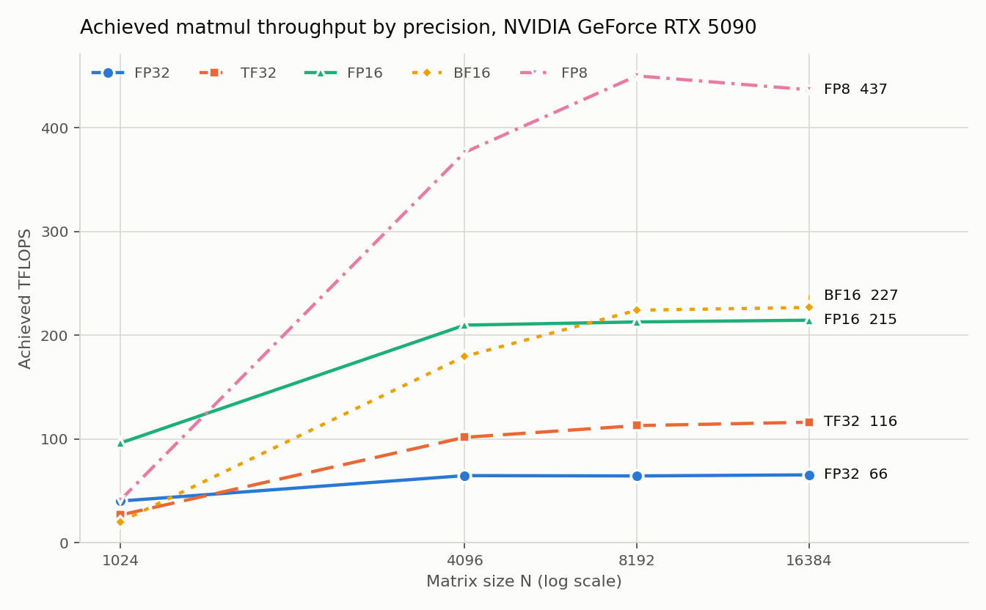
Figure 1. Achieved TFLOPS against matrix size, one line per precision.

3.1 Where each precision plateaus
Plateau is taken as the smallest swept N reaching 95% of that precision’s best measured throughput.
Precision | Best TFLOPS | Plateau at | Throughput at N=1024, as % of best
FP32 | 65.5 | N=4096 | 61.5%
TF32 | 116.25 | N=8192 | 23%
FP16 | 214.58 | N=4096 | 44.8%
BF16 | 226.87 | N=8192 | 8.9%
FP8 | 450.09 | N=8192 | 9.2%

3.2 Why small matrices never plateau
A matmul does 2N cubed FLOPs while touching only 3N squared elements, so arithmetic intensity grows linearly with N and a small matrix simply does not carry enough work per byte moved to keep the tensor cores fed. Two fixed costs dominate instead, and neither shrinks with N.
The first is per launch overhead, meaning kernel launch, cuBLAS algorithm selection and wave quantisation at the tile level. It is roughly constant and is amortised over work growing as N cubed, so it is a large fraction of the 0.053 ms median at N=1024 and disappears entirely into the 134.282 ms at N=16384.
The second is occupancy. A 128 by 128 tiled GEMM at N=1024 produces only 64 tiles, which cannot fill the 170 SMs on GB202, so well over half the machine sits idle for the whole kernel no matter how fast the tensor cores are.
This is also why N=1024 carries by far the largest variance in the sweep, with coefficients of variation between 21.52% and 62.58% against under 1.8% at N=8192. At that size the kernel is short enough that launch and clock ramp noise is comparable to the work itself, so the N=1024 row should be read as an order of magnitude rather than a precise measurement.

3.3 The lower precision
FP8 ran through torch._scaled_mm on E4M3 and is reported in the table above, reaching 450.094 TFLOPS at N=8192. No failure to report for this card and stack.

4. Part C: bandwidth bound against compute bound
Code and artifacts: part_c_roofline.py · results CSV · figure
Two memory bound operations, a large elementwise add and a device to device copy, both over 268435456 elements in FP32, and one compute bound operation, an 8192 square matmul. The ridge point is the card’s peak FLOPS divided by its peak bandwidth, and is a property of the card rather than of the kernel.
Operation | Effective GB/s | % of spec | Arithmetic intensity (FLOPs per byte) | Ridge point | Side
elementwise_add | 1555.16 | 86.78 | 0.0833 | 58.48 | memory bound
device_copy | 1501.32 | 83.78 | 0.0 | 58.48 | memory bound
matmul_n8192 | 48.2 | 2.69 | 1365.3333 | 58.48 | compute bound
The elementwise add reached 1555.16 GB/s, which is 86.78% of the 1792 GB/s specified bandwidth. Its arithmetic intensity of 0.0833 FLOPs per byte sits roughly three orders of magnitude below the ridge point of 58.48, so it is firmly bandwidth bound. The copy moves two bytes per element against the add’s three and does no arithmetic at all, so its intensity is zero. The 8192 matmul at 1365 FLOPs per byte is far to the right of the ridge and is compute bound, which is why its effective bandwidth of 48.2 GB/s is low: bandwidth is simply not what limits it.
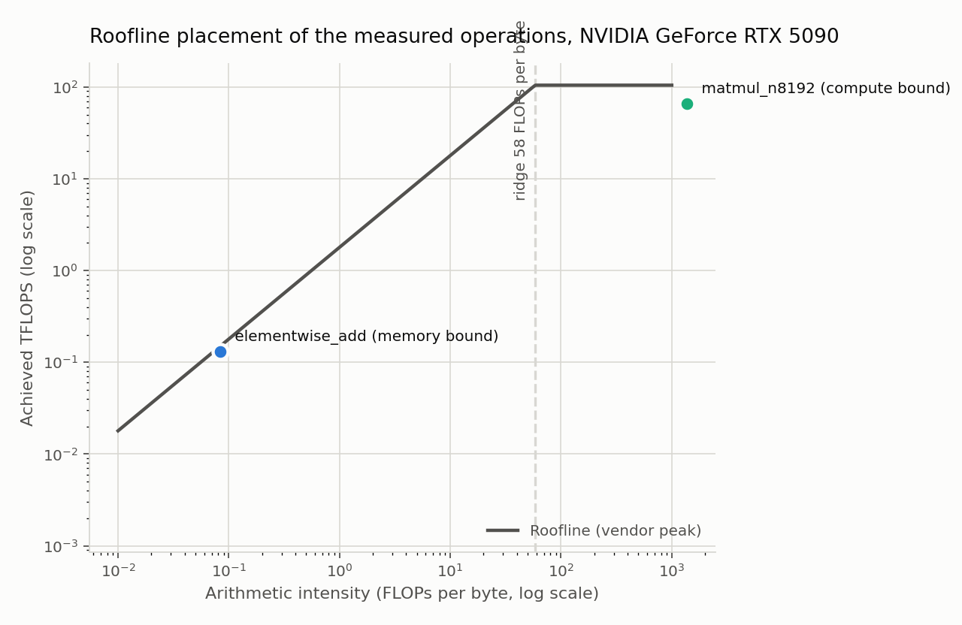
Figure 2. The measured operations placed against the card roofline. The copy does no useful FLOPs, so its intensity of zero cannot be drawn on a logarithmic axis.

5. Part D: the cost of attention
Code and artifacts: part_d_attention.py · results CSV · summary JSON · memory figure · latency figure
Naive scaled dot product attention materialises the full sequence by sequence score matrix in VRAM, and is measured against the fused kernel that PyTorch selects through scaled_dot_product_attention. Configuration: batch=1 heads=8 head_dim=64 dtype=fp16 reps=20.
Impl | S | Peak memory (GiB) | Latency (ms) | Speedup vs naive | Peak memory ratio
naive | 512 | 0.0177 | 0.1503
naive | 1024 | 0.0431 | 0.07
naive | 2048 | 0.1407 | 0.2926
naive | 4096 | 0.5236 | 1.2071
naive | 8192 | 2.0392 | 4.6977
naive | 16384 | 8.0704 | 17.9389
fused | 512 | 0.0119 | 0.0912 | 1.648 | 1.489
fused | 1024 | 0.0158 | 0.0319 | 2.194 | 2.72
fused | 2048 | 0.0158 | 0.0704 | 4.156 | 8.903
fused | 4096 | 0.0237 | 0.2131 | 5.664 | 22.107
fused | 8192 | 0.0394 | 0.8127 | 5.78 | 51.717
fused | 16384 | 0.0709 | 2.7823 | 6.448 | 113.79
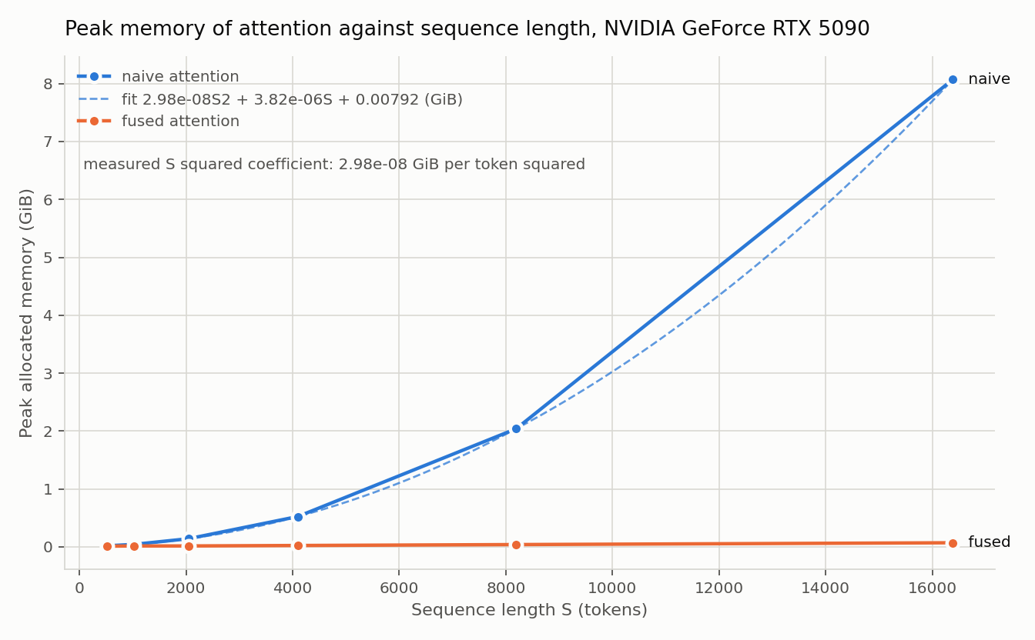
Figure 3. Peak memory against sequence length, with the quadratic fitted to the naive sweep.
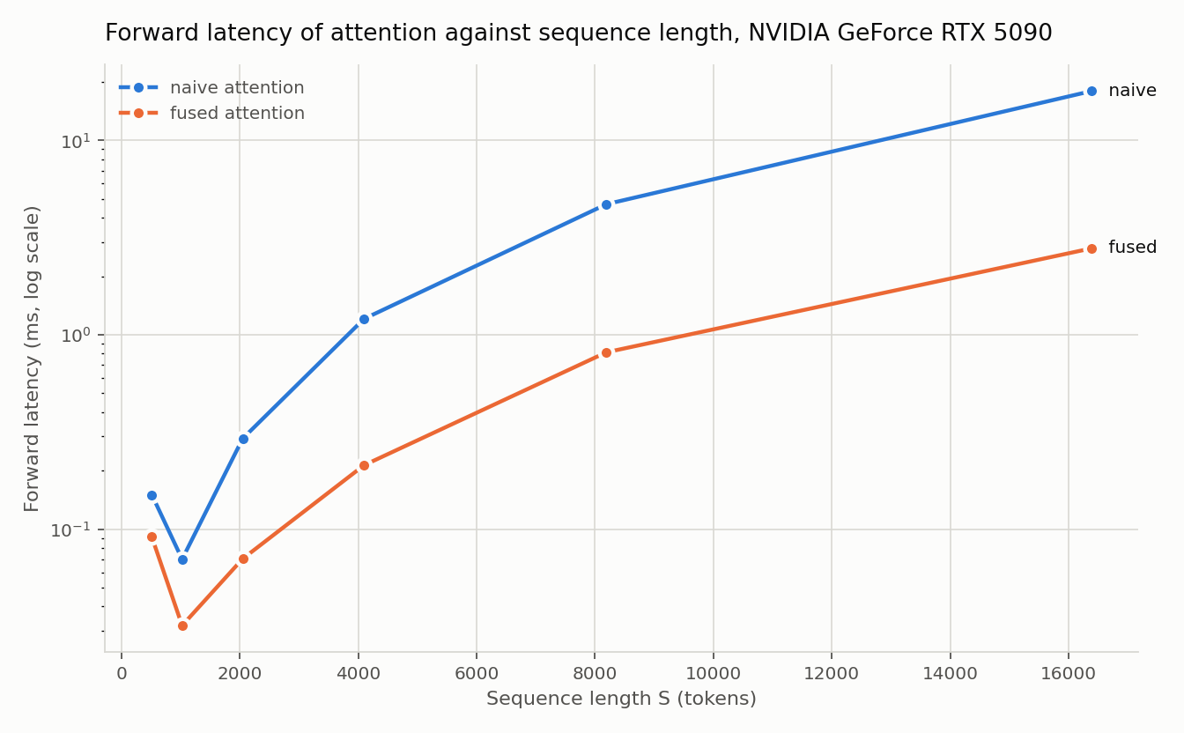
Figure 4. Forward latency against sequence length, logarithmic axis.

5.1 The quadratic, confirmed from the data
Fitting peak memory against sequence length over the naive sweep gives 32.0000 times S squared plus 4096 times S, with R squared of 1.000000. The quadratic term is therefore 32.0000 bytes per token squared, against 32 expected if two S by S FP16 tensors are materialised, which is batch times heads times 2 times itemsize. The fit confirms the quadratic rather than assuming it. The fused kernel fits 0.0331, which is 0.104% of the naive coefficient, so it has no quadratic term at all.

5.2 The out of memory boundary
Reported as a bracket, refined by bisection to 256 token resolution. Naive attention: largest success S=32512, smallest failure S=32768. This is not an exact single token boundary and is not claimed as one. Fused attention: no OOM up to S=131072, the extension cap, which is the expected result because its peak memory is linear in S.
The bracket agrees with an independent prediction. Solving 32 times S squared plus 4096 times S against the 31.84 GiB the driver reports gives S of about 32623, which falls inside the measured bracket.
One probe, at S=32768, reported a peak of 32.13 GiB, which exceeds the card’s physical 31.84 GiB. On this WSL2 backed machine allocations were spilling into host memory instead of failing, so torch reported a false success with a latency of several seconds. The script now cross checks every reported peak against torch.cuda.mem_get_info and records any result above physical VRAM as a failure with an implausible marker rather than a success. Without that check the search walked to S=50688, roughly 50% past the true boundary.

5.3 What the fused kernel avoids doing
The fused kernel never materialises the S by S score matrix in HBM at all, where the naive version writes the scores, reads them back for the softmax, writes the weights, then reads those back for the second matmul, so the quadratic term in the naive version is HBM traffic as much as it is HBM capacity. Instead it tiles the computation and runs the softmax online over blocks, keeping a running maximum and sum so each block can be rescaled as later blocks arrive, which lets the QK product, the softmax and the AV product stay fused in a single kernel with the intermediates held in SRAM and registers rather than round tripping through HBM. It performs the same arithmetic, so what it saves is bandwidth and capacity rather than FLOPs, which is exactly what the fit shows: the S squared coefficient falls from 32 bytes per token squared to 0.0331, and peak memory at S=16384 is 113.79 times smaller. The payoff compounds with sequence length, giving a 6.448x speedup at S=16384 and letting the fused path still run at S=131072 where the naive path already fails at S=32768.

6. Part E: sustained load and thermal behaviour
Code and artifacts: part_e_thermal.py · thermal log · throughput CSV · summary JSON · figure
A sustained BF16 matmul load at N=8192 ran for 20 minutes while nvidia-smi was sampled every 5 seconds, giving 238 samples of SM clock, memory clock, temperature, power draw and utilisation. The full log is committed at logs/part_e_thermal_74396ae57bdb.csv.
Measurement | Value
Duration | 1200 s
Peak throughput, first 30 s | 230.52 TFLOPS
Steady state, final 5 min | 217.49 TFLOPS
Steady state over peak | 94.3%
Throttle onset | 5 s, SwPowerCap
Conditions at onset | 52 C, 574.98 W, SM clock 2737 MHz
Peak temperature | 73 C
SM clock range under load | 2640 to 2737 MHz
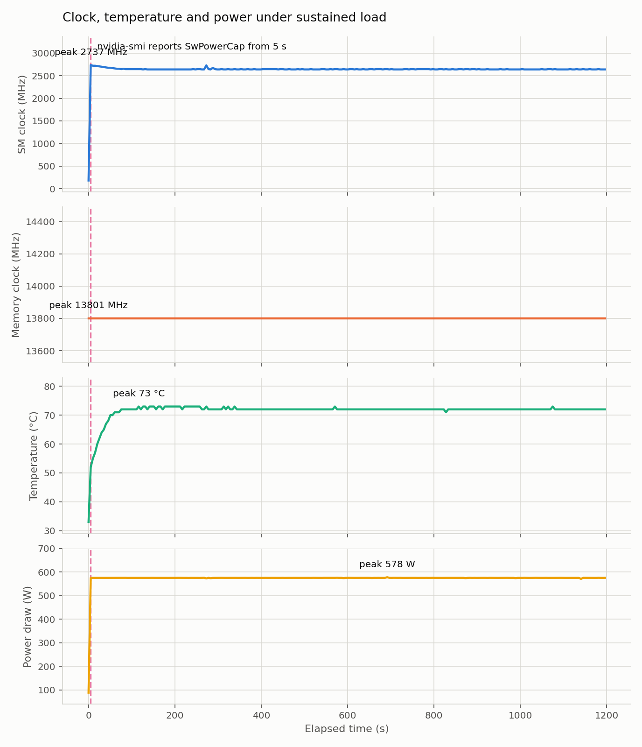
Figure 5. SM clock, memory clock, temperature and power draw over the 20 minute run. The dashed line marks the throttle onset.
The card throttled against its power ceiling, not its thermal ceiling. The SwPowerCap bit is set from the first loaded sample at 5.16 s, where power draw is already 574.98 W against a 575 W limit at only 52 C. Temperature then climbs to a peak of 73 C over the following minutes while the SM clock declines gently from 2737 to 2640 MHz, so thermal effects compound on top of a power limit that was already binding from the start of load.
Steady state throughput is 94.3% of the peak measured in the first 30 seconds. For a training run this is the number that matters: a benchmark quoted from a cold card overstates sustained throughput by about 5.7%. The figure is specific to this card, this chassis and this room.

7. Part F: summary and analysis
Code and artifacts: METRICS.md · make_metrics.py · make_figures.py · ANALYSIS.md · RUN_LOG.txt
Table HW2.5.1. Every cell is traceable to a UUID labelled run in RUN_LOG.txt.
Measurement | Value | Notes
Peak achieved TFLOPS (BF16) | 226.866 | N=16384, 50 timed reps
% of theoretical peak (BF16) | 108.29% | vendor dense BF16 peak 209.5 TFLOPS
Effective bandwidth (GB/s) | 1555.16 | elementwise add, 86.78% of 1792 GB/s spec
Naive attention OOM length | S=32512 ok, S=32768 fail | 256 token resolution, 1 implausible probe rejected
Fused attention OOM length | no OOM to S=131072 | extension cap, memory is linear in S
Steady state over peak throughput | 94.3% | 230.52 then 217.49 TFLOPS
Throttle onset | 5 s | SwPowerCap at 52 C and 574.98 W

7.1 Readings above 100% of theoretical peak
Several Part B readings exceed 100% of the recorded theoretical peak, up to 110.93% at N=16384 TF32. The first thing to rule out is the denominator being set too low.
It is not. The peaks in section 2.2 are the dense figures rather than the sparse ones. The whitepaper prints each tensor row as a dense/sparse pair, and the sparse rate is reachable only on matrices deliberately structured so that half the values are zero, which these are not. They are also the FP32 accumulate variants, because cuBLAS runs torch.matmul on half inputs with FP32 accumulate rather than the faster FP16 accumulate. Both are the smaller figure of the pair available, so the readings cannot be explained away by a generous denominator. For completeness, the 3352 AI TOPS headline on the product page is FP4 with sparsity, exactly twice the 1676 dense rate, and is not used anywhere in this report.
The explanation is clock. The peak figures assume the NVIDIA rated boost clock of 2407 MHz, while Part E measured a sustained SM clock of 2737 MHz under load, 1.14 times the rated boost clock, which alone accounts for readings up to 114% of the rated peak.
The inflation is not uniform across precisions at N=16384, running 1.109x for TF32, 1.083x for BF16, 1.042x for FP8 and 1.024x for FP16. That supports the clock explanation rather than undermining it: the heavier the tensor operation, the more power it draws, so the lower the clock it can sustain against the 575 W cap that Part E recorded as active from the first loaded sample onward.

7.2 Corrections made during the work
The first Part D run reported an OOM boundary of S=50688 to 50944, which was wrong for the host memory fallback reason described in section 5.2. The corrected boundary agrees with the arithmetic to within the 256 token bracket.
A separate crash, torch.AcceleratorError with CUDA error device not ready, followed two consecutive large failed allocations. That exception type is a RuntimeError subclass, so it was already being caught; the real defect was that the out of memory classifier did not recognise device not ready as a caught failure and re raised it.
The Part E throttle onset originally read 0 seconds because the scan compared every sample, including the idle sample at 0.1 s taken before the load ramped, against the loaded baseline. Excluding pre ramp samples gives the correct onset of 5 s.

7.3 Environment
The lab Docker image ships PyTorch 2.1.2, which does not support the RTX 5090 Blackwell architecture at CUDA capability sm_120. torch.cuda.is_available() returns true but any real kernel launch fails with no kernel image is available for execution on the device. PyTorch was upgraded in place inside the container to 2.11.0+cu128 before any measurement was taken, so this affects every number in this report.

8. Reservation and GPU hours
Code and artifacts: reservations.md
Field | Value
Lab and machine | ISB 840, machine 33
Slot reserved | Fri 18 Sep 2026 12:00 PDT to Sat 19 Sep 2026 11:59 PDT
Hours reserved | 23.98
Time at the machine | 12:00 to 19:00 PDT on 18 Sep 2026, 7:00
Of which GPU compute | roughly 30 minutes
Checked in | Fri 18 Sep yes, Sat 19 Sep no, measurements already complete
Timestamps in RUN_LOG.txt come from the container clock, which ran 7 hours ahead of local time, so the runs logged at 21:52 to 00:47 are 14:52 to 17:47 PDT.

9. Appendix: every committed file
The complete submission is tagged hw2-5 at github.com/aneessaheba/DATA266 under GPU-assignments/GPU-Lab-1. Every file below is a live link into that tag, so each figure, table and claim in this report can be opened at source.
File | What it is
.gitignore | ignore rules, outputs are deliberately not ignored
AI_USE.md | AI use disclosure
ANALYSIS.md | written answers for Parts B, D and F
ASSIGNMENT.md | the assignment brief as given
HW2.5_Document.docx | this report
METRICS.md | generated, Table HW2.5.1 and the per part detail tables
README.md | repository layout and how to reproduce
RUN_LOG.txt | append only UUID labelled trace of every run
data/part_a_identity_74396ae57bdb.json | Part A card identity and vendor spec
data/part_b_74396ae57bdb.csv | Part B, 20 timed configurations
data/part_c_74396ae57bdb.csv | Part C, three operations with roofline placement
data/part_d_74396ae57bdb.csv | Part D, sweep, extension and bisection probes
data/part_d_summary_74396ae57bdb.json | Part D, OOM brackets and quadratic fits
data/part_e_summary_74396ae57bdb.json | Part E, peak against steady state
data/part_e_throughput_74396ae57bdb.csv | Part E, throughput samples across the run
figures/part_b_tflops_vs_size_74396ae57bdb.png | Figure 1
figures/part_c_roofline_74396ae57bdb.png | Figure 2
figures/part_d_latency_74396ae57bdb.png | Figure 4
figures/part_d_peak_memory_74396ae57bdb.png | Figure 3
figures/part_e_clock_temp_74396ae57bdb.png | Figure 5
logs/part_e_thermal_74396ae57bdb.csv | Part E thermal log, 238 samples at 5 s
provenance/nvidia-smi-q_GeForce_RTX_5090_74396ae57bdb.txt | complete nvidia-smi -q capture
reservations.md | reservation record, hours reserved against consumed
run_all.sh | runs Parts A to E then rebuilds figures and tables
scripts/common.py | shared helpers: timing, GPU identity, run log
scripts/fakecuda.py | simulated CUDA device used for offline testing
scripts/gpu_specs.json | vendor peaks transcribed from the whitepapers
scripts/make_figures.py | builds every figure from data and logs
scripts/make_metrics.py | builds METRICS.md including Table HW2.5.1
scripts/part_a_provenance.py | Part A
scripts/part_b_precision.py | Part B
scripts/part_c_roofline.py | Part C
scripts/part_d_attention.py | Part D
scripts/part_e_thermal.py | Part E
scripts/rehearse.py | offline harness, runs all parts against the simulated device

10. Repository and AI use
All code, data, logs, figures and generated tables are committed and tagged hw2-5 at github.com/aneessaheba/DATA266. AI use is disclosed separately in
AI_USE.md

