DATA 266 Assignment 3: Prompt Engineering and Self Attention from Scratch
Notebook: assignment3_prompting_and_self_attention.ipynb. All numbers below come from that executed notebook.

1. Prompt Engineering Techniques
Model: llama3.1 8B via Ollama, called through LangChain ChatOllama, temperature 0 with a fixed seed. Two fixed tasks are used for all six techniques. Task A: a tank drains at 6 L per minute while a pipe adds 2.5 L per minute for the first 20 minutes, starting from 240 liters; ground truth 9:48 am. Task B: five students in five chairs under four seating constraints; ground truth Eli.

1.1 Zero Shot Prompting
Task A: 9:40 am, wrong. Task B: Cleo, wrong. Zero Shot gives the model no mechanism to reason toward either answer.

1.2 Few Shot Prompting
Task A: 9:34 am, wrong. Task B: Cleo, wrong. The answer only examples changed the reply format but not the reasoning quality.

1.3 Chain of Thought (CoT) Prompting
Task A: 9:48:20 am, correct. Task B: Dev, wrong. CoT solved Task A by splitting the timeline at 20 minutes; on Task B it committed to one seating without checking every constraint.

1.4 Zero Shot Chain of Thought
Task A: approximately 9:48 am, correct. Task B: Cleo, wrong. Reasoning through the two phases worked for Task A; Task B again ended in an early, unverified commitment.

1.5 Meta Prompting
Task A: 9:31 am, wrong. Task B: Dev, wrong. The procedure the model wrote for itself used a single rate over the whole timeline, so stage 2 followed a flawed plan faithfully.

1.6 Tree of Thoughts (ToT)
Task B: Eli, correct. Task A: 9:49 am, wrong. ToT was the only technique to solve Task B, by discarding a seating once evaluation rejected it; on Task A it reasoned to 9:48:20 am and then rounded to the wrong minute.

1.7 Overall Comparison Across Techniques
Technique | Task A answer | A correct | Task B answer | B correct
Zero Shot | 9:40 am | No | Cleo | No
Few Shot | 9:34 am | No | Cleo | No
Chain of Thought | 9:48:20 am | Yes | Dev | No
Zero Shot CoT | approximately 9:48 am | Yes | Cleo | No
Meta Prompting | 9:31 am | No | Dev | No
Tree of Thoughts | 9:49 am | No | Eli | Yes

No technique solved both tasks. Chain of Thought and Zero Shot Chain of Thought were the only techniques correct on the math problem; Tree of Thoughts was the only technique correct on the logic puzzle. Tree of Thoughts also used far more LLM calls than any other technique.

2. Self Attention and Causal Masking from Scratch
Implemented entirely from raw PyTorch primitives: nn.Embedding, nn.Linear, matrix multiplication, softmax, and cross entropy. No nn.MultiheadAttention, nn.Transformer, or HuggingFace transformer class is used.

2.1 Dataset and Tokenization
The exact five sentence passage given in the assignment, tokenized at the word level into 46 tokens over a vocabulary of 32 words plus an end of sequence token.

2.2 Embedding Layer
A trainable token embedding plus a trainable positional embedding, needed because attention alone is permutation equivariant and cannot represent order on its own.

2.3 Part 1: Unmasked Scaled Dot Product Self Attention
Q, K and V come from three separate bias free linear projections; scores are Q K transpose divided by the square root of d_k, then softmax. Trained for 600 epochs with a next token objective and no mask. The mean row maximum rose from 0.0793 before training to 0.7593 after (uniform is 0.0217), reaching a next token accuracy of 1.000, so the heatmap below reflects learned structure rather than random initialization.
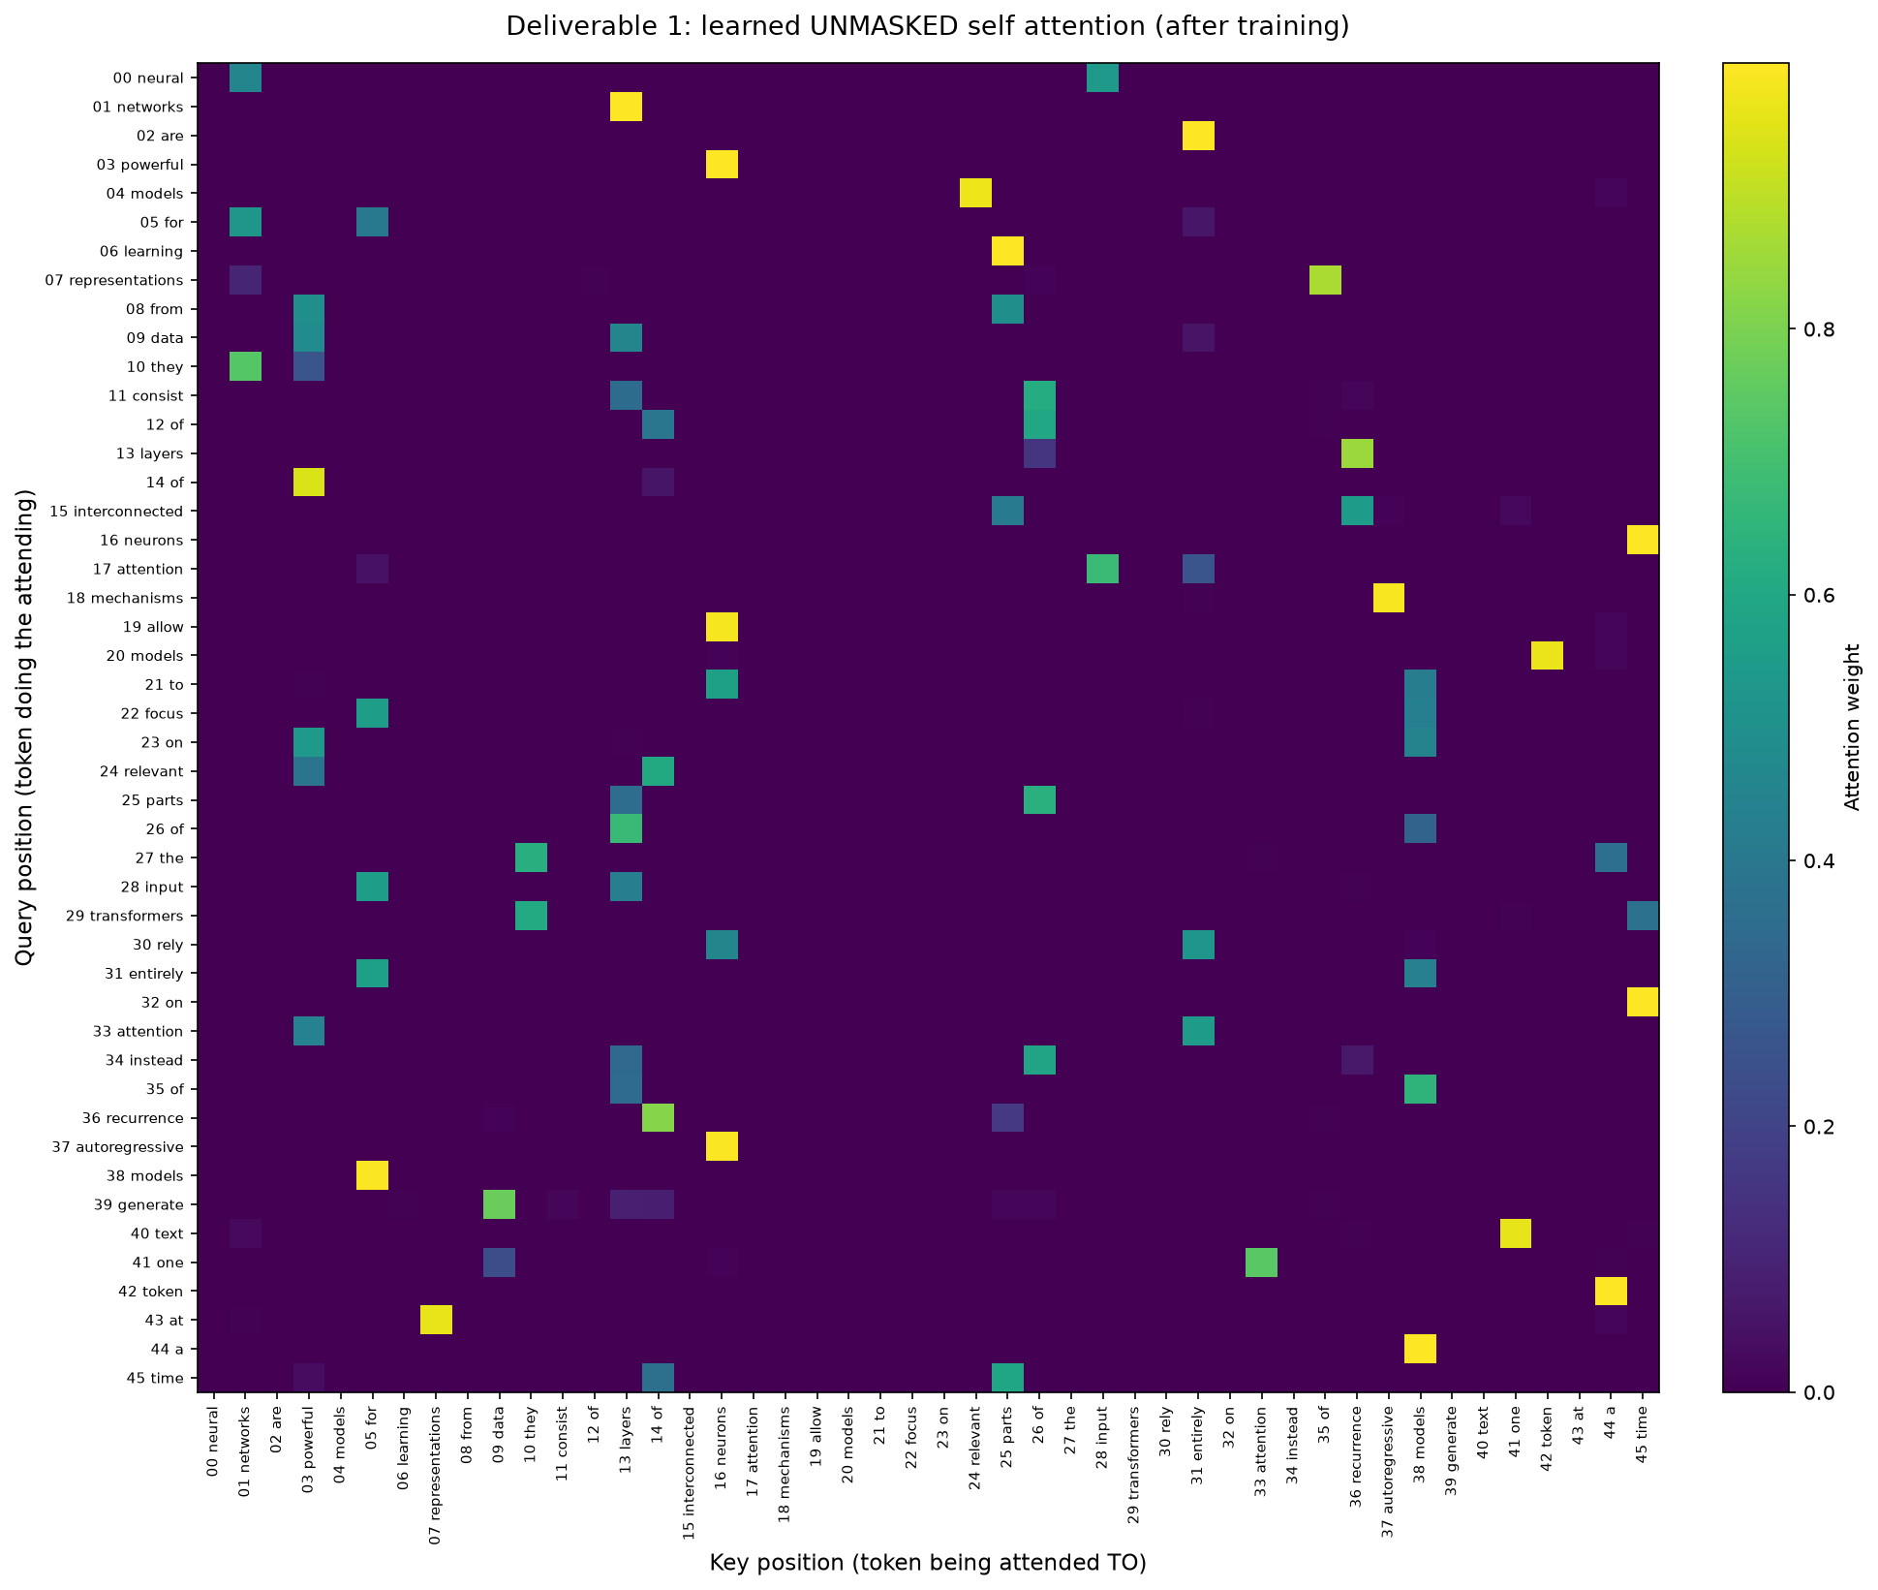
Deliverable 1. Unmasked self attention after training.

2.4 Part 2: Causal Masking
A lower triangular mask blocks future keys before softmax. Part 1 and Part 2 are two separately trained models: a second model is trained from scratch with the mask applied throughout, so it never sees future tokens at any point.
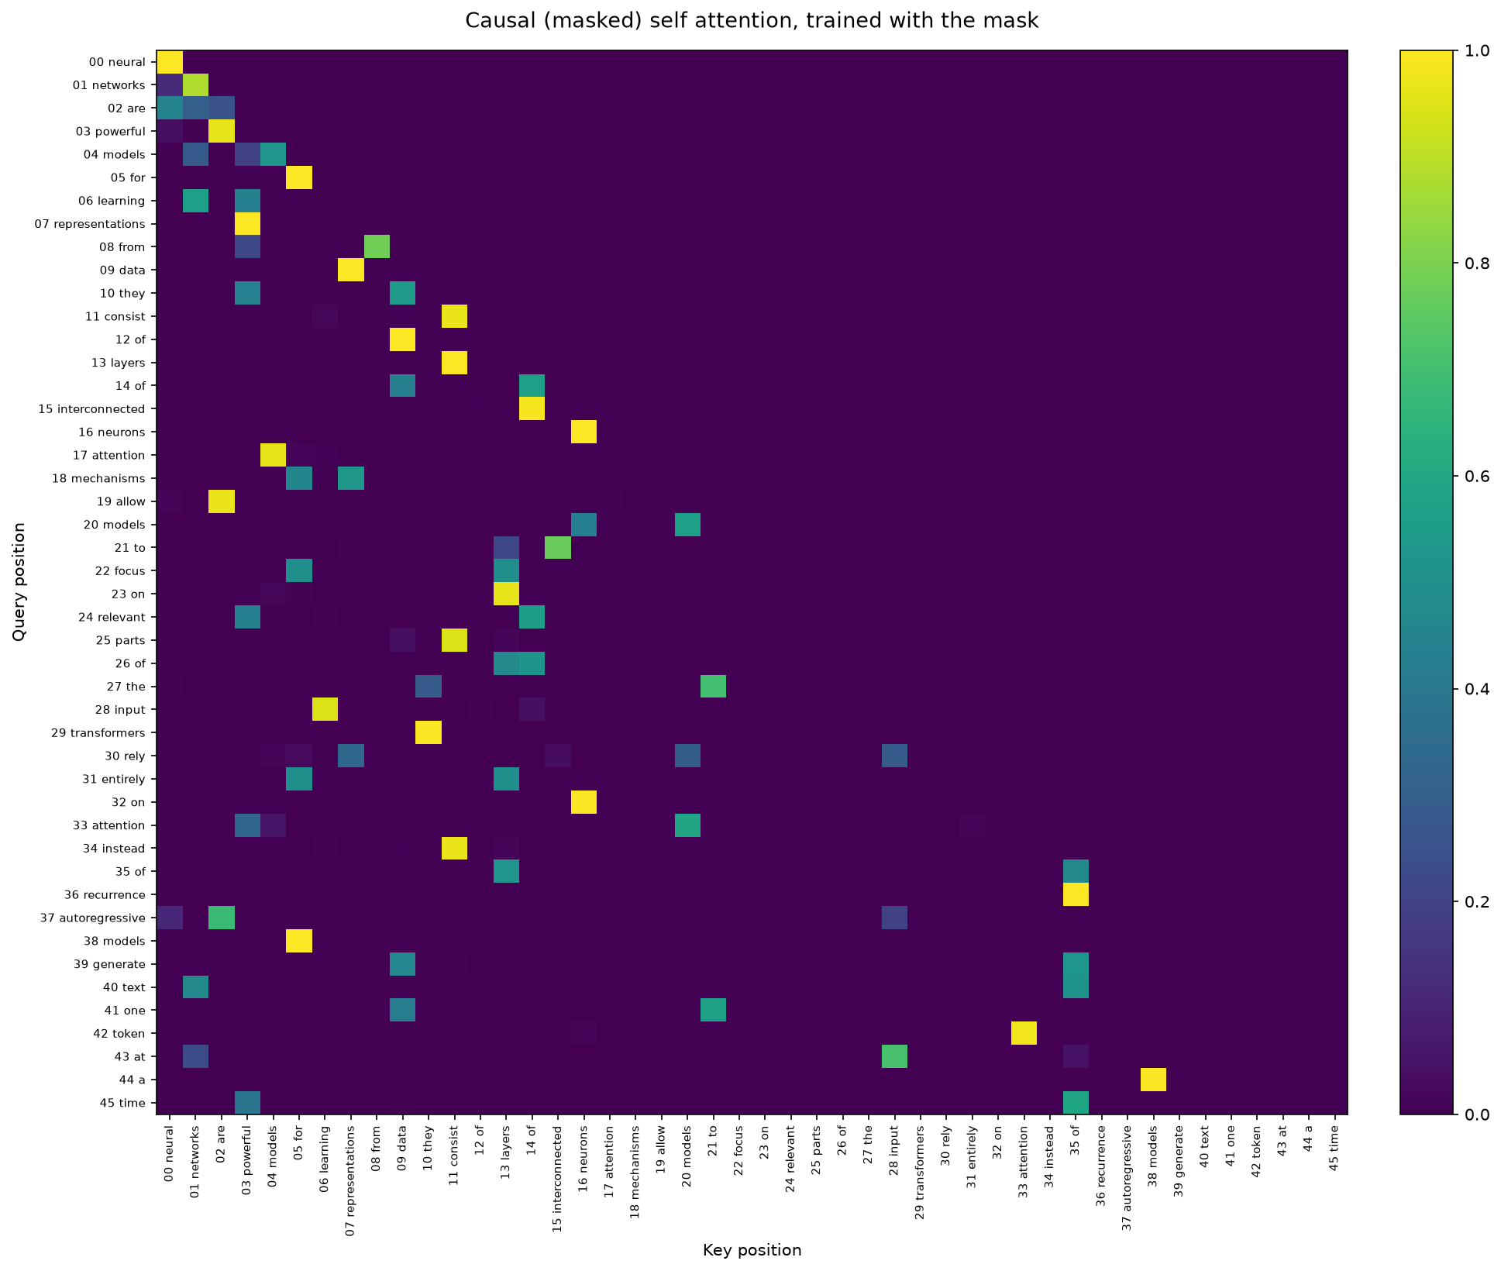
Deliverable 2. Causal self attention, trained with the mask.

Every entry above the diagonal is exactly 0 and every row still sums to 1. Part 1 (no mask) reaches accuracy 1.000; Part 2 (masked throughout training) converges to 0.978, since it genuinely has less information at each position. As a secondary check, applying the mask only at test time to the Part 1 model drops its accuracy to 0.391, showing how much it had relied on future tokens during training.

3. Conclusion and Final Findings Summary
No prompt engineering technique solved both tasks. Chain of Thought and Zero Shot Chain of Thought solved the math problem by working through the two phases of the timeline in order. Tree of Thoughts alone solved the logic puzzle because it could discard a branch after generating it. More visible reasoning was not the same as more correct reasoning: several techniques produced fluent, confident, and wrong reasoning on the logic puzzle.
For self attention, the unmasked model's attention map went from close to uniform to sharply peaked during training, confirming the heatmap reflects learned structure, and it relied on future positions to reach perfect accuracy. The separately trained causal model never had that option and converged to a lower accuracy instead. Both halves of this assignment show the same lesson: a model's fluent output is not on its own evidence that it solved the problem the intended way.

