Distributed Systems for Data Engineering Class Group Project: Kayak Simulation

Project Due Date (Presentation and Demo): 1st December 2025 and 8th December 2025

History & About Kayak
KAYAK is a travel metasearch and booking platform. It aggregates options for flights, hotels, and rental cars from multiple providers, enabling travelers to search, compare, and choose the option that best fits their needs. Your simulation will emulate these core functions- search, filter, book, bill, and analyze usage within a distributed, service-oriented architecture.

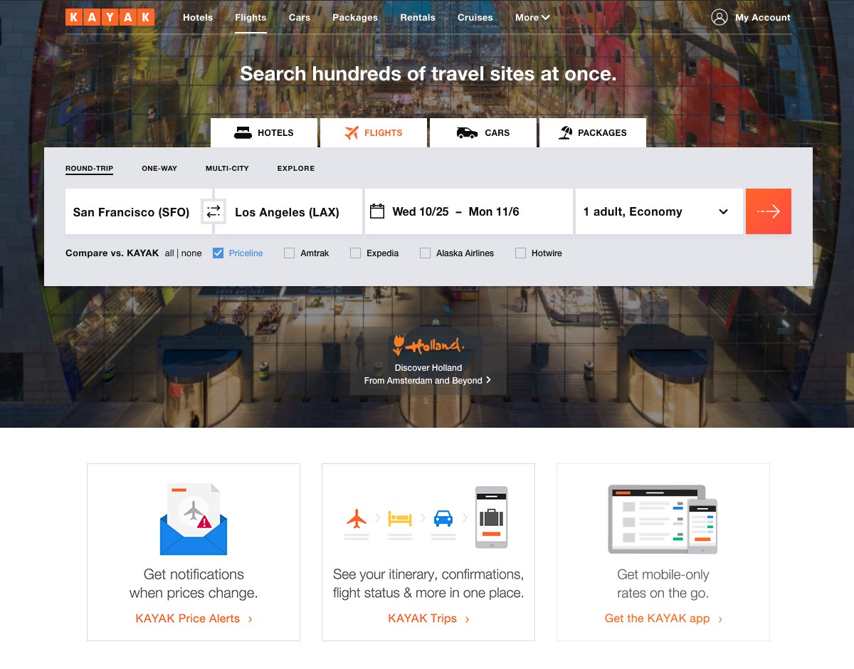

Project Overview
https://www.kayak.com/
In this project, you will design a 3-tier application that implements the functions of a Kayak-like travel system. You will build on the techniques used in your lab assignments (like html, css, js, jsx, nodejs, express, redux(for all the frontend), reactjs, mongodb for all the database work, reddis for caching), for the agent features (Python FastAPI + Langchain + open AI key) to create the system.
Basically, in this project users should be able to search flights, hotels, cars, and make billing and book. Admin should be able to create or update or edit hotels, cars, flights, accept booking of user and they should have some good charts to track things etc. For more details of each service look below:

In the Kayak System, you will manage and implement different types of objects:
- Users
- Listings (Flights, Hotels, Cars)
- Billing
- Admin
For each type of object, you will also need to implement an associated database.
Your project should be built upon a distributed architecture. You have to use REST-based web services and message queues (Kafka) as middleware technology. You will be given a great deal of “artistic liberty” in how you choose to implement the system.

System Requirements: You must support the following entity types (minimum).
Users service – Users should be able to login with email id and their password.
It represents information about an individual user registered on Kayak. You must manage the following information for this service.
- User ID [Should be an SSN (Social Security Number) format is a nine-digit number].
- First Name
- Last Name
- Address
- City
- State
- Zip Code
- Phone Number
- Email
- Profile Image
- Credit Card / Payment Details
- Booking History (Past / Current / Future Trips)
- Reviews submitted for flights, hotels, and cars

Flights - It represents information about available flights that users can search and book through Kayak. You must manage the following information for this entity:
- Flight ID (e.g., AA123)
- Airline / Operator Name
- Departure Airport
- Arrival Airport
- Departure Date and Time
- Arrival Date and Time
- Duration
- Flight Class (Economy / Business / First)
- Ticket Price
- Total Available Seats
- Flight Rating
- Passenger Reviews
Hotels - It represents information about hotels listed on Kayak. You must manage the following information for this entity:
- Hotel ID
- Hotel Name
- Address
- City
- State
- Zip Code
- Star Rating
- Number of Rooms
- Room Type (Single, Double, Suite, etc.)
- Price per Night
- Amenities (e.g., Wi-Fi, Breakfast, Parking)
- Hotel Rating
- Guest Reviews
- Images of Rooms and Property
Cars - It represents information about cars available for rent through Kayak. You must manage the following information for this entity:
- Car ID
- Car Type (SUV, Sedan, Compact, etc.)
- Company / Provider Name
- Model and Year
- Transmission Type
- Number of Seats
- Daily Rental Price
- Car Rating
- Customer Reviews
- Car Availability Status
Billing - It represents information related to payment and transaction details for bookings made by users. You must manage the following information for this entity:
- Billing ID
- User ID
- Booking Type (Flight / Hotel / Car)
- Booking ID
- Date of Transaction
- Total Amount Paid
- Payment Method (Credit Card, PayPal, etc.)
- Transaction Status
- Invoice / Receipt Details
Administrator - It represents information about the administrators responsible for managing the Kayak system. You must manage the following information for this entity:
- Admin ID
- First Name
- Last Name
- Address
- City
- State
- Zip Code
- Phone Number
- Email
- Role / Access Level
- Reports and Analytics Managed
Your project will consist of three tiers:
- The client tier, where the user will interact with your system
- The middle tier/middleware/messaging system, where the majority of the processing takes place
- The third tier, comprising databases to store the state of your entity objects
Tier 1 - Client Requirements
The client will be an application that allows a user to do the following:

User Module/Service
- Create a new User (use Kayak official page for guidance)
- Delete an existing User
- Change a user’s information (name, address, profile image, etc.) - This function must support the ability to change ALL attributes
- Display information about a User
- Search listings for different categories (Flights, Hotels, Cars) ● Filter listings
○ Filter hotels by stars, price
○ Filter flights by departure/arrival times, price
○ Filter cars by car type, price
- Book a hotel/flight/car
- Make Payment
- View Past/Current/Future bookings

Admin Module/Service
- Allow only authorized (admin) users to access Admin Module
- Add listings (hotel/flight/car) to the system
- Search for a listing and edit it
- View/Modify user accounts
- Search for a Bill based on attributes (by date, by month)
- Display information about a Bill

Sample Admin Analysis Report
The admin dashboard will present graphs/charts such as:
- Top 10 properties with revenue per year (bar/pie/any chart)
- City-wise revenue per year (bar/pie/any chart)
- 10 hosts/providers with the maximum properties sold last month and associated revenue
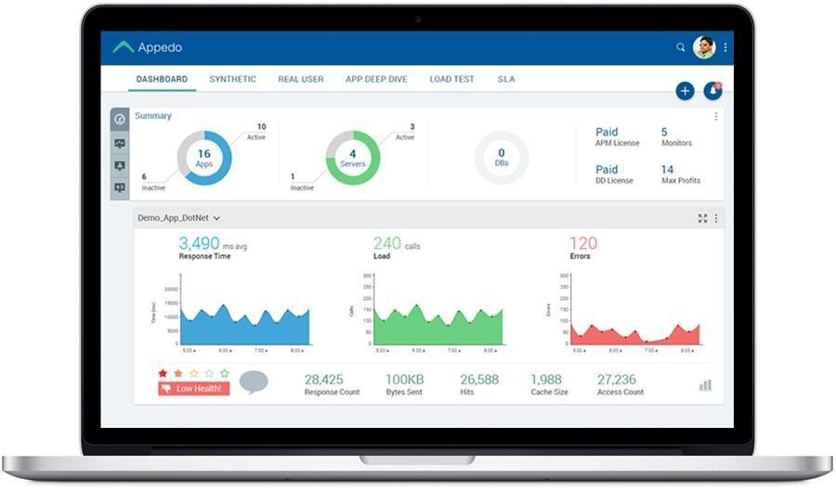

Tier 2 - Middleware
You will need to design middleware using Kafka that can accomplish the above requirements. Implement it using REST-based Web Services as middleware technology. Next, decide on the interface your service will expose. Ensure you appropriately handle error conditions/exceptions/failure states and return meaningful information to your caller.

Your project should also include a model/data access layer that uses standard modules to access your databases. Entity objects will use the data object to select/insert/update state.
Use Kafka as a messaging platform for communication between front-end channels and backend systems. Separate Node into two parts connected via message queues. Design “backend services” as consumer and “frontend services” as producer as shown below diagram.
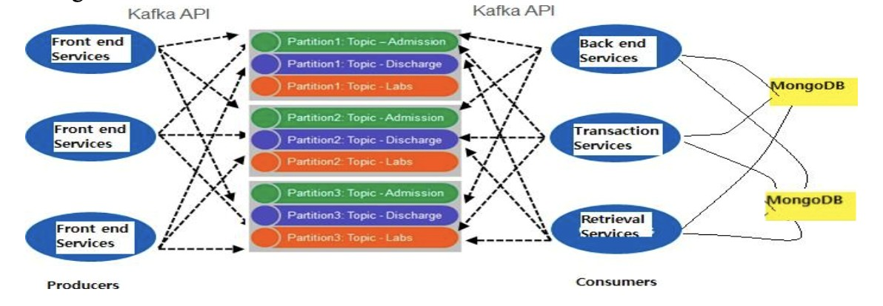

Tier 3 - Database Schema and Database Creation
Design and create your databases.
- MongoDB

Agentic AI Recommendation Service in FastAPI
This service is a multi-agent travel concierge that periodically discovers great deals (scheduled scans), reasons about user needs in conversation, and turns those insights into actionable trip recommendations. It behaves less like a search box and more like a proactive teammate that plans, explains, and adapts. Use FastAPI for HTTP + WebSockets to push updates to the UI. (FastAPI)
Deals Agent (backend worker): ingests small CSV/mock feeds on a schedule, detects & tags deals, and emits updates via websocket connection (feel free to use Kafka as well)
Concierge Agent (chat-facing): understands user goals, composes simple flight+hotel bundles from cached deals, explains tradeoffs, and sets price/stock watches. Model requests/responses with Pydantic v2 and persist normalized entities with SQLModel (SQLite locally). (Pydantic)

What the Agent does (at a glance)
- Understands intent & constraints in natural language (e.g., “weekend in Tokyo under $900, pet-friendly, near public transit”).
- Finds and tags flight + hotel deals only (cars out-of-scope for MVP) using simple rules (e.g., price drop >15%, scarce inventory, limited-time promo).
Builds coherent itineraries (bundles) that optimize for cost, convenience, and essential preferences.
- Explains recommendations (tradeoffs, why this hotel over that one, key fees, cancellation rules) with short, template-based snippets.
Watches for changes (price drops, sold-out risk) on a schedule and notifies the UI asynchronously over WebSockets. (FastAPI)
- Answers questions about policies, logistics, and alternatives using fields present in the datasets (refundability, pets, breakfast, neighborhood).

For Example, if a user asks “I’ve got Oct 25–27, SFO to anywhere warm, total budget $1,000 for two.”
- Outcome: The service proposes 2–3 complete bundles with clear, comparable summaries (price, travel time, hotel neighborhood, cancellation terms), and a short “why this pick works for you.”
Again user continue to chat/ask another question like “Make it pet-friendly and avoid red-eye flights.”
-Outcome: The service preserves earlier context, regenerates options that respect new constraints, and highlights what changed (e.g., “+ $38, earlier departure, 20-minute longer connection”).

Agent should Decide with confidence for example if a user asks
- User: “Is the Marriott rate actually good?”
- Outcome: It explains: “This is 19% below its 60-day rolling average for these dates; similar 4 star options nearby are $25–$60 higher per night.”

Book or hand off cleanly
- Outcome: The service returns a complete, validated quote (fare class, baggage, fees, cancellation) and hands off to a partner flow. (Keep the “quote” purely from available dataset fields in MVP.)

Scalability, Performance and Reliability
The hallmark of any good project is scalability. A highly scalable system will not experience degraded performance or excessive resource consumption when managing large numbers of objects or when processing large numbers of simultaneous requests. You need to make sure that your system can handle many listings, users, and incoming requests.
- Pay careful attention to how you manage “expensive” resources like database connections.
- Your system should easily be able to manage 10,000 listings, 10,000 users, and 100,000 reservation/billing records. Consider these numbers as minimum requirements.
Project Presentation
1. Group number and team details

Database Schema 3. System Architecture Design Diagram
4. Scalability/Performance comparison bar graphs that show differences by adding features: B (Base), S (SQL Caching), K (Kafka), and additional techniques for 100 simultaneous user threads (4 total bar charts). You may use Apache JMeter.
Combinations:
- B
- B + S
- B + S + K
- B + S + K + other techniques you used
Note: Populate DB with at least 10,000 random data points and measure performance.
Explain in your report how your detection rules, caching policy, and messaging flows support timeliness and scalability.

