# Project Based Learning

# These are simple and basic level small projects for learning purpose. Also you can modify these systems as per your requirements and develop an advance level project.

1. Create a structure named **DateFormat** which represents the date in various formats. The program works as follows :

At first the program prompts the user to select /choose any data format, and the program will then display the date in that format.

Sample output

Select date format :

1. DD-MM-YYYY
2. MM-DD-YYYY
3. YYYY-MM-DD

2

Date format MM-DD-YYYY is selected : 09-30-2023

Continue for next selection (y/n) : y

Select date format :

1. DD-MM-YYYY
2. MM-DD-YYYY
3. YYYY-MM-DD

3

Date format YYYY-MM-DD is selected : 2023-09-30

Continue for next selection (y/n) : n

End of the Program

1. Construct a C++ program on Hospital Management system which includes registration of patients, storing their details into the system, and also booking their appointments with doctors. The system works by entering a valid username and password. (Use structures or nested structures to build the system)
2. Build a C++ program on Students Attendance. The program manages the attendance of students.

Admin/ Teacher can register students, mark their attendance and can create username & password for students.

Students can login, and can see their attendance. (Use structures or nested structures to build the system)

1. Create a C++ program on Restaurant Management System. The program prints the main page/ startup screen which includes:
2. Menu Card
3. Order an item with quantity
4. Bill details
5. Exit.

1

Menu card

1. Burger
2. Biryani
3. Roll
4. Others

1

Enter Quantity

…..

…..

1. Create a C++ program on mcqs Test where the user will be asked questions and the result of each question whether it is correct or wrong with the updated score will be shown.(Use structures or nested structures to build the system)

The program works as follows:

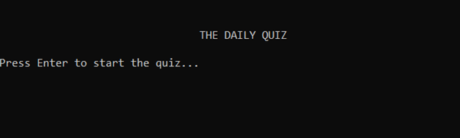

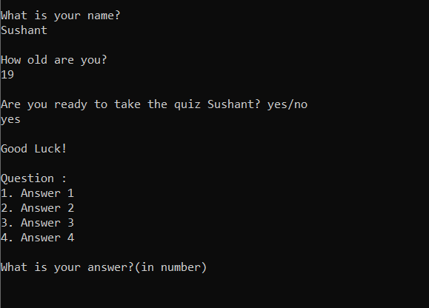

************************************

*********** Your Result ************

************************************

Total number of questions : 10

Correct answer : 6

Wrong answer : 4

1. Create a C++ program on Simple Login system. The program also contains forgot password feature. (Use structure for storing login information)

-This program asks the user to enter a user name and password (which is already pre-defined in the code).  
-It then checks the user's input in the if-else-if statements.  
-If the login condition is true, it will print a welcome message to the user.  
-Otherwise it will tell the user the entry is invalid and allows them to try 4 more times. (5 in total)