FAST National University of Computer and Emerging Sciences
Software Quality Engineering

UNIT TEST AUTOMATION REPORT
Building a Unit Test Automation Solution
Project Under Test: TinyDB
Document-Oriented Database in Pure Python | Version 4.9.0
Course | Software Quality Engineering
Assignment | Assignment 3: Build Unit Test Automation Solution
Instructor | Mr. Talha Dar
Submitted By | Muhammad Anees (24F-3107)  Muhammad Abdullah Jamal (24F-6022)
Repository | github.com/aneeszafar/tinydb-unit-test-automation
Submission Date | 23 October 2026
Document Version | 1.0 (Final)

Document Control
Document Information
Report Title | Unit Test Automation Report: TinyDB
Project Name | TinyDB (document-oriented database in pure Python)
Project Version | 4.9.0 (forked from msiemens/tinydb)
Repository | https://github.com/aneeszafar/tinydb-unit-test-automation
Document Version | 1.0 (Final)
Document Status | Submitted for evaluation
Test Scope | Module 1: Queries, Module 2: Storage and Middleware, Module 3: Table
Prepared By | Muhammad Abdullah Jamal and Muhammad Anees
Submitted To | Mr. Talha Dar
Revision History
Version | Date | Description | Author
0.1 | 23 October 2026 | Working notes and progress log | Group
1.0 | 23 October 2026 | Final report with results and evidence | Group
Related Deliverables in the Repository
Deliverable | Location
ECP / BVA design notes | docs/notes/
Excel test case sheet | docs/Test_Cases.xlsx
Setup video link | docs/setup_video.md
Automated tests | sqe_tests/anees/, sqe_tests/abdullah/
CSV test data | sqe_tests/data/
Configuration | sqe_tests/pytest.ini
Run instructions | README_SQE.md
Table of Contents
1. Executive Summary 4
1.1 Overview 4
1.2 Key Results 4
1.3 Key Findings 4
2. Introduction 5
2.1 Scope 5
3. Project Selection 6
3.1 Overview of the Modules Under Test 6
4. Team, Task Distribution and Collaboration 7
4.1 Collaboration Workflow 7
5. Task 1: Local Development Environment Setup 9
5.1 Setup Steps 9
5.2 Setup Video 9
5.3 Issues Faced and Resolutions 10
6. Task 2: Test Design and Automated Unit Tests 11
6.1 Test Design Approach 11
6.2 Module 1: Queries (Muhammad Anees) 11
6.3 Module 2: Storage and Middleware (Muhammad Anees) 12
6.4 Module 3: Table (Muhammad Abdullah Jamal) 12
6.5 Automated Test Summary 12
6.6 Notable Behaviours Discovered 13
7. Task 3: Excel Test Cases and CSV Data-Driven Tests 14
7.1 Excel Test Case Sheet 14
7.2 CSV Test Data and Data-Driven Tests 14
8. Task 4: Test Configuration and Execution 15
8.1 Configuration File 15
8.2 Test Groups and Suites 15
8.3 Parallel Execution 16
8.4 Parameterization 16
8.5 Execution Order 16
9. Results 18
9.1 Code Coverage 18
9.2 HTML Test Report 19
10. Repository Structure 21
11. How to Run the Tests 22
12. Challenges and Lessons Learned 23
13. Conclusion 24

1. Executive Summary

1.1 Overview
This report presents the unit test automation solution that our group built for TinyDB, an MIT-licensed open-source database written in pure Python. Three modules (Queries, Storage and Middleware, and Table) were analysed with Equivalence Class Partitioning and Boundary Value Analysis, and the resulting test cases were automated with pytest. Part of the suite is data-driven from CSV files, and the suite is configured to run in groups, in parallel and in a defined order.

1.2 Key Results
Total automated tests | 133 (118 unit tests + 15 CSV data-driven tests)
Result | 133 passed, 0 failed, 0 errors
Tests per member | Muhammad Anees: 79 | Muhammad Abdullah Jamal: 54
Excel test cases | 15 documented test cases linked to CSV data
Code coverage | 74% of the TinyDB package (storages.py 98%, middlewares.py 88%, table.py 83%, queries.py 74%)
Execution | Normal, grouped, parallel (8 workers) and ordered runs all pass
Original TinyDB suite | 228 passed in the local environment

1.3 Key Findings
Boundary-focused design exposed several behaviours that are easy to miss: insert_multiple() is all-or-nothing, document IDs restart at 1 after truncate(), the write cache saves only at exactly 1000 writes, and comparing a string field with a number raises TypeError. All of these are now covered by automated tests (see Section 6.6). No defects were found in the tested modules; every observed behaviour matched the code’s intended design.

2. Introduction
This report documents our work for Assignment 3 of Software Quality Engineering, in which we built a unit test automation solution for an open-source Python project. The goal was to set up the project locally, design unit tests with black-box techniques such as Equivalence Class Partitioning (ECP) and Boundary Value Analysis (BVA), automate those tests, drive part of them from external test data, and configure the test suite so that it can be run in groups, in parallel and in a defined order.
The project we selected is TinyDB, a lightweight document-oriented database written in pure Python. All of our work, including test design notes, automated tests, test data, the Excel test case sheet, configuration and run instructions, is committed to the group repository listed on the cover page.

2.1 Scope
- Three modules of TinyDB were selected for testing: Queries, Storage and Middleware, and Table.
- A total of 133 automated unit tests were written, of which 15 are data-driven from CSV files.
- The original TinyDB source code and its own test suite were not modified; our tests live in a separate sqe_tests/ folder.

3. Project Selection
Before selecting a project we checked several public repositories. One candidate repository was rejected because it had no license file, which means it is not legally open source even though its code is publicly visible. We then chose TinyDB for the following reasons.
Criterion | TinyDB
Repository | github.com/msiemens/tinydb (forked to the group repository)
License | MIT License, an OSI-approved open-source license that allows forking and modification
Language | Python, version 3.10 or higher (TinyDB 4.9.0)
Dependencies | None at run time; written in pure Python
Code structure | Small, well-separated modules with clear classes: Table, Query, JSONStorage, MemoryStorage, CachingMiddleware
Existing tests | 228 tests in the original suite, which made it easy to confirm that the local environment works
Table 1: Project selection summary

3.1 Overview of the Modules Under Test
Module | Source file(s) | Responsibility
Module 1: Queries | tinydb/queries.py | Builds conditions such as Query().age >= 18 that decide whether a document matches
Module 2: Storage and Middleware | tinydb/storages.py, tinydb/middlewares.py | Decides where data is kept (JSON file or memory) and caches writes before saving them
Module 3: Table | tinydb/table.py | Stores documents and provides insert, search, update, remove and related operations
Table 2: Modules selected for unit testing

4. Team, Task Distribution and Collaboration
Activity | Muhammad Anees | Muhammad Abdullah Jamal
Repository | Created the fork, added collaborator, owns the repository | Accepted collaborator invite
Task 1: Setup and video | Local setup and setup video | Local setup
Task 2: Modules | Module 1 (Queries), Module 2 (Storage and Middleware) | Module 3 (Table)
Task 2: Unit tests | 71 tests in test_queries.py and test_storage.py | 47 tests in test_table.py
Task 3: Excel and CSV | 8 test cases, query_age_data.csv, test_queries_csv.py | 7 test cases, table_insert_data.csv, test_table_csv.py
Task 4: Configuration | sqe_tests/pytest.ini, markers and order for own files, README run instructions | Markers and order for own files
Summary report | Shared | Shared
Table 3: Task distribution between group members

4.1 Collaboration Workflow
The repository is a fork of the original TinyDB project owned by Muhammad Anees, with Muhammad Abdullah Jamal added as a collaborator. Commits for each member’s assigned files were made from that member’s own GitHub account directly to the master branch. Work was split into small commits (for example one commit per group of test classes), so that the commit history clearly shows each member’s individual activity. Since the members worked on separate files, no merge conflicts occurred.
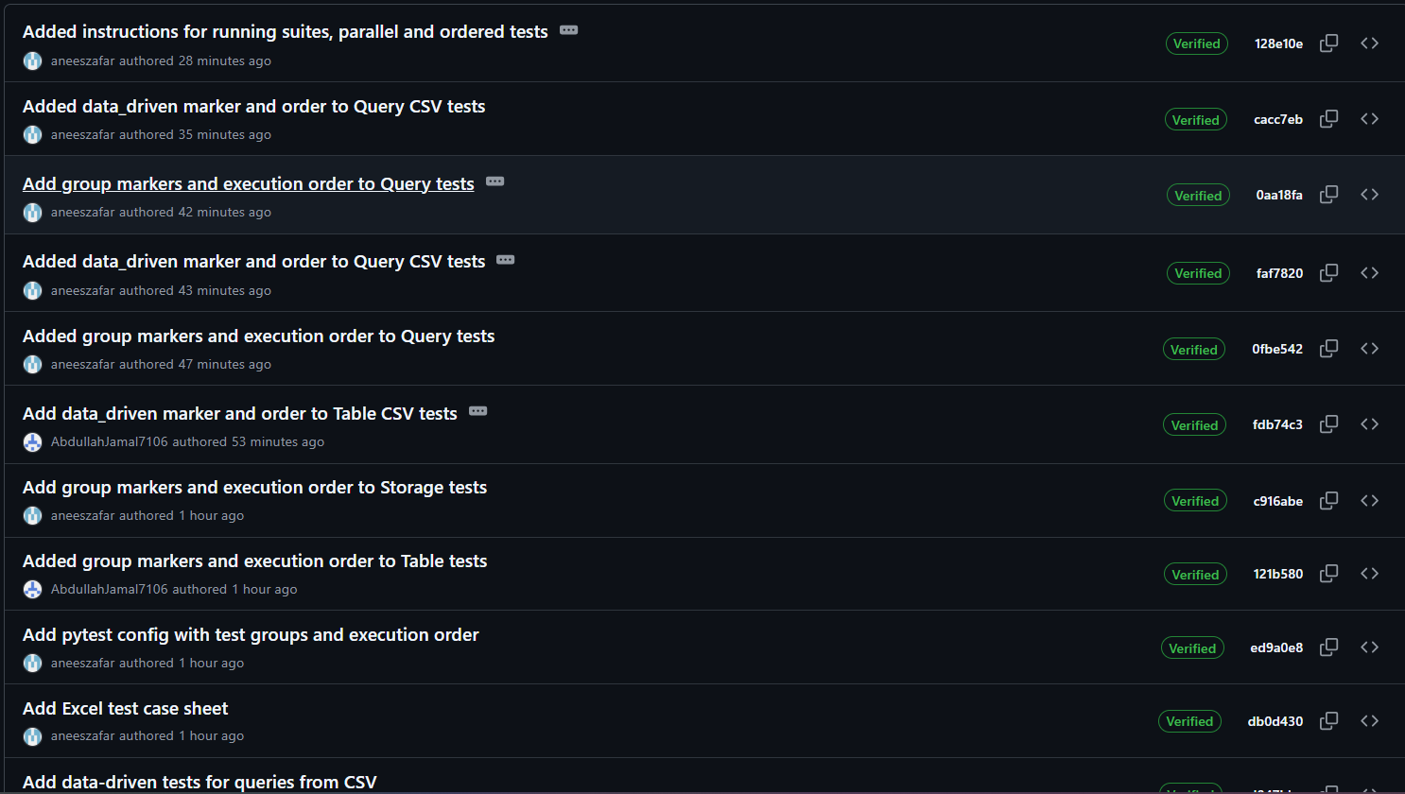
Figure 1: Commit history on GitHub showing commits by both group members

5. Task 1: Local Development Environment Setup
Component | Version / Detail
Operating system | Windows 11 (10.0.26200)
Python | 3.13.17 (64-bit Windows installer)
Editor | Visual Studio Code with integrated PowerShell terminal
Project | TinyDB 4.9.0, installed in editable mode
Test framework | pytest 9.1.1
Plugins | pytest-cov 7.1.0, pytest-xdist 3.8.0, pytest-order 1.5.0, pytest-html 4.2.0, pytest-metadata 3.1.1
Table 4: Development environment

5.1 Setup Steps
- Forked msiemens/tinydb into the group repository on GitHub.
- Installed Python 3.13.17 with the option “Add python.exe to PATH” enabled. Version 3.13 was chosen instead of the newest 3.15 because TinyDB is officially tested up to Python 3.14.
- Downloaded the repository source as a ZIP file and opened the project folder in VS Code.
- Created and activated a virtual environment so that project packages stay separate from the system Python.
- Installed TinyDB in editable mode (pip install -e .) so that tests run against the code in the repository.
- Installed pytest and the plugins listed above, then ran the original test suite: all 228 tests passed.

python -m venv venv
venv\Scripts\activate
pip install -e .
pip install pytest pytest-cov pytest-xdist pytest-order pytest-html pyyaml
pytest

5.2 Setup Video
A screen recording of the complete setup, from installing Python to running the test suite, is linked in docs/setup_video.md in the repository. Video link: [add Google Drive link here]

5.3 Issues Faced and Resolutions
Issue | Resolution
Activating the virtual environment in PowerShell failed with “running scripts is disabled on this system”. | Allowed local scripts for the current user with Set-ExecutionPolicy -Scope CurrentUser RemoteSigned.
pip install -e . failed with “neither setup.py nor pyproject.toml found”. | Extracting the ZIP had created a nested folder of the same name; moved into the inner folder that contains pyproject.toml.
pytest was not recognised, and later No module named tinydb. | The virtual environment was not active or the packages had not been installed in it; activated it and reinstalled TinyDB and pytest.
Git was not installed on the machine. | Used ZIP download for the local copy and the GitHub web interface (create, edit and upload files) for commits.
Table 5: Setup issues and how they were resolved

6. Task 2: Test Design and Automated Unit Tests

6.1 Test Design Approach
Each function was analysed before any test was written. The design notes for every module are committed in docs/notes/, and every test in the code carries a comment with the matching ID (for example EC3, BVA, ERR1) so that each test can be traced back to the design.
- Equivalence Class Partitioning (ECP): inputs were grouped into classes that the function should treat the same way (for example a valid dictionary, an empty dictionary, a list, a string), and one representative of each class was tested.
- Boundary Value Analysis (BVA): values just below, on and just above each boundary were tested, for example ages 17, 18 and 19 for age >= 18, or 999, 1000 and 1001 writes for the write cache.
- Negative testing: invalid inputs and invalid call patterns were checked to confirm that the correct exception is raised.
- Isolation: pytest fixtures create fresh data for every test, and MemoryStorage or temporary folders are used, so that no test depends on another.

6.2 Module 1: Queries (Muhammad Anees)
Function | Equivalence classes | Boundary values
Comparison operators | Condition true, condition false, field missing, wrong type | 17 / 18 / 19 for >=, > and <= with limit 18
exists() | Field with value, field with None, field absent | Nested field absent
matches() vs search() | Match at start, match in middle, no match | Empty string with pattern ^$
one_of() | Value in list, value not in list | Empty list, single-item list
any() / all() | Some match, none match, all present, one missing | Empty list field
Logical &, |, ~ | Both true, one false, negation | Empty Query() raises RuntimeError
Table 6: ECP and BVA design for the Queries module

6.3 Module 2: Storage and Middleware (Muhammad Anees)
Class / function | Equivalence classes | Boundary values
MemoryStorage | New storage, after write, overwrite | Empty dictionary written
JSONStorage creation | Existing folder, missing folder with and without create_dirs, unsafe access mode | —
JSONStorage read/write | Valid JSON, read-only mode, corrupted JSON, smaller second write | Empty file (size 0) returns None
CachingMiddleware | Flush with and without pending writes, close with pending writes, use after close | 999 / 1000 / 1001 writes; 2 / 3 writes with a cache size of 3
Table 7: ECP and BVA design for the Storage and Middleware module

6.4 Module 3: Table (Muhammad Abdullah Jamal)
Function | Equivalence classes | Boundary values
insert() | Valid dict, list, string, integer, None, duplicate document ID | Empty dict; IDs 1, 2, 3; ID restarts at 1 after truncate
insert_multiple() | Valid list, list with one invalid item | Empty list, one item
get() | Existing ID, missing ID, mixed ID list, condition, no argument | IDs 0 and -1
update() | No condition, matching condition, no match, missing IDs, function as fields | —
remove() / truncate() | By condition, by IDs, missing IDs, no argument | Truncate an empty table
count() / contains() / upsert() | Match and no match, missing ID, no argument, upsert without condition | Count with age limits 10, 20, 30 and 31
Table 8: ECP and BVA design for the Table module

6.5 Automated Test Summary
Tests are organised into one test class per function or class under test, which satisfies the requirement of 5 to 10 test cases per function and per class. @pytest.mark.parametrize is used where the same check applies to several input values.
Member | Test file | Test class | Tests
Muhammad Anees | test_queries.py | TestComparisonOperators | 15
 |  | TestExists | 5
 |  | TestRegex | 7
 |  | TestOneOf | 5
 |  | TestAnyAll | 6
 |  | TestLogicalOperators | 7
 | test_storage.py | TestMemoryStorage | 5
 |  | TestJSONStorageCreate | 5
 |  | TestJSONStorageReadWrite | 5
 |  | TestCachingMiddleware | 11
Muhammad Abdullah Jamal | test_table.py | TestInsert | 9
 |  | TestInsertMultiple | 5
 |  | TestGet | 8
 |  | TestUpdate | 6
 |  | TestRemoveAndTruncate | 6
 |  | TestCountContainsUpsert | 10
 |  | TestDocument | 3
Total (unit tests) |  |  | 118
Table 9: Number of automated unit tests per test class

6.6 Notable Behaviours Discovered
Designing tests at the boundaries revealed several behaviours of TinyDB that are not obvious from the documentation. Each is now covered by a test.
- insert_multiple() is all-or-nothing: if one item in the list is invalid, none of the documents are inserted.
- After truncate(), document IDs start again from 1.
- A comparison on a missing field returns False, but a comparison of a string with a number raises TypeError.
- CachingMiddleware saves data to the real storage only at exactly 1000 writes; after 999 writes nothing has been saved.
- get(), remove() and contains() without arguments raise RuntimeError instead of silently doing nothing.

7. Task 3: Excel Test Cases and CSV Data-Driven Tests

7.1 Excel Test Case Sheet
The test case sheet docs/Test_Cases.xlsx contains 15 documented test cases: 7 for Table.insert() by Muhammad Abdullah Jamal and 8 for Query boundary conditions by Muhammad Anees. Each test case records its ID, module, function, technique (ECP or BVA), scenario, preconditions, test data, steps, expected result, actual result, status and the automated test that executes it. A Summary sheet counts total, passed and failed cases using formulas.

7.2 CSV Test Data and Data-Driven Tests
The test data for these cases is not written in the code. It is stored in CSV files in sqe_tests/data/ and read at run time. The test case IDs are the same in the Excel sheet, in the CSV files and in the pytest output, so each result can be traced to its documented test case.
Item | Table (Abdullah) | Queries (Anees)
CSV file | table_insert_data.csv | query_age_data.csv
Test file | test_table_csv.py | test_queries_csv.py
Test case IDs | TC-T-01 to TC-T-07 | TC-Q-01 to TC-Q-08
What varies per row | Document to insert (valid and invalid types) and expected result | Operator, limit, age and expected result
Table 10: Data-driven test files
Each test file reads its CSV with Python’s csv.DictReader and passes the rows to @pytest.mark.parametrize. Adding a new test case only requires adding a new row to the CSV file.
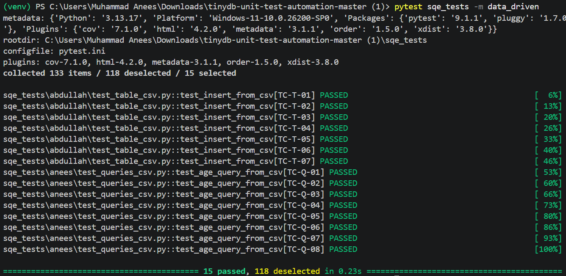
Figure 2: Data-driven tests selected with the data_driven marker, showing CSV test case IDs

8. Task 4: Test Configuration and Execution

8.1 Configuration File
The configuration for our tests is in sqe_tests/pytest.ini. It applies only to our tests, so the original TinyDB suite keeps its own configuration. It registers the test groups as markers, enables strict marker checking, and turns on group-based execution order.
[pytest]
python_files = test_*.py
addopts = -v --order-group-scope=module --strict-markers -p no:cacheprovider
markers =
storage: Module 2 - Storage and Middleware tests
table: Module 3 - Table tests
queries: Module 1 - Query tests
data_driven: tests that read their data from CSV files
smoke: small set of critical tests for a quick health check
negative: tests that check invalid input raises the correct error

8.2 Test Groups and Suites
Marker | Contents | Tests | Command
storage | Module 2: Storage and Middleware | 26 | pytest sqe_tests -m storage
table | Module 3: Table, including CSV tests | 54 | pytest sqe_tests -m table
queries | Module 1: Queries, including CSV tests | 53 | pytest sqe_tests -m queries
data_driven | Tests that read data from CSV files | 15 | pytest sqe_tests -m data_driven
smoke | Critical tests for a quick health check | 6 | pytest sqe_tests -m smoke
negative | Tests that expect an exception | 17 | pytest sqe_tests -m negative
Table 11: Test groups defined with pytest markers
Markers can be combined, for example -m "storage or queries" or -m "table and not negative". Each file declares its groups with a module-level pytestmark, and individual tests carry @pytest.mark.smoke or @pytest.mark.negative.
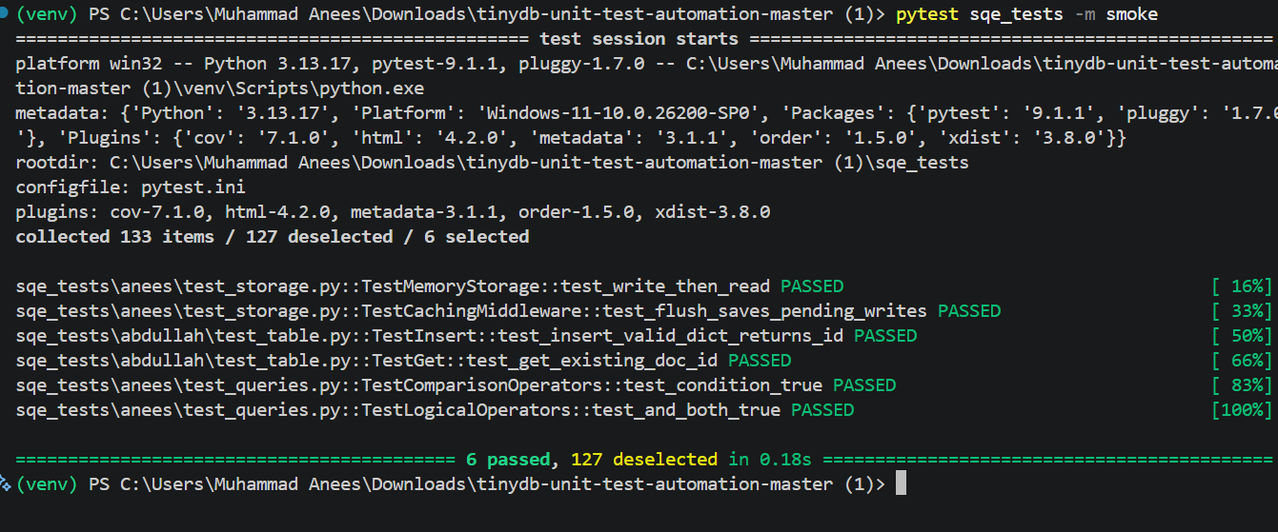
Figure 3: Running only the smoke suite: 6 tests selected, 127 deselected

8.3 Parallel Execution
Parallel execution is provided by pytest-xdist. pytest sqe_tests -n auto starts one worker per CPU core; on our machine eight workers (gw0 to gw7) ran the 133 tests. --dist loadfile can be added to keep all tests of one file on the same worker.
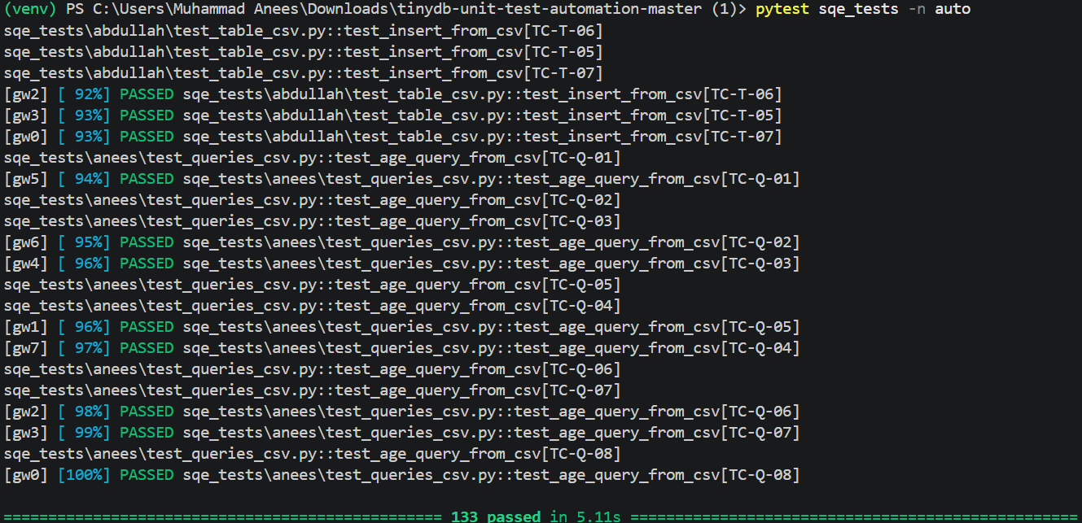
Figure 4: Parallel execution with pytest-xdist using eight workers

8.4 Parameterization
Parameterization is used throughout the suite: @pytest.mark.parametrize runs one test with several boundary or invalid values (for example document IDs 99, 0 and -1, or four invalid document types), and the CSV-based tests are fully data-driven.

8.5 Execution Order
Execution order is controlled with pytest-order. Each test file has an order number, and --order-group-scope=module makes pytest order whole files first and then the tests inside each file.
Order | Group (file) | Reason
1 | anees/test_storage.py | Storage is the lowest layer of TinyDB, so it is verified first
2 | abdullah/test_table.py | Tables are built on top of storage
3 | anees/test_queries.py | Queries are used by table search operations
4 | abdullah/test_table_csv.py | Data-driven tests run after the unit tests
5 | anees/test_queries_csv.py | Data-driven tests run after the unit tests
Table 12: Execution order of test groups
Inside a group, tests run in file order, and tests marked @pytest.mark.order("last"), such as the close() and truncate() tests, always run at the end of their group. In a parallel run the tests are distributed across workers, so the order is only guaranteed in a normal run.

9. Results
All 133 tests passed in a normal run, in the parallel run and in every group run. The final check was done on a fresh download of the repository from GitHub, which confirms that the committed files are complete.
Run | Command | Result
Full suite | pytest sqe_tests | 133 passed
Smoke suite | -m smoke | 6 passed
Data-driven suite | -m data_driven | 15 passed
Parallel run (8 workers) | -n auto | 133 passed
Original TinyDB suite | pytest (root) | 228 passed
Table 13: Summary of test runs
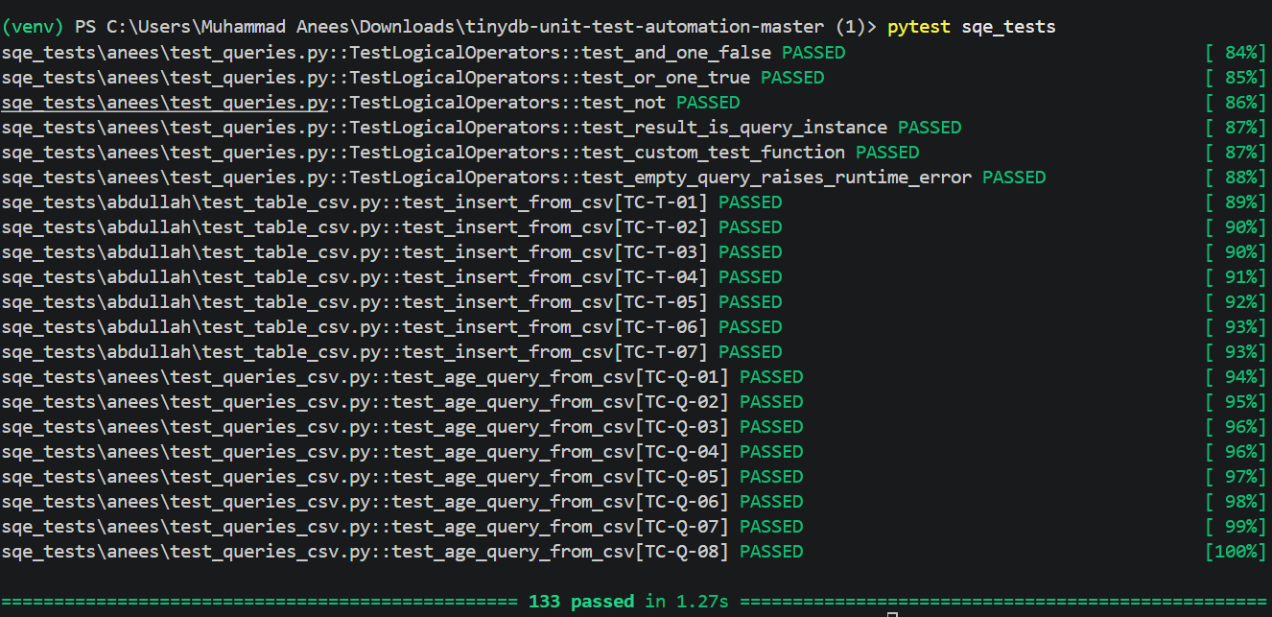
Figure 5: Full test suite run: 133 tests passed

9.1 Code Coverage
Coverage was measured with pytest-cov. Our tests reach 74% statement coverage of the whole TinyDB package, even though they target only three modules. Coverage of the modules we tested is shown below.
Source file | Statements | Missed | Coverage
storages.py | 57 | 0 | 98%
middlewares.py | 44 | 4 | 88%
table.py | 241 | 32 | 83%
queries.py | 130 | 25 | 74%
Whole package | 661 | 152 | 74%
Table 14: Code coverage of the modules under test
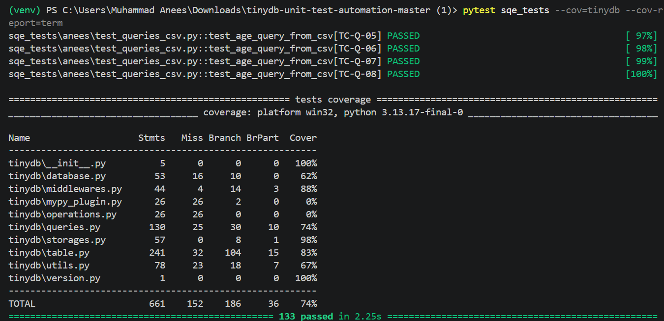
Figure 6: Coverage report generated with pytest-cov

9.2 HTML Test Report
An HTML report was generated with pytest-html (--html=report.html --self-contained-html). It lists the environment, a summary of 133 passed, 0 failed and 0 errors, and the result and duration of every test.
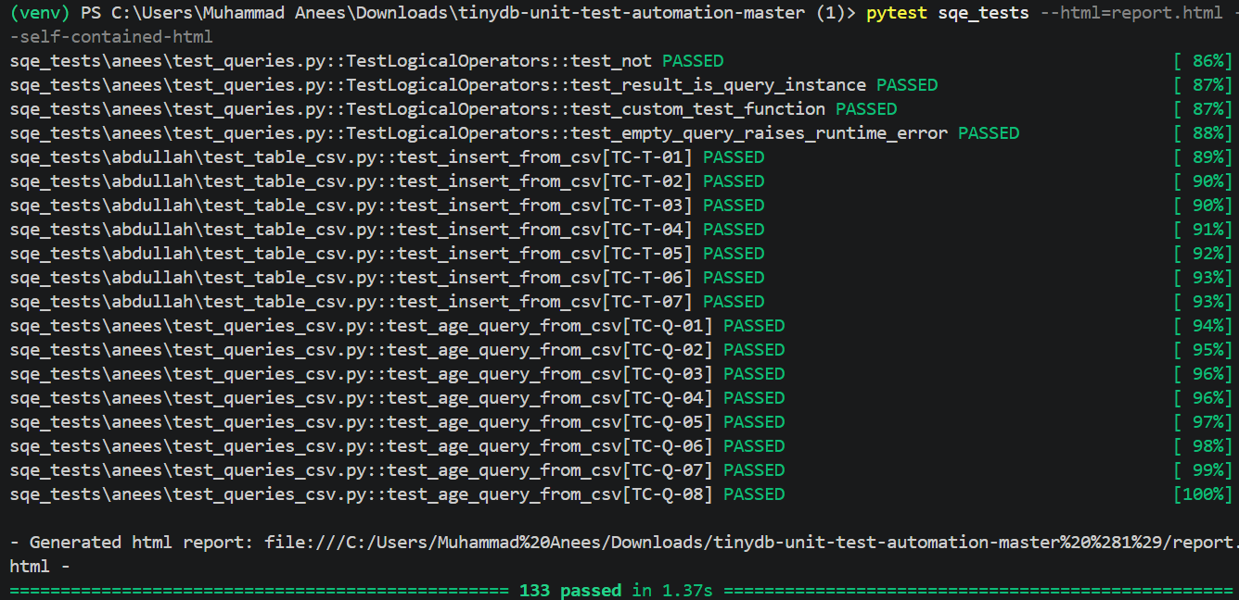
Figure 7: Generating the HTML report
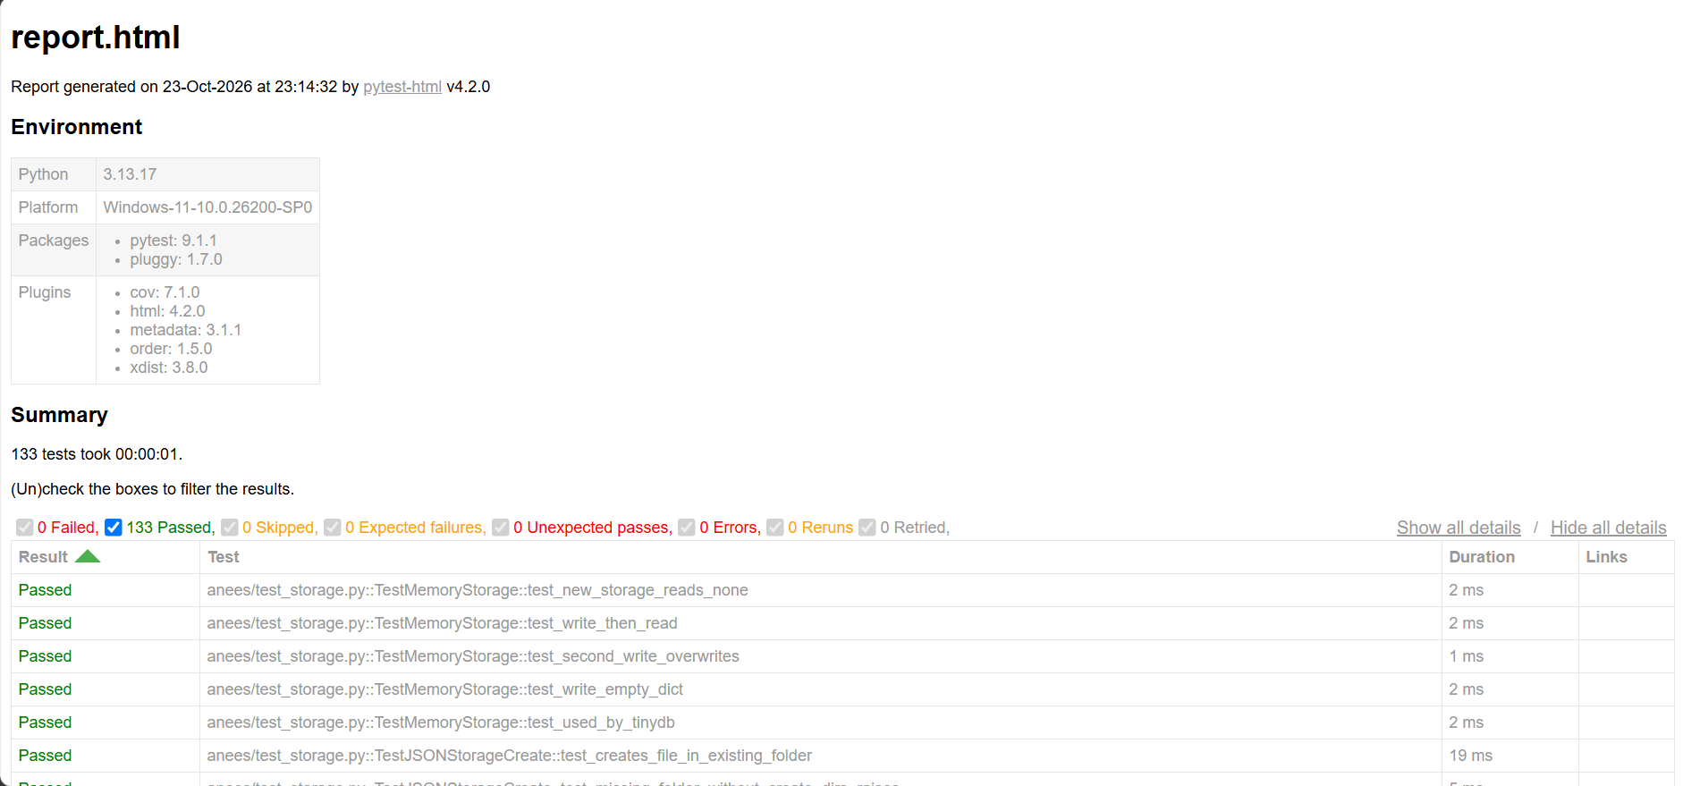
Figure 8: HTML report: environment and summary
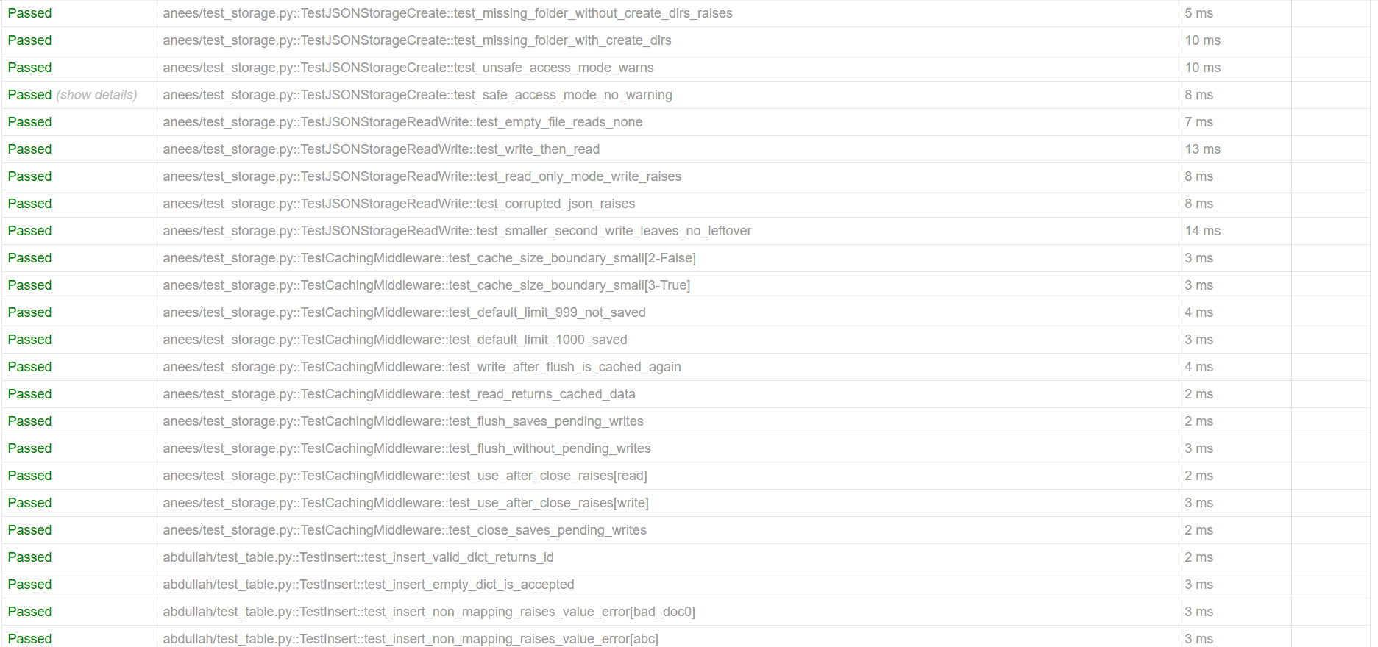
Figure 9: HTML report: individual test results
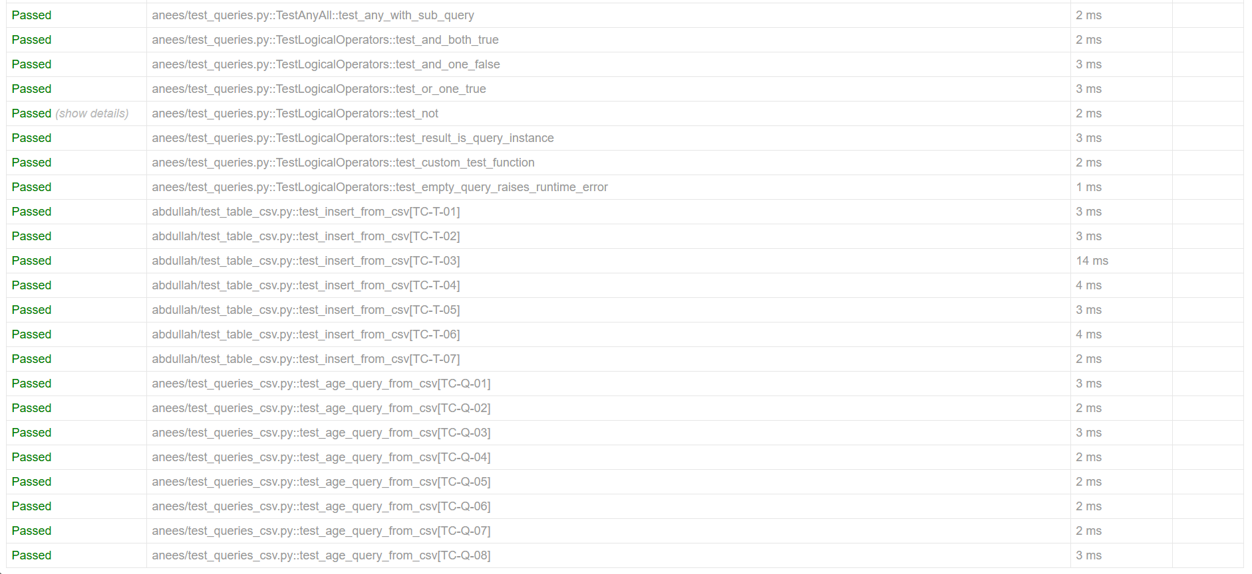
Figure 10: HTML report: individual test results (continued)

10. Repository Structure
Only the files below were added by our group; the rest of the repository is the original TinyDB project.
tinydb-unit-test-automation/
├── README_SQE.md Group info and run instructions
├── docs/
│ ├── setup_video.md Link to the setup video
│ ├── Test_Cases.xlsx Excel test case sheet
│ └── notes/ ECP / BVA design notes
│ ├── module1_queries_ecp_bva.md
│ ├── module2_storage_ecp_bva.md
│ └── module3_table_ecp_bva.md
└── sqe_tests/
├── pytest.ini Groups, strict markers, order
├── anees/
│ ├── test_queries.py
│ ├── test_storage.py
│ └── test_queries_csv.py
├── abdullah/
│ ├── test_table.py
│ └── test_table_csv.py
└── data/
├── query_age_data.csv
└── table_insert_data.csv

11. How to Run the Tests
All commands are run from the repository root with the virtual environment active. Full instructions are also in README_SQE.md.
# Setup
python -m venv venv
venv\Scripts\activate
pip install -e .
pip install pytest pytest-cov pytest-xdist pytest-order pytest-html pyyaml

# All tests, in the configured order
pytest sqe_tests

# One group / suite
pytest sqe_tests -m storage
pytest sqe_tests -m "storage or queries"
pytest sqe_tests/abdullah

# Parallel
pytest sqe_tests -n auto

# Reports
pytest sqe_tests --cov=tinydb --cov-report=term
pytest sqe_tests --html=report.html --self-contained-html

12. Challenges and Lessons Learned
- Choosing a valid open-source project: a public repository is not automatically open source; a license file is required. Checking the license first saved us from building on a project we were not allowed to reuse.
- Environment issues on Windows: PowerShell execution policy, nested ZIP folders and an inactive virtual environment caused most of our setup errors. Reading the error message carefully pointed to the cause each time.
- Working without Git on the command line: we used the GitHub web interface for all commits. This required care to edit the correct file; one commit was made to the wrong file and was corrected with a follow-up commit, which the history preserves.
- Value of boundary testing: most of the interesting behaviours in Section 6.6 were found only because tests were designed at the boundaries rather than with typical values.
- Order versus parallelism: we learned that a fixed execution order and parallel execution work against each other, and documented when each should be used.

13. Conclusion
We built a complete unit test automation solution for TinyDB. Three modules were analysed with ECP and BVA, and 118 automated unit tests plus 15 CSV-driven tests were written, all of which pass. The suite is organised into groups that can be run separately, runs in parallel with pytest-xdist, runs in a defined order with pytest-order, and produces coverage and HTML reports. The design notes, Excel test cases, test data, configuration and run instructions are committed to the group repository, and the commit history shows the individual contribution of each member.

