riteria | Ratings | Pts
MVC Description (VIDEO) | 30 pts  Clear  Student clearly explained their MVC and how the different components interact  20 pts  Fuzzy  Student explain their MVC but there are blurry lines between the model, the view, and the controller  10 pts  Needs Improvement  Student explanation of code assumed the viewer already knew their implement OR they just jumped around so much it was hard to follow OR student just read code to us.  0 pts  No Marks  Student did not submit a video. | / 30 pts
Controller (VIDEO) | 30 pts  Full Marks  Student implemented two controllers keeping one for the batch file processing and the other for the GUI  20 pts  Monolithic  Student implemented their controllers as one unified class.  10 pts  Confusing  Student did not explain the differences between the batch file controller and their GUI controller.  0 pts  No Marks  Student did not submit a video | / 30 pts
Demo (LIVE) | 30 pts  Full Marks  Student demoed the requested elements of their application AND explained the interaction with the controller.  20 pts  Mostly  Student demo included the requested elements BUT there is still some confusion on how to interact with their controller  10 pts  Lacking  Student struggled to demo the requested elements OR only demoed some of them.  0 pts  No Marks  Student did not attend a meeting OR their program crashed during the demo. | / 30 pts
SAIL Reflection | 10 pts  Full Marks  Student submitted a reflection.  0 pts  No Marks  Student did not submit a reflection by the deadline | / 10 pts
Total Points: 0
You may not see all comments right now because the assignment is currently being graded
Add a Comment: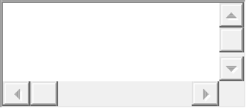
Media CommentAttach File
Save

