ipd12 – C#  
Super Mario Project (3D Game)

March 26, 2018

**Name: Qian Gao – Anita Mirshahi**

## Description of project content and purpose

We have a 3D game named Super Mario. It is a known nostalgic game including platform video games.

Player can run and jump across platforms and jump on top of the enemies in different levels. There are multitude of power-ups and items that give Mario special magic.

There is only one player mode in the game.

## List of technologies, libraries, components used

|  |
| --- |
| Entity Framework FOR Database SQLite  Unity platform Using C#  Unity is the ultimate game development platform. Use Unity to build high-quality 3D and 2D games, deploy them across mobile, desktop, VR/AR, consoles or the Web, and connect with loyal and enthusiastic players and customers.  UTiled  UTiled is a C#/Unity package for reading and rendering TMX maps created in Tiled Map Editor. |
|  |  |

## Database structure:

We save only top score on Database.



## Screenshots of all the project’s windows:

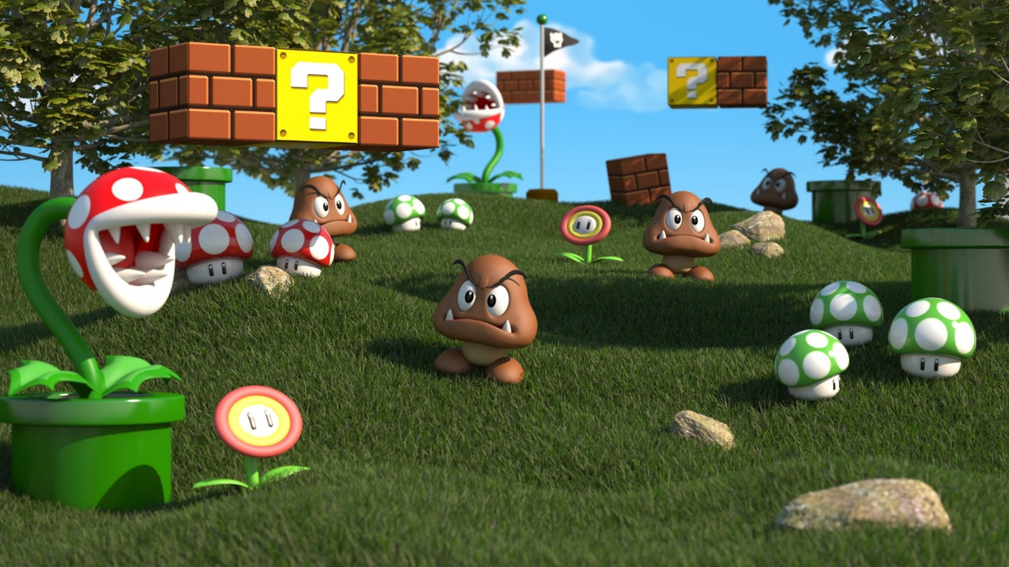

## Game elements:

## Logic

* Game logic: user input by mouse or keyboard
* Physical logic: gravity, collision detector, inertia, speed and other physical calculations
* AI: NPC (non-player character) interactive

## Display

* Animation System: Control the animation
* Underlay rendering; generating photorealistic or non-photorealistic image from 3D model and display on screen

## Audio

* Music: background
* Sound: Jumping, moving, running, coin, plants