ipd12 - java3  
Tanks war Project

February 28, 2018

**Name: Qian Gao – Anita Mirshahi**

# Overview

## Description of project content and purpose

## We have a small 2D tank game including start/setting window and main/play window.

## Player can control the tank, called hero, using the up, down, left and right keys to move it. Player also use the spacebar to launch the bullets (shoot).

* Player can choose the hero’s color, model and the number of enemies.

## There are two modes in the game:

## Only 1 player and enemies battle:

## The enemy moves, and attack modes are random. Player has to destroy them and survive to win.

## The two players fight each other until one of the players wins:

## The two players control their tanks to destroy each other. Both players start with 3 lives. Player 1 controls are: a key (left), w key (up), d key (right), s key (down), and space bar (shoot). Player 2 controls are: left arrow key, up arrow key(up), right arrow key, down arrow key(down), and enter(shoot).  last stand to win

## List of technologies, libraries, components used

|  |
| --- |
| * Java language Collection (Array List, Vector), Swing, Multithreading, Exception and other knowledge points to prepare a tank war game. * Database SQLite or MySQL |
|  |  |

## Database structure

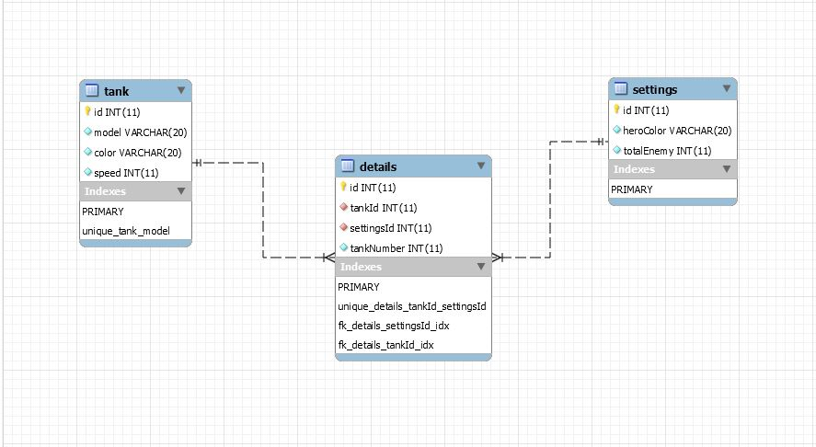

## Screenshots of all the project’s windows

