**HIRE CAR**

**PROJECT SYNOPSIS (14pt. bold)**

OF TRAINING PROJECT (12pt.)

**BACHELOR OF TECHNOLOGY** (14 Pt. bold)

Branch (16pt.)



**NAME OF THE DEPARTMENT (16 size font)**

**SCHOOL OF ENGINEERING**

**DESH BHAGAT UNIVERSITY, MANDI GOBINDGARH, PUNJAB**

**INDIA- 147203 (16 size font)**

**SUBMITTED BY**

<Times New Roman><Font Size 14>

**NAME OF THE CANDIDATE(S)**

<Times New Roman><Font Size 14>

**UNIVERSITY ROLL NO**

<Times New Roman><Font Size 12><Bold>

**TABLE OF CONTENTS**

|  |  |  |
| --- | --- | --- |
| **Sr. No** | **Topic** | **Page No.** |
| **1** | Introduction to the project | 3-4 |
| **2** | Feasibility Analysis | 4-5 |
| **3** | Problem Definition | 6 |
| **4** | Methodology/ Planning of work | 6-9 |
| **5** | Bibliography | 9 |

**1. Introduction**

**1.1 Brief Introduction to topic**

We aim to become a pioneer in the vehicle rental industry by completely focusing on customers, our employees, growth, innovation and efficiency. All of these elements will drive us towards success and show us as one company that can perform and give value for money.

When it comes to cab rental services, Service is the most trusted and reliable name in the travel business. The most advanced travel agents offering cab rental and car hire in India, making full use of information technology to improve the level of our efficiency. However, this is only one aspect of services. And this project continually strives to offer the best of services - both in terms of man and machine, to our clients.

**1.2 Existing System**

Cab Service is an innovative thought to simplify the Transportation problems of Employees of an organization. In the present System, Organization do maintain a person for the allocating and proper functioning of transportation .The Person appointed needs to look after the assigning and movement of cabs.Authorised person maintains the transportation details in papers, which is a tedious task if any updations or changes need to be done.

* Details are stored in Papers.
* Maintenance is a huge problem.
* Updation, changes in details is a tedious task.
* Performance is not achieved up to the requirements.

**1.3 Proposed System**

In the Previous System,Details are Stored Manually in papers,to share the details between employees was a Financial drawback. Updations in the details is a tedious task.

But a new system was proposed to overcome the above drawbacks.Functionalities and advantages of proposed system are:

* Data is Centralized which has overcome the Sharing problem in previous system.
* As data is Maintained electronically, it’s easy for a person to update the details, which has overcome the tedious updation in previous system.
* Maintenance is easy and performance is good.
* Mainly the system has automated the Transportation Process.

**1.4 Technology/Platform**

In PHP we use various technologies like:

* HTML (Hyper Text Markup Language )
* CSS (Cascading Style Sheet)
* JavaScript & JQuery
* Bootstrap
* PHP (Hypertext PreProcessor)
* MySQL

**2. Feasibility Analysis**

Preliminary investigation examine project feasibility, the likelihood the system will be useful to the organization. The main objective of the feasibility study is to test the Technical, Operational and Economical feasibility for adding new modules and debugging old running system. All system is feasible if they are unlimited resources and infinite time. There are aspects in the feasibility study portion of the preliminary investigation:

* Technical Feasibility
* Operation Feasibility
* Economical Feasibility

**2.1. Technical Feasibility**

The technical issue usually raised during the feasibility stage of the investigation includes the following:

* Does the necessary technology exist to do what is suggested?
* Do the proposed equipments have the technical capacity to hold the data required to use the new system?
* Will the proposed system provide adequate response to inquiries, regardless of the number or location of users?
* Can the system be upgraded if developed?
* Are there technical guarantees of accuracy, reliability, ease of access and data security?

Earlier no system existed to cater to the needs of ‘Secure Infrastructure Implementation System’. The current system developed is technically feasible. It is a web based user interface for audit workflow at NIC-CSD. Thus it provides an easy access to the users. The database’s purpose is to create, establish and maintain a workflow among various entities in order to facilitate all concerned users in their various capacities or roles. Permission to the users would be granted based on the roles specified.

**2.2. Operational Feasibility**

Proposed projects are beneficial only if they can be turned out into information system. That will meet the organization’s operating requirements. Operational feasibility aspects of the project are to be taken as an important part of the project implementation. Some of the important issues raised are to test the operational feasibility of a project includes the following: -

* Is there sufficient support for the management from the users?
* Will the system be used and work properly if it is being developed and implemented?
* Will there be any resistance from the user that will undermine the possible application benefits?

This system is targeted to be in accordance with the above-mentioned issues. Beforehand, the management issues and user requirements have been taken into consideration. So there is no question of resistance from the users that can undermine the possible application benefits.

**2.3. Economic Feasibility**

A system can be developed technically and that will be used if installed must still be a good investment for the organization. In the economical feasibility, the development cost in creating the system is evaluated against the ultimate benefit derived from the new systems. Financial benefits must equal or exceed the costs.

**3. Problem Definition**

This project has a fleet of cars ranging from luxury to budget cabs. While, it offers online cab hire service for corporate houses. And this project claim to offer the best of rates, which are tailor-made depending upon the facilities, availed and offer both intercity and intra-city cab facilities. All cabs have proper permits and documentation so that the clients couldn't be hassled for the lack of documents. However, this project has strategic backup system for any eventuality. Cab drivers are educated, polite, and reliable and are trained to handle acute breakdowns. The cab service includes all categories of cars from luxury to budget.   
Further, this project’s utmost priority is quality. To achieve this, vehicles are well maintained and tested for delivering optimum and uninterrupted performance. Team of professionals in the travel business enables this system to design trips that suits to all budgets and preferences of the travelers. In addition, workforce including drivers and administrative staff are well trained to discharge their duties with a lot of efficiency.

**4. Methodology/ Planning of work**

The prototyping model:

The mode is used for developing the “hire cab” is the prototyping model.

Prototyping Model is based on the idea of developing an initial implementation, exposing this to user comment and defining this through many until an adequate system has been developed.

The prototype design, is often, quite different from that of the final system. The benefits of developing a prototype early in the software process are:

* Misunderstanding between software developers and users may be identified, as the functions are demonstrated.
* Missing user services may be detected.
* Difficult to use or confusing user services may be indentified and refined.
* Software development staff may find incompleteness and inconsistency in requirement as the prototype is developed.
* A working albeit limited systems is available quickly to demonstrate the feasibility and usefulness of the application to the management.
* The prototype serves as a basis for writing the specification for a production quality system. Though the principle purpose of prototyping is to validate software requirements, software prototype also has other uses.
* A prototype system can be used for training users before the formal system has been delivered.
* Prototype can be run back-to-back tests. This reduces the need for tedious manual checking of test run. The same test is given to both the prototype and the system under test to look for differences in the final results and thereby making necessary changes. Thus prototype serves as a technique of risk reduction.
  1. **Modules**

**Admin Module**

* Admin can create vehicle brands
* Manage Vehicle Brands(Edit ,Delete)
* Post Vehicle
* Manage vehicle(Edit, Delete)
* Manage Booking(Admin can confirm and Cancel Booking)
* Manage Testimonials (Active and Inactive)
* Manage Contact us Query
* Admin Can the details of registered users
* Admin can also update the page content
* Admin can update the contact us details
* Manage Subscribers

**User**

* Car Booking
* View Car booking history
* Update His/Her profile
* Update his/her password
* Post Testimonials
* View Testimonials

**4.2 ER diagram**

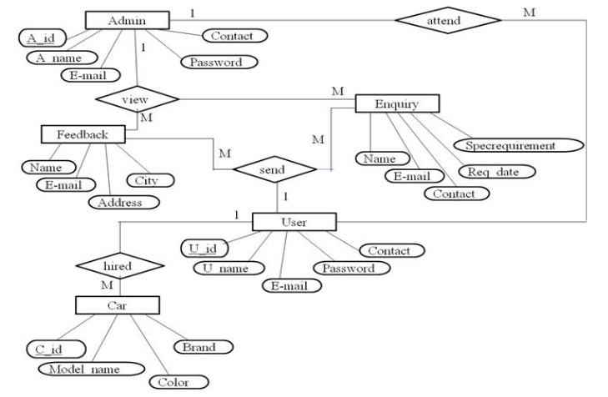

**Fig 4.2 E-R Diagram**

## ****4.3 Hardware/ Software Requirement**:**

**Server Side Requirement:**

|  |  |  |
| --- | --- | --- |
| **Minimum Hardware Requirement** | **Processor** | CORE i3 |
| **Main Memory** | 4 GB RAM |
| **HDD** | 80 GB |
| **Minimum Software Requirement** | **Operating System** | Window Server 2003 |
| **Database** | My SQL |
| **Platform** | PHP 5.3.10 |
| **Server** | Wamp |
| **Browser** | Internet Explorer 9.0 |

**Client Side Requirement:**

|  |  |  |
| --- | --- | --- |
| **Minimum Hardware Requirement** | **Processor** | Pentium IV |
| **Main Memory** | 1 GB RAM |
| **HDD** | 4 GB |
| **Minimum Software Requirement** | **Browser** | Internet Explorer |
| **Operating System** | Windows XP or Higher |

**5. Bibliography:**

* Browsing the Net
* <https://www.google.co.in>
* W3School JavaScript Tutorials, References and Examples @ [http://www.w3schools.com](http://www.w3schools.com/).
* PHP mother site @ <http://php.net/>.
* PHP Manual @ <http://php.net/manual/en/>.
* MySQL Mother Site @ [www.mysql.com](http://www.mysql.com/).
* MySQL 5.7 "Reference Manual" @ <http://dev.mysql.com/doc/>.