**FITNESS CLUB MANAGEMENT**

**PROJECT SYNOPSIS (14pt. bold)**

OF TRAINING PROJECT (12pt.)

**BACHELOR OF TECHNOLOGY** (14 Pt. bold)

Branch (16pt.)



**NAME OF THE DEPARTMENT (16 size font)**

**SCHOOL OF ENGINEERING**

**DESH BHAGAT UNIVERSITY, MANDI GOBINDGARH, PUNJAB**

**INDIA- 147203 (16 size font)**

**SUBMITTED BY**

<Times New Roman><Font Size 14>

**NAME OF THE CANDIDATE(S)**

<Times New Roman><Font Size 14>

**UNIVERSITY ROLL NO**

<Times New Roman><Font Size 12><Bold>

**TABLE OF CONTENTS**

|  |  |  |
| --- | --- | --- |
| **Sr. No** | **Topic** | **Page No.** |
| **1** | Introduction to the project | 3-4 |
| **2** | Feasibility Analysis | 4-5 |
| **3** | Problem Definition | 6 |
| **4** | Methodology/ Planning of work | 6-9 |
| **5** | Bibliography | 9 |

**1. Introduction**

**1.1 Brief Introduction to topic**

Our proposed “Gym Management System” is for those who run a gym business. Before doing anything we did a decent research on major difficulties for gym owners. We examined carefully about how to make a huge registering system without failure as well as different functions for different kind of user depending on their privilege.

The Gym Management requires a system that will handle all the necessary and minute details easily and proper database security accordingly to the user. They requires software, which will store data about members, employees, products, payroll, receipts of members & all transactions that occur in Gym.

**1.2 Existing System**

In gym management system, if we take the current system and compare with the proposed it is far behind. Every work in the existing is manual and done on the paper.

There might be a computer used somewhere for the work but it’s is not doing exactly it’s is supposed which is reducing the manual work. Entering everything manual to the computer by creating a file is not exactly we are talking in computerization.

The existing system requires a lot of manual work which results in taking more time than it should. The operations like updating and synchronizing data are also done manually in the existing system that is not automated and again time-consuming process.

These practices are not at all reliable as the one wrong entry can take a lot of time in detection and then there is a correction. Humans are prone to errors and can mistakes often unless it has some inbuilt programs which can take check the input and save from error.

We introduced the system to reduce the manual work effectively as there is the backend of the system which will take care of synchronizing and updating of the data for the system.

So, if there is any change in the system data it will appear to all other users of the system. As the system was not online the member cannot see their timeline that the event generated by them in past such as fee payment, attendance, batch timing and trainer profile etc.

Keeping an automated system is also helps in managing the member’s information secure and safe. As it can only be seen by the administrator with the correct credentials which is not an option in the existing system.

Unless the records are kept in a physically safe location such as a locker. Some major drawbacks of the existing system:

Required a lot of paperwork and the process takes time.

Everything is done on the paper and these are highly prone to damages and requires a good amount of security and space to store.

Required Buying of goods more frequent as compared to online system e.g.: paper, pen.

Likely to have an error.

Lack of storage space for the handwritten documents.

**1.3 Proposed System**

In gym management system, after the planning and analysis phase of the system gets completed. Then the next phase required to transform the collected required system information into structural blueprint which will serve as a reference while constructing the working system.

It is a phase when most of the risks and error unveiled so it’s is good practices to take care of this thing from the start.

This is a fully fledged system which will be the backbone of the while management of the gym so ignoring the risk or error is not an option as later it can make a greater form of itself.

**1.4 Technology/Platform**

In PHP we use various technologies like:

* HTML (Hyper Text Markup Language )
* CSS (Cascading Style Sheet)
* JavaScript & JQuery
* Bootstrap
* PHP (Hypertext PreProcessor)
* MySQL

**2. Feasibility Analysis**

Preliminary investigation examine project feasibility, the likelihood the system will be useful to the organization. The main objective of the feasibility study is to test the Technical, Operational and Economical feasibility for adding new modules and debugging old running system. All system is feasible if they are unlimited resources and infinite time. There are aspects in the feasibility study portion of the preliminary investigation:

* Technical Feasibility
* Operation Feasibility
* Economical Feasibility

**2.1. Technical Feasibility**

The technical issue usually raised during the feasibility stage of the investigation includes the following:

* Does the necessary technology exist to do what is suggested?
* Do the proposed equipments have the technical capacity to hold the data required to use the new system?
* Will the proposed system provide adequate response to inquiries, regardless of the number or location of users?
* Can the system be upgraded if developed?
* Are there technical guarantees of accuracy, reliability, ease of access and data security?

Earlier no system existed to cater to the needs of ‘Secure Infrastructure Implementation System’. The current system developed is technically feasible. It is a web based user interface for audit workflow at NIC-CSD. Thus it provides an easy access to the users. The database’s purpose is to create, establish and maintain a workflow among various entities in order to facilitate all concerned users in their various capacities or roles. Permission to the users would be granted based on the roles specified.

**2.2. Operational Feasibility**

Proposed projects are beneficial only if they can be turned out into information system. That will meet the organization’s operating requirements. Operational feasibility aspects of the project are to be taken as an important part of the project implementation. Some of the important issues raised are to test the operational feasibility of a project includes the following: -

* Is there sufficient support for the management from the users?
* Will the system be used and work properly if it is being developed and implemented?
* Will there be any resistance from the user that will undermine the possible application benefits?

This system is targeted to be in accordance with the above-mentioned issues. Beforehand, the management issues and user requirements have been taken into consideration. So there is no question of resistance from the users that can undermine the possible application benefits.

**2.3. Economic Feasibility**

A system can be developed technically and that will be used if installed must still be a good investment for the organization. In the economical feasibility, the development cost in creating the system is evaluated against the ultimate benefit derived from the new systems. Financial benefits must equal or exceed the costs.

**3. Problem Definition**

We hereby are grateful to present our software project through this report.Our proposed system is compute based. Which provide various User interfaces (Forms) for various operations and hence interactive. The system is able to generate calculations , bills ,reports automatically. Operations such as adding, removing, searching customers, suppliers and employees can be done efficiently and effectively by proposed system. Adding Parcels category and unit wise is possible with the help of this system. System can efficiently perform various transactions such as sales, purchase and maintain data after each transaction. In short proposed system is user-friendly.

**4. Methodology/ Planning of work**

The prototyping model:

The mode is used for developing the “hire cab” is the prototyping model.

Prototyping Model is based on the idea of developing an initial implementation, exposing this to user comment and defining this through many until an adequate system has been developed.

The prototype design, is often, quite different from that of the final system. The benefits of developing a prototype early in the software process are:

* Misunderstanding between software developers and users may be identified, as the functions are demonstrated.
* Missing user services may be detected.
* Difficult to use or confusing user services may be indentified and refined.
* Software development staff may find incompleteness and inconsistency in requirement as the prototype is developed.
* A working albeit limited systems is available quickly to demonstrate the feasibility and usefulness of the application to the management.
* The prototype serves as a basis for writing the specification for a production quality system. Though the principle purpose of prototyping is to validate software requirements, software prototype also has other uses.
* A prototype system can be used for training users before the formal system has been delivered.
* Prototype can be run back-to-back tests. This reduces the need for tedious manual checking of test run. The same test is given to both the prototype and the system under test to look for differences in the final results and thereby making necessary changes. Thus prototype serves as a technique of risk reduction.
  1. **Modules**

There are two basic modules in this system as describe briefly in below

**Administrative module:** This user is an admin type who has full rights on the system.

**User module:** This is a normal level of user who will be very few number of functionality of website.

**4.1.1 Administrative Module**

This module includes storing and retrieving the details of the data.

* Create , Update, Manage, Delete User
* Creating Offer Plan
* Manage Billing
* Manage User Enquiry through Email
* Manage Owner Info

**4.1.2 User Module**

Depends on the privilege user’s access to features of the application is granted. Below are the some important functionality of user module.

* Applying for Package
* Account Update
* Online Payment Facility
* Login by Email Address Verification on Sign Up
* Enquiry to Authority

**4.2 Features**

There are many features in our system. Some salient and new features are:

* Login by Face Recognition
* Phone number verification through SMS on sign up
* Online Payment Gateway
* Webcam Integration
* Activity Log of User’s

**4.2 ER diagram**

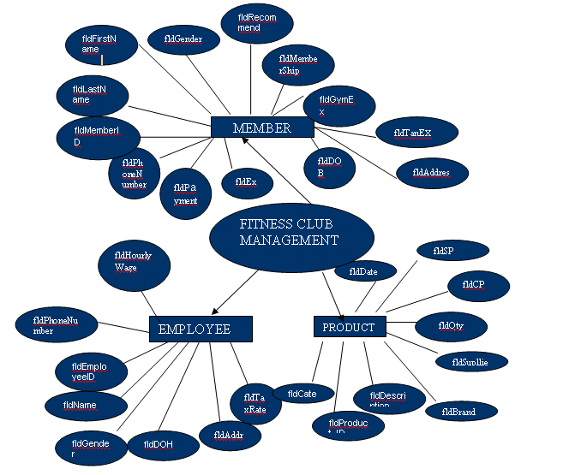

**Fig 4.2 E-R Diagram**

## **4.3 Hardware/ Software Requirement:**

**Server Side Requirement:**

|  |  |  |
| --- | --- | --- |
| **Minimum Hardware Requirement** | **Processor** | CORE i3 |
| **Main Memory** | 4 GB RAM |
| **HDD** | 80 GB |
| **Minimum Software Requirement** | **Operating System** | Window Server 2003 |
| **Database** | My SQL |
| **Platform** | PHP 5.3.10 |
| **Server** | Wamp |
| **Browser** | Internet Explorer 9.0 |

**Client Side Requirement:**

|  |  |  |
| --- | --- | --- |
| **Minimum Hardware Requirement** | **Processor** | Pentium IV |
| **Main Memory** | 1 GB RAM |
| **HDD** | 4 GB |
| **Minimum Software Requirement** | **Browser** | Internet Explorer |
| **Operating System** | Windows XP or Higher |

**5. Bibliography:**

* Browsing the Net
* <https://www.google.co.in>
* W3School JavaScript Tutorials, References and Examples @ [http://www.w3schools.com](http://www.w3schools.com/).
* PHP mother site @ <http://php.net/>.
* PHP Manual @ <http://php.net/manual/en/>.
* MySQL Mother Site @ [www.mysql.com](http://www.mysql.com/).
* MySQL 5.7 "Reference Manual" @ <http://dev.mysql.com/doc/>.