**Let's Get Started Coder!!**

**Fill the following Document**

**__________________________________________________________________________**

1. Which one of the following is an Imperative Language??

1. HTML
2. CSS
3. Java Script

Answer: 1. Java Script

2. Which one of the following is a Declarative Language??

1. HTML
2. CSS
3. Java Script

Answer: HTML and CSS

3. Name two uses of a DIV tag??

Answer:

* The <div> tag is used for **grouping the HTML elements** into sections on a webpage
* The <div> tag is used as a container for HTML elements - which is then styled with CSS or manipulated with JavaScript.
* The <div> tag is easily styled by using the class or id attribute.

4. What is the difference between relative positioning and absolute positioning in HTML?

Answer:

## Relative Positioning

* When position:relative is given to an element without any other attributes (top, bottom, left, right) nothing will happen.
* But when an attribute left:20px is added the element moves 20px to the right from its normal position. The element effects no other element on the layout. Other content will not be adjusted to fit into any gap left by the element.
* The child of this element can be positioned within this block only. So position:relative has its limitations.

[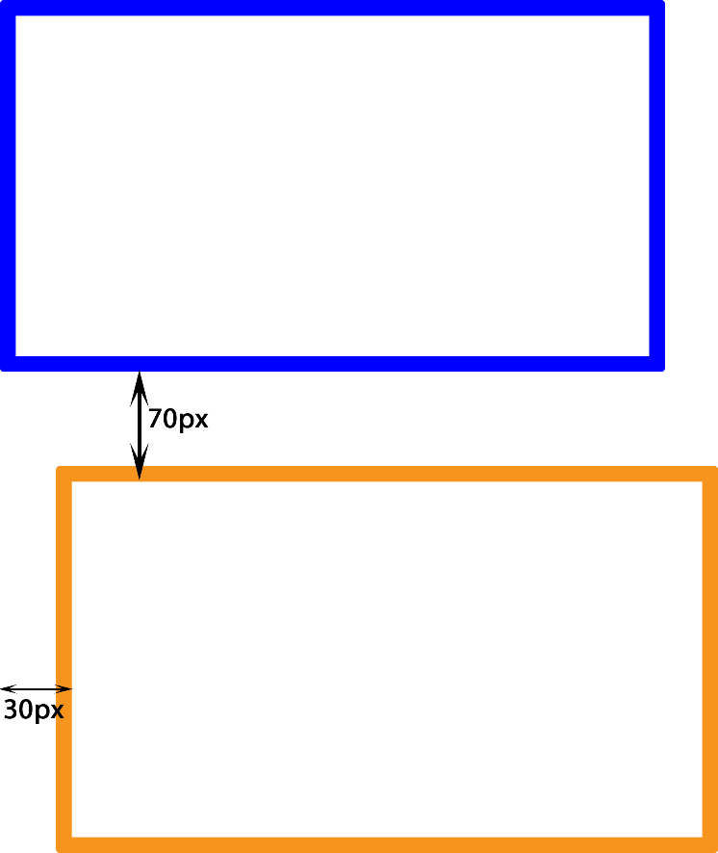](https://www.sanjaywebdesigner.com/articles/wp-content/uploads/2020/06/position-relative.png)

HTML CODE

<!doctype html>

<html>

<head>

<title>DIFFERENCE BETWEEN POSITION RELATIVE AND POSITION ABSOLUTE</title>

<link href="example.css" rel="stylesheet">

</head>

<body>

<div id="a1">FIRST</div>

<div id="a2">SECOND</div>

</body>

</html>

CSS CODE

#a1 {

width:304px;

height:154px;

background-color:white;

border:2px solid blue;

position:relative;

text-align:center;

}  
  
#a2 {

width:304px;

height:154px;

background-color:white;

border:2px solid orange;

top:70px;

left:30px;

position:relative;

text-align:center;  
}

## Absolute Positioning

* When position:absolute is given to an element the element can be placed precisely where one wants to.
* The element is positioned nearest to the first relatively or absolutely positioned parent element.
* When there is no parent element the absolutely positioned element is positioned directly to the HTML page itself.

[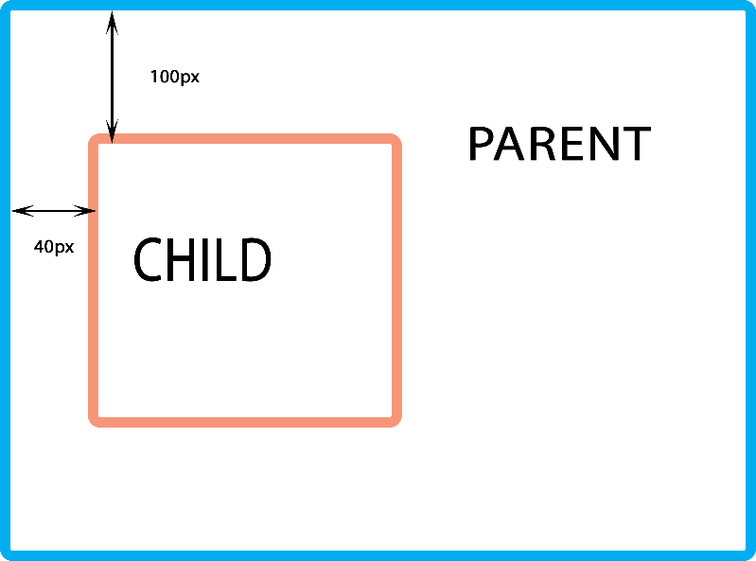](https://www.sanjaywebdesigner.com/articles/wp-content/uploads/2020/06/position-absolute.png)

HTML CODE

<!doctype html>

<html>

<head>

<title>ABSOLUTE POSITIONING</title>

<link href="example1.css" rel="stylesheet">

</head>

<body>

<div class="a1">

<div class="a2"></div>

</div>

</body>  
</html>

CSS CODE

.a1 {

width:304px;

height:304px;

background-color:white;

border:3px solid blue;

text-align:center;

position:relative;

}  
.a2 {  
 width:154px;

height:154px;

background-color:white;

border:3px solid orange;

text-align:center;

position:absolute;

top:100px;

left:40px;

}

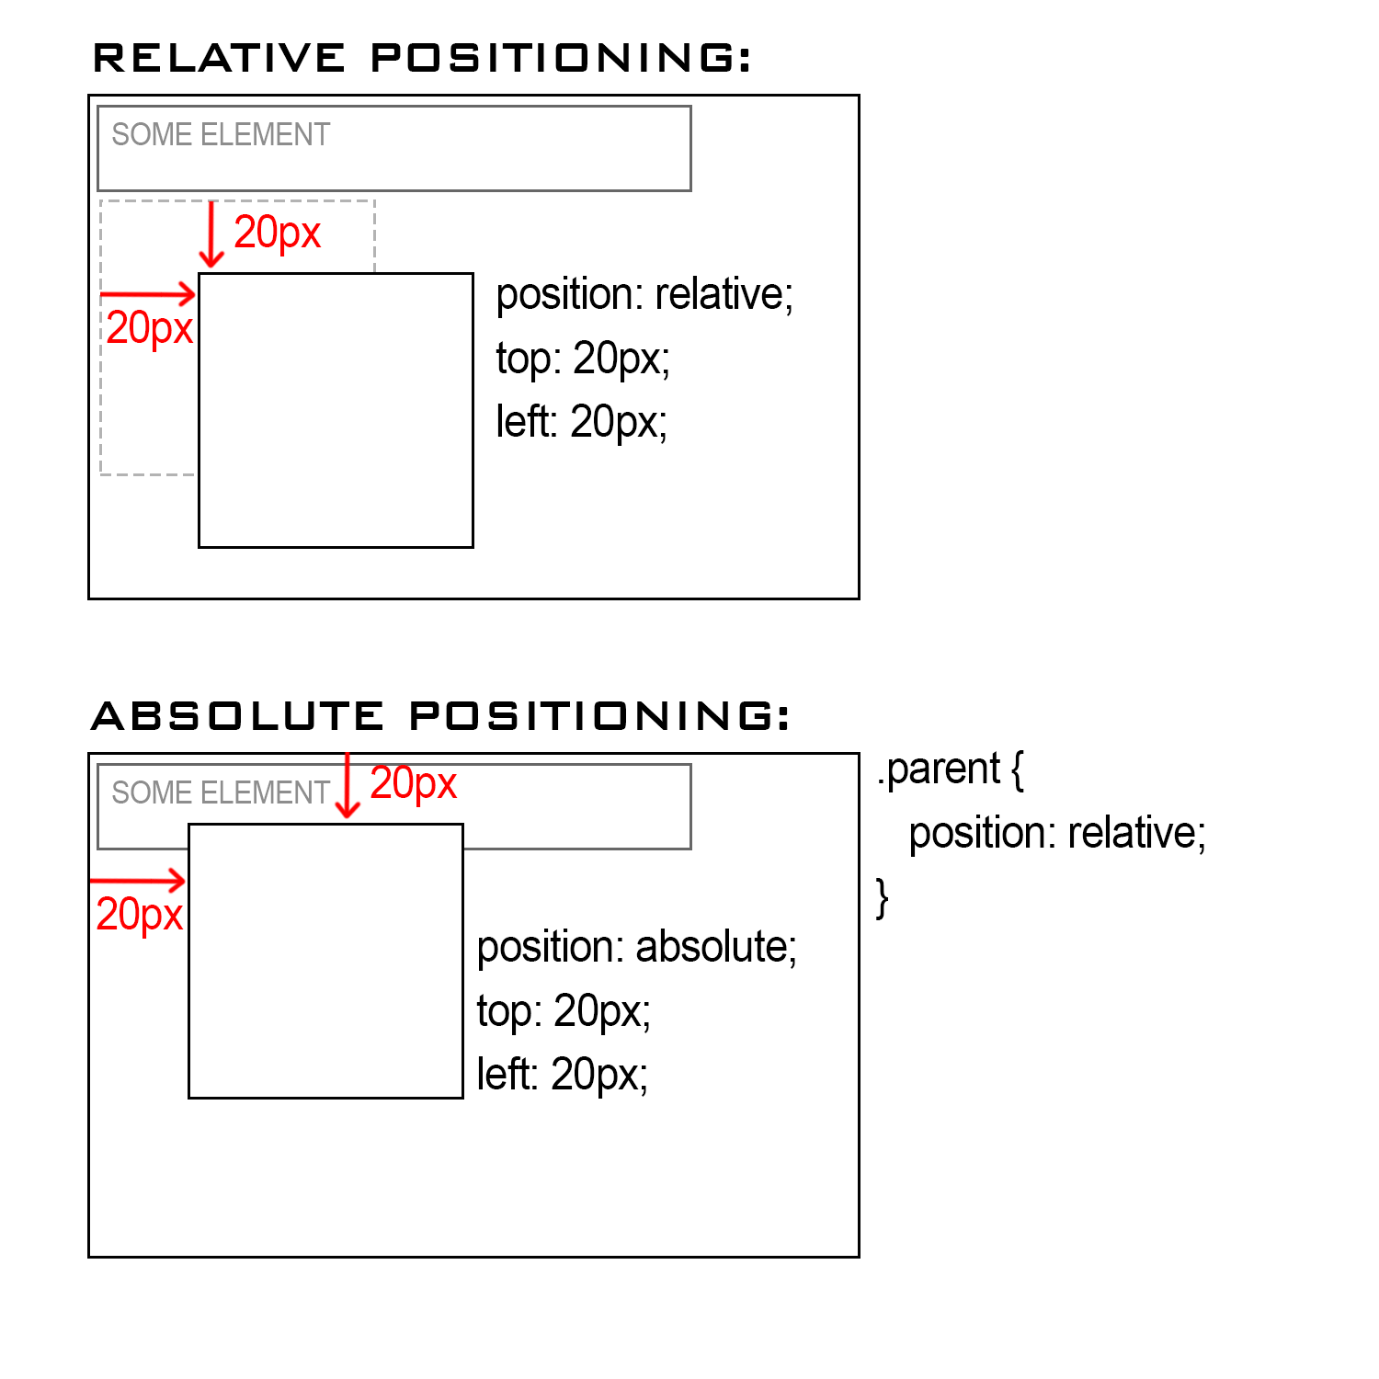

5. What is the use of opacity in CSS??

Answer:

The opacity property specifies the opacity/transparency of an element.

The opacity property can take a value from 0.0 - 1.0. The lower value, the more transparent:

6. Which is the programming language used in the React Native Framework??

Answer:

React Native is based on React.js, which is written in JavaScript.

React Native applications are written using a mixture of JavaScript and XML-extensible markup, known as JSX.

Then, under the hood, the React Native “bridge” invokes the native rendering APIs in Objective-C (for iOS) or Java (for Android). Thus, your application will render using real mobile UI components, not webviews, and will look and feel like any other mobile application. React Native also exposes JavaScript interfaces for platform APIs, so your React Native apps can access platform features like the phone camera, or the user’s location.

7. Which online editor are we using for creating our apps in React Native Framework??

Answer:

Expo snack

8. Write the steps to test your first designed app in the online editor on a mobile.

Answer:

* Expo client – scan QR code
* Tap to play – Android/iOS
* Web

9. What is the use of the render function in React Native Framework??

Answer:

render() function simply displays whatever components are returned by it on the screen

10. What is the use of return function in React Native Framework??

Answer:

To return components.

11. What are the various components in your first app that you designed??

Answer:

Text, Button, View, Custom component