DLC implementation
For this project, DLC will be sound. In order to use DLC, Players must have the sound file named “battle_start.mp3” in their data folder. The sound will be played when transitioning into battle scenes. Without DLC, there will be no sound.

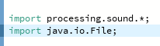

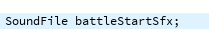
Starting with the library, Sound library, and java.io must be imported. The sound library is used to load and play the sound, and the java.io is used to check for DLC (“battle_start.mp3”).

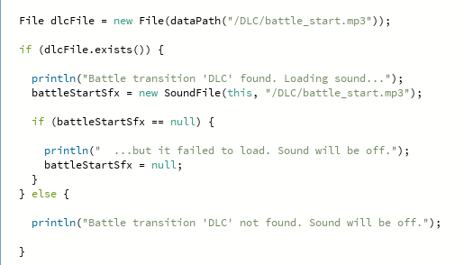

This part of the code is for checking for DLC. A file variable is created to store the path to the sound file. Afterwards, using .exists to check if the sound file exists or not.
If the sound file exists, it will be loaded into “battleStartSfx” and checked if it is loaded correctly.
If the sound does not exist or did not load correctly, “battleStartSfx” will be null.

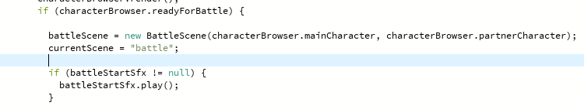

This part is when the scene transitions to a battle scene. “battle StartSfx” will be checked if it is null or not. If it is not null, the sound will be played right when the scene changes.

