Group: DUI
Team members:
- Pimkwan Chiraprawattrakun StudentID 6788017 Section 3
- Sithinon Techkarnjanaruk StudentID 6788128 Section 3

A brief introduction of the idea
Activity 2 requires us to develop a new class called Unit, which is used to represent the characters and their various animations. Also, it requires us to show a character taunting randomly. For our section, the challenge is to add 4 specific taunting sentences that only appear when 2 characters specifically match each other. In our design, we made both characters play the generic taunt randomly each time the player clicks on the portrait. After that, the player selects, confirms, and the specific taunts are going to show. The taunt sentence will show for 3 seconds. Furthermore, this class shows the health bar of the selected characters and enemies.

Activity 3 is the implementation of Activity 2. Using the CharacterBrowserGUI class as a base program and the CharacterBrowser class as a logic class for the program.

Reflect the design

Unit Class
Before beginning, we consider using an enumeration to track the animation state, which is idle and teaser.

In Unit Class, we use for calling each character that appears on the screen, whether it is a playable character or an enemy character. It contains the portrait, sprite, sprite animation, taunts, and health.

First, we loaded a sprite image from a certain path for the portrait image of the character, and also called functions to load two animations: idle and teaser.

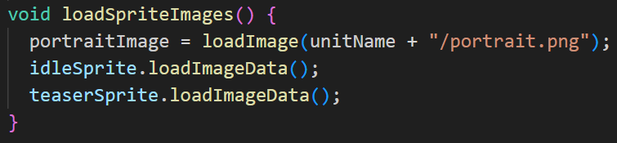

Thereafter, we created a function to list all possible generic taunts.

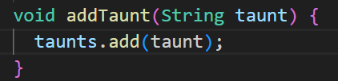

Next, we created a function called ‘playTeaser’ to start the whole teaser process, including teaser animation and random generic taunts. Also, we set the default value if there weren’t any taunts.

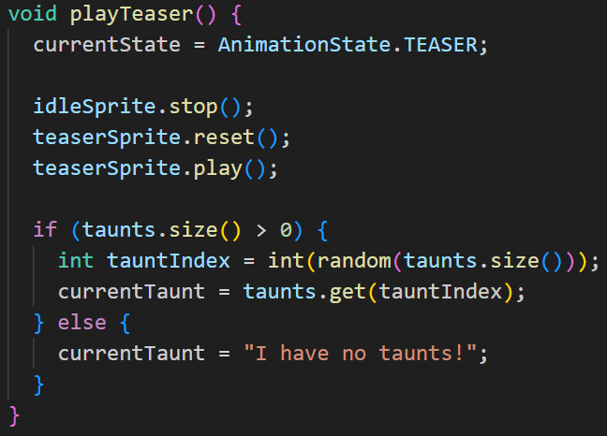

Subsequently, when the playTeaser functions finish, we use the stopTeaser function to clear all. Then, we use the update function to check if the animation in the teaser is actually finished. In this stage, these can help prevent an overlapping action.

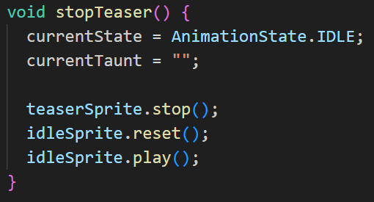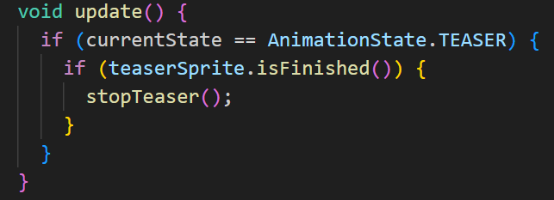

After that, we created a function to detect the mouse click.

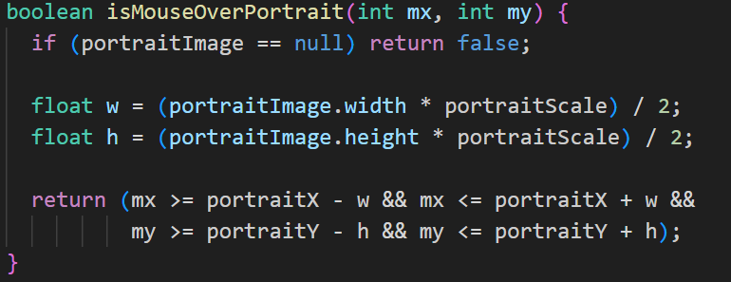

At last, we defined functions to draw all of the attributes.

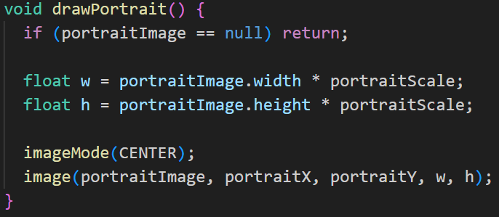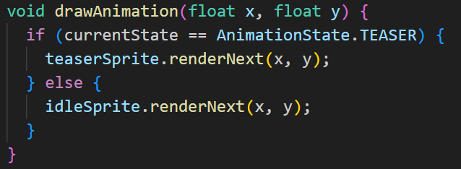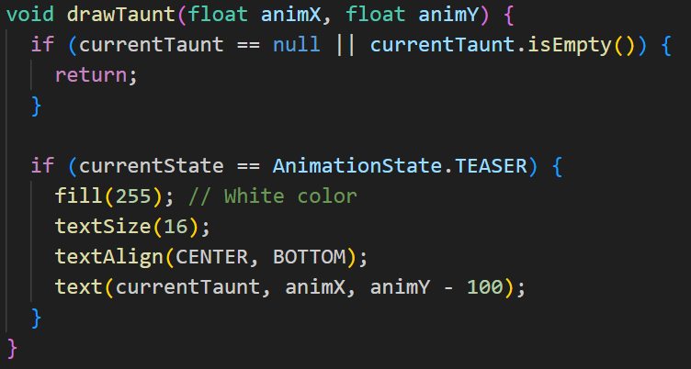

CharacterBrowser Class
This class contains all the logic we used for the character browser screen.
Before beginning, we created a helper class called TeamTaunt to help us store the sequence.

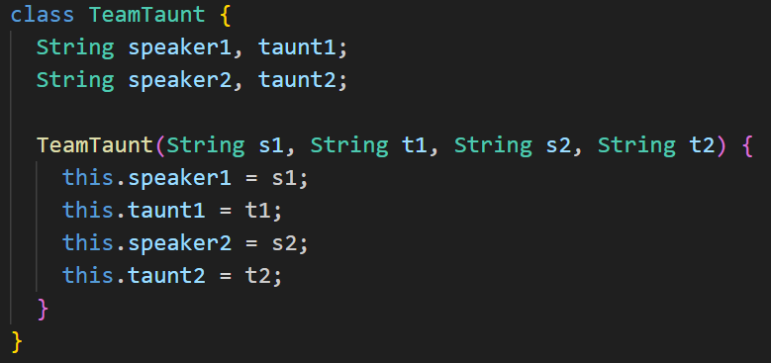

First, in this class, we also used enumeration to keep track of team taunts or special taunt. We used delays to pause between speaking taunts.

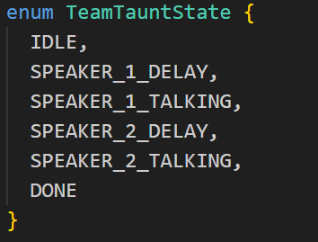

Because of the special taunts that will appear if and only if the two characters are selected, we used a HashMap to keep a record of key and value.

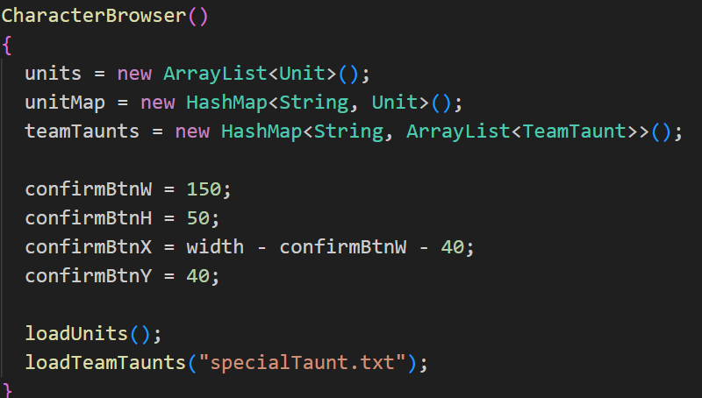

After that, we created these functions to be called in CharacterBrowserGUI, which can show us if we successfully loaded all the sprites or not.
- loadAllSpriteImages
- loadUnits
- loadTeamTaunts

In the loadUnits function, we also mapped the name and their generic taunts together.

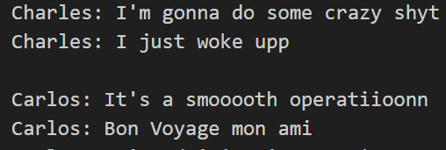

This is an example of what the genericTaunt.txt looks like. We separated names and taunts by using “:” or a semicolon.

For the loadTeamTaunts, we loaded the file from another text file called specialTaunt.txt.

We knew the pair of two specific characters and separated them from the taunts by “/” or a slash. Then, we put them in ArrayList called teamTaunts, so we can called the special taunts later.

Subsequently, we use updateTeamTauntState function to work on the core logic of the conversation. After that, we use drawTeamTaunt to draw the current part of the conversation. Furthermore, we add a helper function to draw text over the correct character. Afterward, we create an object, “findTeamTaunt” for a random taunt of the currently selected pair of characters.

The next part is mostly a control function. We use “handleMouseClick” function to check for button clicks or character clicks. Moreover, we add the condition that won’t allow the user to click while it is in a loading state. Additionally, we do a character selection stage. To prevent the error of redundancy taunts, we reset the team taunt state on any new selection and stop any currently playing special taunts. We use “handleConfirmClick” to confirm when the confirm button is clicked. We also added a condition that it is going to work unless a full team is selected. Subsequently, we use a boolean function to check if mouse is over the confirm button. We find and start the special taunt in this function by calling “findTeamTaunt.”

Finally, we created a “Render” function to draw the background and the environments in the character browser’s screen. Then we use functions to draw a character name, a confirm button, a selection box, and a unit in box.

