1. **Description:**

Tests are automated to get the definitions of the valid word and the success response (200) and the failure response(404) for no results. The tools used are RestSharp and NUnit framework**.**

1. **Installation:**

Install the below version on visual studio and .net framework

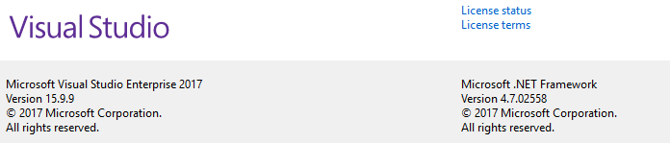

1. **Opening the project:**

Open the.sln file to open the project and run the tests

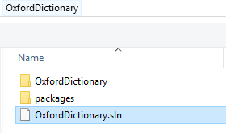

1. **Framework Structure:**

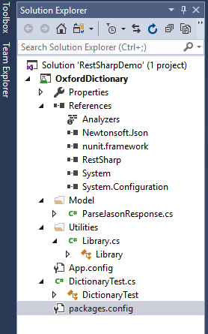

References: The list of Plugins used for testing.

Utilities: Common libraries used across tests

App. Config: Contains details of URL, key. Appid and language details

DictionaryTest – Nunit tests to verify the responses and meaning of the word

Model: Class to parse the Jason string

1. **Running the Test:**

Open test in Test Explorer and execute the required tests.

* Exception test – User responds with a 404 for invalid words that do not exist
* Positive Test - User gets a response of 200 and is able to find the meanings of Valid words from the Retrieve dictionary information for a given word api

For the positive test once executed verify the meaning of the word and the response code in Output. 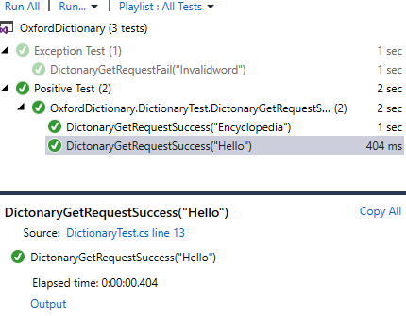  
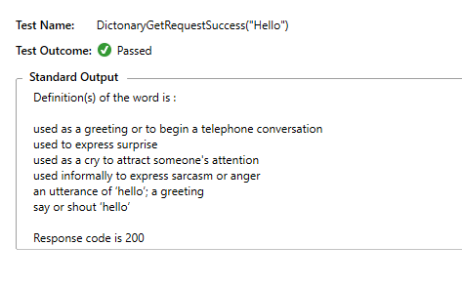

For the negative test once executed the response code in Output. 