**PEDAL BOOSTER CABLE FOR BACCABLE**

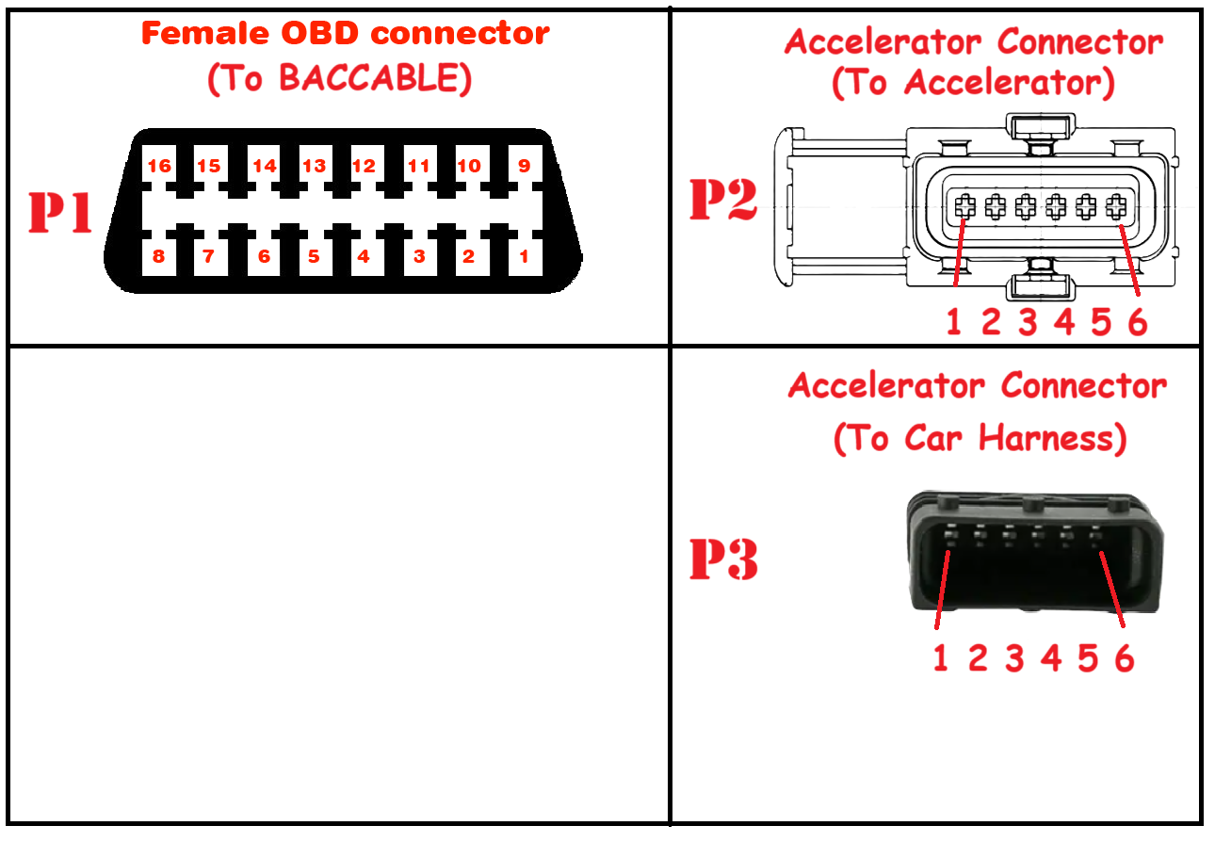

|  |  |  |  |  |
| --- | --- | --- | --- | --- |
| **From Connector** | | R101 (200k ohm)  R102 (200k ohm) | **To Connector** | |
| OBD (P1) | 16 (+12V) | +12V | Car OBD or Car Harness before SGW |
| 4 (GND) | GND |
| 6 (C1H) | Can Bus C1 H |
| 14 (C1L) | Can Bus C1 L |
| 12 (C2H) | Can Bus C2 H |
| 13 (C2L) | Can Bus C2 L |
| 3 (BH H) | Can Bus BH H |
| 11 (BH L) | Can Bus BH L |
|  |  |  |
| 1 (V2+) | Accelerator (P2) |
| 2 (V1+) |
| 10 (STS2) | 3 (Acc1) |
|  | 4 (V1-) |
| 5 (V2-) |
| 7 (STS3) | 6(Acc2) |
|  |  |  |
|  | 2 (V1+) | Accelerator Harness (P3) |
| 15 (CMD2) | 3 (Acc1) |
| 4 (GND) | 4 (V1-) |
| 4 (GND) | 5 (V2-) |
|  |  |
|  | 1 (V2+) |
| 2 (CMD3) | 6(Acc2) |