**PEDAL BOOSTER CABLE FOR BACCABLE**

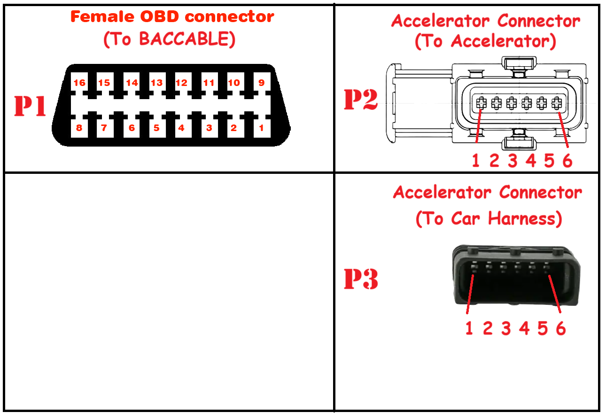

|  |  |  |  |  |
| --- | --- | --- | --- | --- |
| **From Connector** | |  | **To Connector** | |
| OBD (P1) | 16 (+12V) | 16 (+12V) | Car OBD or Car Harness before SGW |
| 4 (GND) | 4 (GND) |
| 6 (C1H) | 6 (Can Bus C1 H) |
| 14 (C1L) | 14 (Can Bus C1 L) |
| 12 (C2H) | 12 (Can Bus C2 H) |
| 13 (C2L) | 13 (Can Bus C2 L) |
| 3 (BH H) | 3 (Can Bus BH H) |
| 11 (BH L) | 11 (Can Bus BH L) |
|  |  |  |
| 1 (V2+) | Accelerator (P2) |
| 2 (V1+) |
| 10 (STS2) | 3 (Acc1) |
|  | 4 (V1-) |
| 5 (V2-) |
| 7 (STS3) | 6(Acc2) |
|  |  |  |
| 15 Vref2 | 2 (V1+) | Accelerator Harness (P3) |
| 1 (CMD2) | 3 (Acc1) |
| 4 (GND) | 4 (V1-) |
|  | 5 (V2-) |
|  |  |
| 2 Vref3 | 1 (V2+) |
| 9 (CMD3) | 6(Acc2) |