DWP Report

**1.** **Code optimization** 2

**2.** **Issues and solutions** 3

1. **Code optimization** 
   * New field on database that saves the icon class

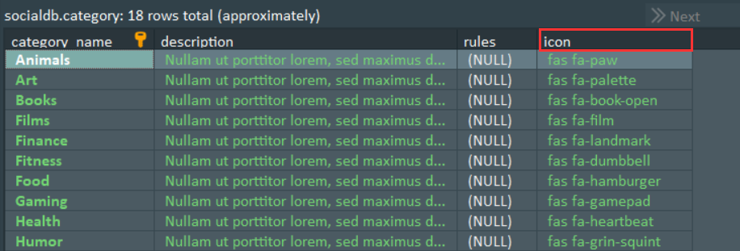

BEFORE: foreach that depending on the category name creates a different icon

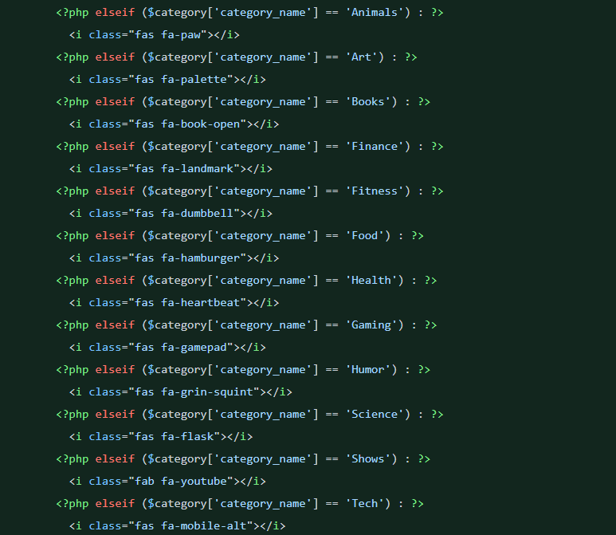

AFTER : foreach that loads the icon dynamically based on the class name

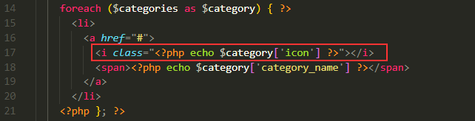

1. **Issues and solutions applied** 
   * Problems when nesting a database query inside another foreach query

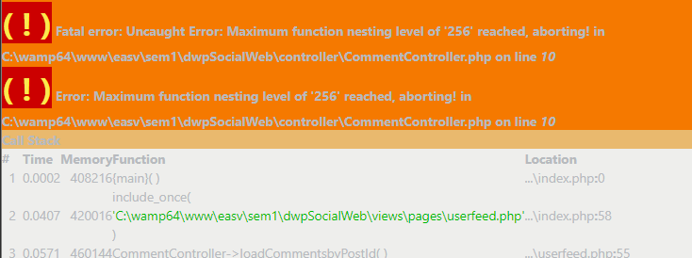

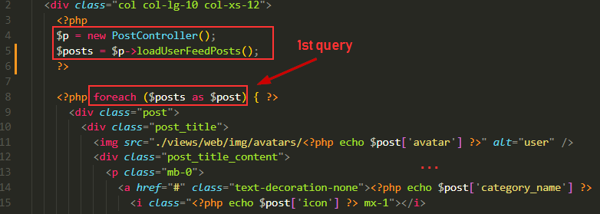

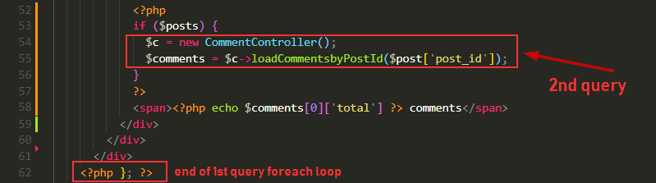

Solution: creating an **extra field** on post table called “comments”, so we can have all the info with only one query. Also, this field value gets updated with a **trigger** every time a user makes a comment on a post.