PORTFOLIO CREATOR · STUDENT INSTRUCTIONS

Build and Publish Your Portfolio
Create a professional portfolio without coding, then publish it as your own website with GitHub Pages.

Part | What you do | Steps
A · Build your portfolio | Add your content, preview it, and export one file: index.html. | 1–6
B · Introduction to GitHub | Create a GitHub account and a repository, upload your file, and turn on GitHub Pages to get your link. | 7–15

Online version
The same guide is on the Portfolio Creator site: select Guide in the top menu.

PART A
Build your portfolio
You work in your web browser. There is nothing to install.

Explore Portfolio Creator
Open the Portfolio Creator link from your instructor.
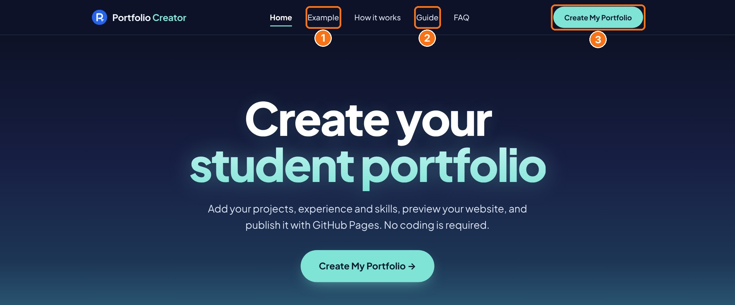
1 Example: a finished sample portfolio in all three designs · 2 Guide: these instructions online · 3 Create My Portfolio: opens the editor

Create your portfolio
1 Open the editor
On the home page, select Create My Portfolio.
2 Choose a design
At the top, pick Professional, Editorial or Dark. You can switch at any time; your content stays the same.
3 Add your content
Click ✎ Edit next to any part of the page to change it, and + Add to add your Resume, LinkedIn, GitHub and email links, projects, experience, education, skills, certifications or your own sections.
- Upload a profile photo, then drag it or use the sliders to position it.
- If your name is long, the name size is set automatically. You can also choose L, M or S.
- Under your title you can add extra lines, such as a minor, a second degree or a Ph.D. plan.
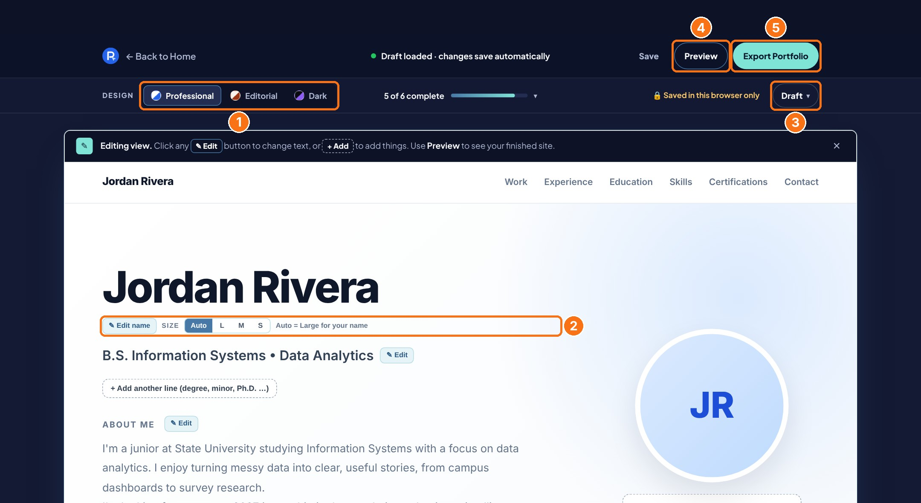
1 Design · 2 Edit name and name size · 3 Draft menu (backup and publishing help) · 4 Preview · 5 Export Portfolio
4 Preview
Select Preview to see exactly what visitors will see. Switch between Desktop and Mobile, then select Back to Editor to make changes.
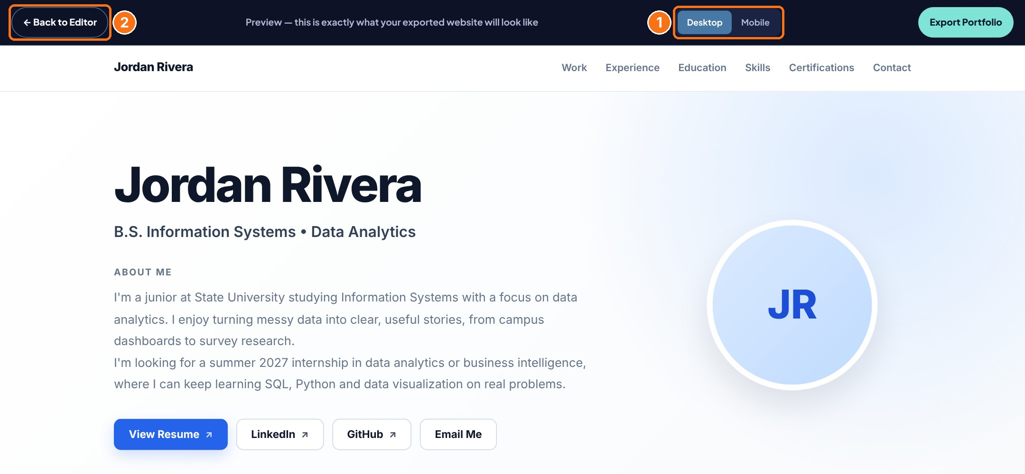
1 Desktop / Mobile · 2 Back to Editor
Saved in this browser only
Your work saves automatically, but only on this computer and in this browser. To continue on another computer, select Draft → Download backup, then Draft → Restore backup on the other computer.

Export your portfolio
5 Export Portfolio
Check your photo, text and links one last time. Then select Export Portfolio. In Chrome or Edge a Save window opens with the name index.html already filled in: choose a folder you can find (for example Desktop) and select Save. If your computer asks to replace an existing file, choose Yes / Replace. In other browsers the file goes to your Downloads folder.

⚠ FILE NAME CHECK: the #1 reason for a "404 File not found" error
Your file must be named exactly: index.html
Not: index (1).html, index(2).html or Index.html
If your computer added a number (this happens when you export more than once), rename the file before uploading: right-click the file → Rename → type index so the full name is index.html. Windows may hide ".html": if you only see "index (1)", rename it to "index".
6 Check the file
Double-click index.html. Your portfolio opens in your browser. This is the file you will publish.

Upload only this one file
Upload only the index.html made by Export Portfolio. Do not upload the Portfolio Creator's own files.

Before you continue
 | Check
✓ | The file is named exactly index.html.
✓ | Your name, title and About Me text are correct.
✓ | Your profile photo looks right.
✓ | Your links (Resume, LinkedIn, GitHub, Email) work.
✓ | Your projects and their links are correct.
✓ | index.html opens in your browser.

PART B
Introduction to GitHub
Learn the GitHub basics and publish your portfolio as a live website.

What is GitHub?
GitHub is a free website where people store, share and show their projects. Developers, analysts and researchers use it as a public record of their work, and many employers look at it. You only need a web browser. Five words are enough to get started:
Word | Meaning
Account | Your profile. Your username becomes part of your website address.
Repository | A "repo": one folder for one project. It keeps the files and the history of every change.
Commit | Saving a change. Each commit has a short message, such as "Add portfolio".
README | The front page of a repository. It explains what the project is.
GitHub Pages | A free feature that turns a repository into a live website.

Create your account
7 Sign up
Go to github.com and select Sign up . If you already have an account, sign in and go to step 10.
Use a personal email that you will keep after graduation. You can add your school email later in Settings → Emails.
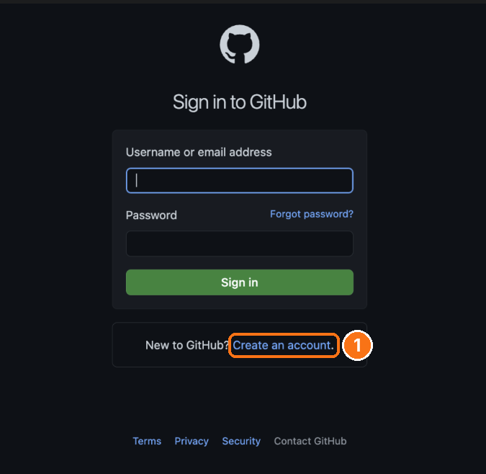
1 New to GitHub? Select Create an account (or sign in if you have one)
8 Choose a professional username
Your username becomes your web address: jordan-rivera → jordan-rivera.github.io. Use your name, lowercase, with a hyphen if needed. Avoid nicknames and random numbers.
9 Verify and secure your account
Enter the code GitHub sends to your email. GitHub may also ask you to turn on two-factor authentication (2FA): use an authenticator app or GitHub Mobile, and save your recovery codes somewhere safe.

Optional
Add a profile photo and a one-line bio under Your profile → Edit profile. It makes your GitHub look professional when you share it.

Create a repository
10 New repository
At the top right of any GitHub page: + → New repository
11 Fill in the form
- Repository name: my-portfolio. Use lowercase letters and hyphens, no spaces. The name becomes the end of your link.
- Visibility: Public. Free accounts can only publish public repositories.
- Add README: leave it off for your portfolio.
Then select Create repository .
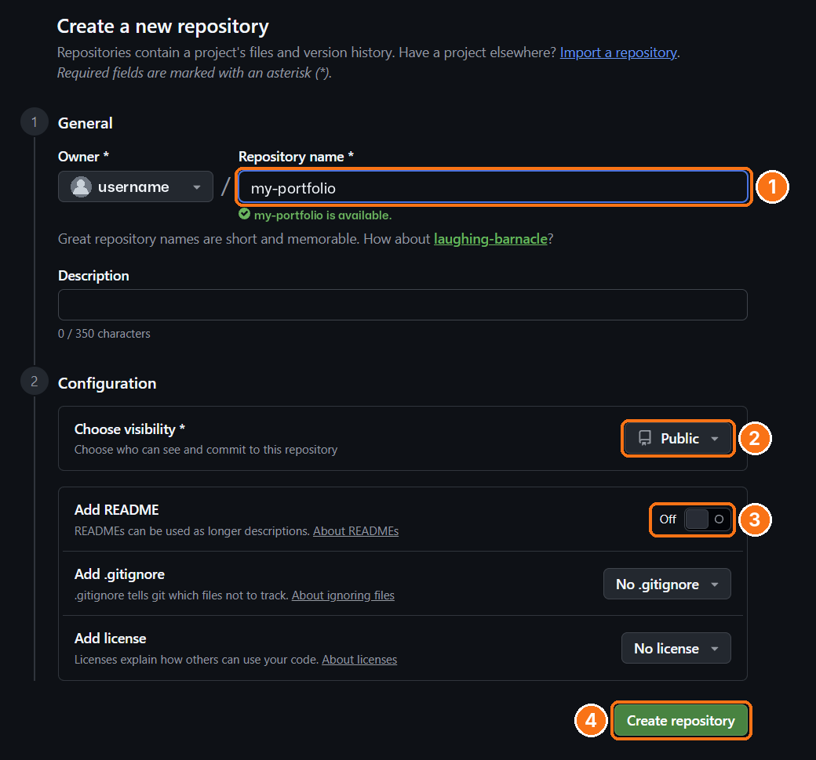
1 Repository name · 2 Public · 3 Add README: Off · 4 Create repository

Upload your file
12 Upload index.html and commit
Select uploading an existing file (or Add file ▾ → Upload files ) and drag in your index.html.
Check that the name in the list is exactly index.html. Type a short message such as Add portfolio, then select Commit changes .
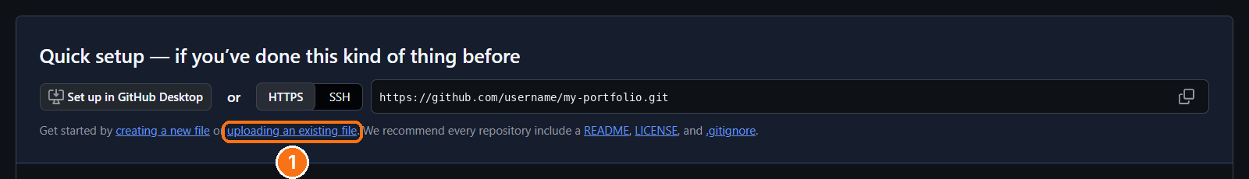
In your new, empty repository: 1 uploading an existing file
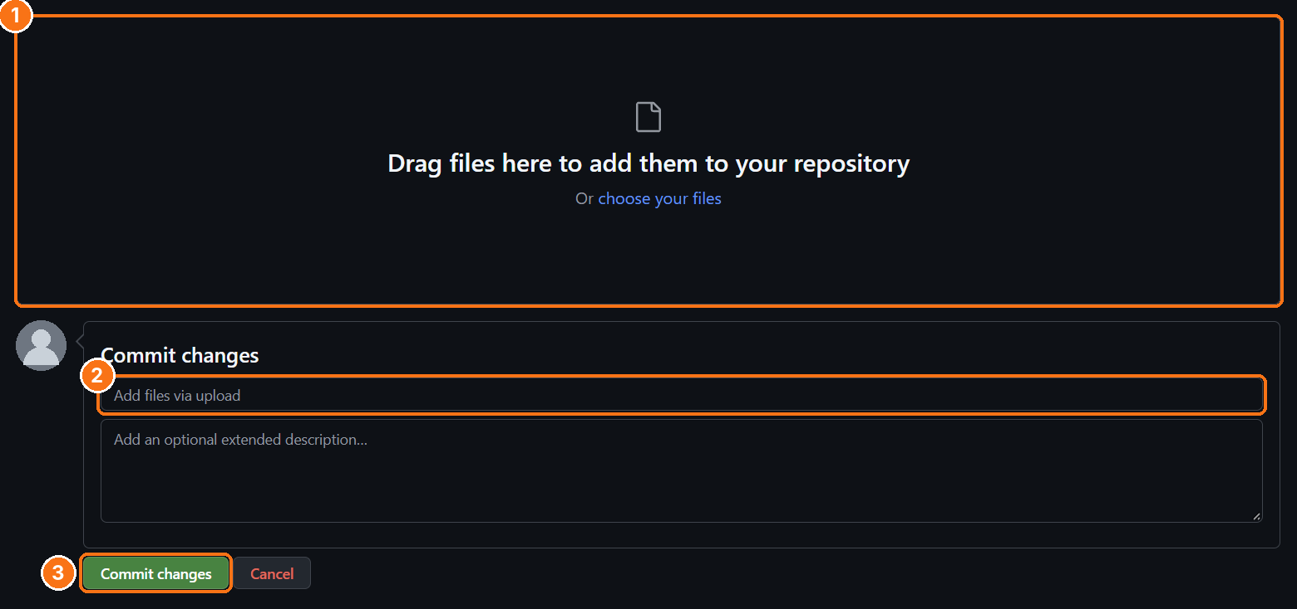
1 Drag your index.html here · 2 Short message, e.g. Add portfolio · 3 Commit changes

In the browser, each file can be up to 25 MB, and you can upload up to 100 files at once.

Publish with GitHub Pages
13 Turn on GitHub Pages
In your repository: Settings → Pages
Under Build and deployment: Source Deploy from a branch, branch main, folder / (root), then Save .
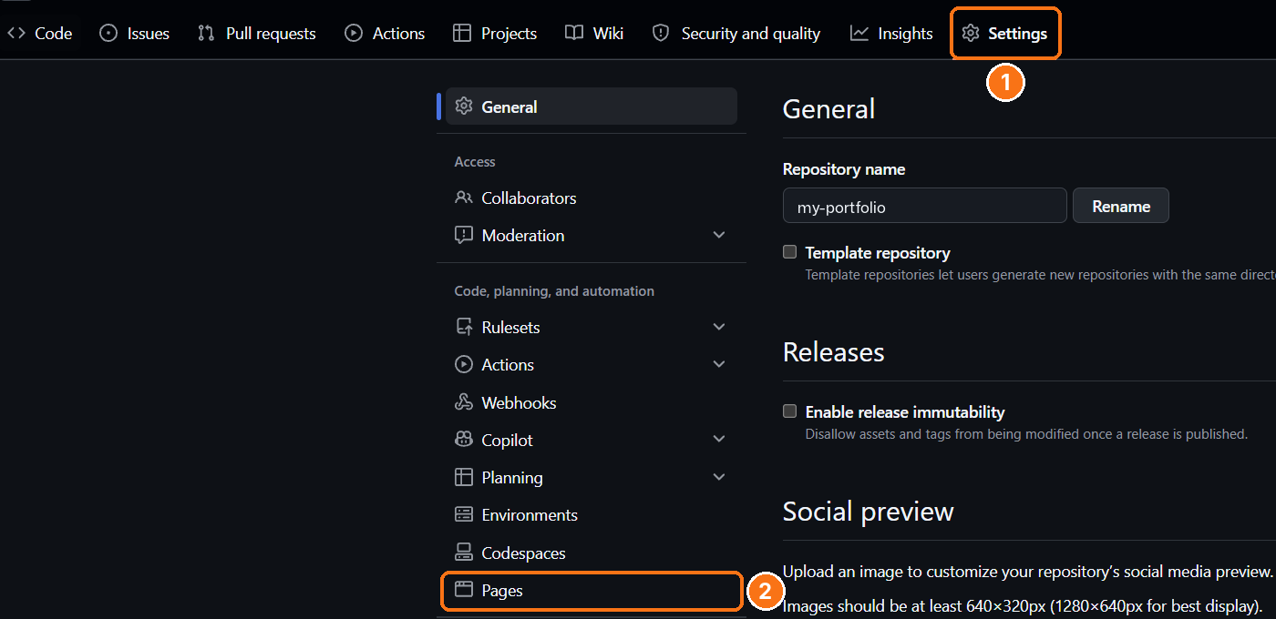
1 Settings · 2 Pages
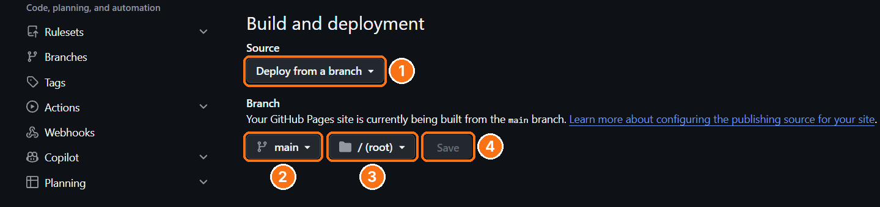
1 Deploy from a branch · 2 main · 3 / (root) · 4 Save
14 Wait for your link
Publishing usually takes 1 to 10 minutes. The Actions tab shows a green ✓ when it is done. Refresh Settings → Pages to see "Your site is live at", then select Visit site .
Your link looks like: https://your-username.github.io/my-portfolio/
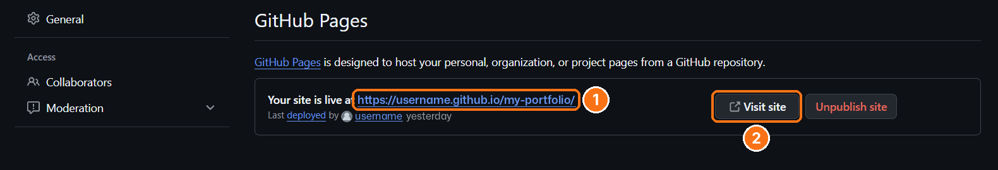
1 Your portfolio link · 2 Visit site

Share and update
15 Test and submit
Open your link in a private window to check it. Then submit the GitHub Pages address to your instructor. Do not submit a file:/// address or the repository page.

Your site is public
Anyone with the link can see it. Do not include your home address, phone number, student ID or other private information.

Updating later
Make your changes in Portfolio Creator (or restore your backup with Draft → Restore backup) and export a new index.html. In the same repository, select Add file → Upload files, drag in the new file and commit. A file with the same name replaces the old one. If you still see the old version, wait a few minutes and press Ctrl + Shift + R.
Shorter link
If you name the repository exactly your-username.github.io, your site is at https://your-username.github.io/, without a repository name at the end.

Use GitHub for your other projects
The same steps work for any class or personal project: create a repository, upload your files and commit. This time, turn Add README on. A good repository has:
- A clear name, such as sales-dashboard or survey-analysis.
- A README that answers: What is it? Which tools did you use? What did you find? Add one or two screenshots.
- Tidy folders, such as data/, notebooks/ and images/. When uploading, you can drag a whole folder.
- No private data: no passwords, API keys, personal information or confidential company data.
Then add the repository link to the project in your portfolio, so visitors can see your work in detail.

Seeing a "404 File not found" page?
Your portfolio is fine. Check these in order:
- File name. In your repository it must be exactly index.html. If it says index (1).html: click the file → ✏️ Edit → change the name → Commit changes.
- Address. Use the link shown at the top of Settings → Pages. It ends with your repository name.
- Pages is on. Settings → Pages → Deploy from a branch → main → / (root) → Save.
- Wait a few minutes. When the Actions tab shows a green ✓, refresh your page.
- Public repository. Free accounts can only publish public repositories.
- File, not folder. index.html must be on the main page of the repository, not inside another folder.

