
Table of Contents
- Introduction
- Methods
- Results
- Conclusion
- Statement on AI Usage

Introduction
CPU scheduling is a fundamental concept in operating systems that determines the order in which processes are allocated CPU time. When multiple processes compete for execution, the scheduler decides which one runs next, directly affecting key performance metrics such as waiting time, response time, turnaround time, and throughput.
This assignment investigates scheduling through a simulation analogy: a busy bar where Allegra the Barman represents the CPU and scheduler. Each patron corresponds to a process, each drink order to a CPU burst and each drinking period to an I/O wait. No pre-emption occurs within a single drink order once Allegra starts preparing a drink, she finishes it before moving on. This mirrors non-pre-emptive CPU scheduling.
Four scheduling algorithms are evaluated:
- First-Come First-Served (FCFS) > orders served in arrival order
- Shortest Job First (SJF) > shortest preparation time served next
- Priority Scheduling > lower patron ID receives higher priority
- Multilevel Feedback Queue (MLFQ) > multiple priority queues with aging
The goal is to compare these algorithms across response time, waiting time, turnaround time, throughput, fairness, predictability and starvation risk then recommend the best scheduler for a real bar environment.

Methods
Experimental Design
Experiments were conducted using the provided Java simulation package. Each run was launched with the command:
To ensure fair comparison across algorithms, all four schedulers were tested under identical workloads achieved by using the same random seeds.
The following configurations were tested:
- Number of patrons: 20, 40, 60, 80, 100
- Random seeds: 5 distinct seeds per configuration for statistical reliability
- Schedulers: FCFS, SJF, Priority, MLFQ
- Total runs: 5 seeds × 5 patron sizes × 4 schedulers = 100 runs

Data Collection
The method in Barman.java was implemented to append one CSV row per completed drink order, recording: scheduler name, patron ID, drink name, execution time, arrival time, service start time, completion time, waiting time, response time, turnaround time, and queue level.
Timing metrics were computed as:
- Waiting time = service start time − arrival time
- Response time = service start time − arrival time (equal to waiting time for non-pre-emptive scheduling)
- Turnaround time = completion time − arrival time
- Throughput = total orders completed ÷ total simulation duration (seconds)

Validation
Validation was performed through four checks:
- Workload fairness: identical seeds were verified to produce identical arrival times and drink choices across all schedulers
- Sanity check: the execution time distribution was confirmed to be statistically identical across all schedulers
- Theoretical consistency: results were checked against expected theoretical behaviour (e.g. SJF should produce lower mean waiting times than FCFS)
- Reproducibility: re-running with the same seed produced identical results

All analysis and visualisations were produced in Python using pandas and matplotlib from the raw CSV output files.

Results
Table 1 summarises the key metrics across all runs and patron sizes. Figures 1 - 7 provide detailed visual comparisons.

Table 1: Summary Statistics for All Scheduling Algorithms
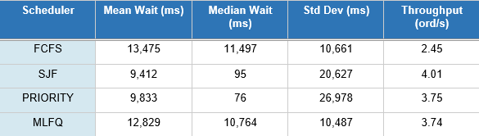

3.1 Mean and Median Waiting, Response and Turnaround Times
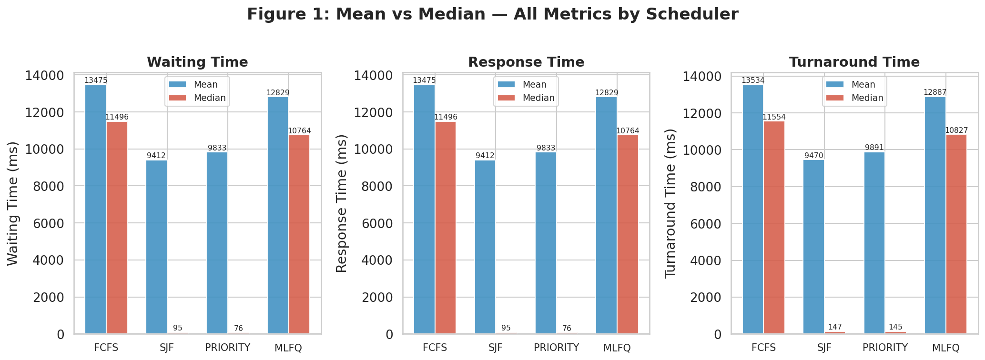
Figure 1: Mean vs Median - Waiting Time, Response Time, and Turnaround Time by Scheduler
Figure 1 reveals a critical distinction between two groups of schedulers. FCFS and MLFQ show closely aligned mean and median values with FCFS at 13,475ms mean and 11,497ms median, and MLFQ at 12,829ms mean and 10,764ms median. This small mean - median gap indicates a symmetric, predictable distribution with no extreme outliers.
SJF and Priority present a different picture. SJF has a mean of 9,412ms but a median of just 95ms; Priority shows an even more extreme gap, with a mean of 9,833ms against a median of 76ms. This large mean - median divergence is the signature of a heavily right-skewed distribution, most orders are served almost instantly nearly zero wait but a small fraction of orders experiences extremely long waits, pulling the mean upward. This is the representation of starvation.
3.2 Distribution of Waiting and Turnaround Times

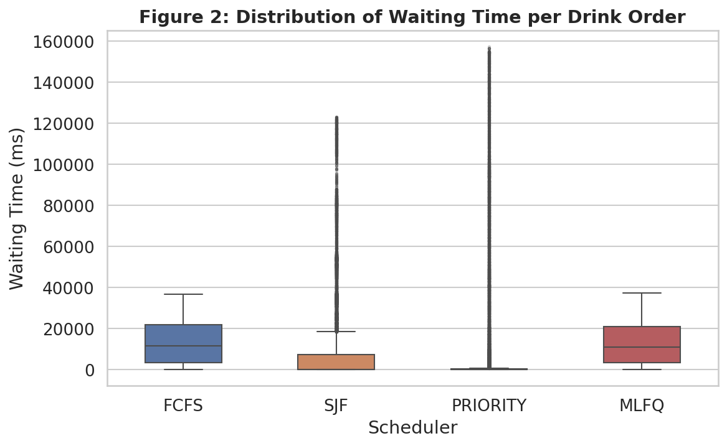
Figure 2: Box Plot - Distribution of Waiting Time per Drink Order
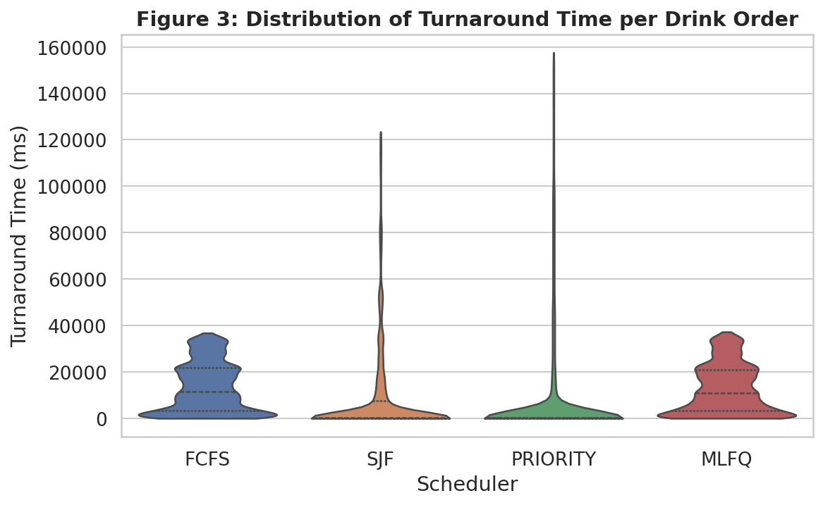
Figure 3: Violin Plot - Distribution of Turnaround Time per Drink Order
Figure 2 confirms the distribution shapes. FCFS and MLFQ have compact, symmetric boxes with a moderate number of high outliers. Their interquartile ranges are wide but balanced indicating consistent service with predictable behaviour.
SJF and Priority both show extremely compressed boxes near zero with a very long upper whisker extending to over 100,000ms. Most of orders under SJF and Priority are served very quickly because short jobs always jump the queue but the remaining orders, the long jobs that keep being displaced and accumulate wait times measured in tens of seconds.
The violin plot (Figure 3) makes the distribution shapes even clearer. FCFS and MLFQ produce broad, roughly bell-shaped distributions. SJF and Priority produce violins with an enormous spike at zero and a thin, extremely long tail visually demonstrating the severity of the starvation effect.
3.3 Throughput
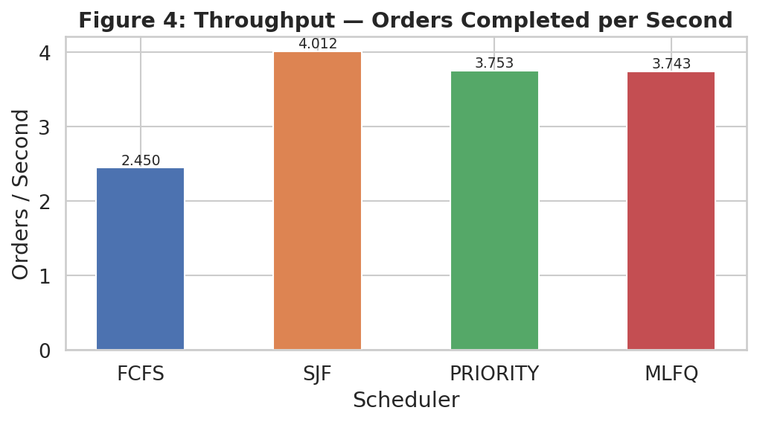
Figure 4: Throughput - Drink Orders Completed per Second
SJF achieves the highest throughput at 4.01, followed by Priority (3.75) and MLFQ (3.74), which are virtually identical. FCFS is the clear outlier at only 2.45 approximately 39% lower than SJF.
SJF’s high throughput is expected: by always serving the shortest available job first, it minimises idle time and maximises the rate at which the queue is drained. FCFS’s low throughput arises from the convoy effect: a long drink order blocks all short orders behind it in the queue, leaving shorter, faster jobs waiting unnecessarily. MLFQ’s throughput is close to Priority and SJF, demonstrating that its aging mechanism does not significantly penalise efficiency.

3.4 Fairness: Per-Patron Total Writing Time

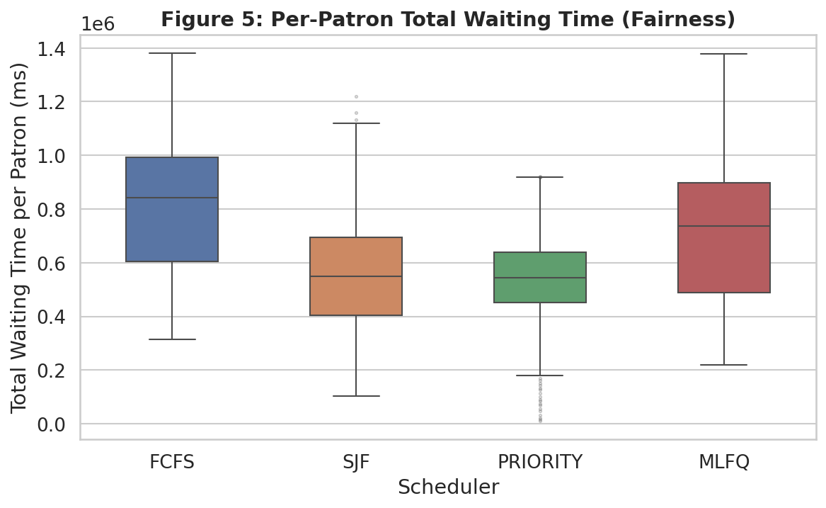
Figure 5: Per-Patron Total Waiting Time - Fairness Comparison
Figure 5 shows the distribution of total waiting time accumulated by each patron across all their drink orders. FCFS produces the most equitable distribution: the box is relatively compact, and no scheduler is systematically disadvantaged. Patrons are served in arrival order regardless of who they are or what they order.
MLFQ produces a similarly fair spread but with slightly lower median total wait, reflecting its ability to prioritise shorter orders early in a patron’s visit. SJF and Priority both show wide boxes with very long upper whiskers, indicating that certain patrons accumulate very large total waits. In Priority scheduling, this is systematic: high-ID patrons (lower priority) are structurally disadvantaged across every single one of their orders

3.5 Starvation Risk
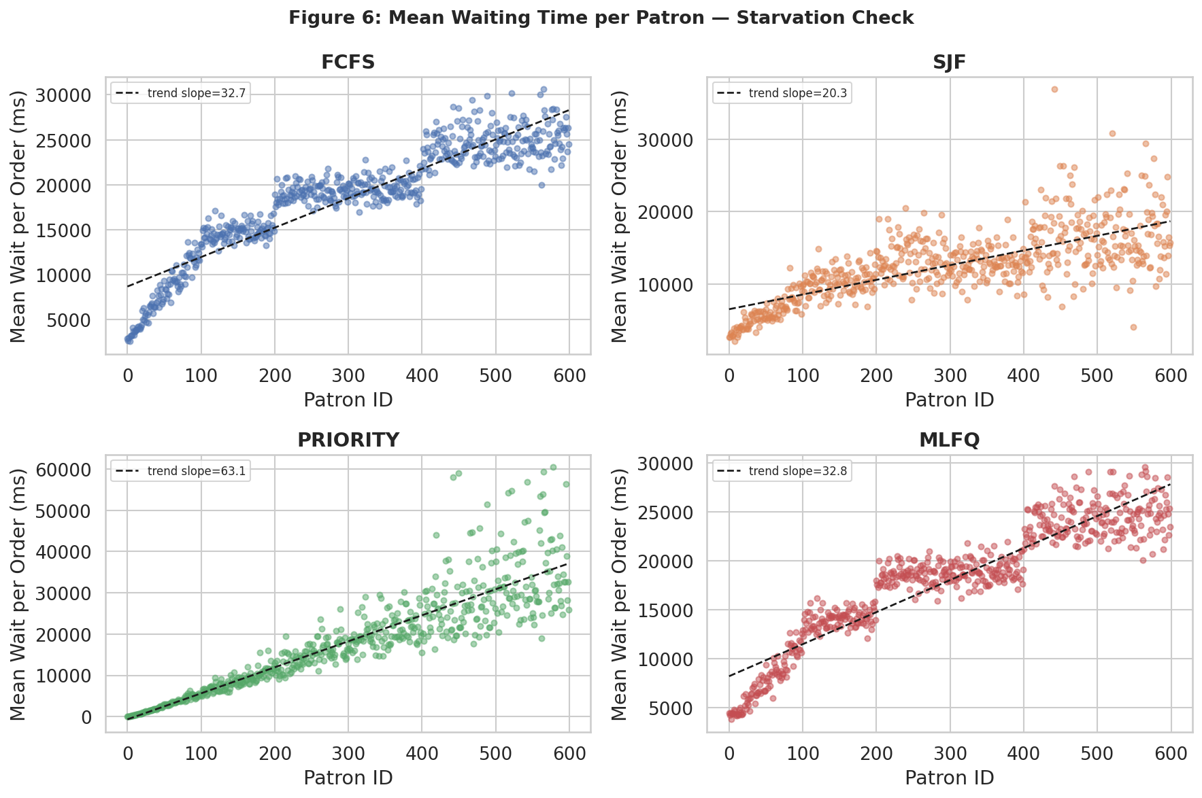

Figure 6: Mean Waiting Time per Patron ID — Starvation Check
Figure 6 plots the mean waiting time per order for each patron ID, with a trend line overlaid. The results are revealing:
- FCFS: near-zero trend slope > all patrons experience similar average waits regardless of ID, confirming
- SJF: slight positive slope > some patron IDs consistently experience longer waits, corresponding to those whose drink orders tend to be longer
- Priority: strong positive slope > higher ID patrons show clearly increasing mean wait times which confirming systematic starvation risk
- MLFQ: near-flat trend > the aging mechanism effectively prevents any patron from being consistently deprioritised
Priority scheduling is the only algorithm that exhibits structural starvation: under sustained load, low-priority IDs patrons can be indefinitely delayed as higher priority patrons continuously jump the queue. SJF also risks starvation for patrons with long drink orders, though it is not as systematically patron dependent. MLFQ’s aging mechanism promotes long-waiting orders to higher queues, preventing indefinite delay.

3.6 Scaling Performance
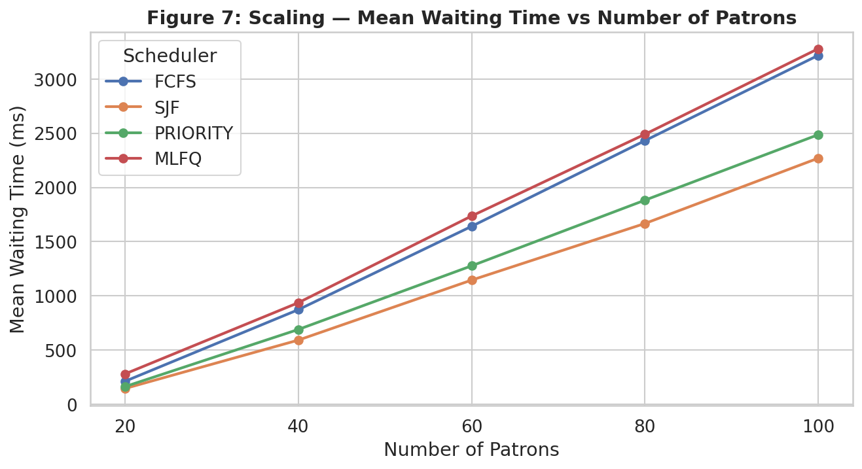
Figure 7: Mean Waiting Time vs Number of Patrons - Scaling Performance
Figure 7 shows how mean waiting time scales with the number of patrons. All schedulers exhibit a linear growth in waiting time as patron count increases from 20 to 100, which is the expected behaviour for a single-server queue approaching saturation.
SJF and Priority maintain consistently lower mean waiting times across all patron counts but as demonstrated earlier this is misleading because of their extreme variance. FCFS and MLFQ track closely together, with MLFQ marginally better at all scales. Notably, the gap between SJF/Priority and FCFS/MLFQ widens as patron count increases under heavier load, SJF and Priority serve short jobs even faster while long jobs wait even longer amplifying the starvation effect.
3.7 Predictability
Predictability refers to how consistently a scheduler delivers service. A low standard deviation in waiting times indicates a predictable scheduler.
MLFQ is the most predictable scheduler, nearly identical to FCFS Both provide consistent and bounded waiting times.
SJF and Priority are highly unpredictable. A patron cannot know in advance whether their order will be served in under a second or over two minutes, depending entirely on what other orders happen to be in the queue at that moment. For a real bar environment, this unpredictability would be unacceptable.

Conclusion
This study compared four CPU scheduling algorithms: FCFS, SJF, Priority and MLFQ in a bar simulation across waiting time, response time, turnaround time, throughput, fairness, predictability, and starvation risk.
The key finding is that SJF and Priority’s apparent advantage in mean waiting time is illusory. Their very low medians and very high standard deviations reveal that they achieve low means by serving most short orders almost instantly at the cost of subjecting a minority of longer orders to extreme delays. This constitutes real starvation risk that is unacceptable in a bar setting.
MLFQ is recommended as the best scheduling algorithm for Allegra the Barman for the following reasons:
- Fairness: MLFQ treats all patrons comparably, with no systematic bias against any patron ID or order type
- Starvation prevention: the aging mechanism ensures that orders which have waited too long are promoted to higher priority queues, bounding the maximum possible wait
- Predictability: lowest standard deviation of all four schedulers, giving patrons a reliable expectation of service time
- Throughput: at 3.74 orders/second, MLFQ nearly matches SJF and Priority (4.01 and 3.75 respectively) while providing far superior fairness
- Scalability: MLFQ maintains stable relative performance as patron count increases

Statement on AI Usage
Claude ai was used for coding assistance in this assignment. Specifically, AI assistance was used to:
- Implement the recordCompletedOrder() method in Barman.java to write per order metrics to CSV files
- Write the shell script (run_experiments.sh) to automate running all scheduling algorithms across multiple patron counts and seeds
- Write the Python/Jupyter analysis notebook (analyse_results.ipynb) to load CSVs, generate graphs, and compute summary statistics
All experimental runs, data collection, and graph generation were performed by the author on real simulation output. All interpretations and recommendations are based on actual data produced by running the simulation. AI was not used to fabricate results, generate fake graphs or write the analysis and conclusions but was used to structure the report.

