**Testing Technique – Homework**

1. An employee has £4000 of salary tax free. The next £1500 is taxed at 10%  
   The next £28000 is taxed at 22%  
   Any further amount is taxed at 40%  
   Which of these groups of numbers would fall into the same equivalence class?  
   a) £4800; £14000; £28000  
   b) £5200; £5500; £28000  
   c) £28001; £32000; £35000  
   d) £5800; £28000; £32000

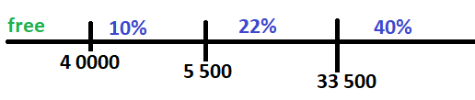

1. A program validates a numeric field as follows:  
   values less than 10 are rejected, values between 10 and 21 are accepted, values greater  
   than or equal to 22 are rejected.  
   which of the following input values cover all of the equivalence partitions?  
   a. 10,11,21  
   b. 3,20,21  
   c. 3,10,22  
   d. 10,21,22  
   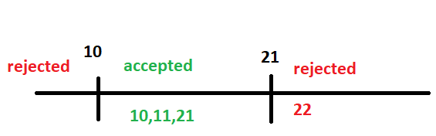
2. Using the same specifications as question 2, which of the following covers the MOST boundary values?  
   a. 9,10,11,22  
   b. 9,10,21,22  
   c. 10,11,21,22  
   d. 10,11,20,21

|  |  |  |
| --- | --- | --- |
| Invalid | Valid5 | invalid |
| Partition1 | Partitio2 | Partition3 |
| 0-9 | 10-21 | 22-∞ |

1. Order numbers on a stock control system can range between 10000 and 99999  
   inclusive. Which of the following inputs might be a result of designing tests for only valid  
   equivalence classes and valid  
   boundaries:  
   a) 1000, 5000, 99999  
   b) 9999, 50000, 100000  
   c) 10000, 50000, 99999  
   d) 10000, 99999  
   e) 9999, 10000, 50000, 99999, 10000  
   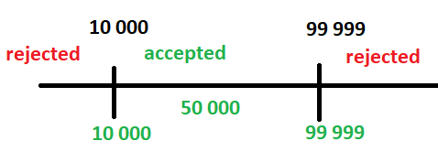
2. Minimum Test Required for Statement Coverage :  
   Disc = 0  
   Order-qty = 0  
   Read Order-qty  
   If Order-qty >=20 then  
   Disc = 0.05  
   If Order-qty >=100 then  
   Disc =0.1  
   End if  
   End if  
   a) Statement coverage is 4  
   b) Statement coverage is 1  
   c) Statement coverage is 3  
   d) Statement Coverage is 2  
   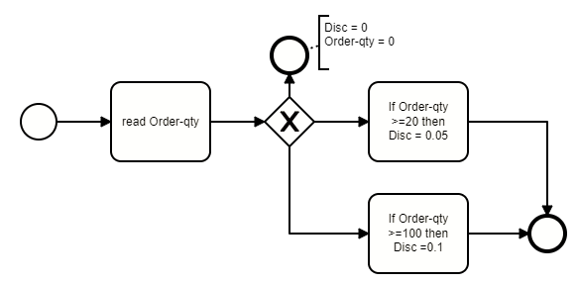
3. An employee’s bonus is to be calculated. It cannot become negative, but it  
   can be calculated to zero. The bonus is based on the duration of the  
   employment. An employee can be employed for less than or equal to 2 years,  
   more than 2 years but less than 5 years, 5 to 10 years, or longer than 10  
   years. Depending on this period of employment, an employee will get either  
   no bonus or a bonus of 10%, 25% or 35%.  
   How many equivalence partitions are needed to test the calculation of the  
   bonus?  
   a) 3  
   b) 5  
   c) 2  
   d) 4

|  |  |  |  |
| --- | --- | --- | --- |
| Invalid | Valid5 | Valid5 | Valid5 |
| Partition1 | Partitio2 | Partition3 | Partition4 |
| 0m -4y & 11m | 2y -4y & 11m | 5-9y 11m | 10g & 10y+ |
| 0% | 10% | 25% | 35% |

1. Analyse the following highly simplified procedure:  
   Ask: “What type of ticket do you require, single or return?”  
   IF the customer wants ‘return’  
   Ask: “What rate, Standard or Cheap-day?”  
   IF the customer replies ‘Cheap-day’  
   Say: “That will be £11:20”  
   ELSE  
   Say: “That will be £19:50”  
   ENDIF  
   ELSE  
   Say: “That will be £9:75”  
   ENDIF  
   Now decide the minimum number of tests that are needed to ensure that all  
   the questions have been asked, all combinations have occurred and all  
   replies given.  
   a)3  
   b)4  
   c)5  
   d)6
2. An input field takes the year of birth between 1900 and 2004.  
   The boundary values for testing this field are:  
   a. 0,1900,2004,2005  
   b. 1900, 2004  
   c. 1899,1900,2004,2005  
   d. 1899, 1900, 1901,2003,2004,2005
3. A search form in a local auto retailer website contains the following elements:  
   - Model [drop-down list]: Golf II / Golf III / BMW M6  
   - Fuel type [drop-down list]: Gas / Diesel / Gasoline  
   - Tuning [check-box]: Checked / Unchecked  
   - Gearbox [drop-down]: Manual / Automatic / Semi-automatic  
   Determine minimum number of tests to cover search functionality using pairwise testing  
   technique.

|  |  |  |  |
| --- | --- | --- | --- |
| Model | Fuel type | tuning | Gearbox |
| Golf 2 | Gas | Checked | Manual |
| Golf 2 | Diesel | Unchecked | Automatic |
| Golf 2 | Gasoline | Checked | Semi-automatic |
| *Golf 2\** | *Gas* | *Checked* | Manual |
|  |  |  |  |
| Golf 3 | Gas | Checked | Manual |
| Golf 3 | Diesel | Unchecked | Automatic |
| Golf 3 | Gasoline | Checked | Semi-automatic |
| *Golf 3\** | *Diesel* | *Checked* | *Automatic* |
|  |  |  |  |
| BMV M16 | Gas | Checked | Manual |
| BMV M16 | Diesel | Unchecked | Automatic |
| BMV M16  *BMV M16\** | Gasoline  *Gasoline* | Checked  *Unchecked* | Semi-automatic  *Semi-automatic* |