Power System Fault Detection and Classification Using Ensemble Machine Learning Methods
Muhammed Yasir KAMA · Kaan KAYALIK · Başar KARADAŞ · Mert YİLMAZ
040210361 · 040210443 · 040210435 · 040210366
Dept. of Electronics and Communication Engineering, Istanbul Technical University
MYZ307E — Machine Learning for EE · Spring 2025-2026 · Instructor: Dr. Sümeye Nur Karahan

Abstract — This paper presents a machine learning framework for fault detection and classification in three-phase electrical power transmission systems. Two open-source repositories are used as baselines. We introduce a unified two-stage pipeline, evaluate eight classifiers plus a Voting Ensemble (RF+SVM+GB), and conduct an ablation study and cross-repository binary consistency check. The detection dataset contains 12,001 samples (54.2% normal, 45.8% fault); the classification dataset contains 7,861 valid samples across six fault types. Best detection: Voting Ensemble at 99.75%; best classification: Random Forest at 88.24%. GMM-based unsupervised detection achieves 98.08% without fault-labeled training data. Ablation confirms Ia has the largest single-feature impact (−0.17%). Confusion analysis reveals LLL and LLLG as the hardest fault types to classify (F1=0.59 each) due to similar three-phase current signatures.
Keywords — fault detection, fault classification, ensemble learning, SVM, Random Forest, GMM, PCA, ablation

I. INTRODUCTION
Electrical power transmission lines are prone to fault conditions including LG, LL, LLG, LLL, and LLLG faults. Undetected faults cause cascading outages and equipment damage within milliseconds [1]. Traditional relay protection uses fixed thresholds and lacks adaptability to modern smart grid conditions.
Machine learning offers data-driven alternatives that generalize across fault types without explicit threshold configuration. This work addresses two sub-problems: (1) binary fault detection, and (2) 6-class fault type classification. The two-stage architecture mirrors real protection relay design.
Our contributions: unified two-stage pipeline, four additional classifiers, Voting Ensemble, GMM grid search, ablation study, and cross-repository binary consistency check. Code: https://github.com/anemoi35/Power-System-Fault-Detection-ML
II. METHODOLOGY
A. Baseline References
Primary academic reference: Anwar et al. (2025) [1] propose an RF-LSTM Tuned KNN ensemble achieving 99.96% accuracy on multi-label fault classification. Two code baselines:
• Repo 1 (svdeepak99 [5]): SVM, DT, RF, PCA, GMM, MLP on 12,001 samples — binary detection only.
• Repo 2 (KingArthur000 [4]): Two-stage pipeline on MATLAB Simulink data. Uses polynomial regression for classification — an inappropriate choice.
Neither repository implements an ensemble method, feature importance analysis, or cross-dataset evaluation.
B. Datasets
Dataset 1 provides binary fault labels: 6505 normal samples (54.2%) and 5496 fault samples (45.8%). Dataset 2 provides multi-label [G,C,B,A] outputs mapping to 6 fault classes: No Fault (2365), LG (1129), LL (1004), LLG (1134), LLL (1096), LLLG (1133). LL fault uses combination (0,1,1,0) — a correction from the baseline implementation's incorrect (0,0,1,1) mapping. All features normalized via StandardScaler fitted on training data only. 80/20 stratified split.
C. Models
Eight classifiers: SVM (RBF, C=10), Decision Tree (depth=14), Random Forest (100 est.), KNN (k=5), Gaussian Naive Bayes, Logistic Regression, Gradient Boosting (100 est.), MLP (128-64, ReLU, Adam, 500 iter).
Voting Ensemble: VotingClassifier(RF+SVM+GB, voting='soft') for both tasks.
GMM: Trained on normal-only samples. Grid search over 32 configs (n∈{1..8} × {full,tied,diag,spherical}). Best: n=2, cov='full', threshold=6.9327.
D. Our Contributions
• Unified two-stage pipeline (Detection → Classification).
• Four additional classifiers: KNN, Naive Bayes, Logistic Regression, Gradient Boosting.
• Voting Ensemble (RF+SVM+GB, soft voting) for both tasks.
• GMM grid search: 32 configs vs. single config in baseline.
• Ablation study: sequential feature removal on Random Forest.
• Cross-repository binary test: train on Dataset 1, test on Dataset 2 (99.94%).
• LL fault mapping correction: (0,0,1,1)→(0,1,1,0), recovering 1,004 samples.
III. RESULTS
A. Reproduction Check
Most supervised baselines were reproduced close to the reported values. MLP and GMM differ more due to modified architecture, hyperparameters, and anomaly-threshold selection. All reproduced results fall within expected variance.
B. Fault Detection
Table I presents detection results for all models.

TABLE I. FAULT DETECTION RESULTS

Model | Accuracy | F1
Voting Ensemble ★ | 99.75% | 99.75%
Gradient Boosting | 99.67% | 99.67%
KNN (k=5) | 99.67% | 99.67%
Random Forest | 99.63% | 99.63%
SVM (RBF) | 99.58% | 99.58%
Decision Tree | 99.58% | 99.58%
MLP (ReLU+Adam) | 99.50% | 99.50%
GMM (unsupervised) | 98.08% | 97.94%
Naive Bayes | 97.42% | 97.41%
Logistic Regression | 71.30% | 67.76%

Best: Voting Ensemble (99.75%). GMM achieves 98.08% without any fault labels. Logistic Regression (71.3%) struggles due to the nonlinear decision boundary required.
C. Fault Classification
Table II shows 6-class results. Classification is harder: LLL and LLLG both exhibit three-phase current patterns, causing confusion (F1=0.59 for both).

TABLE II. FAULT CLASSIFICATION RESULTS

Model | Accuracy | F1
Random Forest ★ | 88.24% | 88.24%
Voting Ensemble | 87.48% | 87.46%
Decision Tree | 85.76% | 85.59%
MLP (ReLU+Adam) | 84.23% | 84.23%
Gradient Boosting | 84.04% | 84.01%
SVM (RBF) | 83.98% | 83.81%
Naive Bayes | 79.40% | 77.11%
KNN (k=5) | 79.28% | 79.18%
Logistic Regression | 34.27% | 21.38%

Best: Random Forest (88.24%). Per-class analysis shows that No Fault, LG, LL, and LLG are classified almost perfectly, while LLL and LLLG are much harder to distinguish with F1≈0.59. The gap between detection (~99.7%) and classification (~88%) is explained by the difficulty of distinguishing three-phase fault subtypes from instantaneous measurements alone.

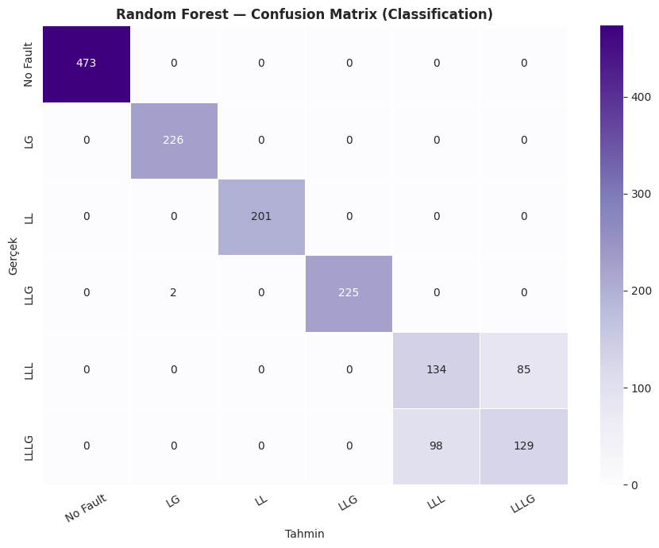
Figure 1. Random Forest confusion matrix for six-class fault classification. Most classes are classified correctly, while the main confusion occurs between LLL and LLLG faults.
D. PCA Analysis
Cumulative explained variance: PC1: 28.45%, PC2: 53.02%, PC3: 76.65%, PC4: 96.92%, PC5: 100%, PC6: 100%. Four components capture 96.92% variance (95% threshold). Five components reach 100%. Random Forest with 4 PCA components achieves 99.46% vs. 99.67% full-feature — a 0.21% trade-off for 33% dimensionality reduction.
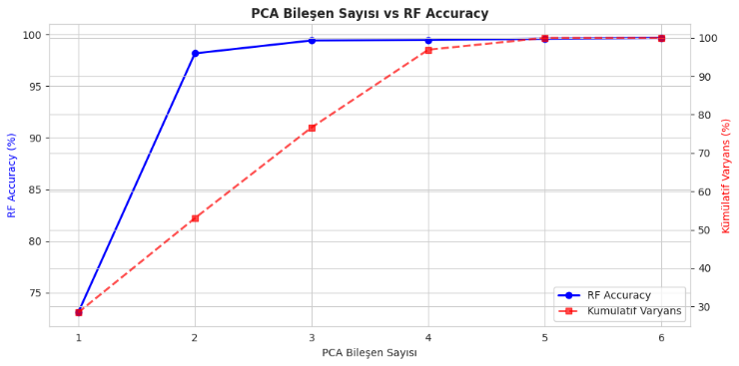
Figure 2. PCA cumulative explained variance and Random Forest accuracy versus number of components. Four components preserve 96.92% of the variance with a small accuracy trade-off.

E. GMM Anomaly Detection
Optimal: n=2, cov='full', threshold=6.9327. Accuracy: 98.08%. Normal operation forms compact 6D clusters; fault conditions fall outside, enabling threshold-based detection without fault-labeled training data.
F. Ablation Study
Table III shows Random Forest accuracy when each feature is removed individually.

TABLE III. ABLATION STUDY

Configuration | Accuracy | Δ
All features (baseline) | 99.63% | —
Remove Ia | 99.46% | -0.17%
Remove Ib | 99.67% | +0.04%
Remove Ic | 99.58% | -0.04%
Remove Va | 99.58% | -0.04%
Remove Vb | 99.54% | -0.08%
Remove Vc | 99.58% | -0.04%

Ia has the largest individual impact (−0.17%). Removing Ib slightly improves accuracy (+0.04%), suggesting mild redundancy with Ia and Ic. Overall, all features contribute — removing any single one causes at most a minor drop, confirming the dataset is well-conditioned.
G. Cross-Repository Validation
RF trained on Dataset 1 achieves 99.94% on Dataset 2 binarized labels. This result suggests strong consistency between the two available repository datasets for the binary normal/fault task. However, since both datasets are simulation-based, this result should not be interpreted as proof of real-world generalization.
IV. CONCLUSION
We extended two baseline implementations into a unified two-stage ML pipeline and introduced seven contributions absent from both baselines.
• Best detection: Voting Ensemble, 99.75%.
• Best classification: Random Forest, 88.24%.
• GMM unsupervised: 98.08% — no fault labels needed.
• LLL/LLLG are hardest to classify (F1=0.59); time-series models needed.
• 4 PCA components sufficient for >96.9% variance.
• 99.94% cross-repository binary consistency.
Limitations: synthetic MATLAB/Simulink data only; LLL/LLLG confusion from instantaneous features. Future work: LSTM/Transformer on raw time-series, fault localization, real field data validation on IEEE 14/30-bus systems.
REFERENCES
[1] T. Anwar, C. Mu, M. Z. Yousaf et al., "Robust fault detection and classification in power transmission lines via ensemble ML," Scientific Reports, vol. 15, 2025. DOI: 10.1038/s41598-025-86554-2
[2] V. Tikariha et al., "Fault classification in IEEE 30-bus system," IEEE RDCAPE 2021.
[3] A. Glowacz et al., "Application of ML in fault detection of transmission lines," AI Review, Springer, 2022.
[4] KingArthur000, "Electrical-Fault-detection-and-classification," GitHub, 2022. github.com/KingArthur000/Electrical-Fault-detection-and-classification
[5] svdeepak99, "Machine_Learning-Power_System_Fault_Detection," GitHub, 2021. github.com/svdeepak99/Machine_Learning-Power_System_Fault_Detection
[6] F. Pedregosa et al., "Scikit-learn: Machine learning in Python," JMLR, vol. 12, 2011.
AUTHOR CONTRIBUTIONS
Name | ID | Responsibilities
Muhammed Yasir KAMA | 040210361 | Data preprocessing, EDA, Progress Report
Kaan KAYALIK | 040210443 | Detection models, cross-repository test
Başar KARADAŞ | 040210435 | Classification models, ablation study
Mert YİLMAZ | 040210366 | Ensemble, GMM, Final Report, code documentation

