<https://automationanywhere.litmos.com/home/LearningPath/46668>

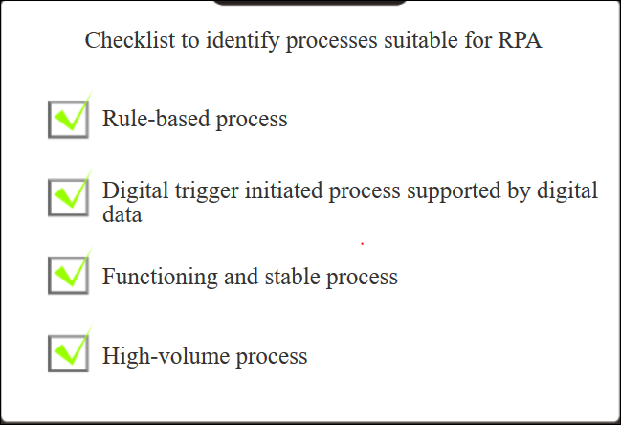

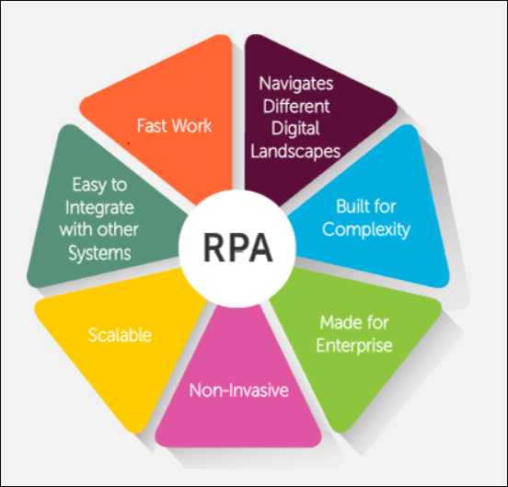

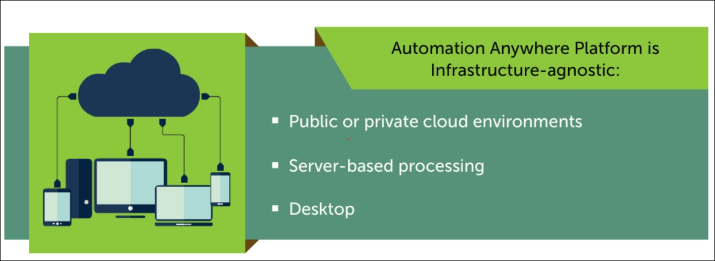

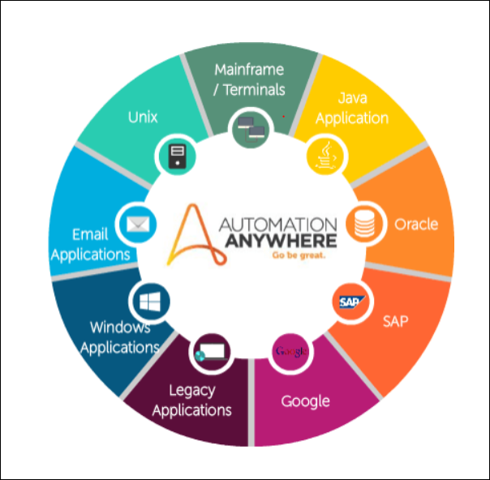

AA has three types of recorders:

1. Object based smart recorder
2. Screen recorder
3. Dedicated web recorder

AA can be used to automate and integrate at UI, API, OS and DB layers.

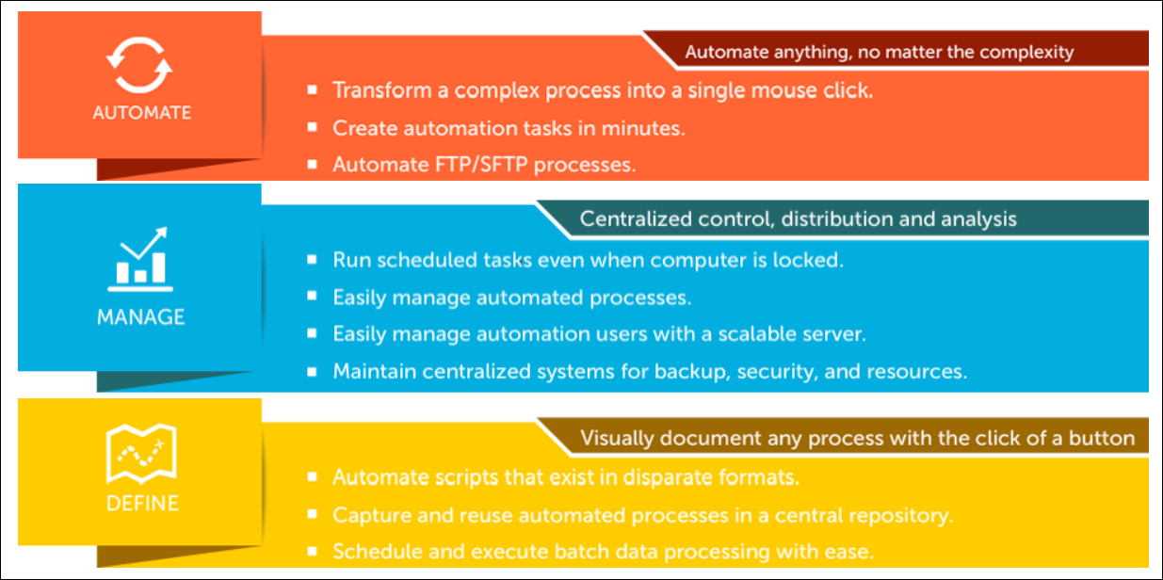

AA Architecture

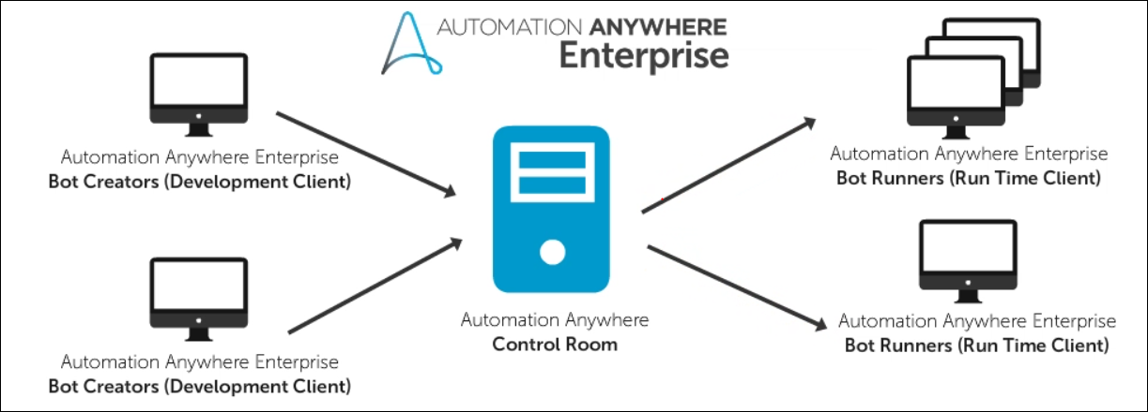

Components:

1. Control Room – Centralized Management & Control Layer. Authorize, control and manage Bot Creator & Runner.
2. Bot Creator (Development Client) – Create, edit and execute Bots as part of the development process.
3. Bot Runner (Runtime Client)– Present on Desktop, Data Centres, Cloud infrastructure. Execute Bots.

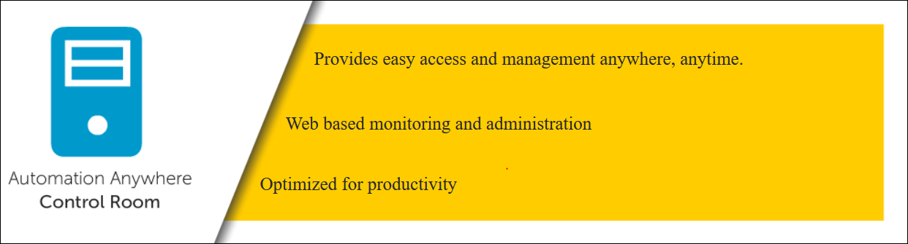

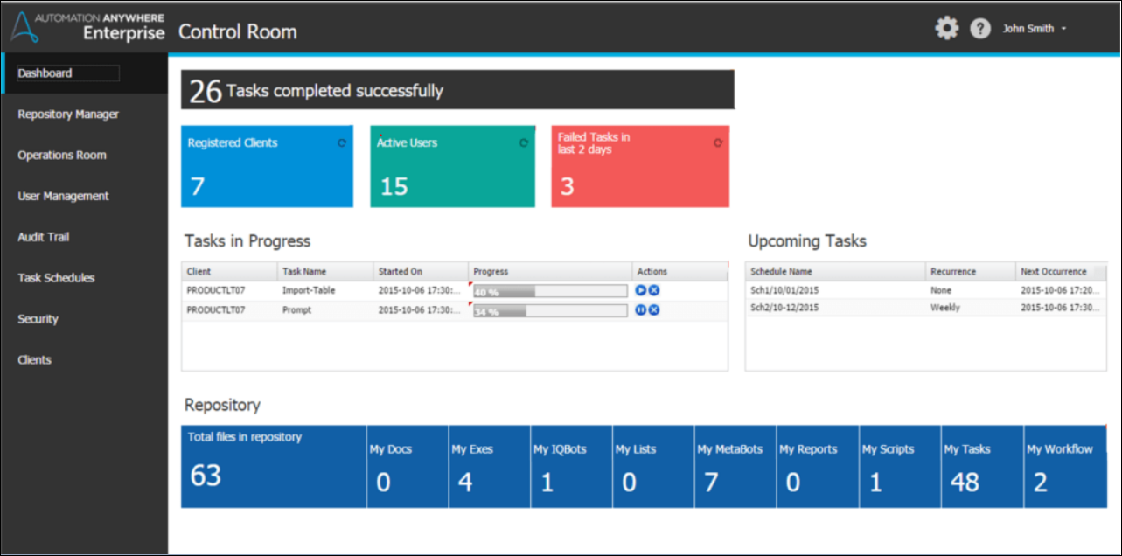

Bot Creator

Runs on Windows and must be registered and connected to an active Control Room in order to function.

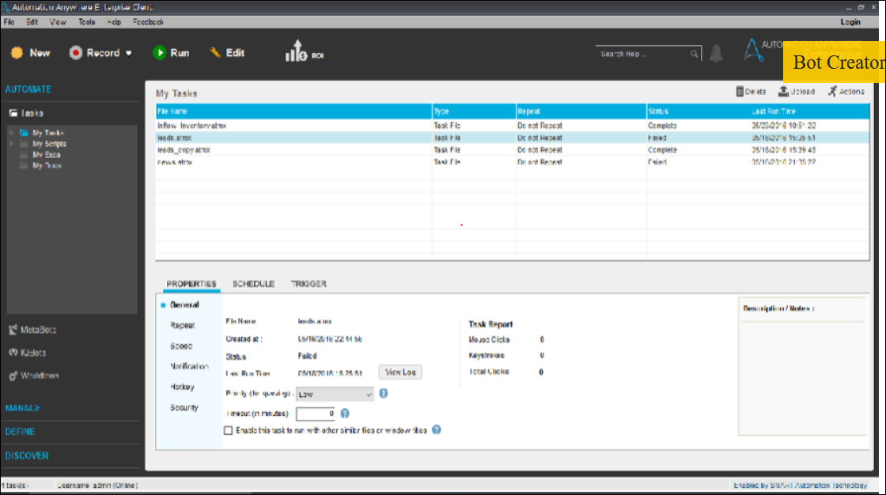

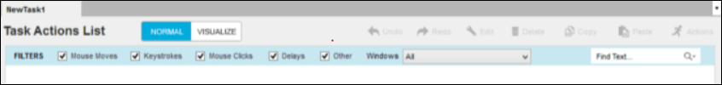

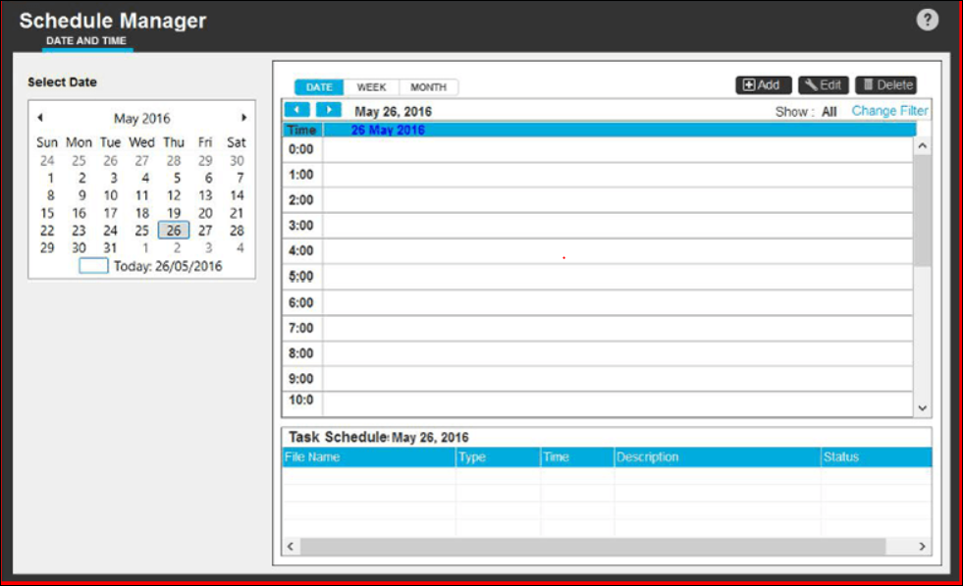

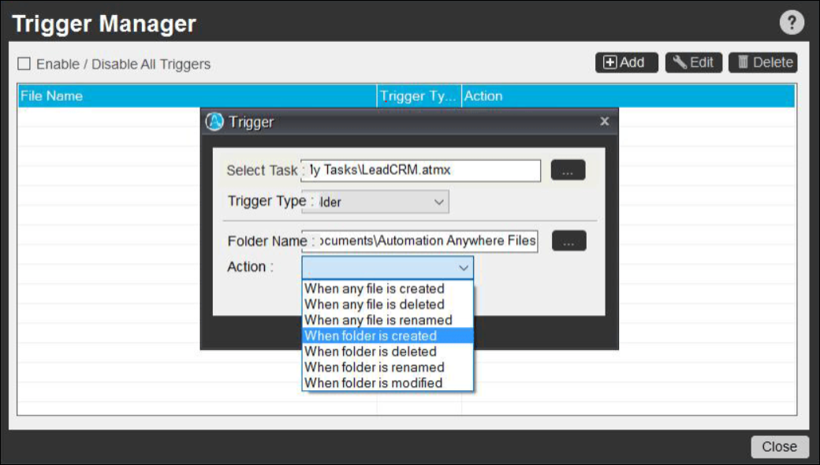

Bot Runner

Control Room schedules and assigns bots to runtime clients for execution that works on Windows OS.

Bot Runners can only execute once they are registered, identified and authenticated by the Control Room.

Once authenticated Bot Runners can execute Bots to run independently and asynchronously.

Bot Runners can be grouped and dynamically allocated, offering a convenient option for scaling up.

All Bot telemetry is cached locally and transmitted to Control Room.

AA – Unique features

1. Auto-calibrate technology - Bots sense and automatically adjust to application changes immediately.
2. Sense AI Technology – Provides adaptive automation experience. Employs “smart pauses” and environment related adjustments to perform tasks.
3. Only enterprise grade RPA with cognitive capabilities and analytics.
4. Unique natural language processing technology.
5. Machine Learning techniques – feature extraction and classification algorithm for data extraction
6. Embedded analytics - business insights
7. System logs and auto-compliance features
8. Web-based Control Room to queue, launch, manage, orchestrate and maintain automation tasks.
9. Versioning system ensure control of automation tasks through lifecycles.
10. Centrally controlled and orchestrated licensing and execution.
11. Priority-based resource allocation and broad array of scheduling algorithms.
12. Private key/public key infrastructure combined with AES encryption
13. Bot execution using stealth mode and keyboard disable features.
14. Credential integration using SAML 2.0 and standard directory service protocol.
15. Secure bot containers combined with obfuscation of business logic.