Name : Darshana Namdeo Mahabale.

Father Name : Late Mr.Namdeo Ramchandra Mahabale.

Mother Name : Smt.Shanta Namdeo Mahabale.
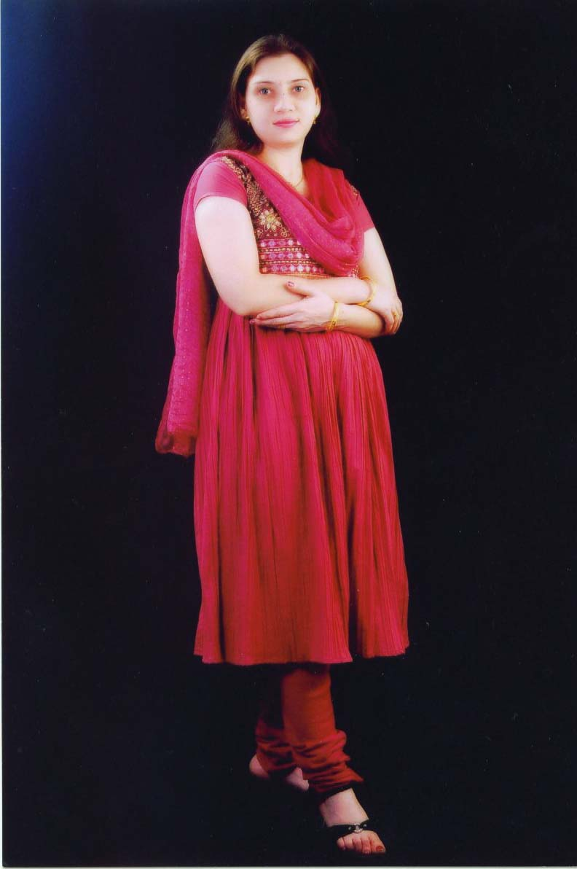
Birth Date : 24 April 1979.

Birth Place : Thane

Birth Time : 5 : 35 AM.

Height : 5.1 ft.

Caste : Hindu Maratha

Rash : Meen.

Nakshatra : U.Bhadrapad

Nadi : Madhya.
Blood Gr. : O+

Gana : Manushya.

Yoni : Go

Jatak : Sarpa

Complesion : Very Fair.

Sisters : 2 ( Married )

Brother : 1 ( Married )

Education : B.Com
Other Qualification : Computer Course.

Service : Working in a M/s Virdev Intermediates Pvt.Ltd. Mumbai as Sr.Accounts Executive .

Relatives : Malusare,Surve,Sapdhar,Utekar,Sawant,Bhoir
. Gambhir,Jadhav,More,Munde,Yadav,Kadam,
Tel no. : Mr.Ramakant Mahabale -09029556091 . Mrs.Anagha Munde - 9821536869

