
临沂大学2026-2027学年第二学期
《有机化学II ZW》试题（A卷）
(适用于2026级动物科学（中外）专业本科学生 闭卷考试 时间120分钟)
题号 | I | II | III | IV | V | VI | 总分 | 合分人 | 复核人
得分

score |  | Ⅰ. Choose one correct answer (Total 8 questions, 2 point per question, Total 16 points)
examiner
1. What is the size of format A4??
A. | 297×420 mm | D. | 210×297 mm
B. | 594×841 mm | E. | 841×1189 mm
C. | 210×148 mm | F. | 420×594 mm
2. Who invented the Cartesian coordinate system??
A. | Alfred Einstein | C. | Leonardo Da Vinci
B. | Rene Descartes | D. | Isaac Newton
3. What type of line is used to represent invisible lines?
A. | Solid lines | C. | Thin lines
B. | Dash-dotted lines | D. | Dashed lines
4. To create a 3D assembly in Kompas 3D, what new document should be created?
A. | 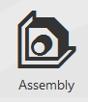 | D. | 
B. |  | E. | 
C. | 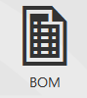
5. What operation in Kompas 3D can be used to create a models that rotates around the axis?
A. |  | C.
B. |  | D.
6. What function in SketchUp can be used to scale objects?
A. | Eraser | D. | Scale
B. | Offset | E. | Paint bucket
C. | Pan
7. Which function in Solidworks can be used to construct a curve line??
A. | Poligon | D.
B. |  | E.
C.
8. Which function in Solidworks can be used to examine the created model on external force?
A. | 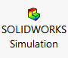
B. | 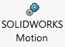
C. | 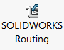
D. | 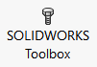

1 | 2 | 3 | 4 | 5 | 6 | 7 | 8

score |  | II.Match letters and numbers of two columns (Total 4 questions, 1 points per blank, Total 19 points)
examiner
1. Match the icon and the name of the function in SketchUp:
A. | 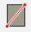 | 1. | rectangle
B. |  | 2. | polygon
C. |  | 3. | arc
D. |  | 4. | rotate
E. |  | 5. | push/pull
F. |  | 6. | zoom

A | B | C | D | E | F

2. Match the icon and the name of the function in Kompas 3D:
A. |  | 1. | Scale
B. |  | 2. | Rectangle
C. |  | 3. | Fillet
D. |  | 4. | Revolution Element
E. |  | 5. | Cut by Extrusion
F. |  | 6. | Dimension

A | B | C | D | E. | F.

3.Put into correspondence the line types to their names:
A. |  | 1. | Dash-dotted line
B. |  | 2. | Solid line
C. | 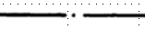 | 3. | Dash line

A | B | C

4. Point the correspondence between the icon and the name of the function in Solidworks:
A. |  | 1. | Offset
B. |  | 2. | Dimension
C. |  | 3. | Trim
D. |  | 4. | Spline

A | B | C | D

score |  | III. Write into the box the name of the geometric projections (Total 3 questions, 3 points per question, Total 9 points)
examiner

1. Oyz
- Oxy
- Oxz

score |  | Ⅳ. Draw axial lines for the following types of axonometric types projections and show angles between axial lines (Total 2 questions, 6 points per question, Total 12 points)
examiner

1. Frontal dimetric
2. Rectangular isometry

score |  | V. Draw horizontal projection of next geometric bodies and wright down their names (Total 4 questions, 6 points per question, Total 24 points)
examiner

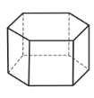
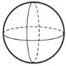
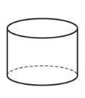
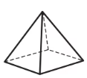
score |  | VI. Draw a rectangular isometry of the cone with height 70 mm and base 50 mm  in diameter. (Total 1 questions, 20 points per question, Total 20 points)
examiner

