
临沂大学2026-2027学年第二学期
《有机化学II ZW》试题（B卷）
(适用于2026级动物科学（中外）专业本科学生 闭卷考试 时间120分钟)
题号 | I | II | III | IV | V | VI | 总分 | 合分人 | 复核人
得分

score |  | Ⅰ. Choose one correct answer (Total 8 questions, 2 point per question, Total 16 points)
examiner

1. What type of line is used to represent axial lines?
A. | Solid lines | C. | Thin lines
B. | Dashed lines | D. | Dash-dotted lines
2. What format has the size A3 mm??
A. | 149x210 | D. | 841x1189
B. | 420x594 | E. | 297x420
C. | 210x297 | F. | 594x841
3. What abbreviation is used for Chinese standards in drawing?
A. | ISO | C. | GOST
B. | DIN | D. | GB
4. What operation in Kompas 3D can be used to create a prism?
A. |  | C.
B. |  | D.
5. To create a 3D drawing in Kompas 3D, what new document should be created?
A. |  | D. | 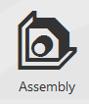
B. |  | E. | 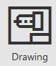
C. | 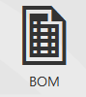
6. What function in SketchUp can be used to measure distances?
A. | 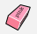Eraser | D. | Scale
B. | Paint bucket | E. | Pan
C. | Tape measure tool
7. Which function in Solidworks can be used to construct a pentagon??
A. |  | D.
B. | Poligon | E.
C.
8. Which document in Solidworks can be used to create a 3D model?
A. | 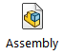
B.
C. | 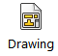
D. | 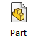

1 | 2 | 3 | 4 | 5 | 6 | 7 | 8

score |  | II.Match letters and numbers of two columns (Total 4 questions, 1 points per blank, Total 19 points)
examiner

1. Place the Solidworks function icon according to its name:
A. |  | 1. | Trim
B. |  | 2. | Extruded Cut
C. |  | 3. | Ellipse
D. |  | 4. | Revolved Boss/Base
E. |  | 5. | Fillet
F. |  | 6. | Dimension

A | B | C | D | E | F

2. Place the Kompas 3D function icon according to its name:
A. |  | 1. | chamfer
B. |  | 2. | rectangle
C. |  | 3. | line
D. |  | 4. | trim
E. |  | 5. | arc
F. |  | 6. | dimension

A | B | C | D | E. | F.

3.Put into correspondence figures and their names:
A. | 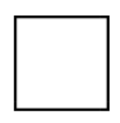 | 1. | Hexagon
B. | 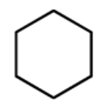 | 2. | Square
C. | 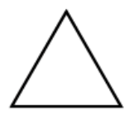 | 3. | Triangle

A | B | C

4. Place the SketchUp function icon according to its name:
A. |  | 1. | Polygon
B. | 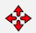 | 2. | Tape Measure Tool
C. |  | 3. | Move
D. |  | 4. | Push/Pull

A | B | C | D

score |  | III. Draws into the box types of lines (Total 3 questions, 3 points per question, Total 9 points)
examiner

1. Dash-dotted line
- Solid line
- Dash line

score |  | Ⅳ. Draw axial lines for the following types of axonometric types projections (Total 2 questions, 6 points per question, Total 12 points)
examiner
1. Rectangular isometry

2. Rectangular dimetric

score |  | V. Draw frontal projections of next geometric bodies and wright down their names (Total 4 questions, 6 points per question, Total 24 points)
examiner

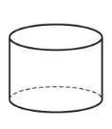
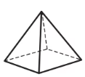
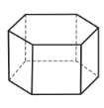
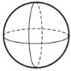
score |  | VI. Draw an orthogonal dimetry the hexagon prism with height 70 mm and base hexagon inside circle of 50 mm in diameter. (Total 1 questions, 20 points per question, Total 20 points)
examiner

