**Words and Images** Day 1

***Before the first day of our summer class session, As a way of introducing yourself to your classmates,* please take some time to write several short biographical “notes.”** Know that I will ask you to share. These might all be variations on the first, longest intro that you write, but they don’t have to be. You might find the different forms suited to representing different aspects of your personal and/or professional life.Imagine the first bio note as something that might appear on the ‘about’ page of a website. It can be serious or playful. If there’s anything you really want us to know about you as we get ready to spend six weeks together, find a way to smuggle it in.

***Everyone should produce:***

**☐** A bio that is **one long-ish paragraph (250-500 words).**

**☐** A bio that is only **one sentence (no more than 50 words)**.

**☐** A bio that includes **exactly 5 words**.

**☐** A bio that consists of **only punctuation marks.**

* This can include emoticons, but it doesn’t have to. Use as many marks as you want.

**☐** A bio that consists of **exactly four Emoji.**

* Either use your phone or ask me to borrow a printed copy of the Emoji dictionary.

**☐** A bio that consists of **as many Emoji as you want.**

***Here are two sample ‘4-Emoji Bios’***

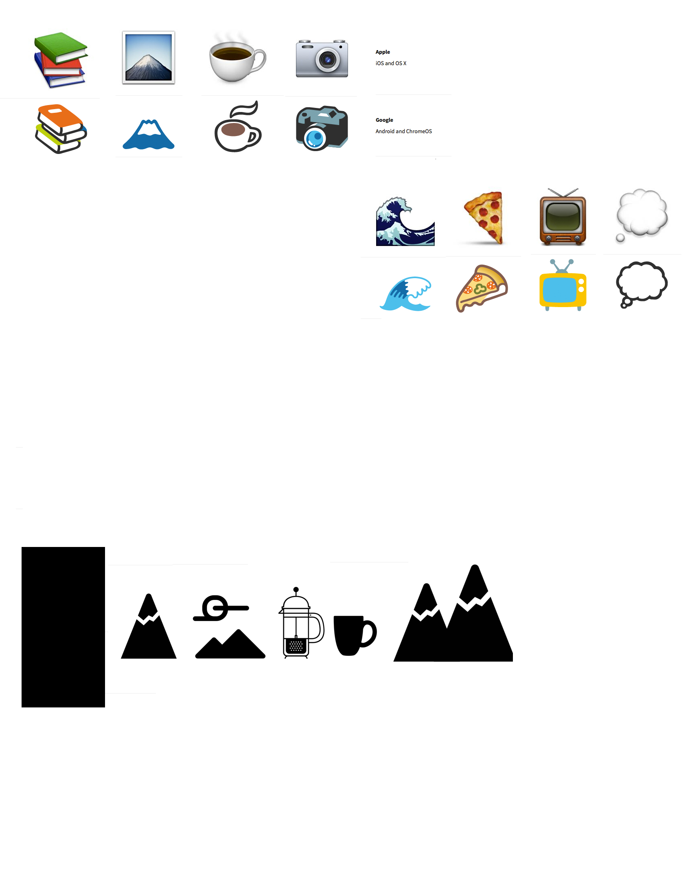*--- both Apple and Google versions are shown for each:*

**Week One**

**On Expectations, Punctuation, and Figurative Marks**

**Some Resources for this week:**

The Noun Project

[*https://thenounproject.com*](https://thenounproject.com)

Wikipedia on Eastern, Western, and 2channel Emoticons

[*http://en.wikipedia.org/wiki/List_of_emoticons*](http://en.wikipedia.org/wiki/List_of_emoticons)

Unicode Emoticon Chart and *Getemoji.com*

[*http://www.unicode.org/charts/PDF/U1F600.pdf*](http://www.unicode.org/charts/PDF/U1F600.pdf)

ZCodyLee’s Instagram (for circles, captions)

[*https://instagram.com/zcodylee/*](https://instagram.com/zcodylee/)

The New Post-literate: A Gallery Of Asemic Writing

[*http://thenewpostliterate.blogspot.com*](http://thenewpostliterate.blogspot.com)

Info on Making Ecritures

[*https://secretbookpublishing.wordpress.com*](https://secretbookpublishing.wordpress.com)

Semiotics for Beginners (Dan Chandler)

[*http://visual-memory.co.uk/daniel/Documents/S4B/sem01.html*](http://visual-memory.co.uk/daniel/Documents/S4B/sem01.html)

Monday June 22 – Introductions by way of various symbols and experiments

**Read in class –** “A Visual Remix” by Teju Cole in *The New York Times* (April 16, 2015)

**Work on –** Micro-auto-biographies

*Homework due Wed:*

**Read –** Intro to *The Cultural Logic of Punctuation* by Jeff Scheible (pgs. 1-21)

**Read –** Intro to *Symbol* (pgs. 6-11). Flip through the book before class and bring it with you.

**Take –** Three pictures of/resembling circles. **And share them via Box before Wed. class**

Give each photo a title. Save your files with this titling convention:

*FirstInitialLastName-Title.ext* (e.g.kbanazek-title.jpg) before uploading.

**Revise and organize on one page –** Your in-class autobiography experiments.

Wednesday June 24 – Create Your Own Logo/Letterhead for Semester Use

**Examine in class –** Collections of professional symbols and asemic writing

**Conduct –** Affect transmission experiments

**Workshop –** Basic technical design skills

**[ First Set of Pages :: Autobiographies, Logo/Letterhead,**

**Asemic texts/recorded reactions, and 500 word Reflection ]**

**Due for grading by end-of-day Saturday, June 27 (via private Box folder)**

**Words and Images** K. Banazek

Summer 2015

*Pages for Week One*

*Due End-of-Day on Saturday June 27*

*\* Please create a Box folder, title it using this convention: “K-Banazek-WAI-private” then share it with me. Each week, put one .pdf in it – include your first initial, last name, and the week number in the file title (e.g.* kbanazek-week-1.pdf*).*

These weekly assignments are meant to encourage you to expand and reflect on the week’s in-class composition experiments and our homework. Three pages (neatly designed) is all that’s necessary. Longer is okay, but focus on quality rather than quantity. **Proofread texts made of words. Edit images (if only lightly) so their colors are decent, graphics are clear. Make sure your spacing and font make sense.**

***This week, your pages should include:***

**☐ Several short biographical “notes.”** I encourage you to include at least one made of words, one made with only punctuation (including, perhaps, emoticons), one made of emoji (perhaps with cross-platform versions provided), and one made with specialty icons from *The Noun Project.*

**☐ A draft of your personal logo or letterhead design (either created electronically or drawn very neatly and scanned/photographed).**

**☐ A short piece of asemic writing (scanned or photographed).**

***Every week, your pages should include:***

**☐ A brief written reflection on the week’s work. Where did it take you? What did it make you think of? What kinds of questions did it prepare you to ask about future encounters?** You’ll be asked for a segment like this each week. These written segments shouldn’t just repeat things we all said in class---rather they should add to discussions. Include things you thought of after class, didn’t get a chance to say, or were thinking in response to homework tasks or supplemental resources that we didn’t get to in our time together**. About 500 words is appropriate here.** You might write this all in one block at the end, but you might also intersperse paragraphs with your various images and experiments.

This week, you *might* write about:

what makes an image or symbol “meaningful;”

how you know when you’re looking at a meaningful symbol;

past experiences with particular shapes, w**o**rds, **o**r images we used;

the idea of “affective transmission;”

found art; collection; self-presentation; emoji as phenomenon;

the relationship between language and punctuation;

decisions you made in creating your experiments;

how various experiments relate to each other;

how class-so-far relates to the expectations you had coming in;

***This week, your pages might also include:***

**☐ A curated collection of circles or other shapes** and a reflection on how this collection relates to the ideas of the class (or your understanding of “symbolic meaning making” more generally).

**☐ A set of new emoji or other icons designed by you** and descriptions of where/how they might be used in the world and/or how they differ from pre-existing symbols in terms of utility.