ktaucenters package: Robust and efficient Clustering

Juan Domingo Gonzalez, Victor Yohai, Ruben Zamar

2019-10-02

## Introduction

This package implements a kind of kmeans algorithm, it has two main advantages:

* The estimator is resistant to outliers, that means that results of estimator are still correct when there are atipycal values in the sample.
* The estimator is efficient, roughly speaking, if there are not outliers in the sample (all data is good), results will be similar than those obtain by a classic algorithm (kmeans)

Clustering procedure is carried out by minimizing the overall robust scale so-called tau scale (see Yohai and Zamar, 1988, [doi:10.1080/01621459.1988.10478611](https://www.tandfonline.com/doi/abs/10.1080/01621459.1988.10478611)).

## How to use the package ktaucenters

### Example 1: behavior when data are clean

rm(list=ls())  
library(ktaucenters)  
#> Loading required package: MASS  
#> Loading required package: dplyr  
#>   
#> Attaching package: 'dplyr'  
#> The following object is masked from 'package:MASS':  
#>   
#> select  
#> The following objects are masked from 'package:stats':  
#>   
#> filter, lag  
#> The following objects are masked from 'package:base':  
#>   
#> intersect, setdiff, setequal, union  
#> Loading required package: dbscan  
#> Loading required package: GSE  
#> Loading required package: Rcpp  
#> Loading required package: ggplot2

We generate synthetic data (three cluster well separated), and apply a classic algorithm (kmeans) and the robust ktaucenters. Results and code are shown below.

# Generate synthetic data (three cluster well separated)  
set.seed(1)  
Z <- rnorm(600);  
mues <- rep(c(-4, 0, 4), 200)  
X <- matrix(Z + mues, ncol=2)  
  
### Applying the ROBUST algortihm ####  
ktau_output <- ktaucenters(X, K=3,nstart=10)  
### Applying the classic algortihm ####  
kmeans_output <- kmeans(X,centers=3,nstart=10)  
  
### plotting the center results   
plot(X,main=" Efficiency")  
points(ktau_output$centers,pch=19,col=2,cex=2)  
points(kmeans_output$centers,pch=17,col=3,cex=2)  
legend(-6,6,pch=c(19,17),col=c(2,3),cex=1,legend=c("ktau centers" ,"kmeans centers"))

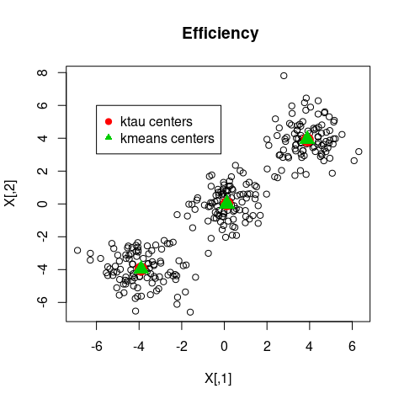

Clean data. Estimated centers by K-means and KTAU-centers algorithms.

Figure shows that there are no differeces between kmeans and ktaucenters in clean data.

### Example 2: behavior in the presence of outliers

We contaminate the previous data by replacing 60 observations to outliers located in a bounding box that contain the clean data. Then apply kmeans and ktaucenters algorithms.

# Generate 60 sintetic outliers (contamination level 20%)  
X[sample(1:300,60), ] <- matrix(runif( 40, 2* min(X), 2 * max(X) ),  
 ncol = 2, nrow = 60)  
  
### Applying the ROBUST algortihm ####  
ktau_output <- ktaucenters(X, K=3,nstart=10)  
### Applying the classic algortihm ####  
kmeans_output <- kmeans(X,centers=3,nstart=10)

### plotting the estimated centers   
plot(X,main=" Robustness ")  
points(ktau_output$centers,pch=19,col=2,cex=2)  
points(kmeans_output$centers,pch=17,col=3,cex=2)  
legend(-10,10,pch=c(19,17),col=c(2,3),cex=1,legend=c("ktau centers" ,"kmeans centers"))

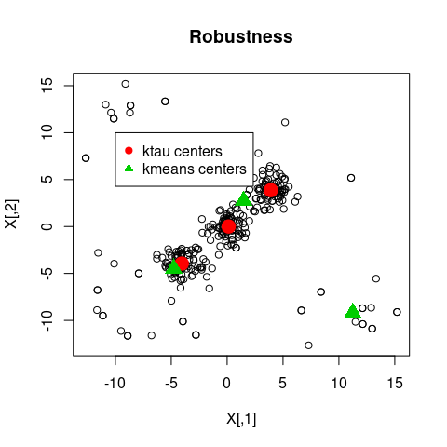

Contaminated data. Estimated centers by K-means and KTAU-centers algorithms.

As it can be observed in Figure kmeans center were very influenced by outliers, while ktaucenters results are still razonable.

### Example 3: Showing clusters and outliers detection procedure

Continuation from Example 2, for outliers recognition purposes we can see the ktau_output$outliers that indicates the indices that may considered as outliers, on the other hand the labels of each cluster found by the algorithm are coded with integers between 1 and K (in this case K=3), the variable ktau_output$clusters contains that information.

plot(X,main=" Estimated clusters and outliers detection ")  
## plottig clusters   
for (j in 1:3){  
 points(X[ktau_output$cluster==j, ], col=j+1)  
}  
  
## plottig outliers   
points(X[ktau_output$outliers, ], pch=19, col=1, cex=1)  
legend(7,15,pch=c(1,1,1,19),col=c(2,3,4,1),cex=1,  
 legend=c("cluster 1" ,"cluster 2","cluster 3","detected \n outliers"),bg = "gray")

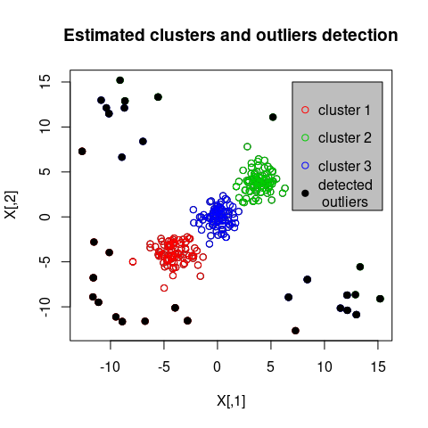

## improved ktaucenters

The algorithm ktaucenter work well under noisy data, but fails when clusters have different size shape and orientation, an algorithm suitable for this sort of data is improvektaucenters. To show how this algorithm works we use the data set so-called M5data from package tclust: tclust: Robust Trimmed Clustering, [tclust](https://cran.r-project.org/web/packages/tclust/index.html). M5 data were generated by three normal bivariate distributions with different scales, one of the components is very overlapped with another one. A 10% background noise is added uniformly

### usage

First we load the data, then, run the improvedktaucenters function.

## load non spherical datadata   
library("tclust")  
data("M5data")  
X=M5data[,1:2]  
true.clusters=M5data[,3]  
### done ######   
  
#run the function to estimate clusters  
improved_output=improvedktaucenters(X,K=3,cutoff=0.95)

We keep the results in the variable improved_output, that is a list that contains the fields outliers and cluster, among others. For example, we can have access to the cluster labeled as 2 by typing

X[improved_output$cluster==2, ].

If we want to know the values of outliers, type

X[improved_output$outliers, ].

By using these commands, it is easy to estimate the original clusters by means of improvedktaucenters routine.

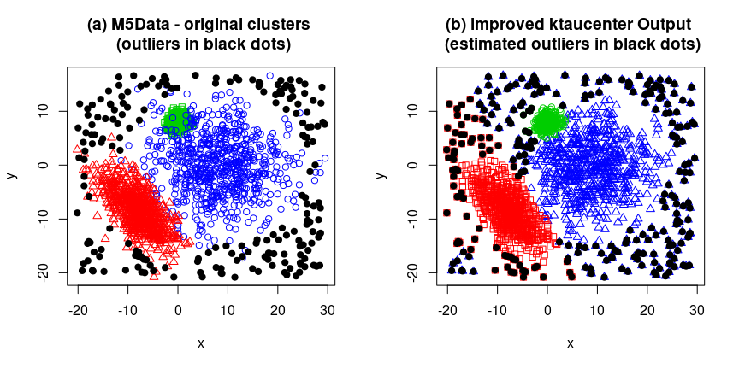

## Real data application: finding a screw in Mars

Package has a dataset called mars_screw, containing the Intensity and Saturation pixels values of a picture from Mars taken from Rover Curiosity.

Data set can be loaded by typing mars_screw$SI_matrix, or mars_screw$geographic_matrix, thats variables means.

* SI_matrix: A matrix with 5063 rows and 128 columns. Elements 1 to 64 of each row indicate the Saturation values of pixels in a square cell 8 x 8 whereas elements 65 to 128 of each row indicate the cell’s Intensity values.
* geographic_matrix: An integer matrix of dimension 5063 x 2, each row indicates each square cell’s locations (x-axis y-axis) at the picture.
* screw_index: the index corresponding to the screw observation (screw_index=4180)

In order to look the screw, in a first stage we do clustering on the matrix A, to separate differents materials presented in the picture

A <- mars_screw$SI_matrix;  
B <- mars_screw$geographic_matrix  
screw_index <-mars_screw$screw_index  
##   
ret1=ktaucenters(X=A,K=3);  
##

To find the screw candidate, we do a clustering procedure on geographic_matrix, for each cluster determined at the previous step. Outliers will be those that are the furthest observations regarding to the gruops they were assigned. The procedure to find them is shown below.

screw_candidate_index=c()  
for (j in 1:3){  
 dj=ktaucenters(B[ret1$cluster==j, ],K=5,nstart=1,startWithROBINPD = FALSE)$di;   
 jcandidate=dj==max(dj);  
 jcandidate=which(ret1$cluster==j)[dj==max(dj)]  
 screw_candidate_index=c(screw_candidate_index,jcandidate)  
}

Figure , shows locations of three candidates to be the screw.

plot(B, type="n" )  
for (j in 1:3){  
# col1=which(orderInd==j)  
 col1=j  
 points(B[ret1$cluster==j,],col=col1+1,pch=19)  
}  
points(B[screw_candidate_index,1],B[screw_candidate_index,2],col=6,pch=1,cex=3,lwd=3)

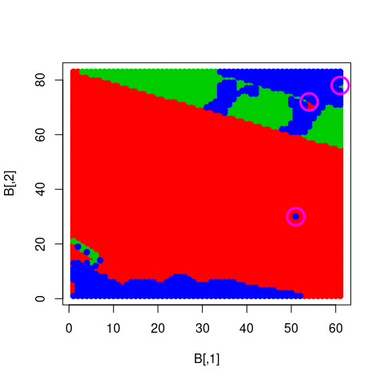

Plot of Geographic sub matrices, pink circles are the outliers candidates in the geographic matix space.

## From package-data mars_screw to image

It is possible to see the image from package-data and screw location by running the following code. To see screw location we use the mars_screw$screw_index information.

####### Reconstruction image from package-data #####   
d=8;  
intensityvar=matrix(0,max(B[,1]+1)*d,max(B[,2])*d)  
svar=matrix(0,max(B[,1]+1)*d,max(B[,2])*d)  
  
for (l in 1:dim(A)[1]){  
 i=mars_screw$geographic_matrix[l,1]  
 j=mars_screw$geographic_matrix[l,2]  
 posi=(i-1)*d;  
 posj=(j-1)*d;  
 intensityvar[posi+(1:d), posj +(1:d)]= mars_screw$SI_matrix[l,(d^2+1):(2*d^2)]  
 svar[posi+(1:d), posj +(1:d)]= mars_screw$SI_matrix[l,1:(d^2)]  
 #A[l,]=c(auxs[,],auxi[,])  
 #B[l,]=c(i,j)  
}  
svar[svar<0]=0

The following transformation from indices ij locations in B matrix to xy coordinates at the picture is useful to plot the screw location at the image.

nrowIm=495 #dim(myjpg)[1] #(nrowIm pixeles equivale a 1 en mi sist. de coordenadas)  
ncolIm=664 #dim(myjpg)[2] #(ncolIm pixeles equivale a 1 en mi sist. de coordenadas)  
index2ejx=function(indexj){(1/(ncolIm-1))*(indexj-1) +1 }  
index2ejy=function(indexi){((2-1)/(1-nrowIm))*(indexi-nrowIm) +1 }  
mapIndex2coord=function(filaij){ c(index2ejx(filaij[2]),index2ejy(filaij[1]))}  
#transforming pixel position ij to equivalent xy values at the image   
xyscrew=mapIndex2coord(d*mars_screw$geographic_matrix[screw_index, ])

We plot the variables intensity and saturation as a raster Image trhough the rasterImage function from graphics package, (a pixel with high/low  
saturation value is drawn in white/black respectively)  
The location of screw is show in pink circle. To transform the ij data from matrix B to its equivalent xy mapIndex2coord was used.

plot(1:2, type="n",yaxs="i",xaxs="i",main="Intensity variable")  
rasterImage(intensityvar, 1, 1, 2, 2)  
points(xyscrew[1],xyscrew[2],col=6,pch=1,cex=6,lwd=3)  
  
plot(1:2, type="n",yaxs="i",xaxs="i",main="saturation variable")  
rasterImage(svar, 1, 1, 2, 2)  
points(xyscrew[1],xyscrew[2],col=6,pch=1,cex=6,lwd=3)

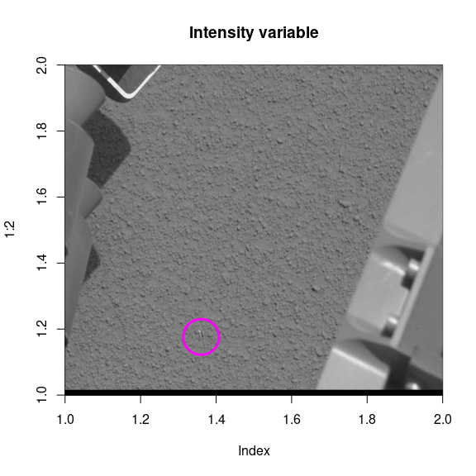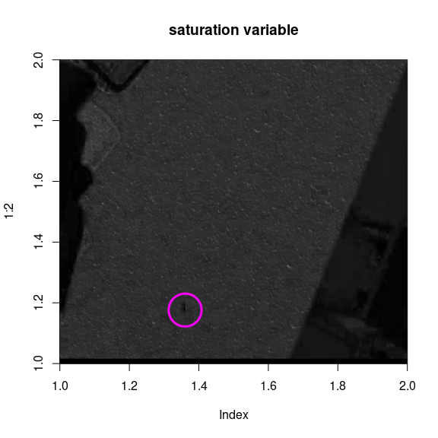

## From image to mars_screw matrix data

First of all, to see the original Image, and its RGB (Red, Gren, Blue) chanels use

### Rebuilding data from image   
library("jpeg")  
imageFile="screw2.jpeg"  
par(mfrow=c(2,2))  
myjpg=readJPEG(imageFile)  
plot(1:2, type="n",yaxs="i",xaxs="i",main="original picture")  
rasterImage(myjpg, 1, 1, 2, 2)  
  
plot(1:2, type="n",yaxs="i",xaxs="i",main="Red Component")  
myjpgR=myjpg;   
myjpgR[,,2]=myjpgR[,,3]=0  
rasterImage(myjpgR, 1, 1, 2, 2)  
  
plot(1:2, type="n",yaxs="i",xaxs="i",main="Green Component")  
myjpgG=myjpg;   
myjpgG[,,1]=myjpgG[,,3]=0  
rasterImage(myjpgG, 1, 1, 2, 2)  
  
plot(1:2, type="n",yaxs="i",xaxs="i",main="Blue Component")  
myjpgB=myjpg;   
myjpgB[,,1]=myjpgB[,,2]=0  
rasterImage(myjpgB, 1, 1, 2, 2)

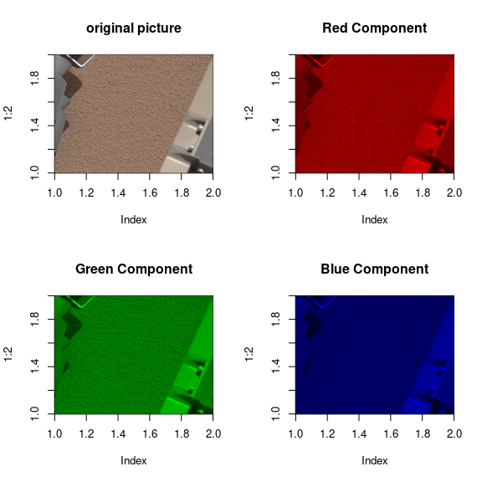

The images corresponding to the three chanels are quite similar, that is consequence of that the RGB pixels values are highly correlated. On the other hand, if we want to rebuild the data-set from the original picture, the following code can be used.

# To reconstruct the data from source image.   
XXX=cbind(myjpg[,,1],myjpg[,,2],myjpg[,,3])  
# define functions Intensity and saturation   
Icolor=function(COLOR){((COLOR[1]+COLOR[2]+COLOR[3]))/3}  
Scolor=function(COLOR){  
 Iaux=Icolor(COLOR)  
 ret=0  
 if(!(Iaux==0)){ret=1 - min(COLOR[1],COLOR[2],COLOR[3])/Iaux}  
 if(Iaux==0){ret=0}  
 ret  
}  
  
I=apply(XXX,1,Icolor)  
S=apply(XXX,1,Scolor)  
  
myjpgHSI=myjpg  
myjpgHSI[,,2]=S  
myjpgHSI[,,3]=I  
scomp=myjpgHSI[,,2];  
icomp=myjpgHSI[,,3];  
d=8  
p=d^2  
nrowIm=dim(myjpg)[1] #(nrowIm pixeles equivale a 1 en mi sist. de coordenadas)  
ncolIm=dim(myjpg)[2] #(ncolIm pixeles equivale a 1 en mi sist. de coordenadas)  
NporM=ncolIm*nrowIm  
  
# transforming each d-square cell into an array of size 2*dxd  
A=matrix(0,ncol=2*p,nrow=NporM/p)  
B=matrix(0,ncol=2,nrow=NporM/p)  
l=1;  
for (i in 1:(nrowIm/d)){  
 for (j in 1:(ncolIm/d)){  
 posi=(i-1)*d;  
 posj=(j-1)*d;  
 auxs=scomp[posi+(1:d), posj +(1:d)];  
 auxi=icomp[posi+(1:d), posj +(1:d)];  
 A[l,]=c(auxs[,],auxi[,])  
 B[l,]=c(i,j)  
 l=l+1;  
 }  
}  
  
A=A[1:(l-1),]

This is a check whether A and mars_screw$SI_matrix are equal

mean(abs(A-mars_screw$SI_matrix))==0  
#> [1] FALSE