Linked List

It is a set of nodes which connect linearly in the form of a chain.

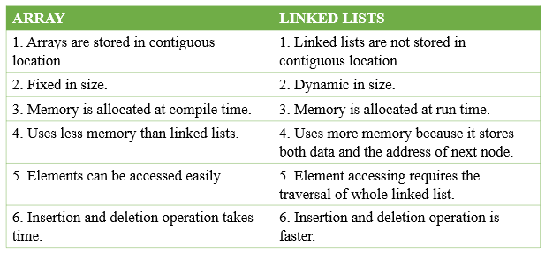

The head will contain the pointer to the first node, hence the type is pointer, all other nodes will be datatype node(which is a custom datatype, i.e. we create it).

Basic operations we can perform on Linked List will be:

1. Insertion (head, tail, middle)
2. Searching (Iteratively, recursively)
3. Deletion (head, middle, tail)
4. Creating a Linked List
5. Deleting a Linked List
6. Printing a Linked List

<https://www.geeksforgeeks.org/linked-list-vs-array/>