Web Development II (ITAS256)

Assignment 3 – django Application

Date assigned: April 1, 2025
Date due: April 21, 2025

Learning Objectives

Upon successful completion of this assignment, the student will be able to:
- Create a web application using django;
- Access data using django

To do:
General idea of the assignment:
You are going to create a registration system to allow people to register for events. There will be two types of users: an administrator and a registrant. The administrator can perform the following tasks: create an event, remove and event, produce a report on system users, produce a report for registrants for an event, produce a report of all registrants for all events. A registrant can perform the following tasks: create an account, register for an event, unregister (cancel) registration for an event, see a report of all events they are registered for.
Tech Stack:
You have some choice in your tech stack. The only constant is that you must use django.
You can either use the full django stack with apps and templates or use the django Rest Framework with a different front end. I would suggest React in this case; however, you can choose Angular or VUE or Raw JavaScript if you like. If you use the ReST framework, you must ensure that the business logic is done at the server.
For authentication you can use either the django username and password, or use OAuth. Remember for OAuth you must still provide access via username and password.
For your database you can start with the basic SQLite database that comes with django; however, you must use MySQL on Digital Ocean as your server at the end. You can develop on SQLite and then move to MySQL once you set up the basic functionality or develop directly on MySQL…it’s up to you.
You must use a virtual environment and provide a requirements.txt file which lists the libraries that will need to be installed. Do NOT load your virtual environment to git…use your .gitignore to make sure you are not doing so.
Details:
Functional Details are as follows. Each of these functional areas can (should) be used as separate applications within your django project, but you are free to split up the project into whatever applications you think are best.
- Accounts –
  - Create – Registrant role can add an account as a new user.
Users enter a username, password (twice), last name and first name.
Username should be an email address (if it is it must be validated as such).
Password must have at least one upper and one lower case letter and one number. Passwords must be at least 6 characters long.
If using OAuth the above is still necessary.
  - Note, Administrator CANNOT register for a new account.
  - Login – Both roles can login to the web application.
  - Logout – Both roles can logout of the system.
  - Both user authenticated and user role must be checked before a page is displayed in the completed application.
If user not authenticated, return to login page.
If user is authenticated but not allowed to see the page, display and error message and return to home page (or, better, display an error message on the home page as you return the user there).

- Events –
  - Create, Update and Delete – Administrator can create, update and delete an event. If the administrator deletes an event, the delete must cascade (that is, delete all the users registered for the event).
  - Register – Registrant role can register for an event.
  - Unregister – Registrant role can unregister for an event.
  - Search – Registrant can see a list of possible events to register for. Note, this search must include all events and indicate which ones the registrant is already registered in.

- Reports – NOTE – this does NOT have to be a separate screen and can be part of the Events screen(s). It can, however, be a separate app within your django project.
  - List of users – Administrator can view of list of current users of the system, their full names and their roles.
  - List of events – Both Roles can view a list of all the events in the system that have NOT already started. Optional, provide a filter to filter on date range.
  - List of All events – Administrator can view a list of all events past, present and upcoming.
  - List of events registered – Registrant can view a list of the events they are registered at.
  - List of events and registrants – Administrator can view a list of events and the registrants at the event.
There is a filter here for the administrator to view all current events (start date <= today and end date >= today), all past events or all upcoming events. Optionally, allow the administrator to specify the date range for events only in that range.
Potential Data Model:
You have some choice in your data model. Below is a list of what information needs to be contained for the functionality and a possible data model. As long as the information is there you can change the data model but do so at your own peril. ALL TABLES MUST HAVE AN ID FIELD as the primary key.
- Users – same as django users table – username, password, first name, last name, email and group.
- Groups – same as the django group table.
- Events – Event name, event description, start date, end date.
- Registrations – A many-to-many relationship table of the primary key in the Users table and the primary key in the Events table. (Will not need to be explicitly created as the ORM will take care of it).

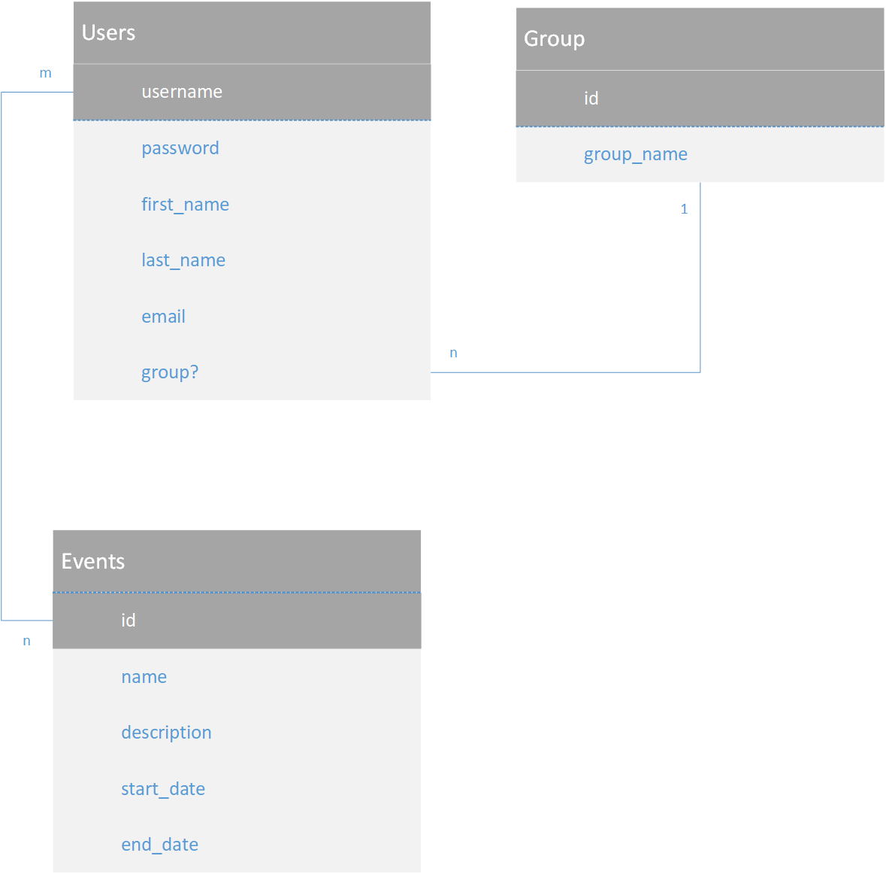

To submit
Create a githib repo with the name <<username>>-256A03 and share it with me. There is nothing to hand in to the portal for the assignment.

