Allison Neyer

Algorithms Homework #4

4.2a)

<http://cseweb.ucsd.edu/~dasgupta/101/sol7.pdf>

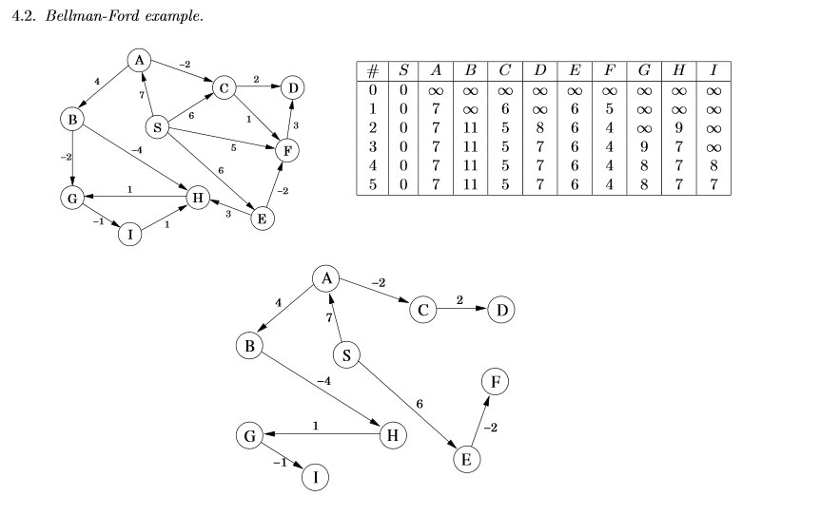

4,8)

http://cseweb.ucsd.edu/~dasgupta/101/sol7.pdf

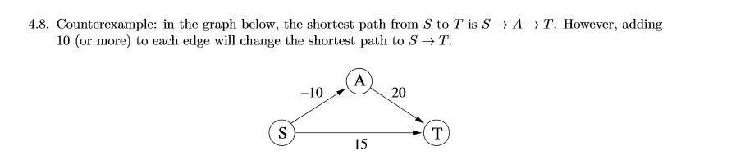

4.17a)

<http://www.ece.northwestern.edu/~dda902/336/hw5-sol.pdf>

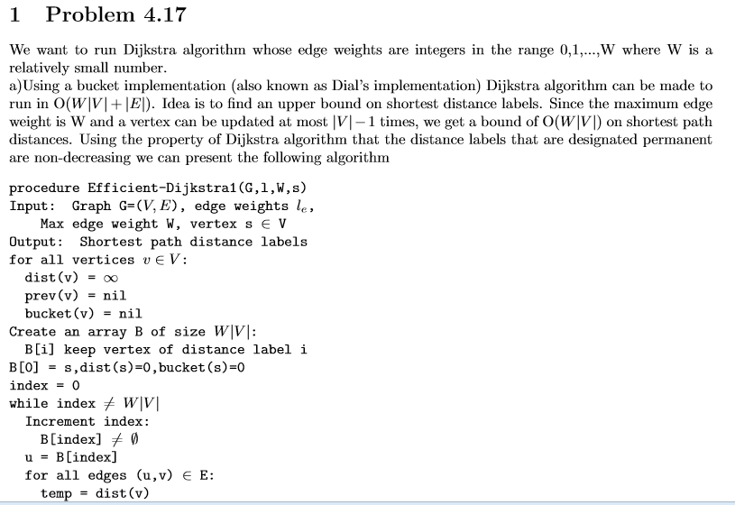

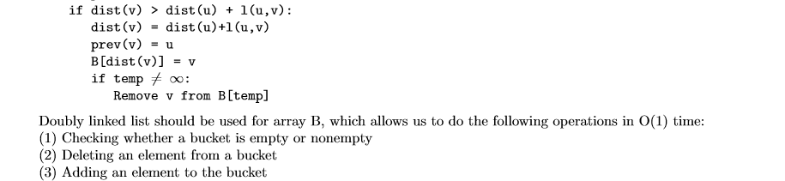

5.2a)

<http://www.eecs.ucf.edu/~wocjan/Teaching/COT5405-Spring2011/> (homework 3 solutions link):

tinyurl.com/qa75gvn has the following solution for problem 5.2a)

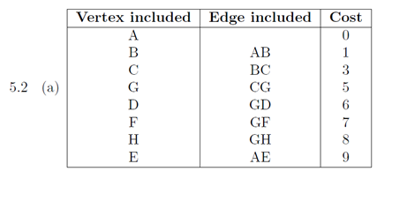

In 5.2 (a), the last number should be 12 and not 9.

5.2b)

Steps: list edges by increasing order of weight. Then add them unless they make a cycle.

total edges: A-B(1); G-D(1); G-H(1); F-G(1); B-C(2);C-G(2);C-D(3);D-H(4);A-E(4);E-F(5);B-G(6);B-F(6);A-F(8)

Included edges: A-B(1); G-D(1); G-H(1); F-G(1); B-C(2);C-G(2); A-E(4);

Edges that were NOT included because they made a cycle: C-D(3) [cycle]; D-H(4) [cycle]; E-F(5) [cycle];B-G(6) [cycle];B-F(6) [cycle];A-F(8) [cycle].

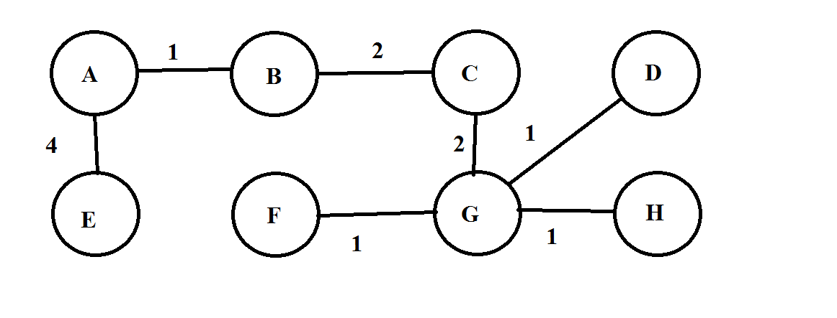

min spanning tree length: 12 = 4+1+2+2+1+1+1

how do you compress and know where to make the directed arrows to??

5) dynamic programming to determine whether a numeric list has a subset of elements that sums to a given value:

see subsetSum.c for dynamic programming solution.

<http://www.geeksforgeeks.org/dynamic-programming-subset-sum-problem/>

6) backtracking solver for the Kirkman Schoolgirl Problem:

<http://www.delphiforfun.org/programs/Kirkman_Tabu.htm> (Not only does it have the solution but it’s a good resource for explaining the problem too)

See the “executable files” subfolder in the “KirkmanLittleSchoolGirlProblem” Folder and the “source files” subfolder for the program in Pascal.