CAPACITY ACTUATION
DELAY REPORT
ANFA Research Project - Step 6
Measured Kubernetes readiness and first-service delay

Local kind / Docker Desktop campaign
Completed 4 August 2026

Executive result
Step 6 measured how long a scaling instruction takes to become usable serving capacity. Thirty cached-image trials covered scale-ups from one Pod to two, three, and four Pods. Ten additional registry-repull trials quantified image availability effects. All retained main trials were valid.
Decision | Final local result | Reason
Forecast horizon | 9 seconds | ceil(6.514 s P95 effective service + 2 s minimum margin)
Operational metric | Effective first service | Covers readiness plus actual Service use by every requested new Pod
Image treatment | Pre-pull and verify | Registry repull increased +1-Pod P95 service by 1.305 s
Transfer rule | Remeasure on native K3s | The local laptop topology and bridge are development-specific

Final local decision: Use a 9-second forecast horizon for the local kind experiments. Replace this value with the native-K3s P95-plus-margin result before the main research campaign.

Contents
Section | Subject
1 | Purpose and relationship to earlier steps
2 | Frozen configuration
3 | Timestamp authority and delay definitions
4 | Experimental methodology
5 | Instrumentation validation
6 | Cached campaign results
7 | Replica-increment comparison
8 | Image cache comparison
9 | Forecast-horizon calculation
10 | Findings and interpretation
11 | Limitations
12 | Corrections and exclusions
13 | Reproducibility artifacts
14 | Completion assessment
15 | Appendix: distribution tables

1. Purpose and relationship to earlier steps
Step 4 created the deterministic benchmark application. Step 5 measured how much load each ready Pod count can safely serve. Step 6 answers the remaining timing question: how early must scaling begin so that the required Pods are actually ready and serving before forecast traffic arrives?
Connection: Step 5 determines how many Pods are needed; Step 6 determines how early those Pods must be requested.

2. Frozen configuration
Item | Frozen value
Cluster | kind-anfa-dev on Docker Desktop / WSL2; two experiment workers
Application | Go benchmark service v0.1.0
Image | anfa/benchmark-app@sha256:0fd880c...61cee
Work | 50,000 SHA-256 iterations; seed anfa-benchmark-v1
Resources | 500m CPU and 128Mi memory request=limit
Readiness probe | HTTP /readyz every 1 second
Service | NodePort 30080 through documented local bridge
Step 5 capacity | Cpod=45 RPS; C2=90; C3=105; C4=130 RPS
Manifest pull policy | IfNotPresent; image pre-pulled and verified before experiments

3. Timestamp authority and delay definitions
Timestamp | Event | Authority
t_forecast | Forecast becomes available | Harness UTC + monotonic clock
t_decision | Controller/harness selects replica target | Harness UTC + monotonic clock
t_scale_sent | Deployment scale request issued | Harness UTC + monotonic clock
t_scale_ack | Kubernetes API acknowledges update | Harness UTC + monotonic clock
t_created | Pod object created | metadata.creationTimestamp
t_scheduled | PodScheduled=True | Condition lastTransitionTime
t_started | Container running | containerStatuses.state.running.startedAt
t_ready | Pod Ready=True | Condition lastTransitionTime
t_app_ready | Application enables readiness | X-Benchmark-Ready-At
t_first_request | New Pod first serves /work | Client monotonic clock + X-Benchmark-Pod-UID

Kubernetes lifecycle fields have whole-second resolution. They are retained for authoritative ordering, while end-to-end creation, readiness, and serving delays use the harness monotonic first-observation clock. This prevents misleading negative differences when whole-second API fields and sub-second client timestamps occur in the same second.
Delay | Definition
Decision | t_decision - t_forecast
Deployment API | t_scale_ack - t_scale_sent
Creation | first observation of new Pod - t_scale_sent
Scheduling | t_scheduled - t_created
Startup | t_started - t_scheduled
Container-to-Ready | t_ready - t_started
Readiness actuation | Ready first observed - t_scale_sent
Effective serving | first /work response from new Pod - t_scale_sent
Increment completion | maximum delay among all requested new Pods

4. Experimental methodology
Each cached trial established exactly one Ready baseline Pod, waited for recovery, emitted forecast and decision markers, scaled to the selected target, polled Kubernetes state, and sent bounded fresh-connection /work probes until every new Pod was Ready and had served. The Deployment was then returned to one Pod.
Factor | Method
Replica increments | 1→2, 1→3, and 1→4
Repetitions | 10 valid trials per increment; 30 total
Ordering | Rotated 2/3/4, 3/4/2, 4/2/3 blocks
Polling | Nominal 100 ms; actual command and network overhead retained
Recovery | 15 seconds for the main repeated block
Timeout | 180 seconds
Completion | Last required new Pod Ready and then first observed serving
Evidence | Immutable trial directories with Pods, events, nodes, EndpointSlices, CSV and JSON

5. Instrumentation validation
Instrumentation pilots were deliberately excluded. They detected a stopped NodePort bridge, overlapping scale processes, HTTP connection reuse that pinned requests to one backend, and whole-second timestamp subtraction. The final runner uses a fail-fast bridge check, one isolated trial at a time, fresh bounded curl connections, Pod UID headers, and monotonic observation times.
Scientific treatment: No failed pilot was silently deleted. Invalid or superseded runs remain preserved and are disclosed separately from the 30 main trials.

6. Cached campaign results
Statistic | Overall effective serving delay
n | 30 trials
Minimum | 2.387 s
Median | 3.569 s
P90 | 5.219 s
P95 | 6.514 s
Maximum | 6.829 s

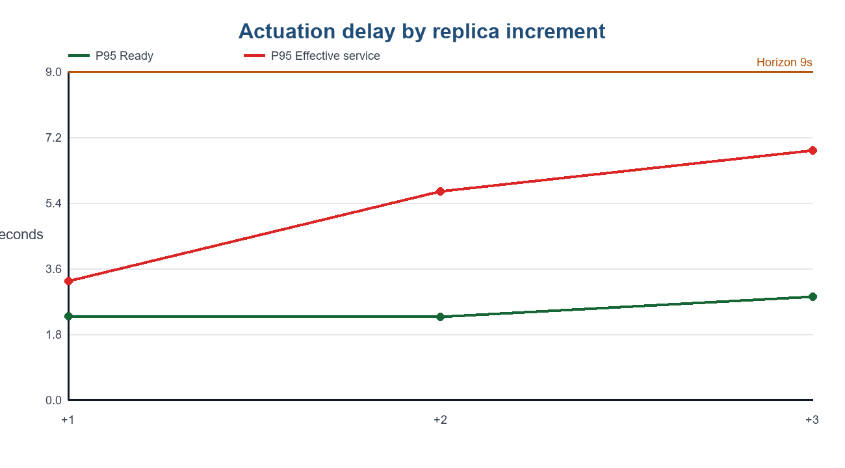

7. Replica-increment comparison
Scale | Metric | Median | P90 | P95 | Maximum
1→2 | Ready | 1.506 | 2.176 | 2.291 | 2.291
1→2 | Effective service | 2.755 | 3.242 | 3.248 | 3.248
1→3 | Ready | 1.868 | 2.257 | 2.270 | 2.270
1→3 | Effective service | 3.997 | 5.219 | 5.715 | 5.715
1→4 | Ready | 2.249 | 2.807 | 2.816 | 2.816
1→4 | Effective service | 4.274 | 6.514 | 6.829 | 6.829

Readiness varied little across increments, but effective service increased as more Pods were added because the completion rule required every new backend to be sampled. This is operationally useful: a controller needs requested capacity to participate in traffic, not merely to have a Ready condition.

8. Image cache comparison
All 60 new Pods in the cached campaign had matching “image already present” events and the expected image ID. A temporary local registry then supported a separate 0→1 treatment Deployment with the identical binary and runtime settings. Ten image-reference-absent registry-repull repetitions were retained; first-use rep00 was excluded.
Treatment | n | Median Ready | P95 Ready | Median service | P95 service
Pre-pulled +1 | 10 | 1.506 | 2.291 | 2.755 | 3.248
Registry repull +1 | 10 | 2.403 | 2.513 | 3.895 | 4.553

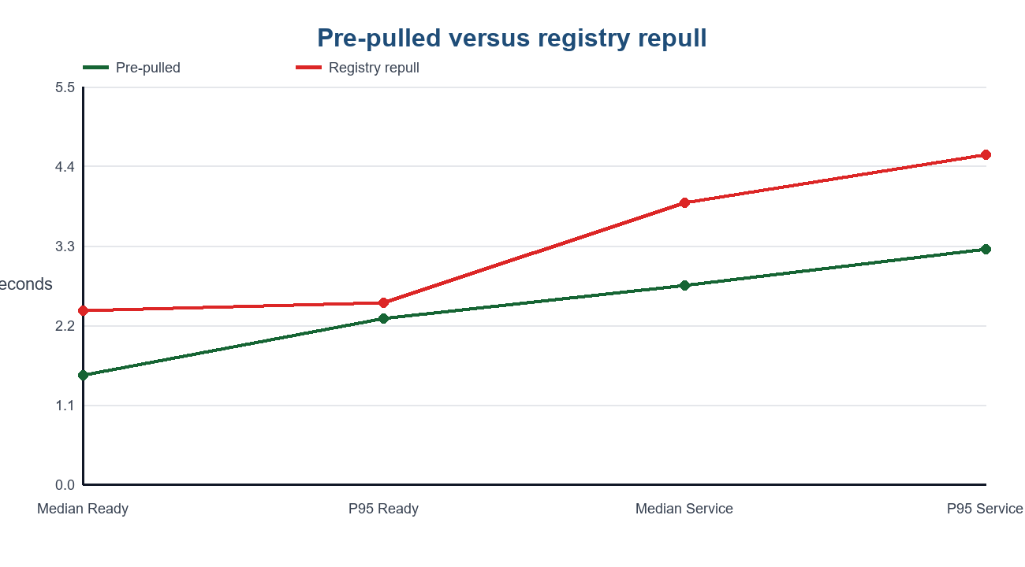
Registry-repull P95 effective service was 1.305 seconds slower. Pull duration median was 1.236 seconds and P95/maximum was 1.310 seconds. The excluded first-use pilot reached 7.344 seconds Ready and 8.772 seconds effective service because pulling began roughly six seconds after scheduling.
Image decision: Pre-pull and verify the immutable image on every experiment worker. Keep IfNotPresent until the native-K3s distribution method is validated; do not introduce registry delay into the main treatment.

9. Forecast-horizon calculation
The selected metric is trial-level effective serving delay, because it includes Kubernetes actuation plus observable Service participation by every requested new Pod. The predeclared rule is:
Formula: H = ceil(P95 effective serving delay + max(2 seconds, 20% of P95)).
Term | Value
P95 effective serving delay | 6.514 s
20% of P95 | 1.303 s
Minimum safety margin | 2.000 s
Selected margin | 2.000 s
Unrounded total | 8.514 s
Final local horizon | 9 seconds

The slowest-increment 1→4 P95 is 6.829 seconds. With ten observations, nearest-rank P95 equals that increment’s maximum; adding two seconds still rounds to the same 9-second horizon. Therefore the decision is robust to using either the pooled operational distribution or the slowest supported increment.

10. Principal findings
Finding | Interpretation
API acknowledgement is small | P95 scale API delay remained below 0.265 s.
Pods become Ready quickly | Cached P95 Ready was 2.29–2.82 s across increments.
Ready is not equivalent to serving | Last-backend sampling raised P95 service to 3.25–6.83 s.
Increment size matters | More new Pods require more backend observations and increase tail delay.
Image availability matters | Registry repull added 1.305 s to +1-Pod P95 service.
Nine seconds is conservative locally | It covers measured P95 plus the declared two-second margin.

11. Limitations
Limitation | Consequence
One physical laptop | All logical nodes share CPU, memory, cooling, WSL2, and Docker Desktop.
Local NodePort/socat bridge | First-service path differs from native K3s.
100 ms requested polling | kubectl and HTTP execution make first observation an upper bound.
Whole-second Kubernetes fields | Sub-second scheduler/startup components cannot be estimated precisely.
Harness decision marker | Not yet the real predictive controller’s computation delay.
Ten trials per increment | Nearest-rank per-increment P95 equals the maximum.
Registry repull treatment | May reuse containerd layer content; not a remote WAN cold pull.
Post-campaign cleanup | Containerd restarts occurred after measurement and do not affect retained windows.

12. Corrections and exclusions
Event | Classification | Treatment
Bridge stopped | Invalid pilot | Fail-fast preflight added; excluded
Overlapping runners | Invalid pilot | Serial campaign enforced; excluded
Persistent HTTP connection | Biased pilot method | Replaced with bounded fresh curl connections
Negative API-derived creation value | Resolution artifact | Monotonic first-observation used for totals
Registry rep00 | First-use pilot | Disclosed separately; excluded from ten-repetition distribution
Progress-array error | Automation bookkeeping | Two valid trial artifacts preserved; campaign resumed at rep03
Image cleanup/reload issue | Post-experiment operations | No retained measurement changed; frozen source policy restored

13. Reproducibility artifacts
Artifact | Purpose
STEP6.md | Protocol, timestamp model, rules, and decisions
step6/experiment-config.json | Machine-readable campaign configuration
scripts/run-step6-actuation.ps1 | Single cached scale-up collector
scripts/run-step6-campaign.ps1 | Rotated 30-trial campaign driver
scripts/run-step6-cold-trial.ps1 | Registry-repull treatment collector
tools/analyze_step6.py | Nearest-rank aggregation and horizon calculation
step6/runs/* | Immutable raw trial directories
step6/report/cached/* | Cached normalized datasets and distributions
step6/report/registry-repull/* | Repull normalized datasets and distributions
step6/report/step6-final-result.json | Final machine-readable decision

14. Completion assessment
Completion criterion | Status
Readiness delay measured, not assumed | COMPLETE
Lifecycle timestamps preserved | COMPLETE
Multiple increments repeated | COMPLETE - 10 each
Median/P90/P95/maximum reported | COMPLETE
First-service delay measured | COMPLETE
Image-cache behaviour evaluated | COMPLETE
Pre-pull decision documented | COMPLETE
Forecast horizon tied to evidence | COMPLETE - 9 s local
Native-K3s calibration | REQUIRED BEFORE MAIN CAMPAIGN

Appendix A. Detailed cached delay distributions
+Pods | Metric | n | Median | P90 | P95 | Max
1 | decision_delay_s | 10 | 0.000 | 0.002 | 0.003 | 0.003
1 | deployment_api_delay_s | 10 | 0.156 | 0.213 | 0.265 | 0.265
1 | trial_readiness_delay_s | 10 | 1.506 | 2.176 | 2.291 | 2.291
1 | trial_effective_serving_delay_s | 10 | 2.755 | 3.242 | 3.248 | 3.248
1 | per_pod_creation_delay_s | 10 | 0.355 | 0.456 | 0.510 | 0.510
1 | per_pod_scheduling_delay_s | 10 | 0.000 | 0.000 | 0.000 | 0.000
1 | per_pod_startup_delay_s | 10 | 1.000 | 1.000 | 1.000 | 1.000
1 | per_pod_container_to_ready_s | 10 | 0.000 | 0.000 | 0.000 | 0.000
2 | decision_delay_s | 10 | 0.000 | 0.001 | 0.003 | 0.003
2 | deployment_api_delay_s | 10 | 0.154 | 0.189 | 0.201 | 0.201
2 | trial_readiness_delay_s | 10 | 1.868 | 2.257 | 2.270 | 2.270
2 | trial_effective_serving_delay_s | 10 | 3.997 | 5.219 | 5.715 | 5.715
2 | per_pod_creation_delay_s | 20 | 0.378 | 0.480 | 0.483 | 0.486
2 | per_pod_scheduling_delay_s | 20 | 0.000 | 0.000 | 0.000 | 0.000
2 | per_pod_startup_delay_s | 20 | 1.000 | 1.000 | 1.000 | 1.000
2 | per_pod_container_to_ready_s | 20 | 0.000 | 1.000 | 1.000 | 1.000
3 | decision_delay_s | 10 | 0.000 | 0.001 | 0.003 | 0.003
3 | deployment_api_delay_s | 10 | 0.156 | 0.165 | 0.184 | 0.184
3 | trial_readiness_delay_s | 10 | 2.249 | 2.807 | 2.816 | 2.816
3 | trial_effective_serving_delay_s | 10 | 4.274 | 6.514 | 6.829 | 6.829
3 | per_pod_creation_delay_s | 30 | 0.386 | 0.446 | 0.496 | 0.498
3 | per_pod_scheduling_delay_s | 30 | 0.000 | 0.000 | 0.000 | 0.000
3 | per_pod_startup_delay_s | 30 | 1.000 | 1.000 | 3.000 | 3.000
3 | per_pod_container_to_ready_s | 30 | 0.000 | 1.000 | 1.000 | 1.000

Appendix B. Final handoff
For the local kind environment, forecasts must provide expected workload at least 9 seconds ahead of the arrival time. The controller converts that workload into the empirical Step 5 replica requirement, requests replicas at or before the horizon boundary, and verifies that the required Pods become Ready and serve before traffic arrives. The final native-K3s campaign must repeat Step 5 capacity profiling and Step 6 delay profiling; its values supersede the local constants.
Final local constants: Cpod=45 RPS; empirical capacities C1=45, C2=90, C3=105, C4=130 RPS; forecast horizon H=9 seconds; immutable image pre-pulled on every worker.

