

**Algerian democratic and public republic**

**University Of Sciences and Technology Houari Boumediene**

**The Final Project of TIC Subject**



**First year computer science engineer:**

**Section: A.**

**Groupe: 29.**

**Date: January 2024.**

**-Contents:**

1. **Introduction to TIC.**
2. **TIC and its implications.**
3. **Google Services.**
4. **Microsoft Tools.**
5. **Git and GitHub.**
6. 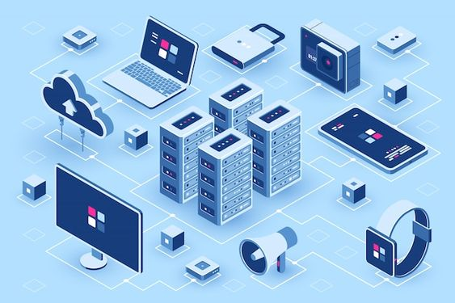**Conclusion.**

**1-Introduction to TIC:**

****Technology, Information, and Communication (TIC) encompass a wide range of digital tools, platforms, and systems that play a crucial role in facilitating access to information, connecting individuals and organizations, and driving technological advancements. TIC includes various technologies such as internet services, communication tools, software applications, and digital infrastructure that enable the exchange of information, collaboration, and innovation in modern society.

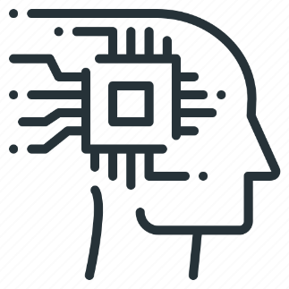Related technologies associated with TIC include popular digital platforms and tools such as Google services (Gmail, Google Drive, Google Workspace), Microsoft tools (Office 365, Teams, SharePoint), version control systems like Git, and collaborative platforms such as GitHub. These technologies are integral to communication, information management, productivity, and software development processes.

Overall, TIC and its related technologies form the backbone of modern digital interactions, enabling seamless communication, effortless access to information, and efficient collaboration across different domains and industries. Understanding the role and impact of these technologies is vital for leveraging their full potential in the contemporary digital landscape.

**2-TIC and Its Implications:**

Technology, Information, and Communication (TIC) have wide-ranging implications across various facets of modern society. Understanding these implications is essential in comprehending the transformative impact of TIC. The implications of TIC can be observed in the following key areas:

1. ****Economic Development: TIC plays a pivotal role in driving economic growth by fostering innovation, enhancing productivity, and enabling new business models. It creates opportunities for entrepreneurial ventures, facilitates global trade, and supports the growth of digital economies.
2. ****Employment and Workforce Dynamics: TIC has reshaped labor markets and the nature of work, leading to the emergence of new job roles, skill requirements, and remote work opportunities. It has also facilitated the gig economy and the growth of digital skill-based careers.
3. ****Access to Information: TIC has revolutionized the way information is accessed, shared, and disseminated. It has democratized knowledge, providing individuals with unprecedented access to educational resources, research findings, and diverse perspectives from around the world.
4. Communication and Connectivity: TIC has transformed communication channels, enabling seamless connectivity across geographical boundaries. It has facilitated real-time collaboration, video conferencing, and social interaction, thereby bridged cultural gaps and fostered global connectivity.
5. ****Social and Cultural Impact: TIC has influenced societal norms, cultural exchange, and the formation of virtual communities. It has altered social dynamics, redefined modes of interaction, and facilitated the sharing of diverse cultural expressions on digital platforms.
6. ****Ethical and Privacy Considerations: TIC has raised complex ethical and privacy concerns related to data protection, online security, and the responsible use of technology. It has necessitated the development of regulatory frameworks and ethical guidelines to address these issues.
7. ****Technological Literacy and Digital Inclusion: TIC has underscored the importance of technological literacy and digital inclusion, as access to and proficiency in using digital tools have become essential for participation in the modern economy and society.

**3- Google Services:**

Google offers a suite of services that are integral to TIC, providing powerful tools for communication, collaboration, and information management. Key services include Gmail, Google Drive, and Google Workspace.

|  |  |  |
| --- | --- | --- |
| -Gmail: | -Google Drive: | -Google Workspace: |
| Gmail revolutionized email communication with its user-friendly interface, efficient spam filtering, and extensive storage capabilities. It has had a profound impact on communication by offering a reliable and feature-rich platform for exchanging messages, attaching files, and managing contacts. Gmail's seamless integration with other Google services enhances productivity and enables efficient information sharing. | Google Drive serves as a central hub for storing and sharing files, documents, and media. Its cloud-based storage provides users with the ability to access their data from any device with internet connectivity. This has greatly impacted information storage and access by facilitating seamless collaboration on documents, spreadsheets, and presentations. Google Drive's sharing and access control features have transformed the way individuals and organizations manage and distribute information. | Formerly known as G Suite, Google Workspace encompasses a suite of productivity tools that enhance collaboration, such as Google Docs, Sheets, Slides, and more. These applications have fundamentally changed the way teams work together, enabling real-time collaboration on documents, spreadsheets, and presentations. Additionally, Google Workspace offers features for business communication, including Google Meet for video conferencing and Google Chat for instant messaging and team collaboration. |

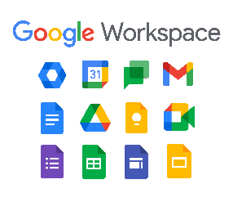The impact of these Google services on communication, collaboration, and information management is profound. They have modernized the way individuals and organizations communicate by offering seamless email communication, real-time collaboration on documents, and centralized storage for easy access to information. The integration among these services allows for efficient collaboration, sharing, and management of information within a unified environment. This, in turn, has contributed to improved productivity, streamlined workflows, and enhanced connectivity, underscoring the essential role of Google services in modern TIC practices.

**4-Microsoft Tools in the Context of TIC:**

Microsoft offers a suite of tools and platforms that are highly relevant to Technology, Information, and Communication (TIC), encompassing a range of applications designed to enhance communication, information management, and productivity within organizations. Key tools include Office 365, Teams, and SharePoint, each contributing to the advancement of TIC in unique ways.

-Office 365:

* Office 365, now known as Microsoft 365, is a comprehensive suite of productivity tools that include popular applications such as Word, Excel, PowerPoint, and Outlook, among others.
* Significantly, Office 365 is cloud-based, enabling seamless access to documents, email, and communication tools from various devices with internet connectivity.
* The suite fosters collaboration through real-time document editing, online meetings, and file sharing, elevating communication and productivity among users.

-Microsoft Teams:

* Microsoft Teams is a unified communication and collaboration platform that integrates chat, video conferencing, file storage, and application integration within a single interface.
* 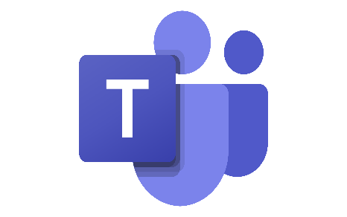By facilitating secure messaging and file sharing, Teams enhances real-time collaboration and information exchange, enabling teams to work together efficiently regardless of geographical locations.
* The platform’s integration with Office 365 applications and third-party tools further enhances its utility in supporting TIC practices.

- SharePoint:

* 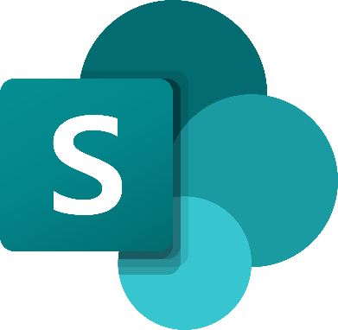SharePoint is a web-based platform that serves as a central hub for document management and collaboration within organizations.
* It enables the creation of intranet sites, document repositories, and team sites, providing a scalable solution for information management and sharing.
* SharePoint's features such as version control, access permissions, and integration with other Microsoft tools contribute to effective information management and collaborative workflows.

Microsoft tools such as Office 365, Teams, and SharePoint are instrumental in supporting TIC practices by offering robust solutions for communication, collaboration, and information management within modern organizations. Their integration with other TIC-related technologies further emphasizes their role in enhancing productivity and connectivity across diverse environments.

**5-Git and GitHub:**

****Git is a distributed version control system that allows developers to track changes in their code, manage different versions, and collaborate with team members. It allows individuals or teams to work on projects concurrently without interfering with each other's work. Git enables developers to create branches, merge code, and track changes, providing a robust framework for managing software development processes.

GitHub, on the other hand, serves as a platform built around Git, providing tools for collaborative software development, project management, and code hosting. It allows developers to store their Git repositories remotely and provides features such as issue tracking, pull requests, and wikis. GitHub facilitates communication and collaboration among developers by offering a centralized hub for sharing code, discussing issues, and managing project milestones.

The role of Git and GitHub in facilitating communication, collaboration, and information sharing among developers is significant. They provide a framework for seamless collaboration on codebases, enabling developers to work together on projects, share their code, review changes, and coordinate their efforts. This enhances transparency and efficiency in software development, fosters a culture of collaboration, and streamlines the process of sharing knowledge and best practices within developer communities. Additionally, the use of Git and GitHub contributes to the establishment of a robust version control and collaboration workflow, which is essential for successful and scalable software development projects.

**6-Conclusion:**

Technology Integration and Communication (TIC) and related technologies have significantly transformed business operations and societal dynamics. TIC has streamlined processes, revolutionized communication, and democratized access to information, leading to improved efficiency and informed decision-making in business. The societal impact includes changes in education, employment, and digital inclusion.

Looking ahead, the future role of TIC involves continuous evolution, deeper integration into daily life, and a focus on ethical considerations. TIC will continue to shape a globally connected world, and addressing challenges such as cybersecurity and environmental impact will be crucial. Embracing these technologies responsibly will contribute to a more inclusive, innovative, and sustainable digital future