Bitácora de ejecución de procedimiento de procesamiento para Systematic Mapping Study

El procedimiento fue realizado en las siguientes secciones:

Cadena de búsqueda definida 2
Preguntas de Investigación 2
Bases de datos para consulta: 2
Procedimiento 2
Preparación de la base de datos 2
1. Raw Search 3
PUBMED: 3
Science Direct: 3
SCOPUS 4
SPRINGERLINK 5
ACM 6
2. Carga de información a la base de datos 8
3. Limpieza y Detección de duplicados 9
4. Enriquecimiento de información 12
5. Criterios de Exclusión 13
6. Análisis de la Pregunta 1 de Investigación 14
7. Análisis de la Pregunta 2 de Investigación 17
8. Análisis de la Pregunta 3 de Investigación 19
9. Análisis de la Pregunta 4 de Investigación 22
10. Estadística descriptiva de los artículos 23
11. Clasificación sobre el enfoque de los artículos 39

Cadena de búsqueda definida

Referencia SCOPUS:
TITLE-ABS-KEY(preeclampsia OR "pre-eclampsia" OR eclampsia)
AND TITLE-ABS-KEY(prediction OR predict OR "risk assessment" OR "risk factor" OR "early detection" OR screening)
AND TITLE-ABS-KEY(pregnancy OR "pregnant women" OR "hypertension of pregnancy" OR proteinuria)
AND TITLE-ABS-KEY("cohort studies" OR "prospective studies" OR "observational study" OR "diagnostic test" OR validation)
AND TITLE-ABS-KEY("machine learning" OR "artificial intelligence" OR "deep learning" OR "supervised learning" OR "unsupervised learning" OR "explainable AI" OR "interpretable model" OR "model interpretability" OR "model transparency" OR explainability)
AND TITLE-ABS-KEY("electronic health records" OR EHR OR "patient data")
AND NOT TITLE-ABS-KEY(imaging OR ultrasound OR mri OR "medical imaging" OR radiology OR doppler OR tomography OR echography OR sonography OR electrocardiogram OR ECG OR EKG)
Filtros: Año 2020 - 2025

La cadena se adaptó para las diferentes bases de datos.

Preguntas de Investigación

1. What machine learning (ML) or artificial intelligence (AI) models have been developed or applied to predict preeclampsia and its complications in pregnant women?
(P: Pregnant women; I: ML/AI models; C: Traditional models or no intervention; O: Prediction of preeclampsia and complications such as eclampsia or HELLP syndrome).
2. What is the reported performance (e.g., AUC, accuracy, sensitivity, specificity) of ML/AI models used for predicting preeclampsia in published studies?
(P: Pregnant women at risk of preeclampsia; I: ML/AI models; C: Comparisons between models; O: Performance metrics such as AUC or accuracy).
3. What public or private data repositories are available for preeclampsia research, including clinical, genomic, or omics datasets?
(P: Preeclampsia patient data; I: Data repositories; C: Public vs. private; O: Accessibility and data types).
4. What clinical variables or electronic health record (EHR) data are most commonly used in ML/AI models for predicting preeclampsia?
(P: Pregnant women; I: Input variables in ML/AI models; C: Clinical variables vs. biomarkers; O: Frequency of use and predictive relevance).
5. What is the accuracy and validity of ML/AI models for predicting preeclampsia in observational studies or prospective cohorts?
(P: Pregnant women in observational/prospective cohorts; I: ML/AI models; C: Retrospective studies; O: Accuracy/validity metrics such as AUC in real-world settings).
6. Are there studies that include external validations or comparisons between different ML/AI techniques for preeclampsia prediction?
(P: Pregnant women; I: ML/AI techniques; C: Comparisons between methods, e.g., ML vs. logistic regression; O: Results of external validations or comparisons).
7. What explainability techniques (e.g., SHAP, LIME, EBM) have been employed in machine learning or artificial intelligence models for predicting preeclampsia, and how do these techniques contribute to interpretability, clinical trust, and applicability in clinical settings? (P: Pregnant women; I: Explainability techniques in ML/AI models; C: Models without explainability or traditional methods; O: Interpretability, clinical trust, and practical applicability).

Bases de datos para consulta:
- Pubmed
- Science direct
- Scopus
- Springer
- ACM

Estrategia de ejecución

- Generación de cadenas de búsqueda por base de datos
- Ejecución de la búsqueda
- Extracción de BIBTEX con códigos Doi
- Enriquecimiento de datos desde los códigos Doi para generar archivos BIBTEX
- Alimentación de abstract de los artículos elegidos
- Enriquecimiento con crossref.
- Procesamiento para que con chatgpt, a nivel de interpretación, se pueda leer título y abstract para encontrar información de referencia que sirva para contestar preguntas de investigación. También para que sirva para excluir artículos no relacionados con el tema específico.
- Almacenamiento de resultados de procesamiento
- Consolidación de información
- Generación de reportes
- Escritura del paper con los resultados

Procedimiento

Preparación de la base de datos

Se creó una nueva base de datos SQL Server vacía, para albergar toda la información de procesamiento.
Se adjunta el script de creación de la base de datos.
La base de datos es la que dispondrá de toda la información necesaria para los pasos paulatinos de tabulación de información.

1. Raw Search

- Yo no hice la búsqueda, ahora solo estoy recibiendo dois. Esta sección de cuáles fueron los criterios dados en cada base, se podrían analizar aquí, y la cantidad de ítems por base de datos.
- Conversión de dois a BIBTEX. https://citation-js.github.io/bibtex-generator/
- Programa Python extracción de dois con abstracts.
- Obtención de referencias específicas de BIB tex manualmente.

2. Carga de información a la base de datos

Consiste en que se carga los registros de formato Bibtex, a la base de datos SQL Server. Se utiliza un parser desarrollado para cargar la información. Desarrollo propio.
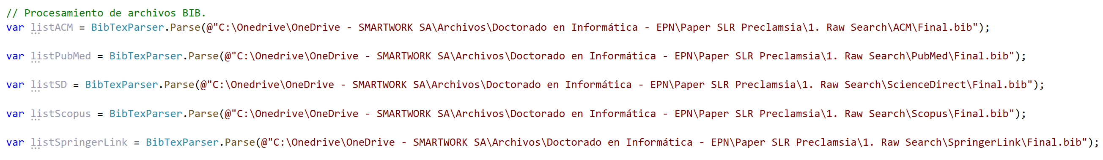

Escritura a la base de datos:

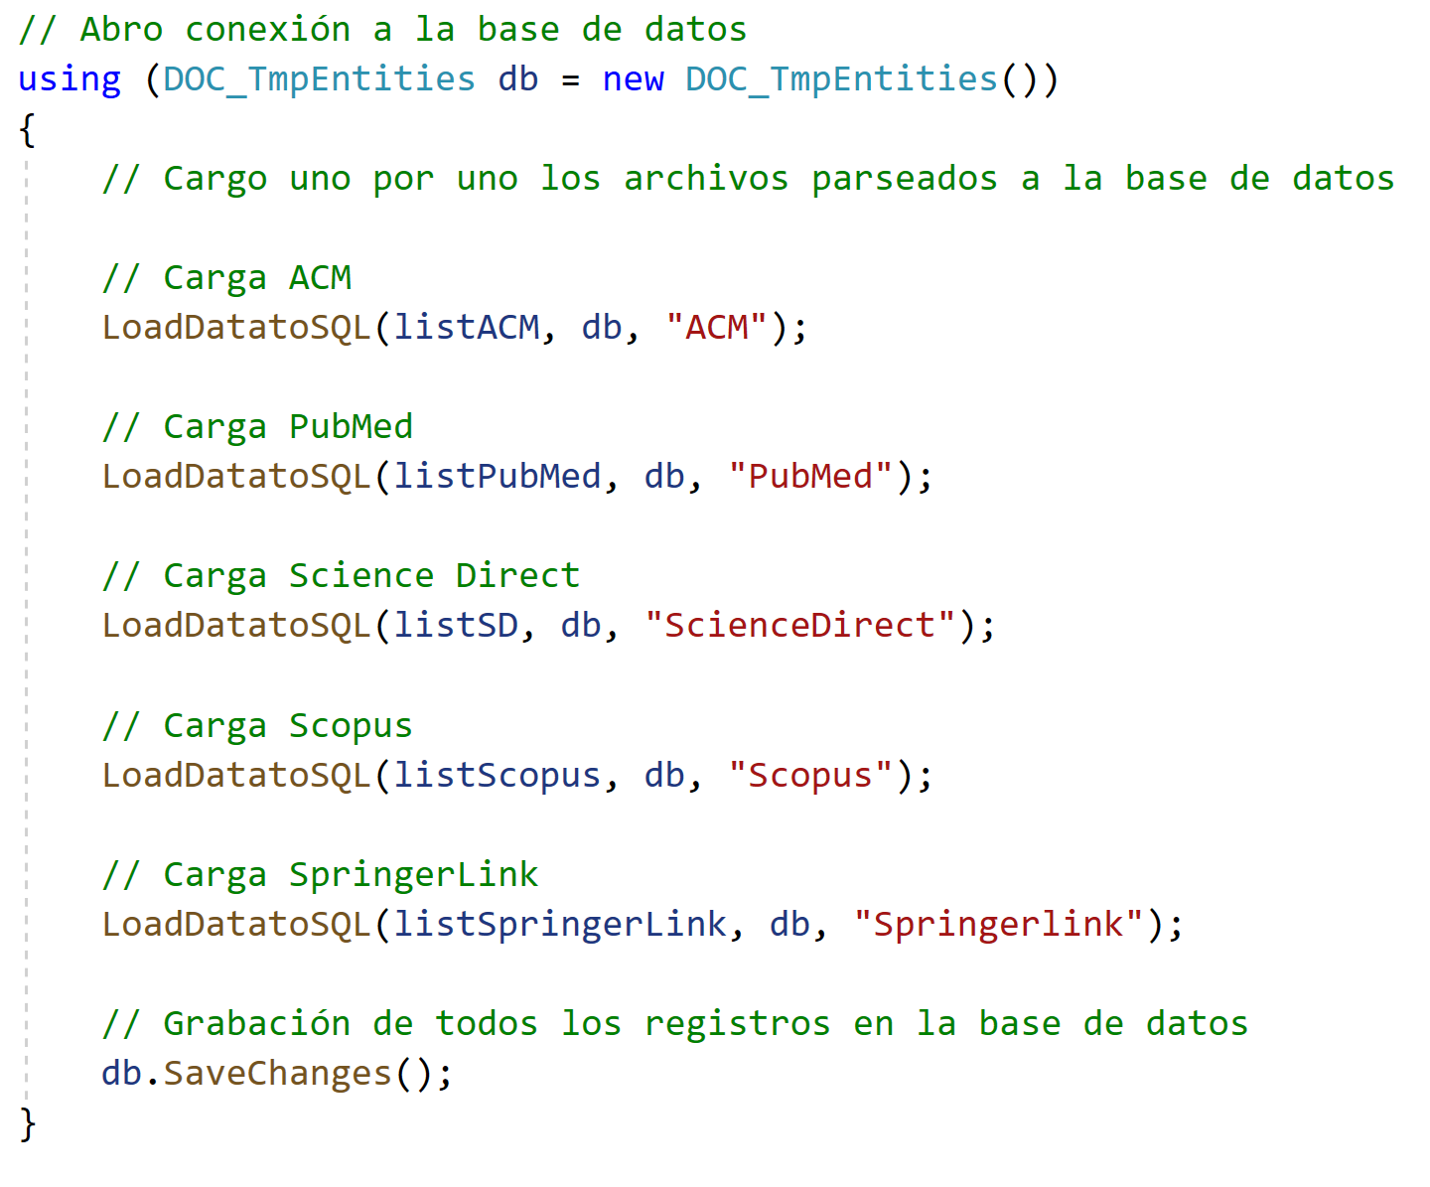

Método LoadDatatoSQL transforma la información que viene desde bibtex, al formato de la tabla de la base de datos. Al final del proceso de carga tenemos un total de 787 registros.

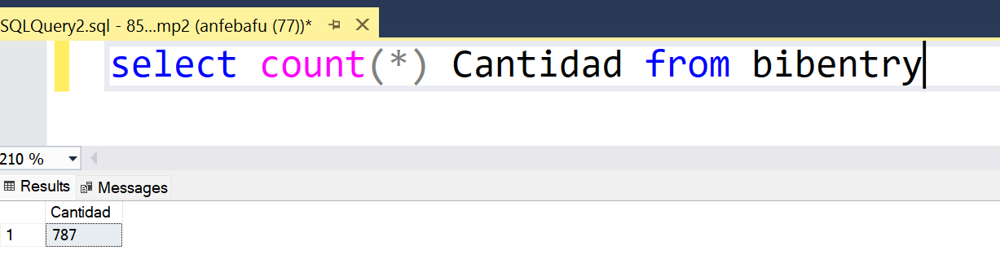

Si los dividimos por base de datos, tenemos lo siguiente:
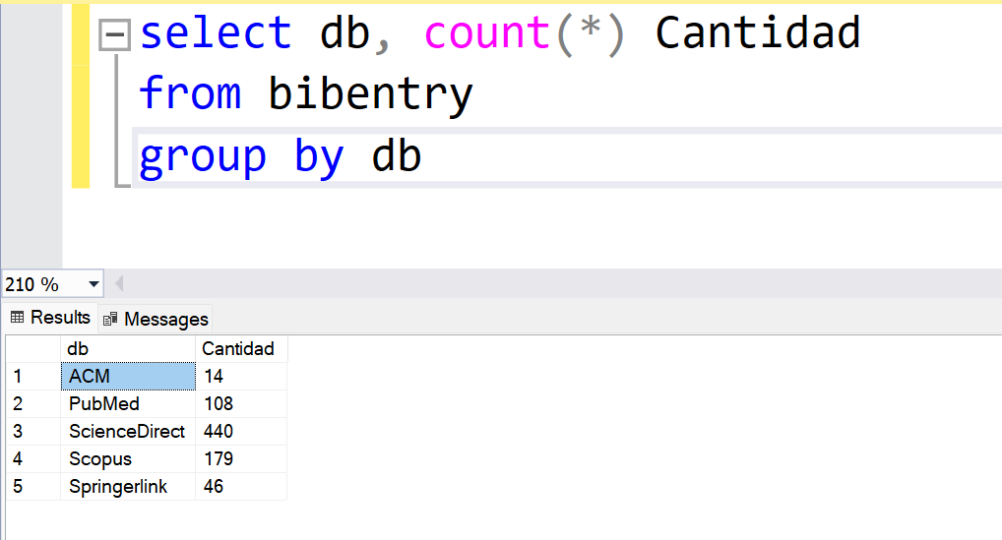

El número de registros cargados coinciden con los registros descargados en cada una de las bases de datos. La información es consistente.
Se explora la información cargada y se ve que tiene los datos cargados en las columnas correctas. No se tiene información con error de formato.
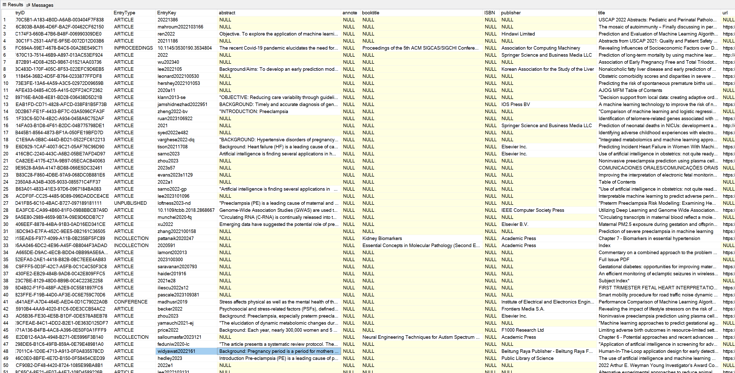

3. Limpieza y Detección de duplicados

Se corre un proceso manual de búsqueda de abstracts que los formatos bib no trajeron. La intención es que se tenga la mayor cantidad de datos posibles, principalmente en el campo de abstract. Se sigue el campo URL para obtener y copiar manualmente el abstract para los que no lo tenían.
Hay artículos que no son realmente publicaciones individuales sino las caratulas de congresos. Estos no tienen abstract y por tanto se deben descartar del procesamiento. (Estado 16)

Además se corre un procedimiento almacenado (BibEntry_Duplicados) que corre los siguientes procesos:
- Limpiar espacios vacíos en doi
- Marca estado de descartado para artículos sin doi (estado 11). Estos normalmente refieren a otro tipo de documentos no indexados en Doi.
- Normalización de formato de doi. Algunos vienen con url completa y otros solo con código. Se le deja solo con código
- Marca estado de duplicado para artículos que tienen mismo doi (estado 12). De los repetidos, deja uno activo, el resto queda con marca de duplicado y ya no pasa a los siguientes procesos.
- Marca estado de duplicado para artículos que aunque no tienen el mismo doi, tienen el mismo título exactamente (estado 13) (NO)
- Detecta si uno de los duplicados tiene más información llena que el que queda activo luego de la marca de duplicado, copia los datos para que el que queda activo tenga la mayor cantidad de información llena posible.
- Retiro de dois que refieren a artículos generales de conferencias o artículos, no a artículos específicos.
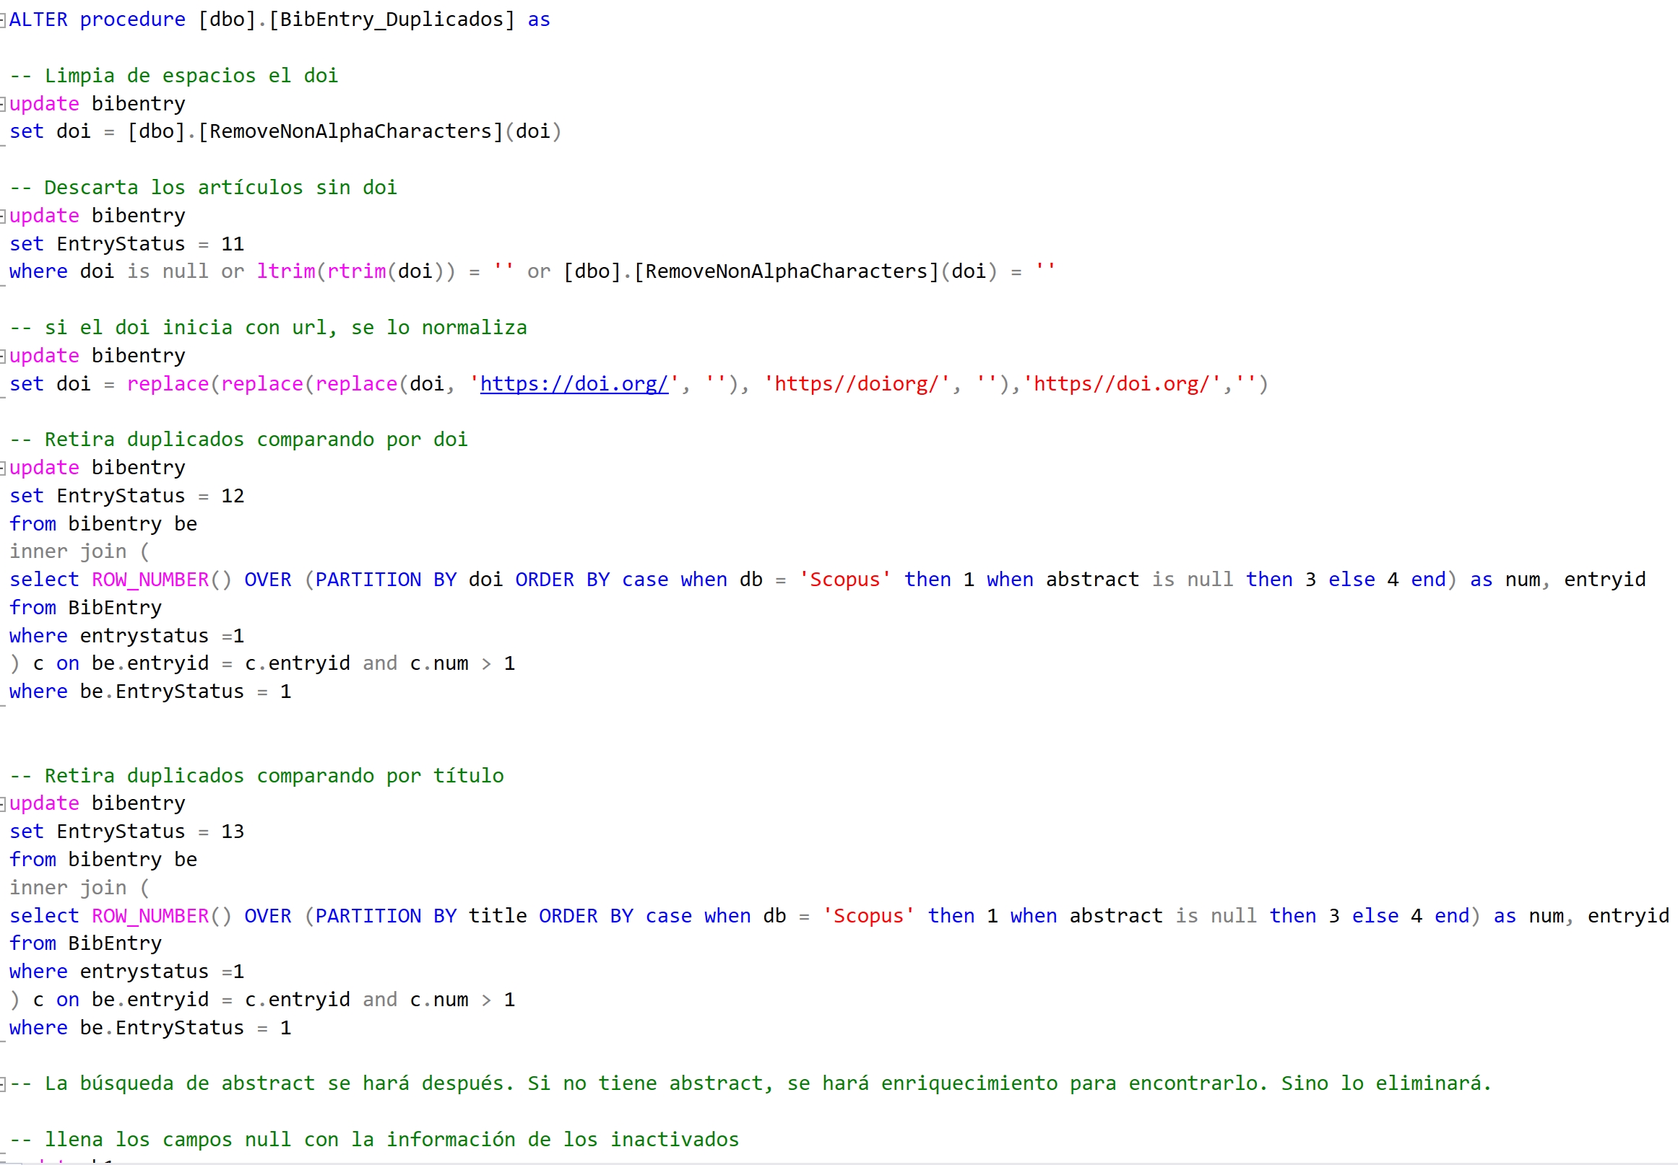

Resultado luego de procesamiento de duplicados:

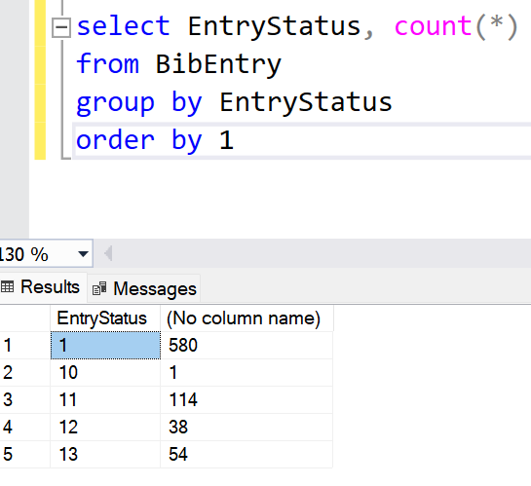

Luego del proceso, siguen 580 artículos activos para la siguiente parte del proceso.

4. Enriquecimiento de información

Dado que las bases de datos científicas no proveen en todos los casos la información completa en los archivos de exportación, y para el procesamiento adecuado, necesitamos tener información completa, se hace un proceso de enriquecimiento de información. Para esto nos conectamos vía llamadas web al sitio web de CrossRef.
Crossref proporciona información separada de autores, eventos (nombres separados de los congresos), referencias a otros artículos (necesario para profundizar en la densidad de referencias del artículo y artículos correlacionados entre sí), temas, cantidad de referencias a la fecha, entre otros. Esta información sirve para generar información correlacionada clave para el análisis de la información.
Un ejemplo del archivo json descargado para un artículo en particular:
{"status":"ok","message-type":"work","message-version":"1.0.0","message":{"indexed":{"date-parts":[[2023,3,1]],"date-time":"2023-03-01T02:41:05Z","timestamp":1677638465621},"reference-count":0,"publisher":"Elsevier BV","license":[{"start":{"date-parts":[[2022,3,1]],"date-time":"2022-03-01T00:00:00Z","timestamp":1646092800000},"content-version":"tdm","delay-in-days":0,"URL":"https:\/\/www.elsevier.com\/tdm\/userlicense\/1.0\/"},{"start":{"date-parts":[[2023,3,1]],"date-time":"2023-03-01T00:00:00Z","timestamp":1677628800000},"content-version":"vor","delay-in-days":365,"URL":"http:\/\/www.elsevier.com\/open-access\/userlicense\/1.0\/"}],"content-domain":{"domain":["mp.uscap.org","elsevier.com","sciencedirect.com"],"crossmark-restriction":true},"short-container-title":["Modern Pathology"],"published-print":{"date-parts":[[2022,3]]},"DOI":"10.1038\/s41379-022-01048-0","type":"journal-article","created":{"date-parts":[[2022,3,18]],"date-time":"2022-03-18T00:22:28Z","timestamp":1647562948000},"page":"1386-1403","update-policy":"http:\/\/dx.doi.org\/10.1016\/elsevier_cm_policy","source":"Crossref","is-referenced-by-count":0,"title":["USCAP 2022 Abstracts: Pediatric and Perinatal Pathology (1172-1186)"],"prefix":"10.1016","volume":"35","member":"78","container-title":["Modern Pathology"],"original-title":[],"language":"en","link":[{"URL":"https:\/\/www.nature.com\/articles\/s41379-022-01048-0.pdf","content-type":"application\/pdf","content-version":"vor","intended-application":"text-mining"},{"URL":"https:\/\/www.nature.com\/articles\/s41379-022-01048-0","content-type":"text\/html","content-version":"vor","intended-application":"text-mining"},{"URL":"https:\/\/api.elsevier.com\/content\/article\/PII:S0893395222001612?httpAccept=text\/xml","content-type":"text\/xml","content-version":"vor","intended-application":"text-mining"},{"URL":"https:\/\/api.elsevier.com\/content\/article\/PII:S0893395222001612?httpAccept=text\/plain","content-type":"text\/plain","content-version":"vor","intended-application":"text-mining"},{"URL":"https:\/\/www.nature.com\/articles\/s41379-022-01048-0.pdf","content-type":"application\/pdf","content-version":"vor","intended-application":"similarity-checking"}],"deposited":{"date-parts":[[2023,3,1]],"date-time":"2023-03-01T02:08:31Z","timestamp":1677636511000},"score":1,"resource":{"primary":{"URL":"https:\/\/linkinghub.elsevier.com\/retrieve\/pii\/S0893395222001612"}},"subtitle":[],"short-title":[],"issued":{"date-parts":[[2022,3]]},"references-count":0,"alternative-id":["S0893395222001612"],"URL":"http:\/\/dx.doi.org\/10.1038\/s41379-022-01048-0","relation":{},"ISSN":["0893-3952"],"issn-type":[{"value":"0893-3952","type":"print"}],"subject":["Pathology and Forensic Medicine"],"published":{"date-parts":[[2022,3]]},"assertion":[{"value":"Elsevier","name":"publisher","label":"This article is maintained by"},{"value":"USCAP 2022 Abstracts: Pediatric and Perinatal Pathology (1172-1186)","name":"articletitle","label":"Article Title"},{"value":"Modern Pathology","name":"journaltitle","label":"Journal Title"},{"value":"https:\/\/doi.org\/10.1038\/s41379-022-01048-0","name":"articlelink","label":"CrossRef DOI link to publisher maintained version"},{"value":"simple-article","name":"content_type","label":"Content Type"},{"value":"\u00a9 2022 United States & Canadian Academy of Pathology.","name":"copyright","label":"Copyright"}]}}

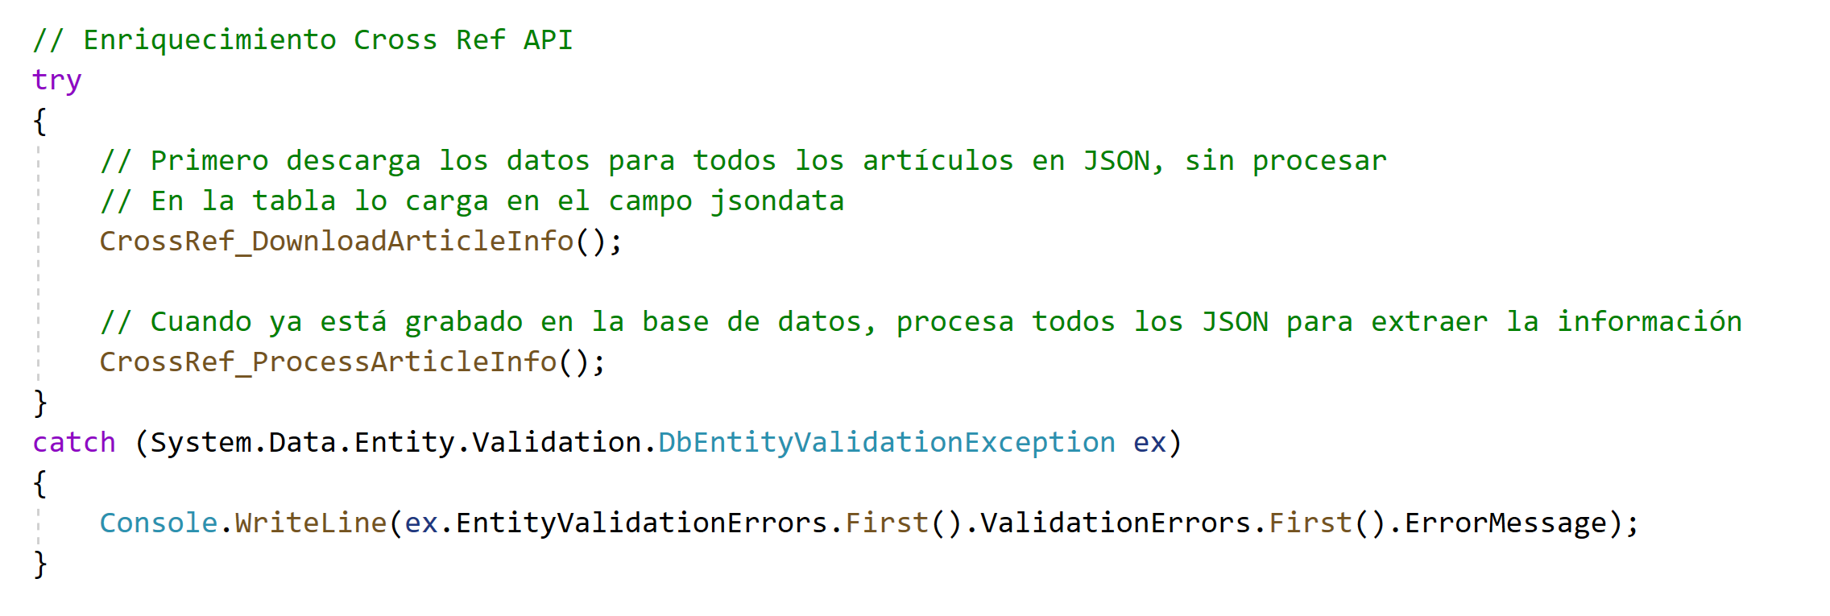

5. Criterios de Exclusión

La intención es retirar del análisis los artículos que no estén dentro del target de estudio. En este caso el objetivo del estudio es evaluar los artículos que hayan propuesto un algoritmo o método de inteligencia artificial para detección temprana de la preeclampsia. Artículos que hayan resultado de los buscadores como coincidentes, pero que no tengan que ver específicamente con esta enfermedad, deben ser descartados.

De esta forma, se hizo un algoritmo que consulte a chatGPT enviándole el título y abstract de todos los artículos calificados (496 artículos), con el siguiente prompt:

"Given the following info of an article:title:\"" + titleField + (abstractField != null ? ("\" and abstract:\"" + abstractField + "\"") : "") + " please give me a single number answer from 1 to 9, in JSON like {\"proximity\": <value>, \"reason\": <valueReason>}, in which 10 is the nearest and 1 is the less coincident, in determining the conceptual proximity of this article with the idea of the usage of the machine learning or deep learning techniques, for predicting or detecting automatically, the preeclampsia, complications and preganancy, hypertension and pregnancy, eclampsia, proteinuric hypertension of pregnancy, or toxaemia of pregnancy. A key element in evaluation should be the presence of preeclamptia or synonyms in the article."

En este prompt se reemplaza el título y el contenido del abstract, antes de enviar al motor de ChatGPT API. Se utilizó el modelo gpt-3.5-turbo de OpenAI.

Se obtuvo respuestas de este tipo en formato JSON:
{"proximity": 4, "reason": "The article does not directly mention preeclampsia or its synonyms, but it discusses the correlation between disease outbreaks and socioeconomic factors using data mining and machine learning techniques. While it may provide insights into disease analysis and prediction, it does not specifically focus on preeclampsia or related complications of pregnancy."}

Hubieron respuestas que tienen explicación complementaria, por lo que se hizo un procedimiento de limpieza y unificación del contenido, para que todas las respuestas tengan un formato JSON totalmente válido.

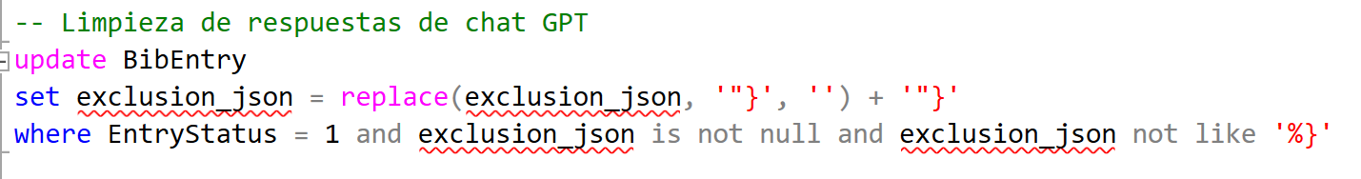

Luego de limpia la información, se procesa el JSON uno a uno llenando una columna numérica con el valor de proximidad calculado por ChatGPT. En base a este valor, se determina los artículos más cercanos, es decir, los que tienen proximidad mayor o igual a 7.
Los artículos no cercanos, se los ha marcado con estado 17.

Estos artículos serían los que representarían el grupo primario de estudio. Quedaron luego de este proceso 99 artículos. A estos se los considera como artículos primarios del estudio.

6. Análisis de la Pregunta 1 de Investigación

La primera pregunta de investigación señala lo siguiente:
¿Qué modelos de Machine Learning existen o se han aplicado para la predicción de preeclampsia y sus complicaciones?

Para responder la pregunta es necesario extraer la lista de modelos de Machine Learning que se han aplicado en los estudios primarios. Para esto se hará un barrido por el abstract de los artículos, pidiéndole a chatGPT (API modelo gpt-3.5-turbo) que extraiga en texto los modelos de Machine Learning, inteligencia artificial o deep learning referidos en cada uno de los artículos. Esta información se almacenará dentro de cada artículo en el formato de JSON.

El prompt propuesto en este caso es:
Given the following info of an article:title:\"" + titleField + (abstractField != null ? ("\" and abstract:\"" + abstractField + "\"") : "") + ";please help me to identify the main machine learning, artificial intelligence or deep learning algorithms or models that were used during the study. If there is more than one identified, please separate with commas. Please in JSON using this format {\"methods\":\"<method_list>\"}

Un ejemplo de JSON descargado para un artículo:
{"methods": "classification via regression model, Weka optimization algorithm, M5P algorithm (decision tree and linear models), repeated 10-fold cross-validation"}

Luego, se tomó toda la información de los JSON consolidados para todos los artículos primarios, y se le preguntará a ChatGPT , modelo gpt-4, en formato WEB, con el siguiente prompt:

We are working on a review of a group of scientific articles. The topic is about the usage of machine learning, artificial intelligence or deep learning techniques for predicting preeclamptia desease. Each line represent of the following represent an article, and the methods value represent the detected AI methods used in each article. We need to summarize this information to show the main AI methods used in this whole context. It would be nice if statistics are generated, and a redaction of the justification. It is important to consider that generic terms like machine learning does not contributes to this study. We need to focus on specific methods used. Below the list of referred articles: <lista de artículos>

No se automatizó mediante API, dado que se trataba de una sola pregunta general para todo el bloque de información disponible de los artículos primarios, y no tenía que ir de artículo en artículo.

El modelo GPT-4 respondió de la siguiente manera, en lo que sería el texto de base para dar respuesta a la primera pregunta de investigación:

Methods Summary:
- Support Vector Machine (SVM): Mentioned in 16 articles.
- Random Forest: Mentioned in 15 articles.
- Artificial Neural Networks (ANN): Mentioned in 9 articles.
- Logistic Regression: Mentioned in 11 articles.
- Decision Tree: Mentioned in 9 articles.
- Gradient Boosting: Mentioned in 6 articles (This includes specific implementations like XGBoost and lightGBM).
- Naïve Bayes: Mentioned in 5 articles.
- K-nearest Neighbors: Mentioned in 4 articles.
- Deep Neural Networks (DNN) / Convolutional Neural Networks (CNN): Mentioned in 6 articles.
- AdaBoost / Adaptive Boosting: Mentioned in 3 articles.
- Gaussian Processes: Mentioned in 2 articles.
- Other Methods: Numerous other methods were mentioned fewer times, such as LASSO, GMNet model, M5P algorithm, U-Net, Gaussian process regression, cluster analysis, etc.

Summary and Justification:
From the data provided, Support Vector Machine (SVM) and Random Forest are the most frequently used methods for predicting preeclampsia across the set of articles. Artificial Neural Networks (ANN) and Decision Trees are also commonly utilized. It's notable that Gradient Boosting, which includes specific implementations like XGBoost and lightGBM, has gained traction in recent research as it is mentioned in several articles. This reflects a trend in machine learning where ensemble methods like Gradient Boosting are favored for their ability to reduce bias and variance, leading to improved predictive accuracy.
Logistic regression, a classic statistical method, also remains popular, highlighting its continued relevance even in an age dominated by more complex models. Deep learning methods, particularly Convolutional Neural Networks (CNN), also feature in the list, showcasing the increasing interest in harnessing the power of deep learning for healthcare predictions.
It is also worth noting that a few articles used a combination of several methods, emphasizing the importance of a multi-faceted approach when addressing complex medical predictions like preeclampsia. Combining multiple models or approaches, such as ensemble methods, can help capture different patterns in the data and lead to more robust predictions.
In conclusion, while a variety of machine learning and AI methods are employed in predicting preeclampsia, the emphasis seems to be on SVM, Random Forest, ANN, and Gradient Boosting methods. Their recurrent mention signifies their perceived efficacy and importance in this domain of medical research.

7. Análisis de la Pregunta 2 de Investigación

¿Cuál es el rendimiento de los modelos utilizados para la predicción de Preeclampsia?

Para responder la pregunta es necesario sintetizar y extraer los factores numéricos específicos provistos por los papers, como indicadores de rendimiento de los modelos de predicción. Para este objetivo se diseñó el siguiente prompt, cuyo resultado se almacenará en la base de datos en una columna específica para cada artículo (modelo: gpt-3.5-turbo):

Given the following info of an article:title:\"" + titleField + (abstractField != null ? ("\" and abstract:\"" + abstractField + "\"") : "") + ";please help me to identify the key performance indicators, results efficiency info or diverse related metrics achieved from the usage of machine learning, artificial intelligence or deep learning algorithms / models of this study, mainly focusing on the prediction capabilities results. It is needed the numeric metric number or percentages presented inside the detected text. if undefined, please set this in the result. If there is more than one metric identified, please separate with commas. Please in JSON using this format {\"metric\":\"<metric_list>\"}

Es de notar que no todos los artículos presentan indicadores en su abstract. De los 99 estudios seleccionados como primarios, 83 presentaron ciertos indicadores numéricos. No todos los indicadores se encuentran sobre el mismo modelo de evaluación, por lo que la comparabilidad entre ellos es un desafío.

A continuación ejemplos de la información extraída para ciertos artículos:

{"metric": "10% of pregnancies worldwide are affected by hypertensive disorders during pregnancy"}
{"metric":"logit AUROC 2.51, 95% CI 1.49-3.53; I2=86%; t2=0.77, logit AUROC 1.2, 95% CI 0.72-1.67; I2=75%; t2=0.09, logit AUROC 2.26, 95% CI 1.39-3.13; I2=75%; t2=0.43, logit AUROC 1.03, 95% CI 0.69-1.37; I2=83%; t2=0.07"}
{"metric":"risk score developed with machine learning"}
{"metric":"NPV: 100%, PPV (sFlt-1/PlGF ratio >45): 49.5%, PPV (sFlt-1/PlGF ratio >45 and NT-proBNP >174): 86%"}
{"metric":"AUC = 81.72%, sensitivity of 70.59% for predicting PIH; AUC = 95.91%, sensitivity of 97.91% for predicting ICP"}

Luego, se tomó toda la información de los JSON consolidados para todos los artículos primarios, y se le preguntará a ChatGPT , modelo gpt-4, en formato WEB, con el siguiente prompt:

Each of the following JSONs represent a single scientific article. All of them were selected because they implement a machine learning, artificial intelligence or deep learning algorithm or method, for prediction of preeclampsia / hypertension in pregnancy. We extracted from them their key performance indicators, results efficiency info or diverse related metrics achieved from each proposal. We want now to consolidate this information in average results, insights or other type of consolidated metric from this data, and also to make a redaction to summarize and obtain conclusions: <Lista de JSONs>

No se envió a procesar los artículos que tenían indicación de “undefined”, pues se le indicó que esta palabra sirva de indicador para aquellos artículos que no tengan definiciones numéricas.

La respuesta del modelo fue la siguiente:

The provided JSONs contain a plethora of metrics from scientific articles related to the prediction of preeclampsia/hypertension in pregnancy using machine learning, artificial intelligence, or deep learning algorithms. The metrics encompass accuracy measures, areas under the curve (AUC), specific values such as specificity and sensitivity, and other related metrics.

Insights:
- Area Under the Curve (AUC): AUC, a measure of the performance of a binary classification system, has values ranging generally between 0.5 (no better than random) and 1.0 (perfect classification). Multiple articles reported AUC values, and the majority of the values were above 0.8, indicating very good to excellent classifier performance.
- Accuracy: Accuracy measures the proportion of true results (both true positives and true negatives) in the population. Many of the articles reported accuracies between 80% and 98%, signifying a high degree of reliability in their predictions.
- Specificity and Sensitivity: These are crucial metrics for diagnostic tests. Specificity measures the proportion of actual negatives correctly identified, while sensitivity measures the proportion of actual positives correctly identified. The data showcases a wide range of values for these metrics across different models, but many models had values above 70%, indicating they were relatively adept at identifying true positive and true negative cases.
- Other reported metrics include precision, recall, F1-score, and risk scores. There are also instances of p-values and confidence intervals that help in understanding the statistical significance and reliability of the results.
- Several articles reported metrics not directly comparable or without specific numerical values, such as "a small amount of articles," "accuracy, area under the receiver operating characteristic curve (AUC-ROC), calibration ability," and descriptions of methodologies.
Conclusions:
- The majority of the AI and machine learning models showcased promising results in predicting preeclampsia/hypertension in pregnancy. This is evident from the high AUC, accuracy, specificity, and sensitivity values reported across various studies.
- While many models demonstrated high accuracy rates (80%-98%), there is variability in performance, underscoring the need for rigorous model validation and potential combination of approaches for enhanced prediction.
- A few models leveraged different metrics like Differential Scanning Calorimetry (DSC), Mean Pixel Accuracy (MPA), and Mean Intersection of Union (MIOU), which might be specific to the methodology or the data type used in the research.
- It's imperative to understand the context and methodology behind each metric. For instance, a high AUC is promising, but if the model's sensitivity is low, it might miss many positive cases, which is crucial for medical predictions.
- The variability in reported metrics suggests a rapidly advancing field with multiple approaches to predicting preeclampsia and related conditions in pregnancy. With further research, refinement, and collaboration, AI can play a transformative role in prenatal care and risk assessment.
Recommendation: For better decision-making and application in clinical practice, it would be beneficial to focus on articles that provide a comprehensive set of metrics, including AUC, accuracy, specificity, and sensitivity, as they offer a holistic view of the model's performance.

8. Análisis de la Pregunta 3 de Investigación

¿Qué técnicas de evaluación del desempeño usan?

Para responder la pregunta es necesario sintetizar y extraer individualmente las técnicas de evaluación de desempeño utilizadas en cada estudio. Para esto se desarrolló el siguiente prompt:

Given the following info of an article:title:\"" + titleField + (abstractField != null ? ("\" and abstract:\"" + abstractField + "\"") : "") + ";please help me to identify the technique of evaluation used for obtaining key performance indicators, results efficiency info or diverse related metrics achieved from the usage of machine learning, artificial intelligence or deep learning algorithms / models of this study, mainly focusing on the prediction capabilities results. It is needed the identification of the evaluation technique used. if undefined, please set this in the result. If there is more than one technique identified, please separate with commas. Please in JSON using this format {\"technique\":\"<techniquelist>\"}7

Ejemplos del resultado obtenido:
{"technique":"logistic regression, liquid chromatography-tandem mass spectrometry (LC-QQQ)"}
{"technique": "Logistics multivariate analysis, XGBoost algorithm model, receiver operating characteristic (ROC) analysis"}
{"technique":"targeted maximum likelihood estimation (TMLE), ensemble machine learning algorithm Super Learner"}
{"technique":"CNN algorithm"}

Luego, se tomó toda la información de los JSON consolidados para todos los artículos primarios, y se le preguntará a ChatGPT , modelo gpt-4, en formato WEB, con el siguiente prompt:
Each of the following JSONs represent a single scientific article. All of them were selected because they implement a machine learning, artificial intelligence or deep learning algorithm or method, for prediction of preeclampsia / hypertension in pregnancy. We extracted from them the technique used for evaluation of the key performance indicators, results efficiency info, or diverse related metrics achieved, focused on the precition capabitilites results. We want now to consolidate this information for obtaining statistical understanding of the most used techniques and insights about their usage. Also We want a redaction to summarize this info and to obtain conclusions <list of JSONs>

El modelo respondió de la siguiente manera:

Let's first start by breaking down the techniques and consolidating them to find the most common ones. From the provided JSONs, several techniques and methods are mentioned multiple times while some are unique.
Here's a consolidated list of techniques/methods and their frequencies:
- Machine Learning - Appears multiple times in various contexts.
- Area under the Receiver Operating Characteristic Curve (AUROC/AUC-ROC/AUC) - Very frequently mentioned.
- Support Vector Machine (SVM) - Mentioned several times.
- Logistic Regression - Mentioned several times.
- Random Forest - Multiple mentions.
- Cross-validation - Mentioned multiple times in different contexts (e.g., 10 x 10-fold cross-validation).
- Receiver Operating Characteristic (ROC) Curve Analysis - Appears several times.
- Deep Learning/Convolutional Neural Networks (CNNs) - A few mentions.
- Precision, Recall, Sensitivity, Specificity, F1-score - Appears together and separately several times.
- Review Methods (e.g., systematic literature review, scoping review, narrative review) - Few mentions.
- Accuracy - Mentioned multiple times.
- XGBoost and Gradient Boosting - Mentioned several times.
- Ensemble Methods (e.g., soft voting ensemble learning, ensemble model) - Few mentions.
- Univariate and Multivariate Analysis - Appears several times.
- Decision Trees (e.g., ID3 algorithm, Decision Tree J48) - Few mentions.
From this list, we can draw a few observations:
- AUROC (AUC) is a leading evaluation metric, commonly used to assess the performance of prediction models. Its frequent mention implies its importance in assessing models' capability to distinguish between positive and negative classes.
- Techniques such as SVM, Logistic Regression, and Random Forest are popular choices for prediction tasks, indicating their robustness and versatility for various datasets.
- The increasing mention of Deep Learning techniques, specifically CNNs, points to the growing relevance of these methods in handling complex datasets, possibly including image data.
- Review methods indicate that some of the articles are not necessarily original studies but reviews, summarizing the existing literature on the topic.
- The mention of metrics like Precision, Recall, Sensitivity, Specificity, and F1-score emphasizes the importance of not just overall accuracy but also the performance concerning false positives, false negatives, and the balance between them.
- Ensemble methods and boosting techniques like XGBoost suggest the aim to enhance model performance by combining multiple models or iterative training techniques.
- Cross-validation is a key method to prevent overfitting and assess the generalized performance of a model.
Conclusion: The analysis of techniques from various scientific articles reveals a diverse range of methodologies employed to predict preeclampsia/hypertension in pregnancy. While traditional machine learning methods like SVM, Logistic Regression, and Random Forest remain popular, there's a noticeable trend towards the adoption of deep learning techniques. The frequent mention of AUROC as an evaluation metric highlights its significance in the domain. Moreover, the presence of various metrics, ensemble methods, and cross-validation implies a comprehensive approach in model evaluation, aiming for models that generalize well and make balanced predictions.

9. Análisis de la Pregunta 4 de Investigación

¿Qué repositorios de datos existen públicos o Privados de preeclampsia?

Para responder la pregunta es necesario sintetizar y extraer individualmente si existe la mención de repositorios de datos públicos o privados, utilizados en cada estudio. Para esto se desarrolló el siguiente prompt:

Given the following info of an article:title:\"" + titleField + (abstractField != null ? ("\" and abstract:\"" + abstractField + "\"") : "") + ";Considering that this article have been selected because its approach to the usage of machine learning, artificial intelligence or deep learning algorithms, for predicting preeclampsia. It is needed to identify if during the study it was used a public or private data repository, and if defined, extract the reference of this repository or the source of data used. if undefined, please set this in the result. If there is more than one repository identified, please separate with commas. Please in JSON using this format {\"repository\":\"<repositorylist>\"}

Luego de la ejecución, es posible ver que solamente para 13 artículos está expuesta la fuente de datos:

{"repository":"The BPJS Kesehatan dataset"}
{"repository":"Massachusetts University Amherst, National Health and Nutrition Survey"}
{"repository":"TriNetX, Inc."}
{"repository": "Logan (2020)"}
{"repository":"plos.figshare.com"}
{"repository": "GSE149440"}
{"repository":"Vanderbilt University Medical Center"}
{"repository":"NICHD Maternal Fetal Medicine Units (MFMU) Network"}
{"repository":"PubMed"}
{"repository":"Iranian Maternal and Neonatal Network"}
{"repository": "GSE75010 dataset"}
{"repository": "Data from the study was obtained from Lucile Packard Children Hospital at Stanford, CA"}
{"repository":"University Medical Center of Ljubljana"}

10. Estadística descriptiva de los artículos

Además de contestar a las preguntas de investigación, la base de datos permite obtener diversa información consolidada.

A continuación, el gráfico de secuencia de ejecución y criterios de exclusión desarrollados:

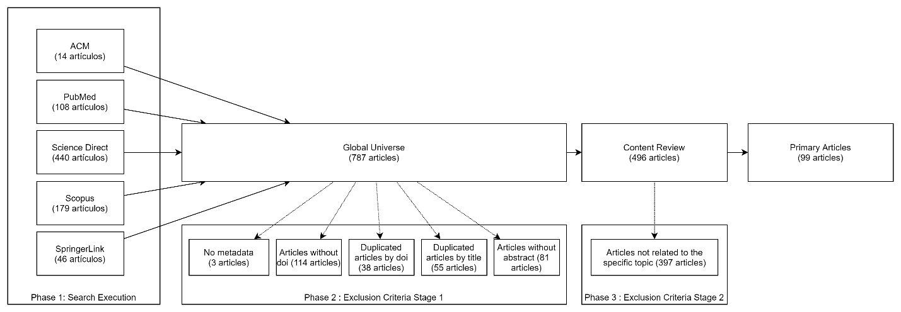

Estadística de origen de información, de todo el universo de archivos:

Estadística de origen de información, solamente de los artículos primarios:

Es de notar que no aparece PubMed, pero la explicación es que en la eliminación de duplicados, seguramente se retiraron esos, al aparecer también en Scopus.

Cantidad de artículos por año de las publicaciones – Universo de artículos:

Se puede ver un crecimiento en el número de artículos. El 2023 hay baja, pero es esperable dado que el año todavía sigue en curso.

Cantidad de artículos por año de las publicaciones – Artículos Primarios:

Para los artículos publicados en revistas, se extrajo la lista de tópicos de dichas revistas y se consolidó en un gráfico sobre los tópicos más cercanos, para el universo de artículos:

El mismo gráfico para los estudios primarios:

Artículos primarios que tienen más referencias dadas desde otros artículos (a fecha de este estudio). Estos artículos serían los más relevantes en la temática:

Rank | title | Reference Number
1 | Prediction model development of late-onset preeclampsia using machine learning-based methods | 80
2 | Deep learning predicts extreme preterm birth from electronic health records | 42
3 | Comparison of multivariable logistic regression and other machine learning algorithms for prognostic prediction studies in pregnancy care: Systematic review and meta-analysis | 42
4 | Early prediction of preeclampsia via machine learning | 40
5 | Predicting common maternal postpartum complications: leveraging health administrative data and machine learning | 32
6 | Machine learning as a strategy to account for dietary synergy: an illustration based on dietary intake and adverse pregnancy outcomes | 30
7 | Artificial intelligence-assisted prediction of preeclampsia: Development and external validation of a nationwide health insurance dataset of the BPJS Kesehatan in Indonesia | 27
8 | Data-Driven Modeling of Pregnancy-Related Complications | 24
9 | A machine learning algorithm for predicting maternal readmission for hypertensive disorders of pregnancy | 22
10 | Using Machine Learning to Predict Complications in Pregnancy: A Systematic Review | 22
11 | Prediction of preeclampsia and intrauterine growth restriction: Development of machine learning models on a prospective cohort | 21
12 | Clinical risk assessment in early pregnancy for preeclampsia in nulliparous women: A population based cohort study | 21
13 | Inflammation in Preeclampsia: Genetic Biomarkers, Mechanisms, and Therapeutic Strategies | 18
14 | GestAltNet: aggregation and attention to improve deep learning of gestational age from placental whole-slide images | 17
15 | A machine-learning–based algorithm improves prediction of preeclampsia-associated adverse outcomes | 15

Autores (colocados de primer autor), más recurrentes entre los estudios primarios:

Rank | given | family | ArticleNumber
1 | Herdiantri | Sufriyana | 4
2 | Kwang-Sig | Lee | 3
3 | Iuliana | Marin | 3
4 | Nickie | Andescavage | 2
5 | Pahriya | Ashrap | 2

Referencias dadas entre los estudios primarios:

A continuación el gráfico de grafo de representación de referencias entre estudios primarios:
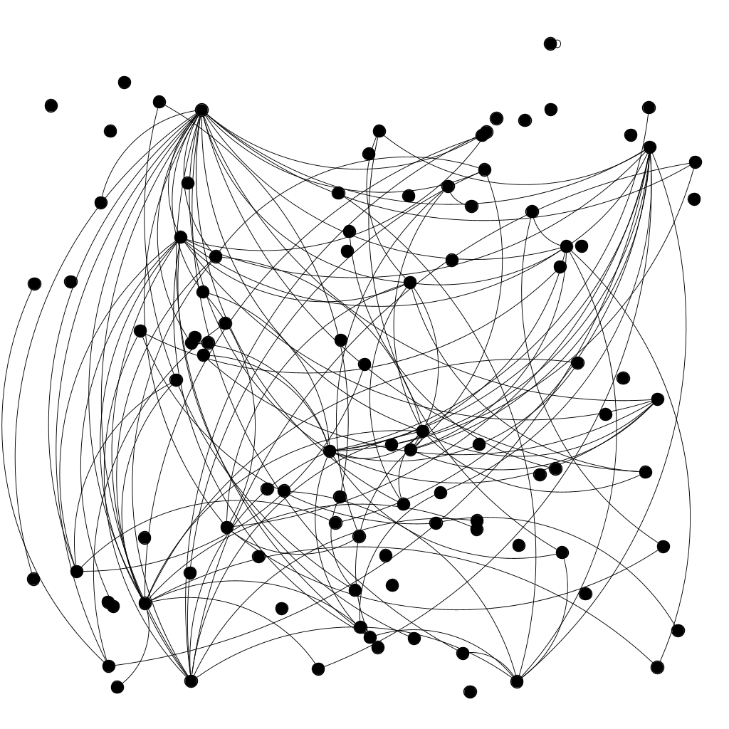
A continuación la descripción de las referencias:
Article | Referred Article
A machine-learning–based algorithm improves prediction of preeclampsia-associated adverse outcomes | A more accurate prediction to rule in and rule out pre-eclampsia using the sFlt-1/PlGF ratio and NT-proBNP as biomarkers
A machine-learning–based algorithm improves prediction of preeclampsia-associated adverse outcomes | Clinical risk assessment in early pregnancy for preeclampsia in nulliparous women: A population based cohort study
A machine-learning–based algorithm improves prediction of preeclampsia-associated adverse outcomes | Early prediction of preeclampsia via machine learning
A machine-learning–based algorithm improves prediction of preeclampsia-associated adverse outcomes | Prediction model development of late-onset preeclampsia using machine learning-based methods
Application of Artificial Intelligence in Screening for Adverse Perinatal Outcomes—A Systematic Review | Application of artificial intelligence in screening for adverse perinatal outcomes: A protocol for systematic review
Application of Artificial Intelligence in Screening for Adverse Perinatal Outcomes—A Systematic Review | Machine Learning Approach for Preterm Birth Prediction Based on Maternal Chronic Conditions
Application of Artificial Intelligence in Screening for Adverse Perinatal Outcomes—A Systematic Review | Prediction model development of late-onset preeclampsia using machine learning-based methods
Application of machine learning to identify risk factors of birth asphyxia | Perinatal health predictors using artificial intelligence: A review
Artificial intelligence technologies in predicting preeclampsia | Early prediction of preeclampsia via machine learning
Artificial intelligence technologies in predicting preeclampsia | Prediction model development of late-onset preeclampsia using machine learning-based methods
Artificial intelligence-assisted prediction of preeclampsia: Development and external validation of a nationwide health insurance dataset of the BPJS Kesehatan in Indonesia | Prediction model development of late-onset preeclampsia using machine learning-based methods
Automatic Placenta Abnormality Detection Using Convolutional Neural Networks on Ultrasound Texture | Prediction model development of late-onset preeclampsia using machine learning-based methods
Automatic Placenta Abnormality Detection Using Convolutional Neural Networks on Ultrasound Texture | Prediction of preeclampsia and intrauterine growth restriction: Development of machine learning models on a prospective cohort
Blood biomarkers representing maternal-fetal interface tissues used to predict early-and late-onset preeclampsia but not COVID-19 infection | Artificial intelligence-assisted prediction of preeclampsia: Development and external validation of a nationwide health insurance dataset of the BPJS Kesehatan in Indonesia
C1431T variant of PPAR? is associated with preeclampsia in pregnant women | A machine learning algorithm for predicting maternal readmission for hypertensive disorders of pregnancy
C1431T variant of PPAR? is associated with preeclampsia in pregnant women | Artificial intelligence-assisted prediction of preeclampsia: Development and external validation of a nationwide health insurance dataset of the BPJS Kesehatan in Indonesia
C1431T variant of PPAR? is associated with preeclampsia in pregnant women | Machine learning as a strategy to account for dietary synergy: an illustration based on dietary intake and adverse pregnancy outcomes
C1431T variant of PPAR? is associated with preeclampsia in pregnant women | Prediction model development of late-onset preeclampsia using machine learning-based methods
Comparison of machine learning and logistic regression as predictive models for adverse maternal and neonatal outcomes of preeclampsia: A retrospective study | Artificial intelligence-assisted prediction of preeclampsia: Development and external validation of a nationwide health insurance dataset of the BPJS Kesehatan in Indonesia
Comparison of machine learning and logistic regression as predictive models for adverse maternal and neonatal outcomes of preeclampsia: A retrospective study | Clinical risk assessment in early pregnancy for preeclampsia in nulliparous women: A population based cohort study
Comparison of machine learning and logistic regression as predictive models for adverse maternal and neonatal outcomes of preeclampsia: A retrospective study | Early prediction of preeclampsia via machine learning
Comparison of machine learning and logistic regression as predictive models for adverse maternal and neonatal outcomes of preeclampsia: A retrospective study | Prediction model development of late-onset preeclampsia using machine learning-based methods
Comparison of machine learning and logistic regression as predictive models for adverse maternal and neonatal outcomes of preeclampsia: A retrospective study | Prediction of preeclampsia and intrauterine growth restriction: Development of machine learning models on a prospective cohort
Comparison of machine learning and logistic regression as predictive models for adverse maternal and neonatal outcomes of preeclampsia: A retrospective study | Predictive models of hypertensive disorders in pregnancy based on support vector machine algorithm
Comparison of machine learning and logistic regression as predictive models for adverse maternal and neonatal outcomes of preeclampsia: A retrospective study | The prediction of preeclampsia: the way forward
Comparison of multivariable logistic regression and other machine learning algorithms for prognostic prediction studies in pregnancy care: Systematic review and meta-analysis | Artificial intelligence-assisted prediction of preeclampsia: Development and external validation of a nationwide health insurance dataset of the BPJS Kesehatan in Indonesia
Comparison of multivariable logistic regression and other machine learning algorithms for prognostic prediction studies in pregnancy care: Systematic review and meta-analysis | Clinical risk assessment in early pregnancy for preeclampsia in nulliparous women: A population based cohort study
Comparison of multivariable logistic regression and other machine learning algorithms for prognostic prediction studies in pregnancy care: Systematic review and meta-analysis | Deep learning predicts extreme preterm birth from electronic health records
Comparison of multivariable logistic regression and other machine learning algorithms for prognostic prediction studies in pregnancy care: Systematic review and meta-analysis | Prediction model development of late-onset preeclampsia using machine learning-based methods
Cyber-Physical Platform for Preeclampsia Detection | Early detection of preeclampsia based on a machine learning approach
Cyber-Physical Platform for Preeclampsia Detection | Hypertension detection based on machine learning
Data-Driven Modeling of Pregnancy-Related Complications | Deep learning predicts extreme preterm birth from electronic health records
Data-Driven Modeling of Pregnancy-Related Complications | Early prediction of preeclampsia via machine learning
Data-Driven Modeling of Pregnancy-Related Complications | Prediction of preeclampsia and intrauterine growth restriction: Development of machine learning models on a prospective cohort
Development of a prediction model on preeclampsia using machine learning-based method: a retrospective cohort study in China | A machine-learning–based algorithm improves prediction of preeclampsia-associated adverse outcomes
Development of a prediction model on preeclampsia using machine learning-based method: a retrospective cohort study in China | Novel electronic health records applied for prediction of pre-eclampsia: Machine-learning algorithms
Development of a prediction model on preeclampsia using machine learning-based method: a retrospective cohort study in China | Prediction model development of late-onset preeclampsia using machine learning-based methods
Development of early prediction model for pregnancy-associated hypertension with graph-based semi-supervised learning | Artificial intelligence-assisted prediction of preeclampsia: Development and external validation of a nationwide health insurance dataset of the BPJS Kesehatan in Indonesia
Development of early prediction model for pregnancy-associated hypertension with graph-based semi-supervised learning | Clinical risk assessment in early pregnancy for preeclampsia in nulliparous women: A population based cohort study
Development of early prediction model for pregnancy-associated hypertension with graph-based semi-supervised learning | Early prediction of preeclampsia via machine learning
Development of early prediction model for pregnancy-associated hypertension with graph-based semi-supervised learning | Prediction model development of late-onset preeclampsia using machine learning-based methods
Development of early prediction model for pregnancy-associated hypertension with graph-based semi-supervised learning | Prediction of preeclampsia and intrauterine growth restriction: Development of machine learning models on a prospective cohort
Dynamic gestational week prediction model for pre-eclampsia based on ID3 algorithm | Prediction of preeclampsia and intrauterine growth restriction: Development of machine learning models on a prospective cohort
Early prediction and longitudinal modeling of preeclampsia from multiomics | Early prediction of preeclampsia via machine learning
Early prediction of preeclampsia via machine learning | Prediction model development of late-onset preeclampsia using machine learning-based methods
GestAltNet: aggregation and attention to improve deep learning of gestational age from placental whole-slide images | Decidual Vasculopathy Identification in Whole Slide Images Using Multiresolution Hierarchical Convolutional Neural Networks
Improving preeclampsia risk prediction by modeling pregnancy trajectories from routinely collected electronic medical record data | Early prediction of preeclampsia via machine learning
Machine learning and disease prediction in obstetrics | A more accurate prediction to rule in and rule out pre-eclampsia using the sFlt-1/PlGF ratio and NT-proBNP as biomarkers
Machine learning and disease prediction in obstetrics | Using Machine Learning to Predict Complications in Pregnancy: A Systematic Review
Machine learning applied in maternal and fetal health: a narrative review focused on pregnancy diseases and complications | Application of Artificial Intelligence in Screening for Adverse Perinatal Outcomes—A Systematic Review
Machine learning applied in maternal and fetal health: a narrative review focused on pregnancy diseases and complications | Artificial intelligence-assisted prediction of preeclampsia: Development and external validation of a nationwide health insurance dataset of the BPJS Kesehatan in Indonesia
Machine learning applied in maternal and fetal health: a narrative review focused on pregnancy diseases and complications | Clinical risk assessment in early pregnancy for preeclampsia in nulliparous women: A population based cohort study
Machine learning applied in maternal and fetal health: a narrative review focused on pregnancy diseases and complications | Comparison of multivariable logistic regression and other machine learning algorithms for prognostic prediction studies in pregnancy care: Systematic review and meta-analysis
Machine learning applied in maternal and fetal health: a narrative review focused on pregnancy diseases and complications | Contribution of Artificial Intelligence in Pregnancy: A Scoping Review
Machine learning applied in maternal and fetal health: a narrative review focused on pregnancy diseases and complications | Deep learning predicts extreme preterm birth from electronic health records
Machine learning applied in maternal and fetal health: a narrative review focused on pregnancy diseases and complications | Early prediction of preeclampsia via machine learning
Machine learning applied in maternal and fetal health: a narrative review focused on pregnancy diseases and complications | Machine learning as a strategy to account for dietary synergy: an illustration based on dietary intake and adverse pregnancy outcomes
Machine learning applied in maternal and fetal health: a narrative review focused on pregnancy diseases and complications | Perinatal health predictors using artificial intelligence: A review
Machine learning applied in maternal and fetal health: a narrative review focused on pregnancy diseases and complications | Prediction model development of late-onset preeclampsia using machine learning-based methods
Machine learning applied in maternal and fetal health: a narrative review focused on pregnancy diseases and complications | Prediction of preeclampsia and intrauterine growth restriction: Development of machine learning models on a prospective cohort
Machine learning applied in maternal and fetal health: a narrative review focused on pregnancy diseases and complications | Ultrasound placental image texture analysis using artificial intelligence to predict hypertension in pregnancy
Machine learning applied in maternal and fetal health: a narrative review focused on pregnancy diseases and complications | Using Machine Learning to Predict Complications in Pregnancy: A Systematic Review
Machine learning models for predicting pre-eclampsia: A systematic review protocol | Early prediction of preeclampsia via machine learning
Machine Learning to Predict Pre-Eclampsia and Intrauterine Growth Restriction in Pregnant Women | Prediction of preeclampsia and intrauterine growth restriction: Development of machine learning models on a prospective cohort
New advances in prediction and surveillance of preeclampsia: role of machine learning approaches and remote monitoring | A machine-learning–based algorithm improves prediction of preeclampsia-associated adverse outcomes
New advances in prediction and surveillance of preeclampsia: role of machine learning approaches and remote monitoring | Artificial intelligence-assisted prediction of preeclampsia: Development and external validation of a nationwide health insurance dataset of the BPJS Kesehatan in Indonesia
New advances in prediction and surveillance of preeclampsia: role of machine learning approaches and remote monitoring | Clinical risk assessment in early pregnancy for preeclampsia in nulliparous women: A population based cohort study
New advances in prediction and surveillance of preeclampsia: role of machine learning approaches and remote monitoring | Early prediction of preeclampsia via machine learning
New advances in prediction and surveillance of preeclampsia: role of machine learning approaches and remote monitoring | Improving preeclampsia risk prediction by modeling pregnancy trajectories from routinely collected electronic medical record data
New advances in prediction and surveillance of preeclampsia: role of machine learning approaches and remote monitoring | Prediction model development of late-onset preeclampsia using machine learning-based methods
Novel Early Pregnancy Multimarker Screening Test for Preeclampsia Risk Prediction | Early prediction of preeclampsia via machine learning
Novel Early Pregnancy Multimarker Screening Test for Preeclampsia Risk Prediction | Prediction model development of late-onset preeclampsia using machine learning-based methods
Novel Early Pregnancy Multimarker Screening Test for Preeclampsia Risk Prediction | Using Machine Learning to Predict Complications in Pregnancy: A Systematic Review
Novel electronic health records applied for prediction of pre-eclampsia: Machine-learning algorithms | Clinical risk assessment in early pregnancy for preeclampsia in nulliparous women: A population based cohort study
Novel electronic health records applied for prediction of pre-eclampsia: Machine-learning algorithms | Prediction model development of late-onset preeclampsia using machine learning-based methods
Polygenic Risk Score and Risk Factors for Preeclampsia and Gestational Hypertension | C1431T variant of PPAR? is associated with preeclampsia in pregnant women
Pre-eclampsia Risk Factors Association with Cardiovascular Disease Prediction and Diagnosing Using Machine Learning | Artificial intelligence-assisted prediction of preeclampsia: Development and external validation of a nationwide health insurance dataset of the BPJS Kesehatan in Indonesia
Predicting the Risk of Preeclampsia using Soft Voting-based Ensemble and Its Recommendation | Early detection of preeclampsia based on a machine learning approach
Prediction of Delivery Within 7 Days After Diagnosis of Early Onset Preeclampsia Using Machine-Learning Models | Early prediction of preeclampsia via machine learning
Prediction of Delivery Within 7 Days After Diagnosis of Early Onset Preeclampsia Using Machine-Learning Models | Prediction model development of late-onset preeclampsia using machine learning-based methods
Prediction of HELLP Syndrome Severity Using Machine Learning Algorithms—Results from a Retrospective Study | A machine-learning–based algorithm improves prediction of preeclampsia-associated adverse outcomes
Prediction of HELLP Syndrome Severity Using Machine Learning Algorithms—Results from a Retrospective Study | Comparison of multivariable logistic regression and other machine learning algorithms for prognostic prediction studies in pregnancy care: Systematic review and meta-analysis
Prediction of HELLP Syndrome Severity Using Machine Learning Algorithms—Results from a Retrospective Study | Prediction model development of late-onset preeclampsia using machine learning-based methods
Prediction of Preeclampsia Using Machine Learning and Deep Learning Models: A Review | A machine-learning–based algorithm improves prediction of preeclampsia-associated adverse outcomes
Prediction of Preeclampsia Using Machine Learning and Deep Learning Models: A Review | Artificial intelligence-assisted prediction of preeclampsia: Development and external validation of a nationwide health insurance dataset of the BPJS Kesehatan in Indonesia
Prediction of Preeclampsia Using Machine Learning and Deep Learning Models: A Review | Development of a prediction model on preeclampsia using machine learning-based method: a retrospective cohort study in China
Prediction of Preeclampsia Using Machine Learning and Deep Learning Models: A Review | Early detection of preeclampsia based on a machine learning approach
Prediction of Preeclampsia Using Machine Learning and Deep Learning Models: A Review | Early prediction of preeclampsia via machine learning
Prediction of Preeclampsia Using Machine Learning and Deep Learning Models: A Review | Feature selection algorithms for predicting preeclampsia: A comparative approach
Prediction of Preeclampsia Using Machine Learning and Deep Learning Models: A Review | Novel electronic health records applied for prediction of pre-eclampsia: Machine-learning algorithms
Prediction of Preeclampsia Using Machine Learning and Deep Learning Models: A Review | Prediction model development of late-onset preeclampsia using machine learning-based methods
Prediction of Preeclampsia Using Machine Learning and Deep Learning Models: A Review | Prediction of Delivery Within 7 Days After Diagnosis of Early Onset Preeclampsia Using Machine-Learning Models
Prediction of Preeclampsia Using Machine Learning and Deep Learning Models: A Review | Prediction of preeclampsia and intrauterine growth restriction: Development of machine learning models on a prospective cohort
Prediction of Preeclampsia Using Machine Learning and Deep Learning Models: A Review | Prediction of severe preeclampsia in machine learning
Prediction of severe preeclampsia in machine learning | Artificial intelligence-assisted prediction of preeclampsia: Development and external validation of a nationwide health insurance dataset of the BPJS Kesehatan in Indonesia
Prediction of severe preeclampsia in machine learning | Prediction model development of late-onset preeclampsia using machine learning-based methods
Predictive Model for Preeclampsia Combining sFlt-1, PlGF, NT-proBNP, and Uric Acid as Biomarkers | A more accurate prediction to rule in and rule out pre-eclampsia using the sFlt-1/PlGF ratio and NT-proBNP as biomarkers
Predictive Performance of Machine Learning-Based Methods for the Prediction of Preeclampsia—A Prospective Study | A machine-learning–based algorithm improves prediction of preeclampsia-associated adverse outcomes
Predictive Performance of Machine Learning-Based Methods for the Prediction of Preeclampsia—A Prospective Study | Comparison of multivariable logistic regression and other machine learning algorithms for prognostic prediction studies in pregnancy care: Systematic review and meta-analysis
Predictive Performance of Machine Learning-Based Methods for the Prediction of Preeclampsia—A Prospective Study | Prediction model development of late-onset preeclampsia using machine learning-based methods
Pregnancy and spontaneous cervical artery dissection: A propensity-matched retrospective cohort study | Pregnancy and spontaneous cervical artery dissection: A propensity-matched retrospective cohort study
Preterm preeclampsia screening using biomarkers: combining phenotypic classifiers into robust prediction models | Machine-learning-based prediction of pre-eclampsia using first-trimester maternal characteristics and biomarkers
Project SWAVE 2.0: An overview of the study design for multimodal placental image acquisition and alignment | Decidual Vasculopathy Identification in Whole Slide Images Using Multiresolution Hierarchical Convolutional Neural Networks
Project SWAVE 2.0: An overview of the study design for multimodal placental image acquisition and alignment | GestAltNet: aggregation and attention to improve deep learning of gestational age from placental whole-slide images
Risk Prediction Model of Early-Onset Preeclampsia Based on Risk Factors and Routine Laboratory Indicators | Prediction model development of late-onset preeclampsia using machine learning-based methods
The role of artificial intelligence in hypertensive disorders of pregnancy: towards personalized healthcare | A cost-effective machine learning-based method for preeclampsia risk assessment and driver genes discovery
The role of artificial intelligence in hypertensive disorders of pregnancy: towards personalized healthcare | A machine learning algorithm for predicting maternal readmission for hypertensive disorders of pregnancy
The role of artificial intelligence in hypertensive disorders of pregnancy: towards personalized healthcare | A machine-learning–based algorithm improves prediction of preeclampsia-associated adverse outcomes
The role of artificial intelligence in hypertensive disorders of pregnancy: towards personalized healthcare | Artificial intelligence-assisted prediction of preeclampsia: Development and external validation of a nationwide health insurance dataset of the BPJS Kesehatan in Indonesia
The role of artificial intelligence in hypertensive disorders of pregnancy: towards personalized healthcare | Development of a prediction model on preeclampsia using machine learning-based method: a retrospective cohort study in China
The role of artificial intelligence in hypertensive disorders of pregnancy: towards personalized healthcare | Development of early prediction model for pregnancy-associated hypertension with graph-based semi-supervised learning
The role of artificial intelligence in hypertensive disorders of pregnancy: towards personalized healthcare | Early prediction and longitudinal modeling of preeclampsia from multiomics
The role of artificial intelligence in hypertensive disorders of pregnancy: towards personalized healthcare | Integrated metabolomics and machine learning approach to predict hypertensive disorders of pregnancy
The role of artificial intelligence in hypertensive disorders of pregnancy: towards personalized healthcare | Prediction model development of late-onset preeclampsia using machine learning-based methods
The role of artificial intelligence in hypertensive disorders of pregnancy: towards personalized healthcare | Prediction of Adverse Outcomes in De Novo Hypertensive Disorders of Pregnancy: Development and Validation of Maternal and Neonatal Prognostic Models
The role of artificial intelligence in hypertensive disorders of pregnancy: towards personalized healthcare | Predictive models of hypertensive disorders in pregnancy based on support vector machine algorithm
The role of artificial intelligence in hypertensive disorders of pregnancy: towards personalized healthcare | Ultrasound placental image texture analysis using artificial intelligence to predict hypertension in pregnancy
The use of artificial intelligence and machine learning methods in early pregnancy preeclampsia screening: A systematic review protocol | The prediction of preeclampsia: the way forward
The use of artificial intelligence and machine learning methods in early pregnancy preeclampsia screening: A systematic review protocol | Using Machine Learning to Predict Complications in Pregnancy: A Systematic Review
Use of artificial intelligence in obstetrics: not quite ready for prime time | Prediction model development of late-onset preeclampsia using machine learning-based methods
Using Machine Learning to Predict Complications in Pregnancy: A Systematic Review | Comparison of multivariable logistic regression and other machine learning algorithms for prognostic prediction studies in pregnancy care: Systematic review and meta-analysis
Using Machine Learning to Predict Complications in Pregnancy: A Systematic Review | Prediction model development of late-onset preeclampsia using machine learning-based methods

Artículos más referidos entre los artículos primarios:
Prediction model development of late-onset preeclampsia using machine learning-based methods | 24
Early prediction of preeclampsia via machine learning | 13
Artificial intelligence-assisted prediction of preeclampsia: Development and external validation of a nationwide health insurance dataset of the BPJS Kesehatan in Indonesia | 11
Prediction of preeclampsia and intrauterine growth restriction: Development of machine learning models on a prospective cohort | 8
Clinical risk assessment in early pregnancy for preeclampsia in nulliparous women: A population based cohort study | 7

Artículos que más refieren a otros artículos del grupo de primarios:
Machine learning applied in maternal and fetal health: a narrative review focused on pregnancy diseases and complications | 13
The role of artificial intelligence in hypertensive disorders of pregnancy: towards personalized healthcare | 12
Prediction of Preeclampsia Using Machine Learning and Deep Learning Models: A Review | 11
Comparison of machine learning and logistic regression as predictive models for adverse maternal and neonatal outcomes of preeclampsia: A retrospective study | 7
New advances in prediction and surveillance of preeclampsia: role of machine learning approaches and remote monitoring | 6

Revistas más utilizadas para publicar este tipo de artículos (primarios):
American Journal of Obstetrics and Gynecology MFM | 9
Frontiers in Cardiovascular Medicine | 3
Lecture Notes in Electrical Engineering | 3
PLoS ONE | 3
Pregnancy Hypertension | 2
Scientific Reports | 2
Life | 2
Frontiers in Physiology | 2
Ultrasound in Obstetrics and Gynecology | 2

Congresos más utilizados para publicar este tipo de artículos (primarios):
2019 E-Health and Bioengineering Conference (EHB) | 1
2020 IEEE International Conference on Bioinformatics and Biomedicine (BIBM) | 1
2020 International Symposium on Community-centric Systems (CcS) | 1
2021 Joint International Conference on Digital Arts, Media and Technology with ECTI Northern Section Conference on Electrical, Electronics, Computer and Telecommunication Engineering | 1
ECBS '19: 6th Conference on the Engineering of Computer Based Systems | 1
KDD '19: The 25th ACM SIGKDD Conference on Knowledge Discovery and Data Mining | 1

11. Clasificación sobre el enfoque de los artículos

A miras de enriquecer el proceso de revisión, se incorporó la evaluación del enfoque de los artículos en una clasificación definida. Para esto se puso todos los títulos de los artículos primarios en chat GPT 4, versión web, y se le pidió que genere la lista de posibles tags de clasificación al respecto del enfoque. Se utilizó el siguiente prompt:

I need 15 classification tags of the different approaches of the following article titles, focusing on the way they achieve predictions of preeclampsia using AI algorithms: <titles>

Se obtuvieron los siguientes tags de clasificación:

Given the vast range of article titles you've provided that revolve around predicting preeclampsia using AI algorithms, there are multiple approaches being taken based on the methods, data types, and strategies mentioned. Here are 15 classification tags derived from these titles:
- Machine Learning Approaches: This would encompass articles mentioning "machine learning", "algorithm", or specific methods like "XGBoost" or "LightGBM".
- Deep Learning Approaches: Articles that reference "Deep Learning", "Neural Networks", or "Convolutional Neural Networks".
- Genetic and Biomarker Analysis: Articles that mention "biomarkers", "genetic", "Single Nucleotide Polymorphism", or specific genes and molecules like "sFlt-1", "PlGF", etc.
- Imaging and Ultrasound Techniques: Titles focusing on "ultrasound", "ultrasonic image features", "placental whole-slide images", or "radiomics".
- Natural Language Processing (NLP): Articles that utilize "natural language processing" for predictions, like admission notes.
- Chatbots and Cyber-Physical Systems: Titles referencing "chatbot" or "cyber-physical platform".
- Clinical and Laboratory Indicators: Articles focusing on "routine laboratory indicators", "maternal characteristics", "blood lipidome", etc.
- Reviews and Meta-Analysis: Titles mentioning "review", "systematic review", or "meta-analysis".
- Dietary and Nutritional Analysis: Titles that mention "dietary synergy" or "dietary intake".
- Integrated Multi-Omics Analysis: Titles referencing "multiomics" or a combination of various 'omics' techniques.
- Data Mining and Database Analysis: Titles that mention "data mining" or specific databases like "nationwide health insurance dataset".
- Risk and Severity Analysis: Articles focusing on "risk factors", "severity", "prognostic models", or "risk assessment".
- Prospective and Retrospective Studies: Mention of study designs like "prospective study", "retrospective study", or "cohort study".
- Special Populations: Titles that might focus on specific populations or conditions, like "COVID-19 pandemic", "gestational diabetes", or "nulliparous women".
- Integration with Clinical Practice: Articles discussing the integration of AI in clinical settings, like "clinical decision support", "clinical risk assessment", or "standardizing quality of care".
These classification tags are broad enough to cover a substantial portion of the approaches taken in the articles while being specific enough to offer a clear distinction between each classification.

Luego se hizo una evaluación uno a uno de los artículos ejecutando una búsqueda por medio del API. Se utilizó el modelo gpt-3.5-turbo de OpenAI. Se utilizó el siguiente prompt:

Given article info:title:\"" + titleField + (abstractField != null ? ("\" and abstract:\"" + abstractField + "\"") : "") + ";Give the tag name of the classification tag it could be mainly related. In JSON like {\"tag\":<value>}.The classification tags are the following: 1.Machine Learning Approaches: 'machine learning', 'algorithm', or specific methods like 'XGBoost' or 'LightGBM'.2.Deep Learning Approaches: 'Deep Learning', 'Neural Networks', or 'Convolutional Neural Networks'.3.Genetic and Biomarker Analysis: 'biomarkers', 'genetic', 'Single Nucleotide Polymorphism', or specific genes and molecules like 'sFlt-1', 'PlGF', etc.4.Imaging and Ultrasound Techniques: 'ultrasound', 'ultrasonic image features', 'placental whole-slide images', or 'radiomics'.5.Natural Language Processing (NLP): 'natural language processing' for predictions, like admission notes.6.Chatbots and Cyber-Physical Systems: 'chatbot' or 'cyber-physical platform'.7.Clinical and Laboratory Indicators: 'routine laboratory indicators', 'maternal characteristics', 'blood lipidome', etc.8.Reviews and Meta-Analysis: 'review', 'systematic review', or 'meta-analysis'.9.Dietary and Nutritional Analysis: 'dietary synergy' or 'dietary intake'.10.Integrated Multi-Omics Analysis: 'multiomics' or a combination of various 'omics' techniques.11.Data Mining and Database Analysis: 'data mining' or specific databases like 'nationwide health insurance dataset'.12.Risk and Severity Analysis: 'risk factors', 'severity', 'prognostic models', or 'risk assessment'.13.Prospective and Retrospective Studies: 'prospective study', 'retrospective study', or 'cohort study'.14.Special Populations: specific populations or conditions, like 'COVID-19 pandemic', 'gestational diabetes', or 'nulliparous women'.15.Integration with Clinical Practice: integration of AI in clinical settings, like 'clinical decision support', 'clinical risk assessment', or 'standardizing quality of care'.

Luego se realizó una limpieza de datos. La clasificación de los artículos seleccionados, conforme su enfoque es el siguiente:

Article focus | Article Number
Machine Learning Approaches | 35
Genetic and Biomarker Analysis | 14
Risk and Severity Analysis | 9
Prospective and Retrospective Studies | 7
Reviews and Meta-Analysis | 6
Imaging and Ultrasound Techniques | 5
Deep Learning Approaches | 5
Clinical and Laboratory Indicators | 4
Integrated Multi-Omics Analysis | 4
Natural Language Processing (NLP) | 3
Chatbots and Cyber-Physical Systems | 2
Data Mining and Database Analysis | 2
Dietary and Nutritional Analysis | 1
Integration with Clinical Practice | 1
Special Populations | 1

estoy haciendo una revisión sistemática de literatura, justo al respecto de estos artículos que estuviste viendo antes y de otros tantos que quiero revisar. Son 145 artículos que entran en revisión. quiero crear un algoritmo en C#, .net framework 4.7.2, que llame a chatGPT (modelo chatgpt-5), le pase todos los datos que dispone descargados del artículo, principalmente el título y el abstract, porque de ninguno tiene el contenido compleeto, y logre responder las preguntas de investigación. tengo 7 preguntas de investigación, que son las siguientes:

1. What machine learning (ML) or artificial intelligence (AI) models have been developed or applied to predict preeclampsia and its complications in pregnant women?
(P: Pregnant women; I: ML/AI models; C: Traditional models or no intervention; O: Prediction of preeclampsia and complications such as eclampsia or HELLP syndrome).
2. What is the reported performance (e.g., AUC, accuracy, sensitivity, specificity) of ML/AI models used for predicting preeclampsia in published studies?
(P: Pregnant women at risk of preeclampsia; I: ML/AI models; C: Comparisons between models; O: Performance metrics such as AUC or accuracy).
3. What public or private data repositories are available for preeclampsia research, including clinical, genomic, or omics datasets?
(P: Preeclampsia patient data; I: Data repositories; C: Public vs. private; O: Accessibility and data types).
4. What clinical variables or electronic health record (EHR) data are most commonly used in ML/AI models for predicting preeclampsia?
(P: Pregnant women; I: Input variables in ML/AI models; C: Clinical variables vs. biomarkers; O: Frequency of use and predictive relevance).
5. What is the accuracy and validity of ML/AI models for predicting preeclampsia in observational studies or prospective cohorts?
(P: Pregnant women in observational/prospective cohorts; I: ML/AI models; C: Retrospective studies; O: Accuracy/validity metrics such as AUC in real-world settings).
6. Are there studies that include external validations or comparisons between different ML/AI techniques for preeclampsia prediction?
(P: Pregnant women; I: ML/AI techniques; C: Comparisons between methods, e.g., ML vs. logistic regression; O: Results of external validations or comparisons).
7. What explainability techniques (e.g., SHAP, LIME, EBM) have been employed in machine learning or artificial intelligence models for predicting preeclampsia, and how do these techniques contribute to interpretability, clinical trust, and applicability in clinical settings? (P: Pregnant women; I: Explainability techniques in ML/AI models; C: Models without explainability or traditional methods; O: Interpretability, clinical trust, and practical applicability). .. necesito desarrollar el algoritmo y el prompt, de tal manera que yo pueda tener un json con la postura de cada artículo a las preguntas. Voy a iterar uno por uno los artículos y llamando el prompt y obteniendo un json de resultado integral con los resultados. Luego la idea es grabar de retorno en la base de datos el json. Luego tendría que hacer un programa que lea esa estructura json (por eso debe ser estandar) y llenar columnas con datos sintetizados.

