**COURSE CODE : MFNCE202 COURSE NAME: FINANCIAL MARKETS and INSTITUTIONS Task brief & rubrics**

Anna Fesiuk

Finance

**Analyst of Boeing**

**Describe graphically the trend of the stock prices during the last 3 years and, in more detail, during the last 3 weeks.**

Boeing experienced turbulence long before the pandemic. Boeing's 737 Max made its first flight in 2016. In 2017, Boeing began accepting orders for their delivery in the amount of 2553 pieces, but in 2019 there were 2 large-scale air crashes with human casualties, which raised doubts about the reliability of this model and the possibility of its further implementation.

Boeing shares have not rebounded after falling 817% in March 2020 to 2019 levels. The fall was caused by quarantine due to the coronavirus. Decrease in demand for travel, restrictions, panic of the population seriously affected the financial condition of the company. The company's shares rose 584% in June 2020, according to data provided by S&P Global Market Intelligence, as investors gained confidence that the worst for Boeing was over. Since news broke in June that the company plans to recertify the 737 Max by the end of June, a key step towards getting the aircraft airborne again. On November 30, shares rose by 675% in connection with the news about the appearance of a vaccine against coronavirus. On March 8, the US stock market rose due to the publication of data on the labor market in America. Boeing shares are up 797% on that day. On May 16, the company's shares fell 302% as the Fed signaled aggressive interest rate hikes to combat inflation. The 10-year treasury yield hit a four-year high before retreating. On September 26, 2022, a 303% drop in Boeing stock prices was caused by general news in the US stock market. Investors were highly concerned about an imminent recession in the world. The Fed failed with control of rising inflation.

Now I'd like to analyze Boeing shares over the last 3 weeks. January 10 was a decrease of 5.78%. In general, the last 3 weeks are characterized by high volatility. However, the overall change in price over the 3 weeks was 0.49%. Growth since the beginning of 2023 was 9.7%. China Southern Airlines has restored the 737 MAX flight schedule. The 737 MAX is flying around the world again and demand for air travel has rebounded.

**Explain the observed trends**

As you can see, Boeing is showing a positive trend for 2023. After a bad reputation due to the failed production of the MAX 737 aircraft, restrictions due to the pandemic, a sharp increase in the US interest rate and scary news of an imminent high recession, the company was able to return to the Chinese market in 2023 and sees an increase in demand for aircraft. At the moment, it is important for the company not to face a new wave of news about the recession, as expected demand for aircraft may fall.

**Relate these trends to relevant contextual information.**

It's important to understand that Boeing's stock price is currently 40% lower than it was before the pandemic, but that doesn't mean it's a bargain. I would like to draw attention to the growth of long-term debt in 2020 due to the pandemic. The company decided to increase its loan portfolio in order to more easily endure a difficult financial period due to the coronavirus. The growth of long-term debt after 2019 amounted to 168%. As you can see from the graph, the company has not significantly reduced the figure since 2019. Moreover, the situation with the 737 MAX aircraft accidents is not only a loss in sales, it is a loss of the company's reputation. In order to regain investor confidence, time is needed and a clear understanding that at the moment all the shortcomings have been eliminated and the company is ready to increase production.Chart, bar chart

**Regarding this context, briefly forecast the changes in prices for the next 5 years.**

In my forecast for the future, I focus on the analysis of the aircraft manufacturing industry until 2030. As you can see from the graph, manufacturing of aircrafts will grow after the crush in 2020 and the industry will come back to the before Covid-19 numbers in 2025. Asia will have more extend growing than other regions in the future. In terms of revenue share, the commercial segment is predicted to dominate the market in 2021 and for the foreseeable future. The estimated factors driving the segment's growth are the rising demand for cargo services and the expansion of international trade. In the forecasted years, the military & defense category is expected to increase at the quickest rate. The global military & defense industry's growing need to replace outdated aircraft is propelling the segment's expansion. Additionally, it is predicted that the market would have significant development potential due to the increased investments in defense aircraft by governments worldwide to improve their capabilities for aerial combat.Chart, bar chart

Next, I would like to analyze the company's financial statements from 2018 to 2022. This will help confirm or refute my predictions that Boeing stock is not a good investment in 2023 and the company will have to get rid of the consequences of the macroeconomic situation in 2021 and its own mistakes in 2019 for a long time.

As you can see, since 2021, the company has normalized FCF, at the moment the indicator is positive, which means that Boeing has free cash after capital asset and operating costs. The indicator was discounted by WACC, which helps to estimate the present value of the free cash flow and total NPV for the company. WACC was calculated based on cost of equity and cost of debt. Cost of debt for the company is 4.39% and cost of equity is 10.02%. The growth of the company is an average CAGR in 2021 and 2022 years. I have decided that Covid-19 is an unusual event for the industry, and I should not include numbers from these years. CAGR is compound annual growth rate. According to the current prices for the Boeings’ shares, the market value of the company is $123,240,000. However, I have decided to calculate the value of the company by myself. According to the EBITDA*10 method, value of the company is $16,390,000. Second method is using formula of perpetuity. I have added discounted FCF from 2018 to 2022 and add PV of perpetuity. My final result (according to NPV method) is $39,499,000 for the company. To sum up, I am sure that price of the shares if not really advantageous.

|  |  |  |  |  |  |  |  |  |  |  |
| --- | --- | --- | --- | --- | --- | --- | --- | --- | --- | --- |
|  | 1 | 2 | 3 | 4 | 5 | 6 | 7 | 8 | 9 | 10 |
| Period | 2018 | 2019 | 2020 | 2021 | 2022 | 2023 | 2024 | 2025 | 2026 | 2027 |
| FreeCashFlow | 13854 | -2566 | -7989 | 2510 | 2871 | 2915 | 2960 | 3006 | 3052 | 3099 |
| WACC | 1,08 | 1,16 | 1,26 | 1,35 | 1,46 | 1,58 | 1,70 | 1,84 | 1,98 | 2,14 |
| PV | 12840,92 | -2204,44 | -6361,44 | 1852,50 | 1963,98 | 1848,40 | 1739,62 | 1637,24 | 1540,88 | 1450,20 |
| CAGR | -7,04% | -12,99% | -8,76% | 1,73% | 1,35% |  |  |  |  |  |

|  |  |
| --- | --- |
| Valuation of the company | 000, $ |
| FCF Y6 | 2915 |
| Perpetuity | 45912 |
| NPV (perpetuity) | 31408 |
| Total NPV | 39499 |
| EBITDA*10 | 16390 |

The next important indicators are ROE and P/E ratio. Equity is negative since 2019 because of negative treasure stock. It means that the company has issued shares and decides to repurchase them lately. So, the number of outstanding decreases in this case.

ROE according to my calculations:

|  |  |  |  |  |  |  |  |  |  |  |
| --- | --- | --- | --- | --- | --- | --- | --- | --- | --- | --- |
|  | **2018** | **2019** | **2020** | **2021** | **2022** | **2023** | **2024** | **2025** | **2026** |  |
| **Capital Returns (millons ,except EPS)** |  |  |  |  |  |  |  |  |  |  |
| **EBIT** | **11843** | **-2102** | **-8485** | **-505** | **-1353** | **35608** | **36676** | **37776** | **38910** |  |
| Interest | -475 | -722 | -2156 | -2682 | -2533 | 2000 | 2000 | 1950 | 1900 |  |
| Taxes | -1144 | 1623 | 2535 | 743 | -31 | 4033 | 4161 | 4299 | 4441 |  |
| **Net income** | **10460** | **-636** | **-11873** | **-4202** | **-4935** | **29453** | **30390** | **31398** | **32436** |  |
| (+) Cash and cash equivalents | 7637 | 9485 | 7752 | 8052 | 14614 | 15052 | 15504 | 15969 | 16448 |  |
| **(+) Debt total** | 116949 | 141925 | 170211 | 153398 | 152948 | 157536 | 162263 | 167130 | 172144 |  |
| (+) Goodwill | 7840 | 8060 | 8081 | 8068 | 8057 | 0 | 0 | 0 | 0 |  |
| (+) Equity | 410 | -8300 | -18075 | -14846 | -15848 | -16323 | -16813 | -17318 | -17837 |  |
|  |  |  |  |  |  |  |  |  |  |  |
| **ROE ( net income / equity )** | **2551%** | **8%** | **66%** | **28%** | **31%** | **-180%** | **-181%** | **-181%** | **-182%** |  |

ROE for a company is an indicator with terrible volatility. Investors should not base their expectation of a company on this indicator. Net income has been negative since 2019. So, there is no returns.

|  |  |  |  |  |  |  |
| --- | --- | --- | --- | --- | --- | --- |
| **­** | **2018** | **2019** | **2020** | **2021** | **2022** | ­­ |
| **Income Statement (millons ,except EPS)** |  |  |  |  |  |  |
| **Sales** | 101 127 | 76 559 | 58 158 | 62 286 | **66 608** |  |
| *Y/Y Growth %* | *-* | *-24%* | *-24%* | *7%* | *3%* |  |
| **EBITDA** | **13 957,0** | **169,0** | **-6 239,0** | **1 639,0** | **1 647,0** |  |
| *EBITDA margin %* | *14%* | *0%* | *-11%* | *3%* | *2%* |  |
| Depreciation & Amortization Expense | 2 114 | 2 271 | 2 246 | 2 144 | 3 000 |  |
| **EBIT** | 11 843,0 | -2 102,0 | -8 485,0 | -505,0 | -1 353,0 |  |
| *EBIT margin %* | *12%* | *-3%* | *-14,6%* | *-0,8%* | *-2%* |  |
| **Interest expense/ Income** | -475,0 | -722,0 | -2 156,0 | -2 682,0 | -2 533,0 |  |
|  |  |  |  |  |  |  |
| **Pretax Income** | **11604** | **-2259** | **-14476** | **-5033** | **-5022** |  |
| Income Taxes | -1 144,0 | 1 623,0 | 2 535,0 | 743,0 | -31 |  |
| *tax rate* | *-10%* | *-72%* | *-18%* | *-15%* | *12%* |  |
| Consolidated Net Income | 10 460 | -636 | -11 941 | -4 290 | -5 053 |  |
| Minority Interest |  |  | 68,00 | 88,00 | 118,00 |  |
| **Net Income** | **10 460** | **-636** | **-11 873** | **-4 202** | **-4 935** |  |
| *Net Incme %* | *10%* | *-1%* | *-20%* | *-7%* | *-7%* |  |
| **Net income per share ( EPS )** | **17,85** | **-1,13** | **-20,87** | **-7,15** | **-8,29** |  |
| Fully diluted shares (millions) | 586 | 565 | 569 | 588 | 595 |  |

Net income per share is negative. In this case, if a share is the ownership of a part of the company, then each investor owns a loss-making company. In 2022, there was a loss of $8.29 per share.

**Behaviour and alignment of the management with shareholders**

Company use stocks to appeal employees for productive work and raise their interest in the growth and success of it. However, the company has no profit since 2019 and has never paid dividends since that time. Management decided to compensate constant loses of the company and creative a plan to compensate 13,933,419 shares.Table

According to the information found, the compensation for shares for the CEO of the company is constantly growing, the salary is very low, and the compensation in 2022 was $ 21,090,000. David Calhoun is the president of the company and works for Boeing 3 years.

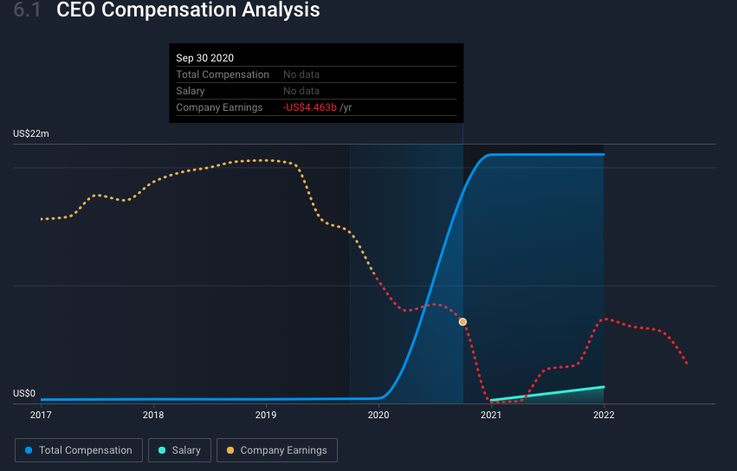

Company has never had positive net profit since 2019, but it continues to repay compensation. CFO of the company received 8 160 000 $ compensation in 2022 and another president received 7 340 000 compensations. As I can see, management of the company is experienced, average age is 52 y.o. and average tenure 2,7 y.

**Risk & Return**

Demand for our commercial aircraft and associated services is significantly influenced by market conditions. Long-term trends in the amount of passengers and cargo carried by airlines are the primary drivers of the commercial aircraft market. Long-term traffic growth is primarily driven by continuous economic expansion and political stability in both developed and emerging nations. The profitability of airlines, the availability of aircraft financing, international trade policies, government-to-government relations, technological advancements, price and other competitive factors, fuel prices, terrorism, pandemics, epidemics, and environmental regulations are additional factors that affect demand for our commercial aircraft. Significant declines in the number of new orders for aircraft or services as well as requests to delay or cancel contractual orders and/or payments to us from customers could occur as a result of significant declines in the global economy, the airline industry as a whole, or the financial stability of one or more of our largest clients. This could lead to a decline in our backlog of contracts as well as lower revenues, profitability, and cash flows. Additionally, any of these macroeconomic, industry, or customer factors could unpredictably disrupt deliveries over a lengthy period of time because our backlog of commercial aircraft includes aircraft planned for delivery over a period of many years.

The Sharp ratio compares the return of an investment with its risk, so I have calculated it in order to evaluate risk&return situation. My risk-free rate is 1,97%, daily standard deviation 3,19% and sharp ratio is equal to -0,612. It means that risk-free rate is greater than the company return. It is better to invest in treasury bonds than in Boeing stocks. Variance measures how far price of stock is spread out from the average.

The level of risk of a company can also be found out with the help of rating agencies. Boeing issued bonds at a rate of 5.705% and maturity on 30/04/2040 and S&P gave these bonds BBB- ( Lower medium grade - Investment-grade ). It means that S&P approved that Boeing has adequate capacity to meet its financial commitments. However, unfavorable economic situations or altering circumstances are more likely to make Boeing less able to fulfill its financial obligations. So, it will be difficult for the company to face one more crisis in the nearest future after Covid-19.

**Explain the business**

One of the largest aerospace companies in the world is the Boeing Company, along with its subsidiaries. Commercial Airplanes (BCA); Defense, Space & Security (BDS); Global Services (BGS); and Boeing Capital are there four reportable segments . Commercial Aircraft Sector

This section designs, manufactures, and sells commercial jet aircraft, primarily to the global commercial airline industry. We are a top manufacturer of commercial aircraft and provide a series of jetliners that are intended to satisfy a variety of airline needs for both passengers and cargo around the world. Sector of global services This division offers services to all of our commercial and defense clients in the world. Supply chain and logistics management, engineering, maintenance and modifications, upgrades and conversions, spare parts, pilot and maintenance training systems and services, technical and maintenance documents, data analytics, and digital services are just a few of the many products and services that BGS offers to sustain aerospace platforms and systems. Boeing Capital Segment. BCC is to minimize overall financial exposure while ensuring that Boeing customers have access to the financing they require to purchase and receive their Boeing goods. Segment for Defense, Space, and Security In this category, manned and unmanned military aircraft and weapons systems for strike, surveillance, and mobility are researched, developed, produced, and modified. The main activity for the company is commercial airplanes. The graph shows that Boeing owns 39,586 thousand square feet of the floor space for the BCA sector. Company is not concentrated on global services.

If we talk about the distribution of profits by country, then the main customers is the United States. According to financial statements, the US is a particularly important sales market in the defense sector. Asia is the second most important market for the sale of products and services. Europe is in third place. In addition, the company indicated that it stopped cooperating with Russia in 2022 due to the war in Ukraine. Therefore, there was a reduction in profits in 2022 in this region.

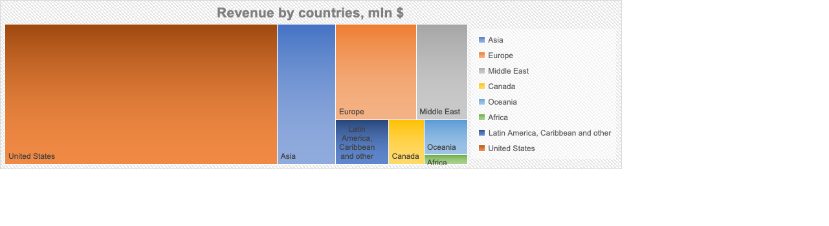

**Compare your company stock behavior with it´s industry**

The average 5-year Revenue CAGR for Boeing is -6.7%. At the same time, other companies in this industry show higher rates. The average 5-year Revenue CAGR for this industry is 2.6%. I clearly understand that aircraft production is facing one of the worst crisis in 2020 and 2021 years, but Boeing is well below the industry average.

|  |  |  |
| --- | --- | --- |
| Revenue CAGR (5y) Benchmarks | | |
| Name | Ticker | Revenue CAGR (5y) |
| [Spirit AeroSystems Holdings, Inc.](https://finbox.com/NYSE:SPR) | [NYSE:SPR](https://finbox.com/NYSE:SPR) | [-10.3%](https://finbox.com/NYSE:SPR/explorer/total_rev_cagr_5y) |
| [General Electric Company](https://finbox.com/NYSE:GE) | [NYSE:GE](https://finbox.com/NYSE:GE) | [-9.1%](https://finbox.com/NYSE:GE/explorer/total_rev_cagr_5y) |
| [The Boeing Company](https://finbox.com/FINBOX:BA) | [FINBOX:BA](https://finbox.com/FINBOX:BA) | [-6.7%](https://finbox.com/FINBOX:BA/explorer/total_rev_cagr_5y) |
| [Honeywell International Inc.](https://finbox.com/NASDAQGS:HON) | [NASDAQGS:HON](https://finbox.com/NASDAQGS:HON) | [-2.6%](https://finbox.com/NASDAQGS:HON/explorer/total_rev_cagr_5y) |
| [Textron Inc.](https://finbox.com/NYSE:TXT) | [NYSE:TXT](https://finbox.com/NYSE:TXT) | [-2.0%](https://finbox.com/NYSE:TXT/explorer/total_rev_cagr_5y) |
| [Embraer S.A.](https://finbox.com/NYSE:ERJ) | [NYSE:ERJ](https://finbox.com/NYSE:ERJ) | [1.1%](https://finbox.com/NYSE:ERJ/explorer/total_rev_cagr_5y) |
| [Industrials](https://finbox.) | [SECTOR:IND.US](https://finbox.) | [2.6%](https://finbox.) |
| [AAR Corp.](https://finbox.com/NYSE:AIR) | [NYSE:AIR](https://finbox.com/NYSE:AIR) | [2.7%](https://finbox.com/NYSE:AIR/explorer/total_rev_cagr_5y) |
| [Ducommun Incorporated](https://finbox.com/NYSE:DCO) | [NYSE:DCO](https://finbox.com/NYSE:DCO) | [3.2%](https://finbox.com/NYSE:DCO/explorer/total_rev_cagr_5y) |
| [General Dynamics Corporation](https://finbox.com/NYSE:GD) | [NYSE:GD](https://finbox.com/NYSE:GD) | [4.9%](https://finbox.com/NYSE:GD/explorer/total_rev_cagr_5y) |
| [Lockheed Martin Corporation](https://finbox.com/NYSE:LMT) | [NYSE:LMT](https://finbox.com/NYSE:LMT) | [5.7%](https://finbox.com/NYSE:LMT/explorer/total_rev_cagr_5y) |
| [Northrop Grumman Corporation](https://finbox.com/NYSE:NOC) | [NYSE:NOC](https://finbox.com/NYSE:NOC) | [7.1%](https://finbox.com/NYSE:NOC/explorer/total_rev_cagr_5y) |

**How does the company behave in a crisis, and with inflation?**

The company is going through crises and high inflation very hard. The graph shows that the company's share price correlates with inflation. The higher the inflation, the lower the stock price. Boeing has a hard time dealing with crises. The graph shows that the company reacts sharply to macroeconomic events in the economy. A significant decline in shares was caused by Covid-19. A significant drop in the share price occurs when the US interest rate rises. News of a recession and a slowdown in economic activity have triggered a re-trend in the share price downtrend in 2022. To sum up, to invest in Boeing stock you need to be sure that the investment period will be characterized by low interest rates, low inflation and growing economic activity.

**Sources**

1. UNITED STATES SECURITIES AND EXCHANGE COMMISSION Washington, D.C. 20549 FORM 10-K The Boeing Company URL: https://s2.q4cdn.com/661678649/files/doc_financials/2022/q4/c93682a4-8b3c-4251-a2ed-97c4e474a214.pdf
2. SimplyWall The Boeing company URL: https://simplywall.st/stocks/at/capital-goods/vie-ba/boeing-shares/management
3. Macrotrends Boeing Debt to Equty Ratio 2010-2022 URL: <https://www.macrotrends.net/stocks/charts/BA/boeing/debt-equity-ratio>
4. Aircraft Manufacturing Market Share, Size, Trends, Industry Analysis Report, By Product (Gliders, Helicopters, Ultra-Light Aircraft, Passenger Aircraft, Unmanned Aerial Vehicle & Drones, Blimps); By Application; By Region; Segment Forecast, 2022 – 2030 URL:https://www.polarismarketresearch.com/industry-analysis/aircraft-manufacturing-market