Quantitative strategies on High Frequency Data

Final Project

Team members: Katarzyna Dybcio 430189 and Quoc Frejter 430201

Academic year 2024/2025

## Approaches undertaken

In the optimization process, several methods were applied across different asset groups to identify optimal parameter combinations for high-frequency trading strategies. Three main entry techniques were tested: **Moving Average (MA), Volatility Breakout (VB), and Double Volatility Breakout (2VB).**

Moving Average strategy used slow and fast moving averages as signals for entering or exiting trades. The Volatility Breakout strategy relied on volatility measures combined with predefined thresholds to generate trading signals. The Double Volatility Breakout strategy introduced stricter entry and exit conditions with separate thresholds to ensure better control over market positioning.

The code implements three types of trading strategies:**momentum (mom)**,**mean reversion (mr)**, and a**dynamic regime-based strategy** (**fl**).

* **Momentum Strategy**: This strategy follows trends by taking a long position when the fast moving average is above the slow moving average and a short position otherwise. It assumes that prices will continue moving in the direction of the trend..
* **Mean Reversion Strategy**: This strategy operates on the opposite principle, assuming prices will revert to their mean. It takes a short position when the fast moving average is above the slow moving average and a long position when it is below.
* **Dynamic Regime-Based Strategy**: This adaptive approach switches between momentum and mean reversion strategies based on the detected market regime. The market regime is determined using rolling windows and thresholds, with the type of regime (momentum or reversal) detected through the **correlation** of price movements. If the regime indicates a trending market, the strategy applies momentum; otherwise, it applies mean reversion.

## Parameters selection

For both sets of assets we considered following parameters in our strategies:

1. **Memory of Moving Averages**:
   * **fast_ma**: Period for the fast moving average (1–60). Smaller values make it more sensitive to price changes.
   * **ma_diff**: Difference between fast and slow moving averages (1–60). Defines the gap for signal generation.
   * **signal_estimator**: Defines whether to use the **mean** or **median** as the moving average calculation method.
2. **Volatility Parameters**:
   * **volat_param**: The lookback period to calculate volatility (2-100).
3. **Double Volatility Breakout Parameters**:
   * **m_exit**: Defines the exit threshold for the strategy based on volatility (0.1-3).
   * **m_diff**: Controls the difference threshold for double breakout detection(0.1-3).
4. **Market Regime Detection**
   * **window_regime**: Rolling window size to detect market regimes (2–100). Larger values capture longer-term trends.
   * **treshold_regime**: Threshold for identifying market regimes (0–0.8). Determines when to switch between momentum and mean reversion.

## Parameters optimalization

**The parameter optimization process was conducted using Optuna in Python**, a hyperparameter optimization framework. The search involved defining a parameter space for moving averages, volatility windows, and thresholds, with each strategy’s performance evaluated as an objective function based on metrics like net profit and Sharpe ratio. Optuna dynamically adjusted parameters during trials to explore high-performing combinations, and results were logged for detailed post-optimization analysis. Each asset group underwent separate optimization to ensure parameters were tailored to the unique characteristics of the data.

The strategies showed that overfitting to highly profitable trades can affect long-term sustainability, especially given the optimization approach in Optuna. To mitigate this, I adjusted the optimization function by adding a penalty based on the mean and standard deviation of the statistics, aiming to reduce the overfitting risk and improve overall strategy robustness.

# Group 1 – summary of results (including out-of-sample)

## Finally selected strategy for **group 1**

The **Volatility Breakout (VB)** strategy for Group 1 assets was chosen. We trade only one selected asset NQ, with point vale of 20$ and transaction cost of 12$. Strategy is based on detecting price breakouts using a combination of moving averages (**MA57** and **MA114**). Volatility memory window was set to 68, allowing the strategy to adjust based on recent volatility. Signals are smoothed using the mean estimator,which helps to reduce noise and improve the quality of trade signals. Regime detection is performed via rolling windows (window_regime = 40 ). A dynamic, regime-based approach (fl) is employed to adapt the strategy to varying market conditions.

## Summary of results for **group 1**

| Dataset 1 | | | | | | | | |
| --- | --- | --- | --- | --- | --- | --- | --- | --- |
| Quarter | grossSR | netSR | grossCR | netCR | stat | avg_ntrans | grossPNL | netPNL |
| 2022_Q1 | 2.85 | 2.58 | 9.08 | 7.61 | 16.11 | 1.28 | 9,276.20 | 8,292.20 |
| 2022_Q3 | 5.76 | 5.63 | 828.22 | 611.40 | 1,726.64 | 0.97 | 17,613.48 | 16,845.48 |
| 2022_Q4 | 4.90 | 4.80 | 70,789.95 | 905.10 | 2,187.12 | 0.62 | 11,685.96 | 11,205.96 |
| 2023_Q2 | 3.07 | 0.91 | 12.12 | 3.06 | 4.03 | 11.78 | 12,780.52 | 3,732.52 |
| 2023_Q4 | -2.51 | -3.08 | -3.12 | -3.31 | -6.17 | 1.78 | -5,085.68 | -6,453.68 |
| 2024_Q1 | -0.48 | -0.72 | -0.65 | -0.94 | -0.74 | 1.00 | -1,443.30 | -2,211.30 |
| 2024_Q2 | -0.90 | -1.17 | -1.51 | -1.80 | -3.33 | 1.85 | -4,913.72 | -6,353.72 |
| 2022_Q2 | 2.82 | 2.71 | 16.63 | 15.65 | 35.64 | 0.65 | 10,253.28 | 9,749.28 |
| 2023_Q1 | 2.63 | 1.51 | 8.04 | 3.50 | 5.92 | 5.17 | 9,471.80 | 5,439.80 |
| 2023_Q3 | 0.68 | -0.54 | 1.59 | -1.03 | -0.51 | 4.74 | 2,060.40 | -1,635.60 |
| 2024_Q3 | -0.59 | -1.22 | -0.93 | -1.76 | -1.83 | 1.82 | -1,389.12 | -2,829.12 |
| 2024_Q4 | 0.14 | -0.18 | 0.33 | -0.43 | 0.00 | 0.95 | 316.10 | -427.90 |
| Out of sample quarters in orange | | | | | | | | |

The results for both “gross” and “net” indicators show significant variability, with notable declines in 2023 and the first half of 2024 for in sample data. Specifically, 2023_Q4 and 2024_Q1 and 2024_Q2 exhibit negative values, suggesting a decrease in performance during the analyzed period.

The “stat”reaches its peak in 2022_Q4 (2,187.12), correlating with high profitability, while very low values, like -6.17 in 2023_Q4, indicate poor performance. Also in 2022_Q4 extraordinary high Gross and Net Calmar ratio was observed.

When it comes to out of sample data, our strategy was backtested on 2022_Q2, 2023_Q1, 2023_Q3, 2024_Q3 and 2024_Q4. As presented in table above, only in 2022_Q2 and 2023_Q3 our strategy resulted in positive net profit. In 2023_Q3 only gross profit was positive, but due to transaction cost, net profit was negative. Only in 2022_Q2 “stat” reached positive value of 35.64.

## PnL of results for **group 1** – quarter 2022Q1

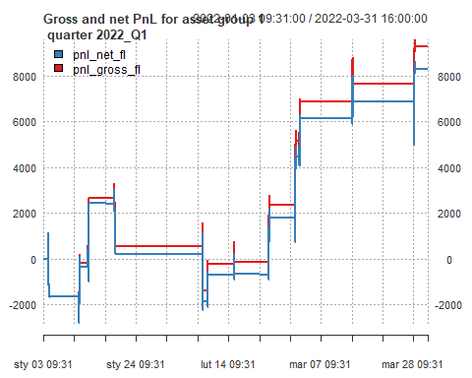

The chart shows the cumulative Net and Gross PnL over the period from January 3, 2022, to March 31, 2022. It reveals that the PnL generally increases over time, with intermittent drops, ultimately reaching a value of over 8,000.

## PnL of results for **group 1** – quarter 2022Q2 – out of sample

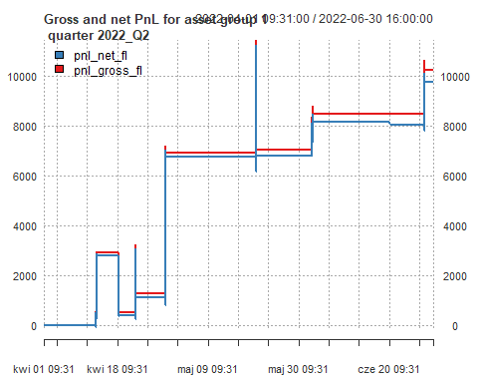

The chart shows the cumulative Net and Gross PnL over the period from April 1, 2022, to June 30, 2022 created based on out of sample data. It reveals that the PnL generally increases over time, without huge drops, reaching a value of over 9,000 net. Just a few transactions were executed.

## PnL of results for **group 1** – quarter 2022Q3

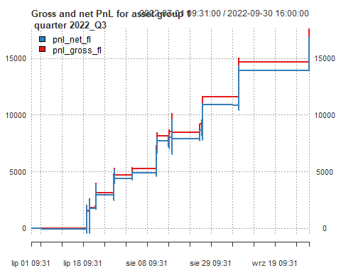

The chart shows the cumulative Net and Gross PnL over the period from July 1, 2022, to September 31, 2022. It reveals that the PnL generally increases over time, with intermittent drops, reaching a value of over 16,000 net.Just a few transactions were executed.

## PnL of results for **group 1** – quarter 2022Q4

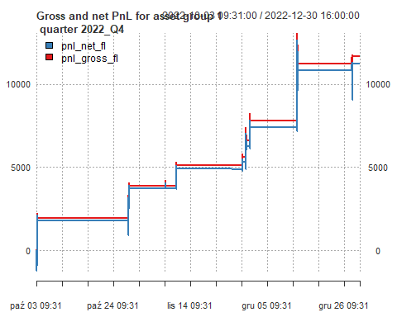

The chart shows the cumulative Net and Gross PnL over the period from October 3, 2022, to December 30, 2022. It reveals that the PnL generally increases over time, with intermittent drops,reaching a value of over 11,000 net.Just a few transactions were executed.

## PnL of results for **group 1** – quarter 2023Q1 – out of sample

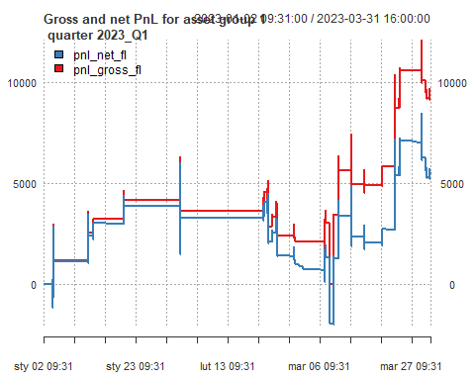

The chart shows the cumulative Net and Gross PnL over the period January 1, 2023, to March 31, 2022 created based on out of sample data. It shows that the PnL generally increases over time, reaching a value of over 5,000 net. At the beginning of the period, the PnL remains around low values with limited number of executed trades. An upward trend is visible in March. At the and of the period more trades were executed.

## PnL of results for **group 1** – quarter 2023Q2

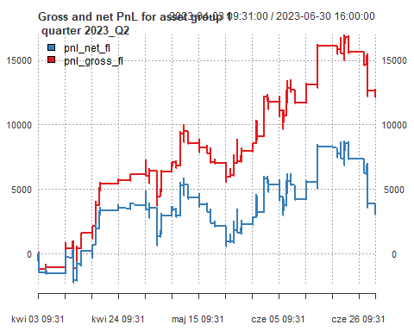

The chart shows the cumulative Net and Gross PnL over the period from April 3 ,2023 , to June 30, 2023. It shows that the PnL generally increases over time, with drop at the end of June, reaching a value of almost 4,000 net. In this quarter more trades were executed in comparison to previous quarters.

## PnL of results for **group 1** – quarter 2023Q3 – out of sample

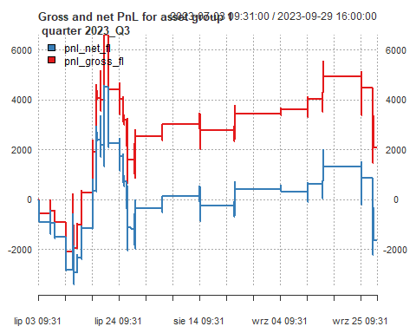

The chart shows the cumulative Net and Gross PnL over the period July 3, 2023, to September 29, 2023 created based on out of sample data. At the start of the period (early July), both Net and Gross PnL fluctuate around negative values, reflecting initial losses.Then, at the end of July, gross PnL increased to more than 6000. Shortly after,it decreased to values around 2000. Then our startegy remains relatively flat with visible drop at the end of the period. Finally, Net PnL reached value of over -1,500 net.

## PnL of results for **group 1** – quarter 2023Q4

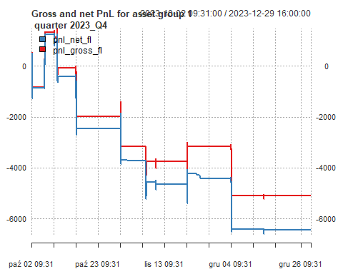

The chart shows the cumulative Net and Gross PnL over the period from October 2, 2023 , to December 29, 2023. It reveals that the PnL generally decreases over time, ultimately reaching a value of over -6,000 net.

## PnL of results for **group 1** – quarter 2024Q1

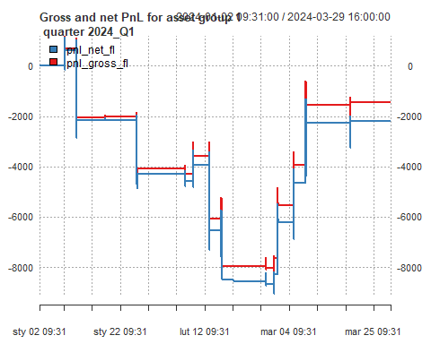

The chart shows the cumulative Net and Gross PnL over the period from January 2 ,2024 , to March 25, 2024. It shows that PnL generally decreases at the beginning of the period. An upward trend is visible in March. At the end PnL reached value a value of almost -2,000.

## PnL of results for **group 1** – quarter 2024Q2

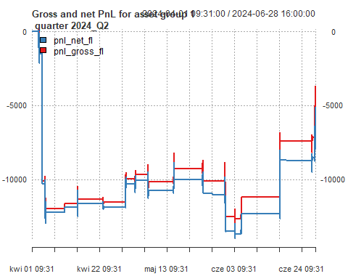

The chart shows the cumulative Net and Gross PnL over the period from April 1 ,2024 , to June 28, 2024. It reveals that the PnL generally decreases over time. Huge drop was observed at the beginning of the period in April. Net PnL reached a value of -5,000.

## PnL of results for **group 1** – quarter 2024Q3 – out of sample

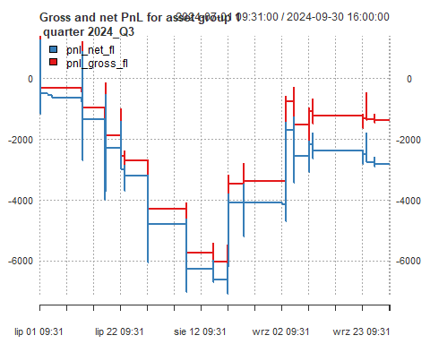

The chart shows the cumulative Net and Gross PnL over the period July 1, 2024, to September 30, 2024 created based on out of sample data. At the start of the period (early July), both Net and Gross PnL perform negative trend , reflecting initial losses. An upward trend is visible starting at the end of July, At the end PnL reached value of over -2,500 net. Strategy didn’t recover from the losses observed at the beginning.

## PnL of results for **group 1** – quarter 2024Q4 – out of sample

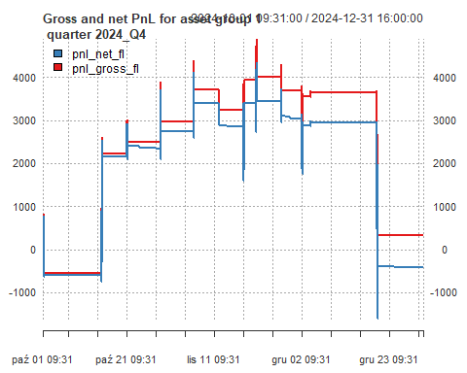

The chart shows the cumulative Net and Gross PnL over the period October 1, 2024, to December 31, 2024 created based on out of sample data. At the start of the period, both Net and Gross PnL perform an upward trend. At the end of December huge drop was observed, resulting in negative net PnL reaching value of -500.

## Finally selected strategy for **group 2**

The *Double Volatility Breakout (VB)* strategy for Group 2 assets was chosen. In this case, we trade two selected instruments: XAG, with point value of 5000$ and transaction cost of 10$ and XAU with point value of 100$ and transaction cost of 15$. The strategy is based on detecting price breakouts using a combination of moving averages and volatility parameters. For XAG, the moving averages are configured as MA51 (fast) and MA140 (slow), while for XAU, they are set to MA58 (fast) and MA115 (slow). Volatility parameters are set to 72 for XAG and 73 for XAU, respectively.

Signals for XAG are smoothed using the *mean* estimator, while for XAU, a *median* estimator is applied. Regime detection is performed through rolling windows with parameters window_regime = 98 for XAG and window_regime = 22 for XAU. Entry and exit thresholds for both instruments are dynamically adjusted, with XAG using m_entry = 3.63864 and m_exit = 1.79056, and XAU using m_entry = 2.026 and m_exit = 0.10742.

## Summary of results for **group 2**

| Dataset 2 | | | | | | | | |
| --- | --- | --- | --- | --- | --- | --- | --- | --- |
| Quarter | grossSR | netSR | grossCR | netCR | stat | avg_ntrans | grossPNL | netPNL |
| 2022_Q1 | -0.41 | -1.81 | -0.69 | -1.90 | 0.00 | 0.47 | -170.0 | -650.0 |
| 2022_Q3 | 2.59 | 2.24 | 24.27 | 12.51 | 0.00 | 0.30 | 760.8 | 470.8 |
| 2022_Q4 | 2.63 | 2.41 | 53.18 | 36.05 | 61.18 | 0.54 | 6,007.9 | 5,457.9 |
| 2023_Q2 | 0.10 | -1.45 | 0.26 | -2.05 | -2.85 | 3.87 | 265.2 | -4,009.8 |
| 2023_Q4 | 1.79 | 1.65 | 35.22 | 28.36 | 34.17 | 0.44 | 3,706.0 | 3,336.0 |
| 2024_Q1 | 0.08 | -0.55 | 0.13 | -0.73 | 0.00 | 0.49 | 54.0 | -366.0 |
| 2024_Q2 | 3.92 | 3.90 | Inf | 2,148.85 | 6,040.60 | 0.28 | 16,878.0 | 16,628.0 |
| 2022_Q2 | 0.88 | 0.60 | 4.47 | 2.35 | 0.00 | 0.26 | 630.0 | 430.0 |
| 2023_Q1 | -1.71 | -2.24 | -1.93 | -2.25 | -4.14 | 1.33 | -4,805.7 | -6,275.7 |
| 2023_Q3 | -2.58 | -3.08 | -2.70 | -2.95 | -6.13 | 1.37 | -6,499.9 | -7,959.9 |
| 2024_Q3 | -2.67 | -2.79 | -3.19 | -3.19 | -5.00 | 0.30 | -4,555.0 | -4,795.0 |
| 2024_Q4 | -0.16 | -0.43 | -0.28 | -0.68 | 0.00 | 0.38 | -207.0 | -547.0 |
| Out of sample quarters in orange | | | | | | | | |

The table summarizes the performance of the strategy across different quarters, showing variability in both gross and net Sharpe Ratios (SR) and Calmar Ratios (CR). While some quarters, like 2022_Q4, 2024_Q2, exhibit strong positive results (e.g., high net CR of 2,148.85 in 2024_Q2), others, such as 2022_Q1 and 2024_Q1, demonstrate negative performance, indicating challenges in those periods.

When it comes to out of sample data, our strategy was backtested on 2022_Q2, 2023_Q1, 2023_Q3, 2024_Q3 and 2024_Q4. As presented in table above, only in 2022_Q2 our strategy resulted in positive net profit. The rest of out of sample quarters finished with negative net profit.

## PnL of results for **group 2** – quarter 2022Q1

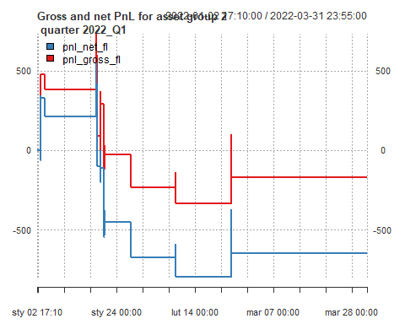

After the first quarter, only a few trades were executed, with the final one being the only profitable trade. However, the overall PnL ended up around -700 net.

## PnL of results for **group 2** – quarter 2022Q2 – out of sample

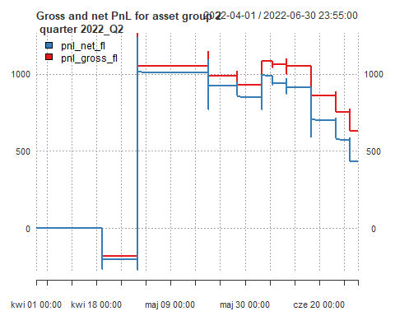

The chart shows the cumulative Net and Gross PnL over the period April 1, 2022, to June 30, 2022 created based on out of sample data. At the beginning of the period an upward trend is visible. PnL reached value of over 1000. At the end of the selected period slight drop was observed with net PnL reaching final value of almost 500 net.

## PnL of results for **group 2** – quarter 2022Q3

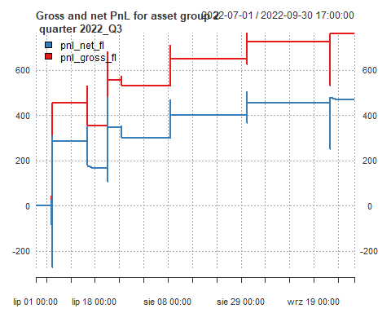

The chart shows the cumulative Net and Gross PnL over the period from July 1, 2022 , to September 30, 2022. It reveals that the PnL generally increases over time, ultimately reaching a value of almost 500 net. Just a few transactions were executed but profitable one.

## PnL of results for **group 2** – quarter 2022Q4

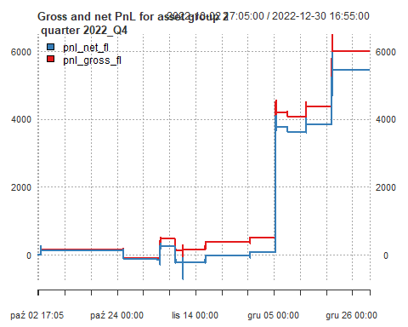

During this quarter, the PnL increases to almost 6000, with the majority of the profits coming from just two trades at the end of the period.

## PnL of results for **group 2** – quarter 2023Q1 – out of sample

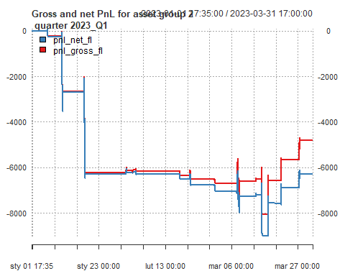

The chart shows the cumulative Net and Gross PnL over the period from January 1, 2023 , to March 31, 2023. It shows that the PnL generally decreases over time, reaching a value of over -6,000 net. First huge drop was observed in mid January, then the position stayed relatively flat.

## PnL of results for **group 2** – quarter 2023Q2

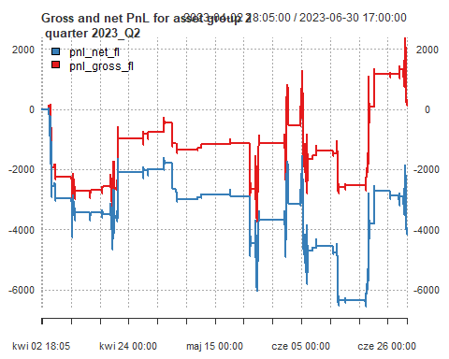

Throughout this quarter, a significant number of trades were executed, but the majority were unprofitable. This is the reason for huge transaction cost. As a result, the final net PnL ended at -4,000. Meanwhile, gross PnL finished positive.

## PnL of results for **group 2** – quarter 2023Q3 – out of sample

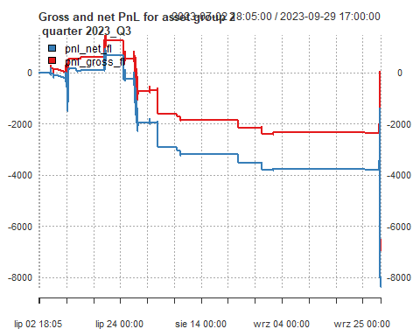 The chart shows the cumulative Net and Gross PnL over the period from July 2, 2023 , to September 29, 2023. It shows that the PnL generally decreases over time, reaching a value of almost -8,000 net. Huge drop at and of the period was observed.

## PnL of results for **group 2** – quarter 2023Q4

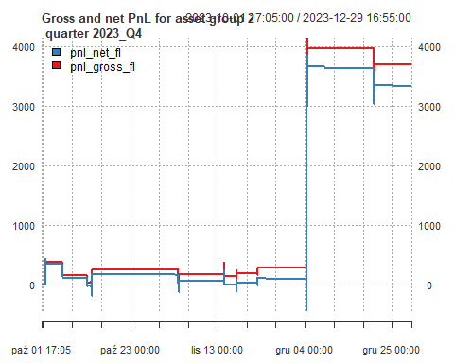

The final net PnL for this quarter stands at approximately 3000, with the bulk of the profits generated from a single trade in December. Value of the net PnL reached over 3,000.

## PnL of results for **group 2** – quarter 2024Q1

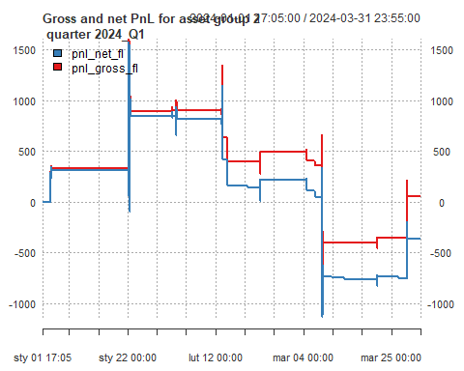

Only a few profitable trades were executed during this quarter, but the final net PnL ended at approximately -300.

## PnL of results for **group 2** – quarter 2024Q2

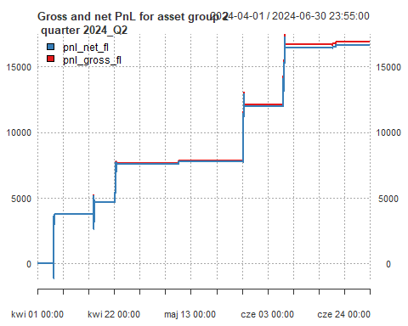

Three significant trades were executed during this period, resulting in a final net PnL of approximately 16,000.

## PnL of results for **group 2** – quarter 2024Q3 – out of sample

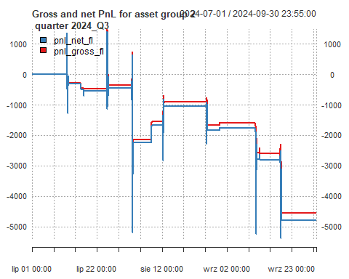

The chart shows the cumulative Net and Gross PnL over the period from July 1, 2024 , to September 30, 2024. It shows that the PnL generally decreases over time, reaching a value of almost -5,000 net.

## PnL of results for **group 2** – quarter 2024Q4 – out of sample

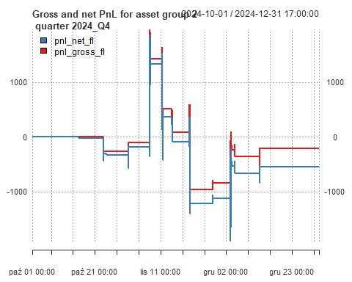

The chart shows the cumulative Net and Gross PnL over the period from July 1, 2024 , to September 30, 2024. PnL stayed around 0 until November. Than profit around 1000was generated. Some drops occurred next. At the and Pnl resulted in negative values, close to 0.

## Summary and conclusions

* The strategy applied to Group 1 data achieved an overall positive net return of approximately 20,700 on in sample data. However, the profits were inconsistent, with the majority of gains generated during two months, while the rest of months saw losses. This suggests that the strategy may have overfitted to a few highly profitable trades, rather than exhibiting sustainable performance across the entire period. On average, around 1-2 trades were made per day, with one quarter seeing as many as 12 trades per day on average. When it comes out of sample data, positive net PnL was observed only i two quarters. The rest was highly unprofitable. That confirms thesis that our strategy might be overfitting.
* The strategy applied to Group 2 generated a net profit of 20,866.9 on in sample data, though the performance was not entirely consistent. Highly profitable PnL was generated in 2024_Q2, which covered the majority of net PnL observed in those quarters. Several trades were made, averaging less than one per day. On the out of sample data, four out five quarters were higly unprofitable. This also indicates that out chosen strategy might have overfitted based on insample data.
* Both strategies displayed positive returns but with notable inconsistencies. Both groups saw the highest profits concentrated in a few months, with some months experiencing losses. The strategies showed that overfitting to highly profitable trades can affect long-term sustainability, and the number of trades did not always correlate with profitability.