ELECTRICITY CONSUMPTION
AND
SMART METER MANAGEMENT SYSTEM

Name & Registration No. | Rammanohar K S – 24BCE2764  Arya Rajeesh – 24BCE2761  Anfy Sony – 24BCE2799
Course Code & Title | BCSE302P / Database Systems Lab
Faculty | Dr. V. Sivakumar
Semester | Fall 2026–27
School | School of Computer Science and Engineering (SCOPE)

1. Abstract
The Electricity Consumption and Smart Meter Management System, named WattWise, is a database-driven web application for organizing consumer accounts, smart meters, energy readings, electricity bills, payment records and meter alerts. The project demonstrates how a relational database and an Object Relational Mapper (ORM) can maintain consistent related data and support common operations such as create, read, update/status changes, search, filtering and reporting. The prototype includes role-based access for administrators and consumers, password hashing, audit records and a responsive dashboard. All readings, tariffs and payment actions in this academic prototype are demonstration data; it is not connected to a utility provider, physical meter hardware or a real payment gateway.

2. Problem Statement
Electricity providers and building administrators need reliable ways to associate consumers with meters, record energy usage, prepare bills and track exceptions. Separate spreadsheets or disconnected records can lead to duplicate information, inconsistent billing details and difficult retrieval. This project proposes a centralized database application that links consumer accounts, meters, readings, bills, payments and alerts through primary and foreign keys. The system aims to improve traceability, data integrity and visibility of consumption records.

3. Objectives
- Store consumer and account details in a structured database.
- Register smart meters and associate each meter with a consumer.
- Record dated energy readings in kWh and calculate illustrative bills from a tariff.
- Track bill status and simulated payment records.
- Create and resolve meter alerts.
- Demonstrate ORM-based CRUD, joins, aggregate summaries, validation and exception handling.
- Enforce authenticated access and distinguish Admin and Consumer roles using one Users table and a Role foreign key.
- Apply normalization, constraints, indexes, version control and a deployable web architecture.

4. Scope and Limitations
Included: user login/logout, dashboard summaries, consumer and meter registration, reading entry, sample bill generation, simulated payment status, alerts, search, pagination for consumer records, input validation and audit logging. The data model is designed to be extensible to utility-scale systems. Limitations: the application uses demo data; it does not ingest readings from real smart meter devices, calculate a jurisdiction-specific progressive tariff, send notifications, verify identity through OAuth, or transfer money. The payment control only records a simulated payment and must not be represented as a real transaction.

5. Team Members and Responsibilities
Rammanohar K S | Flask application, ORM models, authentication and role-based access, CRUD workflows, UI testing, GitHub version control and deployment
Anfy Sony | ER diagram, relational schema, data dictionary, normalization (3NF), SQL queries, constraints, indexes and database testing
Arya Rajeesh | Project coordination, requirements analysis, problem definition, objectives, report preparation and presentation

6. Technology Stack
Frontend: HTML5, Jinja templates and responsive CSS.
Backend: Python with Flask.
ORM: Flask-SQLAlchemy / SQLAlchemy.
Database: SQLite for local demonstration; PostgreSQL is supported through DATABASE_URL for deployment.
Authentication: session-based login and Werkzeug password hashing.
Hosting: Gunicorn-compatible platform such as Render.
Version control: Git and a private GitHub repository.
Configuration: environment variables and .env.example; real secrets are excluded by .gitignore.

7. Functional Modules
1. Authentication and authorization: sign in/out, password hash verification and role-aware navigation; Admin-only user directory.
2. Consumer management: register accounts, tariff and address; search by name, account or email; paginated listing.
3. Meter management: register a unique meter serial, installation date and status.
4. Reading management: validate non-negative kWh readings and associate each reading with a meter.
5. Billing: create a demo bill when a reading is saved, using recorded kWh × consumer tariff rate.
6. Payments: record simulated payment method and update bill status.
7. Alerts: create alerts with severity and mark them resolved.
8. Dashboard and audit: aggregate counts and energy totals; log selected user actions.

8. ER Diagram and Relationships
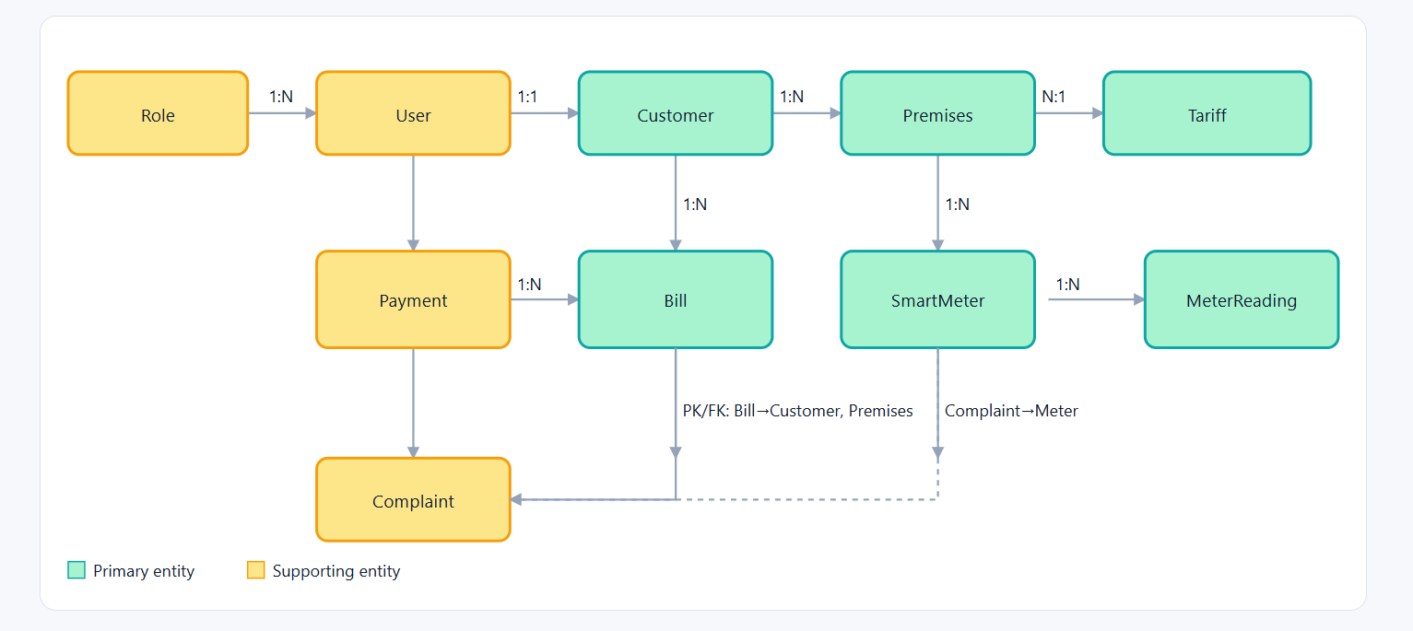

9. Relational Schema
Roles(role_id PK, name UNIQUE)
Users(user_id PK, full_name, email UNIQUE, password_hash, role_id FK → Roles.role_id, created_at)
Consumers(consumer_id PK, user_id FK → Users.user_id, account_number UNIQUE, address, tariff_rate)
Meters(meter_id PK, consumer_id FK → Consumers.consumer_id, meter_serial UNIQUE, installation_date, status)
Readings(reading_id PK, meter_id FK → Meters.meter_id, reading_date, units_kwh)
Bills(bill_id PK, consumer_id FK → Consumers.consumer_id, billing_month, units_kwh, amount, status, issued_at)
Payments(payment_id PK, bill_id FK → Bills.bill_id, amount_paid, payment_date, method)
Alerts(alert_id PK, meter_id FK → Meters.meter_id, message, severity, created_at, resolved)
AuditLogs(log_id PK, user_id FK → Users.user_id, action, entity, created_at)
The exact physical table names generated by SQLAlchemy are lowercase singular names in the prototype; schema.sql is a readable relational schema reference.

10. Data Dictionary (Summary)
Roles: id integer primary key; name unique role label.
Users: id primary key; full_name; unique email; password_hash (never plaintext); role_id foreign key; created_at timestamp.
Consumers: id primary key; user_id foreign key; unique account_number; address; tariff_rate decimal in currency per kWh.
Meters: id primary key; consumer_id foreign key; unique meter_serial; installation_date; status.
Readings: id primary key; meter_id foreign key; reading_date; units_kwh decimal.
Bills: id primary key; consumer_id foreign key; billing_month (YYYY-MM); units_kwh; amount; status; issued_at.
Payments: id primary key; bill_id foreign key; amount_paid; payment_date; method.
Alerts: id primary key; meter_id foreign key; message; severity; created_at; resolved boolean.
AuditLogs: id primary key; nullable user_id foreign key; action; entity; created_at.

11. Normalization, Integrity and Indexes
The design separates users, role definitions, consumer account details, meter details, readings, bills, payments and alerts so attributes depend on the key of their own relation rather than being repeatedly copied into every record. This structure is intended to satisfy Third Normal Form (3NF): each table has a primary key, non-key attributes describe that entity, and repeating groups are separated. Foreign keys maintain valid relationships. Unique constraints apply to email, account number, meter serial and role name. Numeric values use decimal types; readings and tariff rates are validated; required fields are non-null. Indexes are defined in schema.sql for meter/date reading lookup, bill status/month filtering and unresolved alert chronology. The report's schema is a design reference; verify actual constraints in the running database before claiming all SQL-level CHECK constraints are implemented by the ORM.

12. CRUD, Joins, Aggregates, Views and Transactions
CRUD is demonstrated through consumer, meter, reading, bill and alert workflows. The dashboard uses aggregate queries for counts and total recorded kWh. ORM relationships support joins such as Consumer → User, Meter → Consumer and Reading → Meter. A reading and its generated bill are committed in one database session, and the simulated payment operation updates a bill while creating a payment record. The current prototype does not create a named SQL VIEW or a stored procedure/trigger. If the faculty requires those items explicitly, add a database-specific view and trigger/procedure (PostgreSQL supports them) and capture proof from the database client. Do not claim unsupported features as completed.

13. Security
The app stores password hashes using Werkzeug rather than plaintext. SQLAlchemy ORM query construction is used for ordinary database access, helping avoid unsafe string-concatenated SQL. A single Users table references Roles for Admin/Consumer distinction. Secrets are configured using environment variables and .env is ignored by Git. Session-based authentication and Admin-only route checks are included. Before public deployment, set a strong random SECRET_KEY, change demo passwords, use HTTPS, enable secure cookie flags and CSRF protection, implement rate limiting and password reset, and review authorization for consumer-specific data. The demo currently shows a basic role-aware prototype rather than a production security certification.

14. Sample Data and Demonstration Workflow
The app seeds demonstration records on first startup: one administrator, one consumer, one meter, two readings, one unpaid bill and one open alert. Demo administrator: admin@smartmeter.demo / Admin123!; demo consumer: aarav@example.com / Consumer123!. Sign in, review dashboard totals, add a meter, record a reading, confirm that a sample bill is generated, open Bills and mark the bill as paid to create a simulated payment record, then create and resolve an alert. Change demo credentials before deployment and do not use real personal data.

15. Testing Plan
Test 1: Valid admin credentials should open the dashboard; invalid credentials should display an error.
Test 2: Duplicate email, account number or meter serial should be rejected by database uniqueness rules.
Test 3: Empty required form fields should be blocked by browser/server validation.
Test 4: Negative kWh should be rejected; zero and positive readings should be accepted.
Test 5: Saving a reading should create a bill associated with the same consumer.
Test 6: A payment action should update an unpaid bill to Paid and create a payment row; it must be labelled simulated.
Test 7: Alert creation and resolution should update alert state.
Test 8: Search and pagination should filter consumer results.
Test 9: A Consumer-role user should not access the Admin-only user directory.
Test 10: Refresh the app and confirm persisted records remain in the database.

16. Project Timeline (Gantt-Style Plan)
Task | W1 | W2 | W3 | W4 | W5 | W6
Requirements and proposal | ■
ER diagram and schema | ■ | ■
Database implementation |  | ■ | ■
Backend + ORM + Auth |  |  | ■ | ■
Frontend and dashboard |  |  |  | ■ | ■
Docker, CI/CD, deployment |  |  |  |  | ■ | ■
Testing and report |  |  |  |  |  | ■

17. Major Deliverables
- Project proposal and report.
- ER diagram source (ER_DIAGRAM.mmd).
- Relational schema reference (schema.sql).
- Flask application source and templates.
- ORM models and seeded demonstration data.
- README with installation and deployment instructions.
- Test plan and screenshots captured from the running application.
- Private GitHub repository with main and dev branches, meaningful commits and .gitignore.
- Deployed live URL after hosting setup.

18. Conclusion and Future Enhancements
WattWise demonstrates a practical relational database application for electricity consumption and smart meter record management. Its nine-table design models key relationships between users, consumers, meters, readings, bills, payments and alerts. The prototype illustrates ORM-backed data access, validation, dashboard aggregates, simulated billing and role-based access. Future work could integrate real smart-meter telemetry, tariff slabs, bill PDFs, notifications, OAuth, stronger production security, PostgreSQL views/triggers, automated tests, monitoring and CI/CD. All future features should be implemented and tested before being reported as complete.

19. References
1. Flask documentation: https://flask.palletsprojects.com/
2. Flask-SQLAlchemy documentation: https://flask-sqlalchemy.palletsprojects.com/
3. SQLAlchemy documentation: https://docs.sqlalchemy.org/
4. PostgreSQL documentation: https://www.postgresql.org/docs/
5. Render documentation: https://render.com/docs

