Project: <Moffat Bay Lodge>
Course: <CSD-460>
- Description:Testing for:
  - Landing page and backend code.
  - Login page and backend code.
  - User Registration page and backend code.
>
Date: 4/13/2026
To complete the test case plan, fill out the information for Project, Course, Description and Date in the header below.
.
TABLE OF CONTENTS
<Login Page/Logout System> 3-6
<DESCRIPTION> 7
<DESCRIPTION> 7

For each test, the developer should: provide a test description, a test objective, the developer name and date tested. For each step, fill out the actions to be taken and describe the expected results, and indicate yes or no for each step depending upon the result. The peer tester should provide their name, date tested, indicate yes or no for each step depending upon the result, and a screenshot (thumbnail) of the result.

Test 1 | <Login Page/Logout System>
 | Test Objective: Verifies that users can log in to the system and Logout | Developer:  Cameron Mendez  Date tested: <4/13/2026> | Peer tester: Zachary Anderson  Date tested: <4/13/2026>
Step | Action | Expected results: | Developer pass/fail | Tester pass/fail  + Screenshot
1 | <Login using sample user data> | <Login successfully> | <yes> | 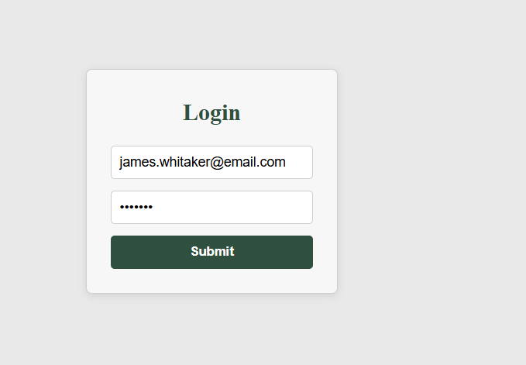  
2 | <Try to login with the wrong password> | <Error message for invalid login> | <yes> | 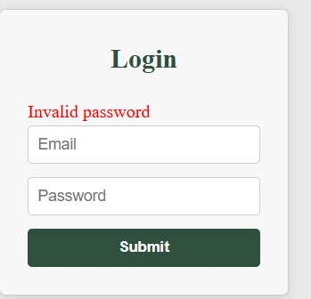
3 | <Login with a user that isn’t registered> | <user not found message> | <yes> | 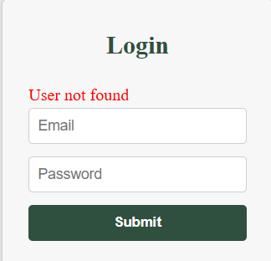
4 | <Logout after a successful login> | <Return to home page> | <yest> | 
5 | <Try to login after already being logged in> | <Already logged in, log out before continuing message> | <no, allows me to login again> |   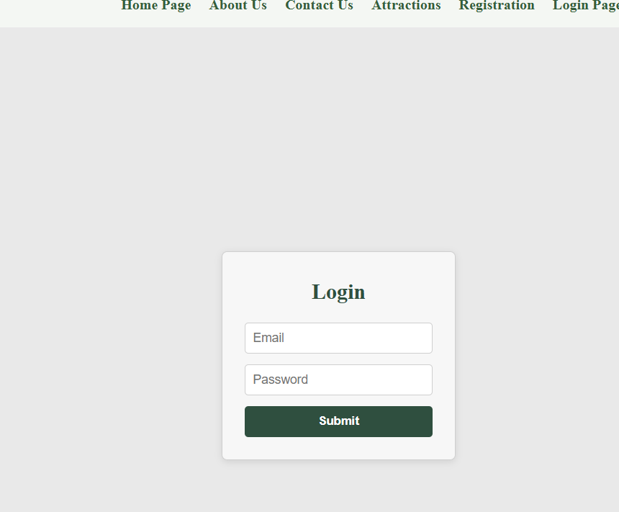
Comments | The login system works well; most of my tests showed that you can indeed log in with a registered user. The hashed passwords work well, and the error messages were functional. I think there should be a change to the login page if the user is already logged in, though.

Test 2 | <DESCRIPTION>
 | Test Objective: | Developer:  Date tested: <yyyy/mm/dd> | Peer tester:  Date tested: <yyyy/mm/dd>
Step | Action | Expected results: | Developer pass/fail | Tester pass/fail
1 | <Enter an action> | <Enter the expected results> | <yes/no> | <yes/no>
2 | <Enter an action> | <Enter the expected results> | <yes/no> | <yes/no>
3 | <Enter an action> | <Enter the expected results> | <yes/no> | <yes/no>
4 | <Enter an action> | <Enter the expected results> | <yes/no> | <yes/no>
5 | <Enter an action> | <Enter the expected results> | <yes/no> | <yes/no>
Comments | Comments should be substantive; this means there should be at least 2-3 well-structured sentences with constructive feedback.

Test 3 | <DESCRIPTION>
 | Test Objective: | Developer:  Date tested: <yyyy/mm/dd> | Peer tester:  Date tested: <yyyy/mm/dd>
Step | Action | Expected results: | Developer pass/fail | Tester pass/fail
1 | <Enter an action> | <Enter the expected results> | <yes/no> | <yes/no>
2 | <Enter an action> | <Enter the expected results> | <yes/no> | <yes/no>
3 | <Enter an action> | <Enter the expected results> | <yes/no> | <yes/no>
4 | <Enter an action> | <Enter the expected results> | <yes/no> | <yes/no>
5 | <Enter an action> | <Enter the expected results> | <yes/no> | <yes/no>
Comments | Comments should be substantive; this means there should be at least 2-3 well-structured sentences with constructive feedback.

