Project: Todo Web Application
Course: CSD 380 – DevOps | Angela Vargas
Description: This test plan was created to verify that the Todo web application meets the business requirements. The tests focus on basic functionality such as loading the site, creating tasks, editing tasks, deleting tasks, and validating user input.
Date: 2/6/2026 | 02/07/2026
To complete the test case plan, fill out the information for Project, Course, Description and Date in the header below.

TABLE OF CONTENTS
Test 1 Access Website via Standard URL 2
Test 2 Create a New Todo Task Item 2
Test 3 Prevent Blank Task Submission 3
Test 4 Edit an Existing Todo Item 3
Test 5 Delete a Todo Task Item 3

Test 1 | Access Website via Standard URL
 | Test Objective: Verify users can access the Todo application using the correct URL. | Developer: Daniel Graham  Date tested: 2/6/2026 | Peer tester: Angela Vargas  Date tested:02/07/2026
Step | Action | Expected results: | Developer pass/fail | Tester pass/fail  + Screenshot
1 | Navigate to https://buwebdev.github.io/todo/ | Website loads successfully | Pass | 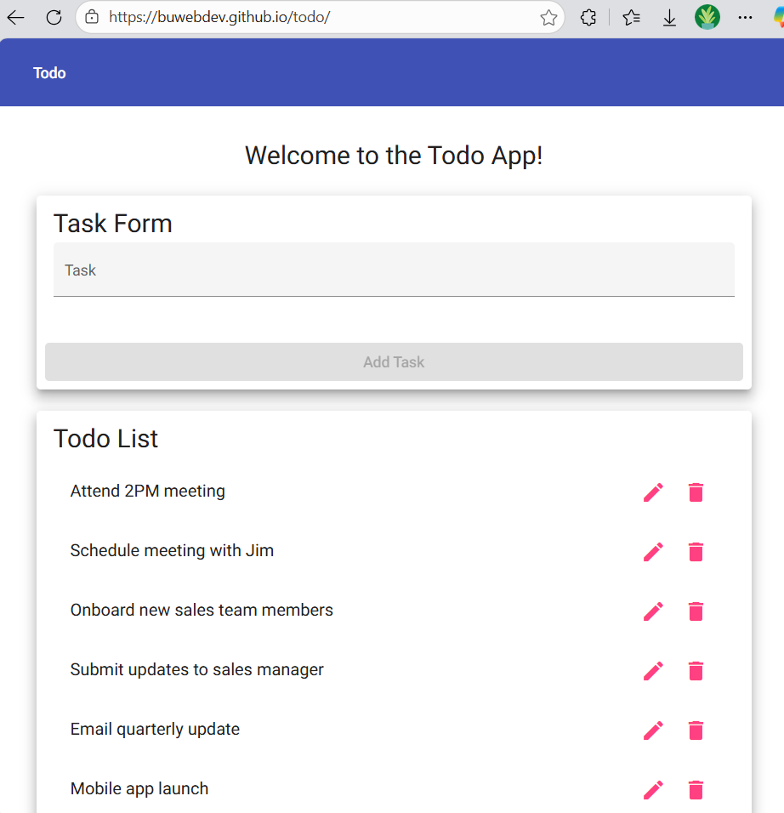
2 | Observe page content | Todo list interface is displayed | Pass
3 | Refresh the browser | Page reloads without errors | Pass
4 | Verify URL remains unchanged | URL stays correct | Pass
5 | Check for error messages | No error messages appear | Pass
Comments | The website loaded successfully using the provided URL. The todo interface displayed correctly and the page refreshed without errors. No console or browser errors were observed. The application met the requirement for standard URL access.

Test 2 | Create a New Todo Task Item
 | Test Objective: Verify users can create a new todo task. | Developer: Daniel Graham  Date tested: 2/6/2026 | Peer tester: Angela Vargas  Date tested:02/07/2026
Step | Action | Expected results: | Developer pass/fail | Tester pass/fail
1 | Enter a task in the input field | Text appears in the field | Pass | 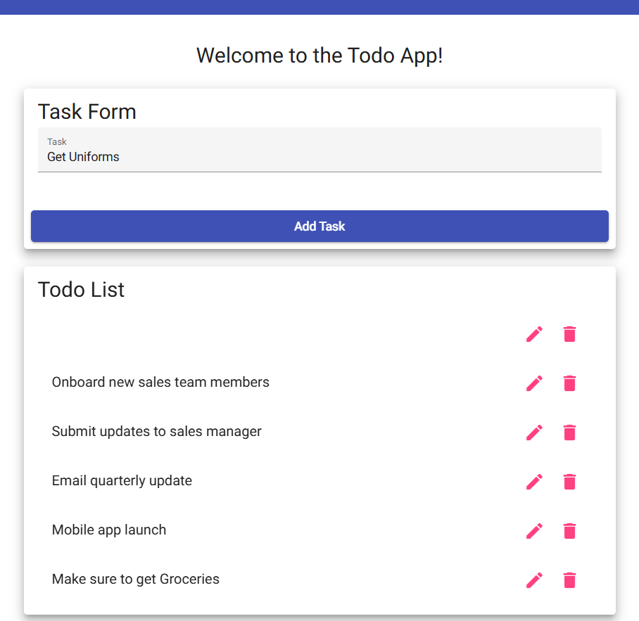
2 | Click the Add button | Task is added to the list | Pass | 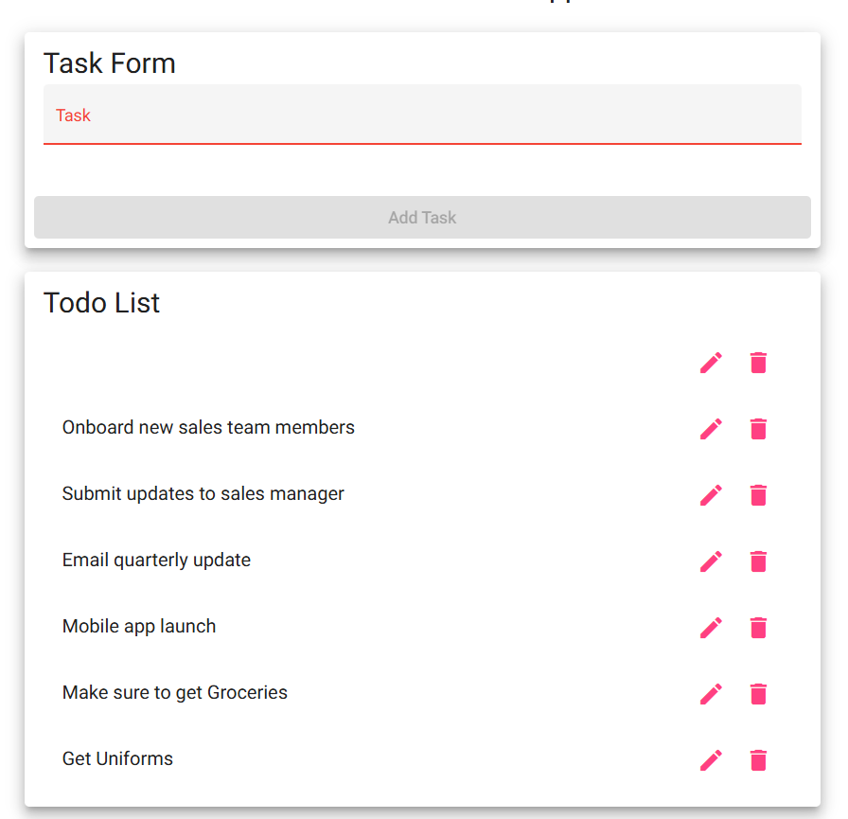
3 | Observe task list | New task appears in list | Pass
4 | Refresh browser | Task remains in list | FAIL | 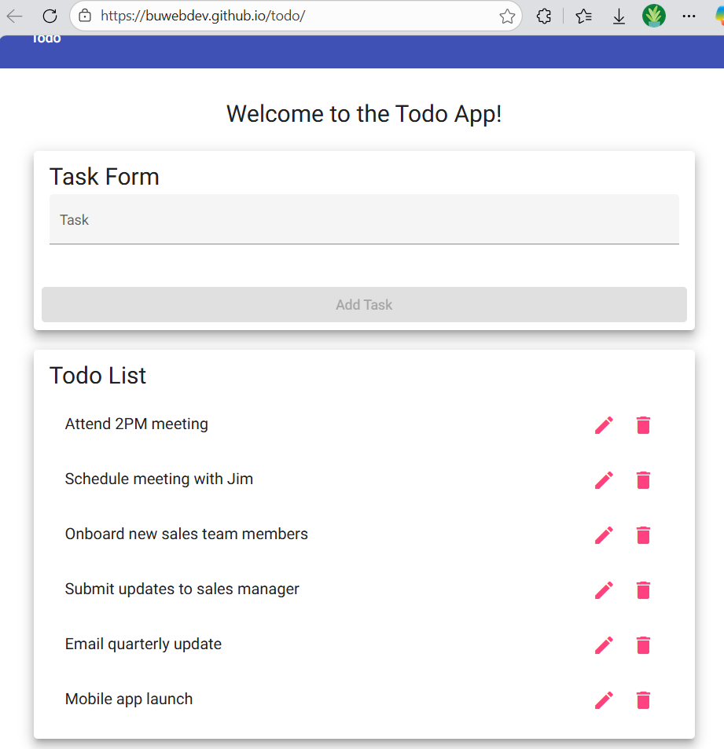
5 | Repeat with another task | Second task is added correctly | Pass | 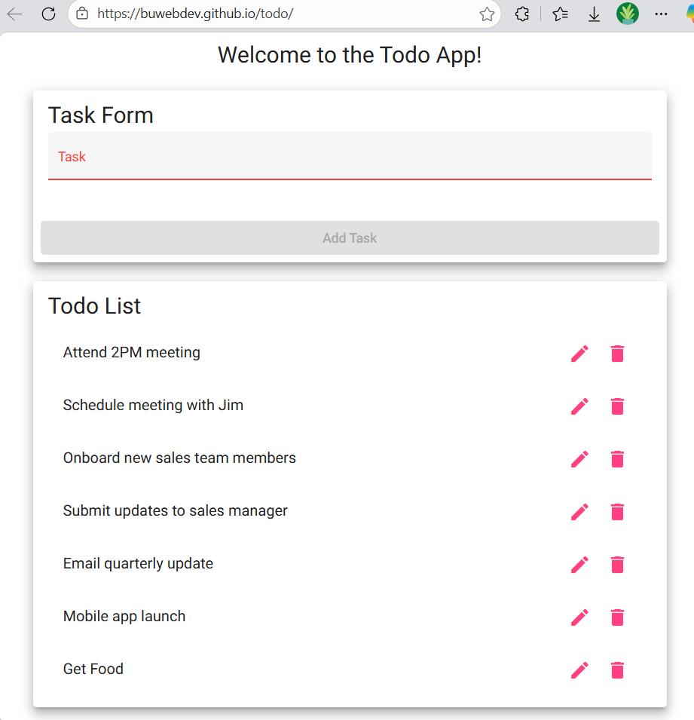
Comments | The system successfully allowed the creation of new tasks. Each task appeared immediately in the list. After refreshing the browser, the tasks did not save and deleted the task I create. I can make a task but if I refresh its deleted.

Test 3 | Prevent Blank Task Submission
 | Test Objective: Verify users cannot submit a task without entering text. | Developer: Daniel Graham  Date tested: 2/6/2026 | Peer tester: Angela Vargas  Date tested:02/07/2026
Step | Action | Expected results: | Developer pass/fail | Tester pass/fail
1 | Leave input field empty | Field remains blank | Pass
2 | Click Add button | Task is not added | Pass
3 | Observe screen | No new task appears | Pass
4 | Enter valid task | Text appears in field | Pass | 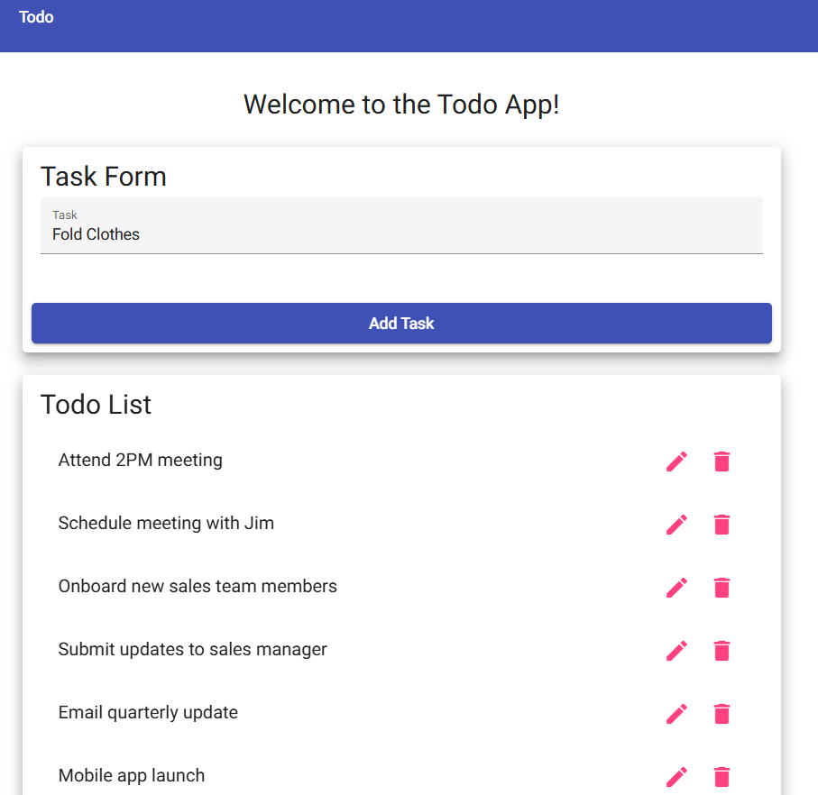
5 | Click Add button | Task is successfully added | Pass | 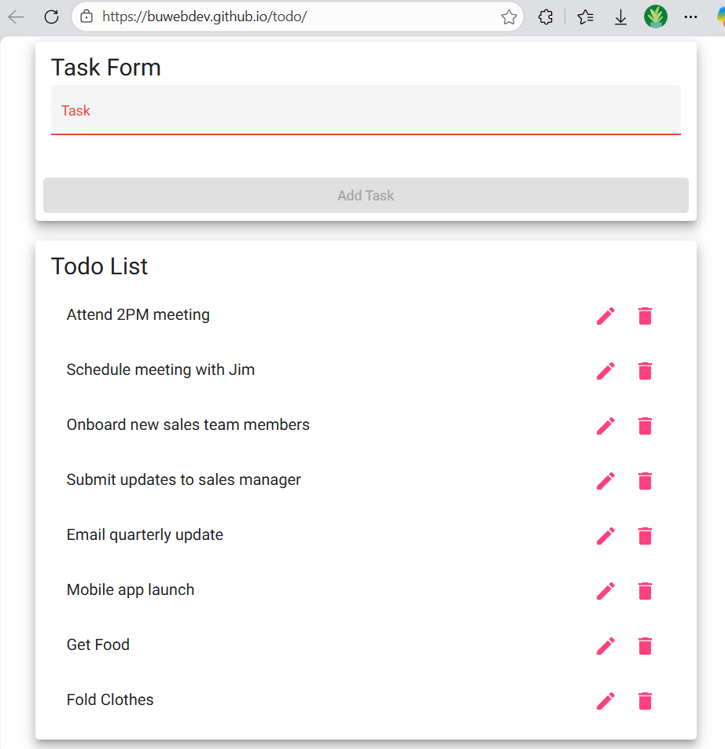
Comments | When attempting to submit a blank task, the system prevented the action. No empty task was added to the list. After entering valid text, the task was successfully added. Input validation is functioning correctly.

Test 4 | Edit an Existing Todo Item
 | Test Objective: Verify users can edit an existing todo task. | Developer: Daniel Graham  Date tested: 2/6/2026 | Peer tester: Angela Vargas  Date tested:02/07/2026
Step | Action | Expected results: | Developer pass/fail | Tester pass/fail
1 | Select an existing task | Task becomes editable | Pass | 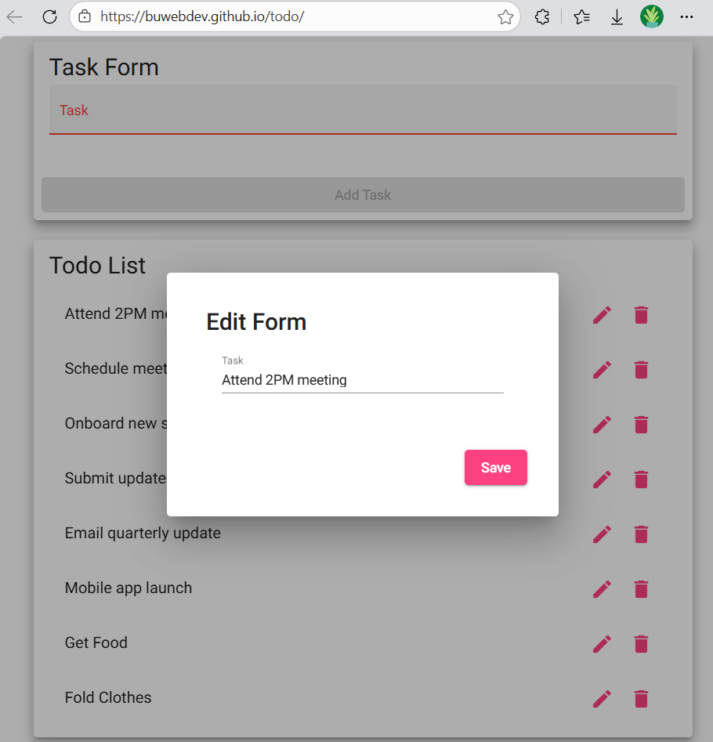
2 | Modify task text | Updated text appears | Pass | 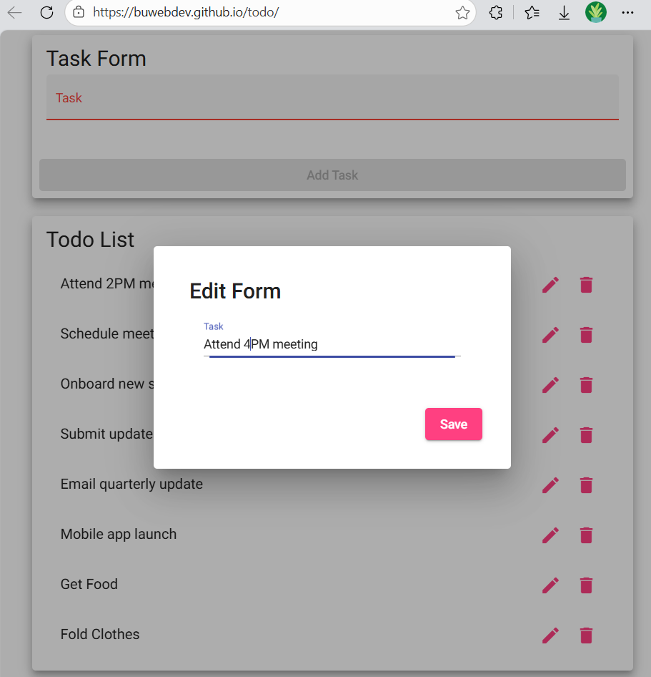
3 | Save the edited task | Changes are saved | Pass | 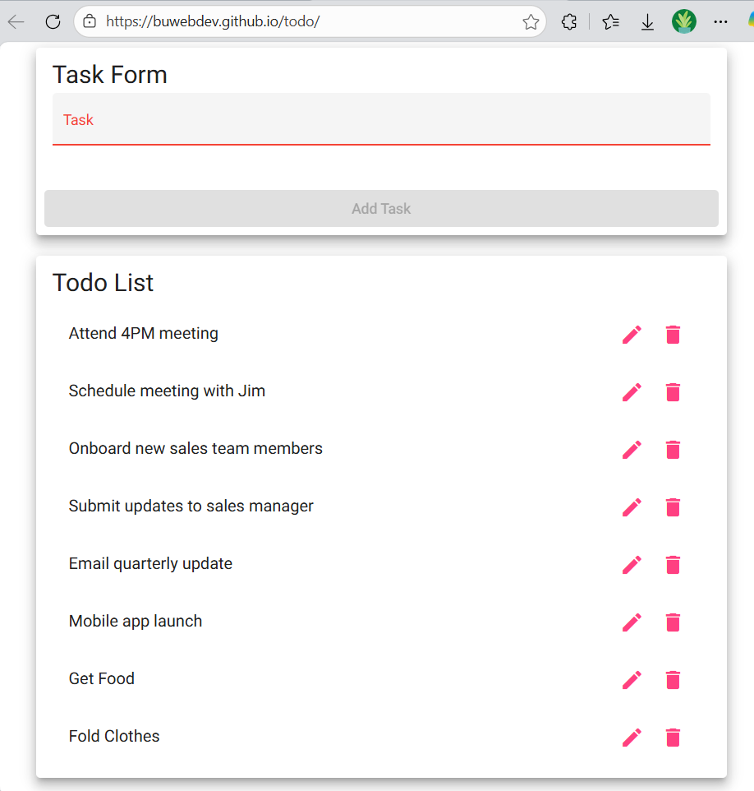
4 | Refresh the page | Edited task remains updated | FAIL | 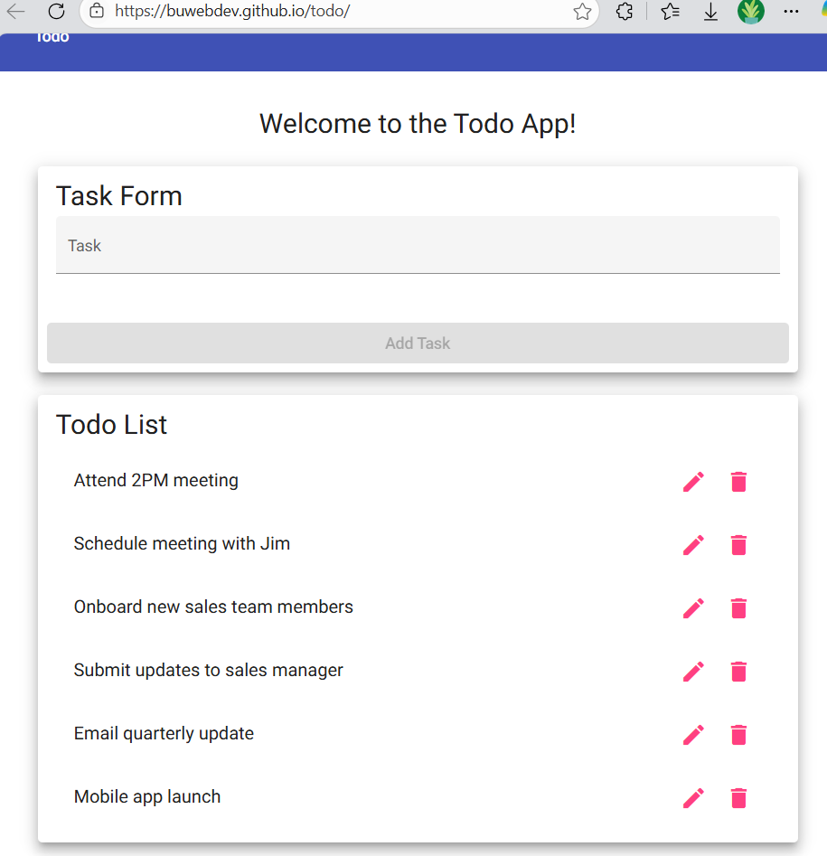
5 | Verify list display | Task shows updated text | FAIL
Comments | The edit feature allowed modification of existing tasks. The updated text saved correctly but did not remained after refreshing the page. This confirms proper data does not persist.

Test 5 | Delete a Todo Task Item
 | Test Objective: Verify users can delete a todo task. | Developer: Daniel Graham  Date tested:2/6/2026 | Peer tester: Angela Vargas  Date tested:02/7/2026
Step | Action | Expected results: | Developer pass/fail | Tester pass/fail
1 | Select an existing task | Task is highlighted or selected | Pass
2 | Click delete/remove option | Task is removed from list | Pass | 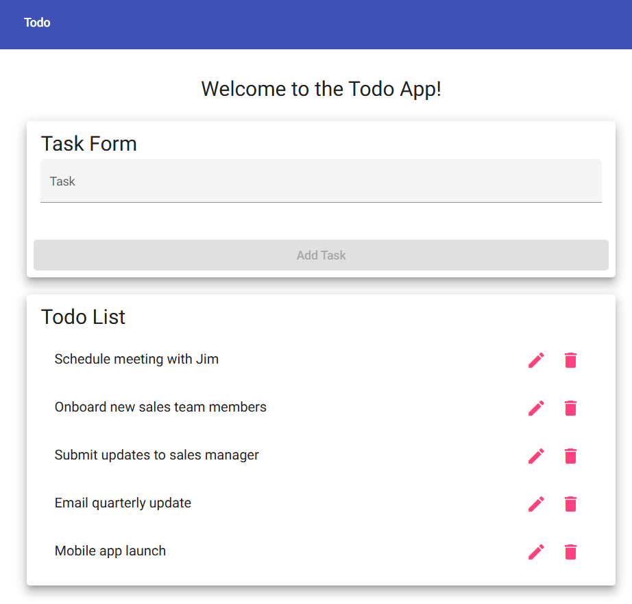
3 | Observe task list | Task no longer appears | Pass
4 | Refresh browser | Deleted task does not return | FAIL
5 | Verify remaining tasks | Other tasks remain unchanged | Pass
Comments | The delete option removed tasks immediately. After refreshing the page, the deleted task did reappear. Other tasks remained unaffected. This confirms correct delete functionality but not working when refreshing, task comes back.

