Project: Test Plan
Course: Alexis Mitchell - CSD380 | Angela Vargas – CSD380
Description: 5 functional tests plan
Date: February 7, 2026 | February 7. 2026
To complete the test case plan, fill out the information for Project, Course, Description and Date in the header below.
.
TABLE OF CONTENTS

The table of contents is empty because you aren’t using the paragraph styles set to appear in it.

For each test, the developer should: provide a test description, a test objective, the developer name and date tested. For each step, fill out the actions to be taken and describe the expected results, and indicate yes or no for each step depending upon the result. The peer tester should provide their name, date tested, indicate yes or no for each step depending upon the result, and a screenshot (thumbnail) of the result.

Test 1 | Add a New Todo Task
 | Test Objective: Verify that a user can add a new todo item using the input field and that item appears on the todo list | Developer: Alexis Mitchell  Date tested: February 7, 2026 | Peer tester: Angela Vargas  Date tested: 02/07/2026
Step | Action | Expected results: | Developer pass/fail | Tester pass/fail  + Screenshot
1 | Locate the todo input field | Input field is visible and enabled | YES | 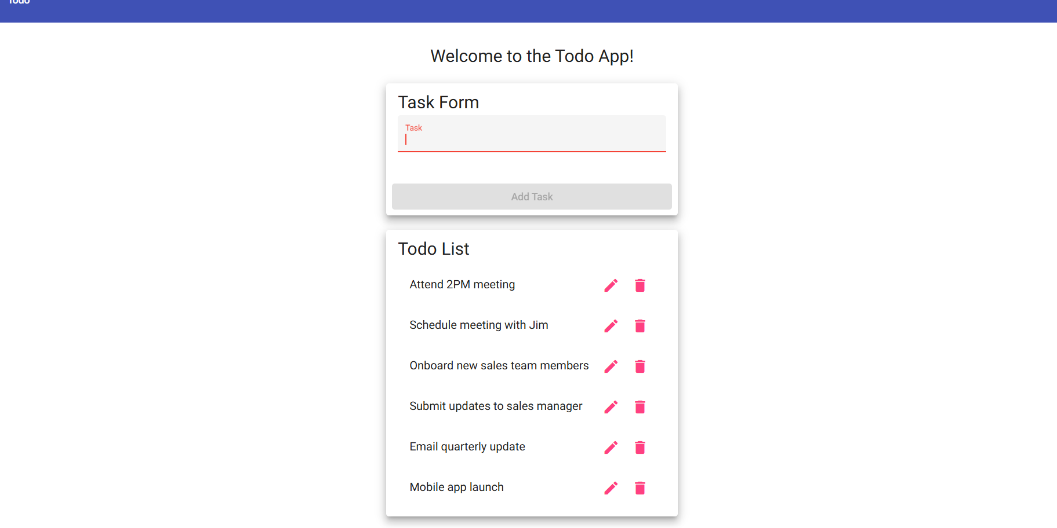
2 | Enter a valid todo item | Text appears in the input field | YES | 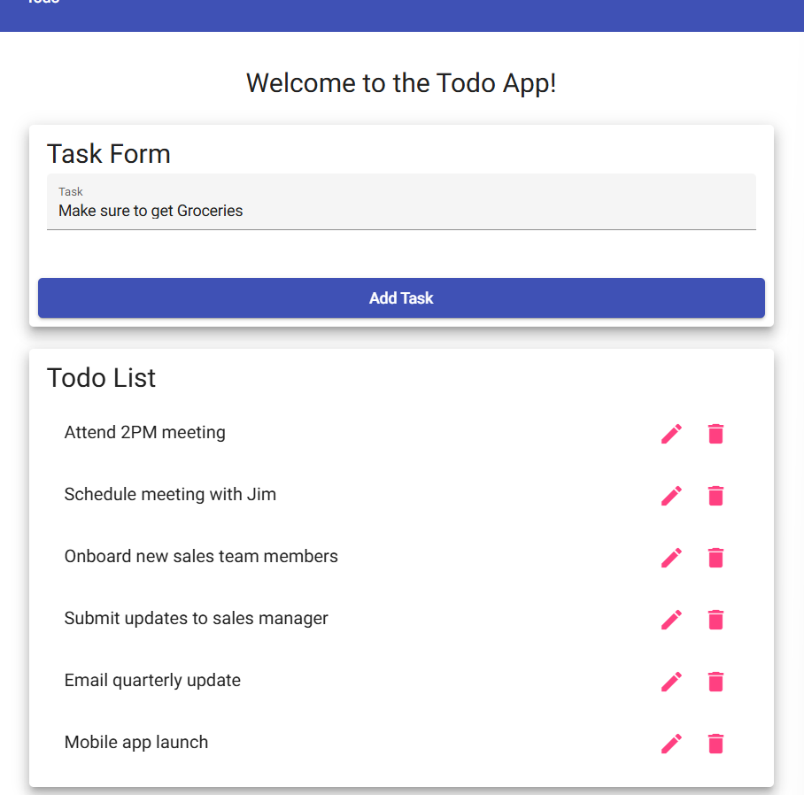
3 | Click the “Add” button | The todo item is added to the list | YES | 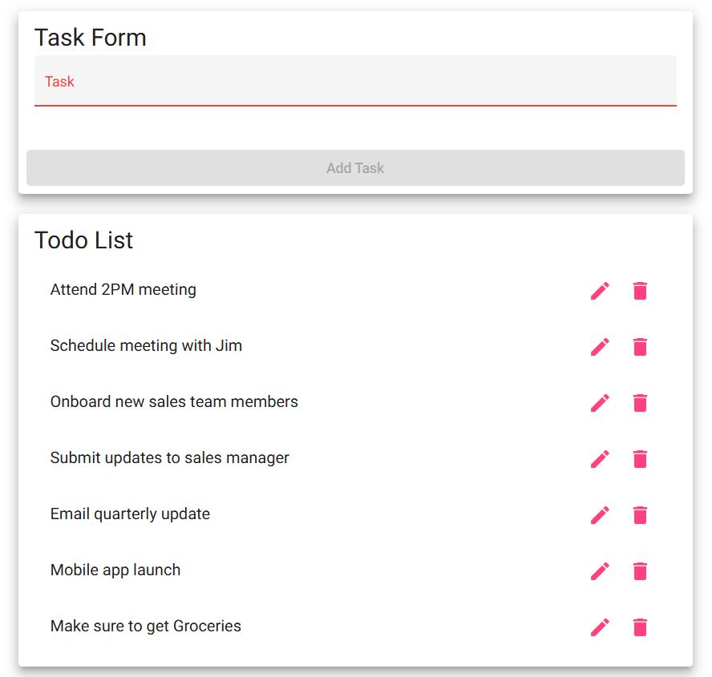
Comments | The application allowed me to successfully enter a new todo item and add it to the list. The input field was visible and functional. After clicking the Add button, the task immediately appeared in the list without any delay or error messages. The functionality worked as expected.

Test 2 | Delete a Todo Task
 | Test Objective: verify that a user can delete an existing todo item and that it is removed from the todo list | Developer: Alexis Mitchell  Date tested: February 7, 2026 | Peer tester: Angela Vargas  Date tested: 02/07/2026
Step | Action | Expected results: | Developer pass/fail | Tester pass/fail
1 | Locate the delete button associated with a todo item | Delete button is visible | YES | 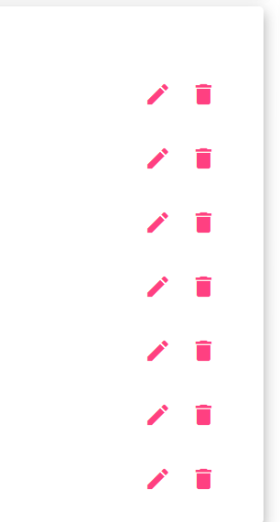
2 | Click the delete button | Todo item is removed from the list | YES | 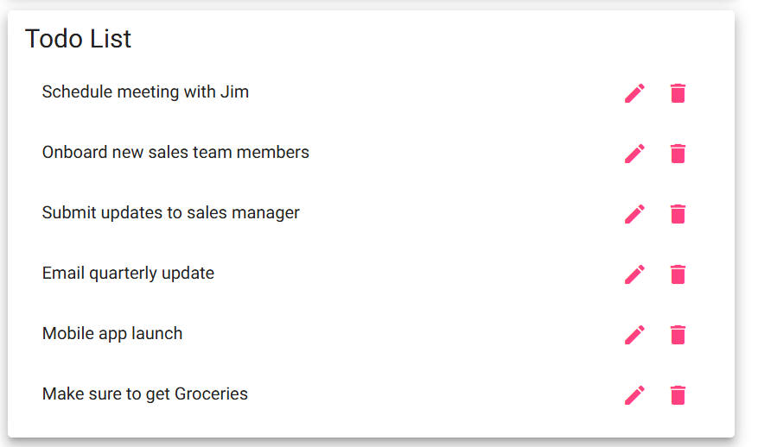
Comments | The delete button was clearly visible next to the todo item. After selecting the first option, the task was removed from the list immediately. The list updated correctly without refreshing the page. The delete functionality worked properly.

Test 3 | Edit a Todo Task
 | Test Objective: verify that a user can edit an existing todo item and that the updated text is saved correctly | Developer: Alexis Mitchell  Date tested: February 7, 2026 | Peer tester: Angela Vargas  Date tested: 02/07/2026
Step | Action | Expected results: | Developer pass/fail | Tester pass/fail
1 | Click the edit button for the todo item | Edit button is visible | YES | 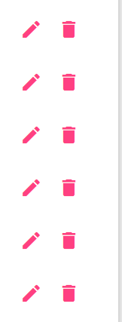
2 | Modify the todo text | Text appears in the edit field | YES | 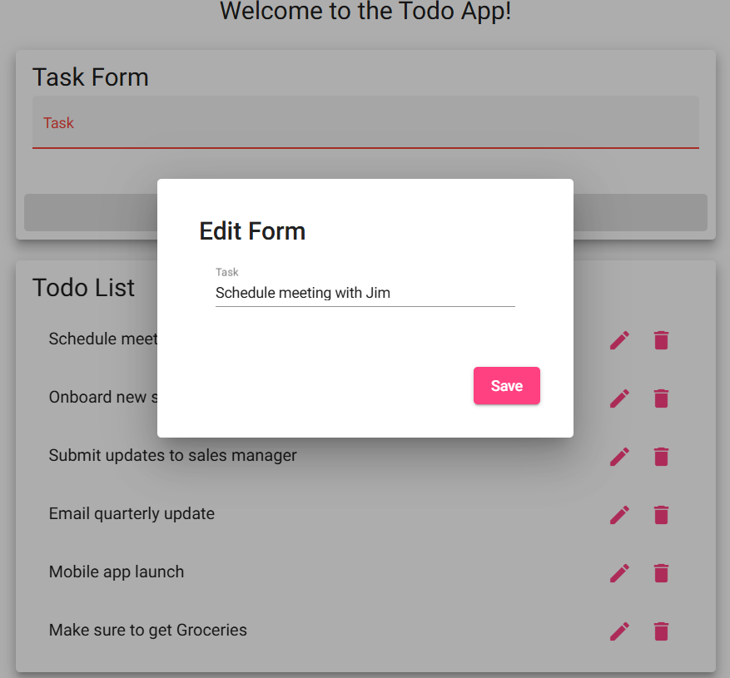
3 | Save the edited todo | Todo item updates with new text | YES | 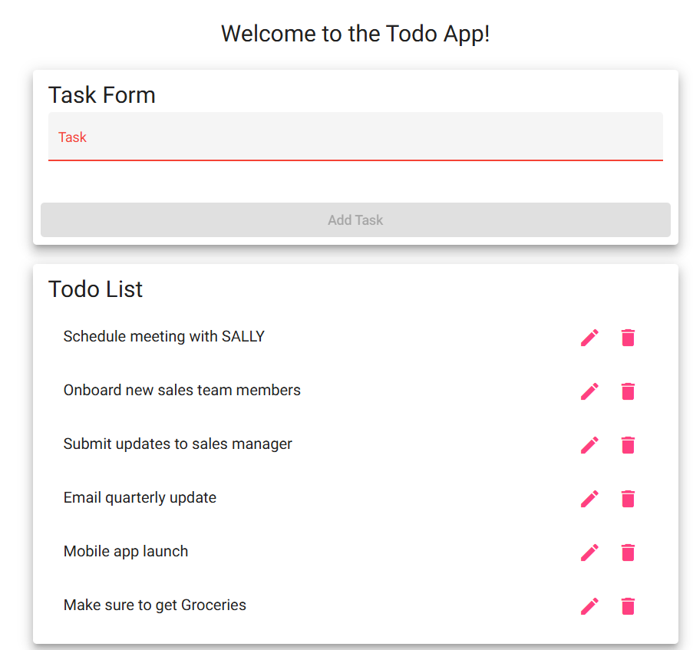
Comments | The edit button displayed correctly and allowed me to modify the task text. The updated text saved successfully and replaced the the name with SALLY. The change remained visible on the screen, confirming that the edit feature functions properly.

Test 4 | Prevent Users from Submitting the Edit Form without Entering a Todo Item
 | Test Objective: verify that the application prevents users from submitting an empty todo item when editing and provides feedback | Developer: Alexis Mitchell  Date tested: February 7, 2026 | Peer tester: Angela Vargas  Date tested: 02/07/2026
Step | Action | Expected results: | Developer pass/fail | Tester pass/fail
1 | Click the edit button on the todo item | Edit form is displayed | YES | 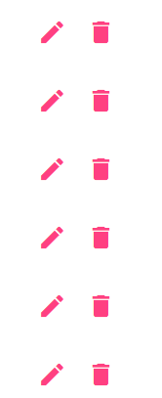
2 | Remove all text from the todo field | Input field is empty | YES | 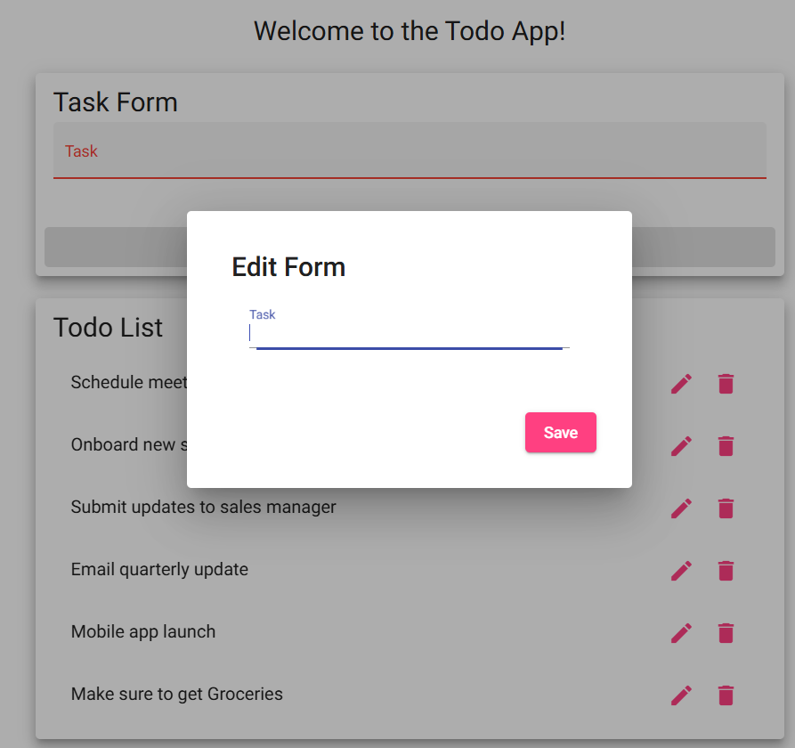
3 | Attempt to save the edit | Error message is displayed or edit is not saved | NO | 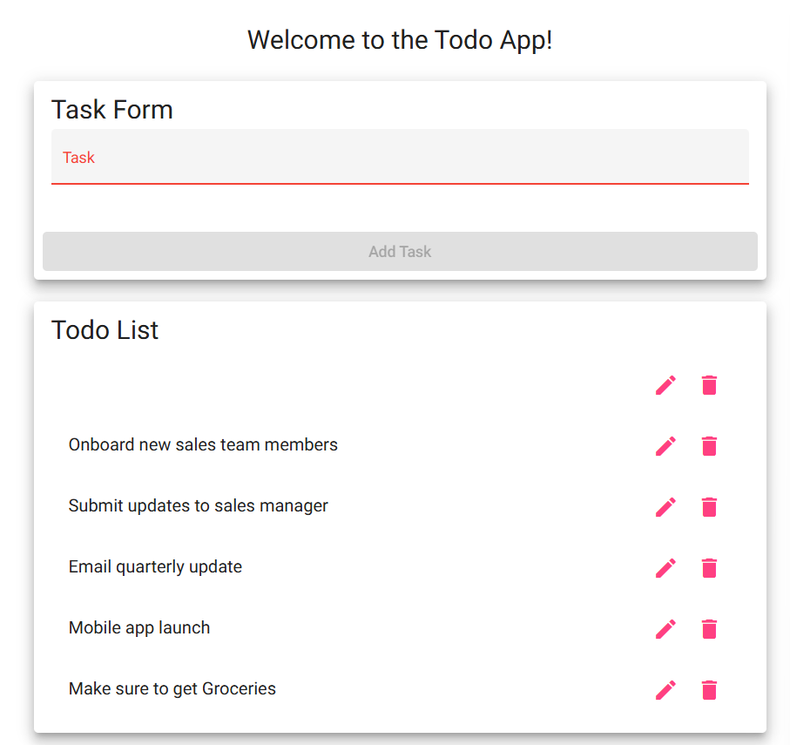
Comments | When attempting to remove all text and save the edit, the system did let me delete all the text. When I saved, it went through without giving me an error message. The application failed on this test because it did let me input an empty field.

Test 5 | Invalid URLs Provide Users with a Custom 404 Error Page
 | Test Objective: verify that users navigating to an invalid URL are shown a custom 404 error page | Developer: Alexis Mitchell  Date tested: February 7, 2026 | Peer tester: Angela Vargas  Date tested: 02/07/2026
Step | Action | Expected results: | Developer pass/fail | Tester pass/fail
1 | Open a new web browser | Browser launches | YES | 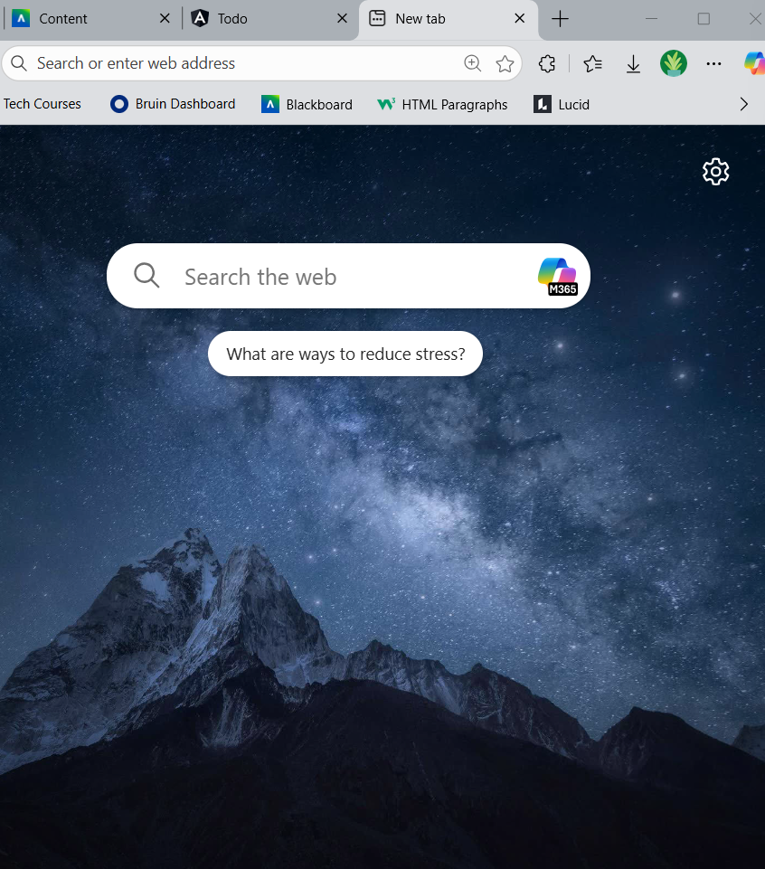
2 | Enter an invalid IRL (e.g. https://buwebdev.github.io/to/ ) | Request is processed | YES | 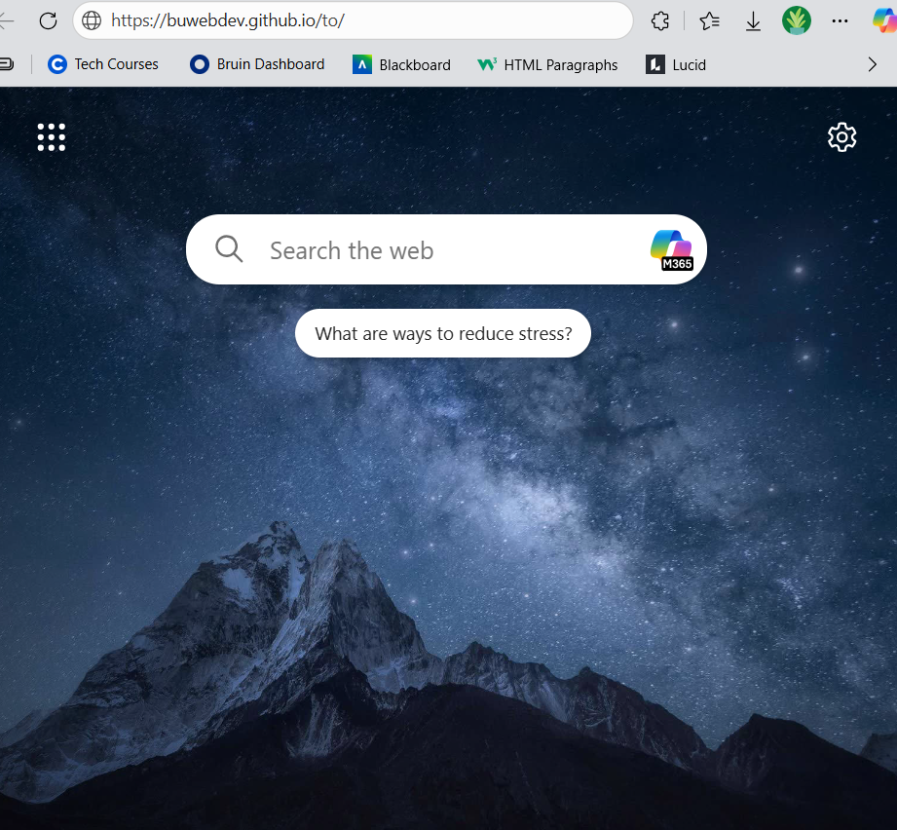
3 | Press Enter | Custom 404 error page is displayed | YES | 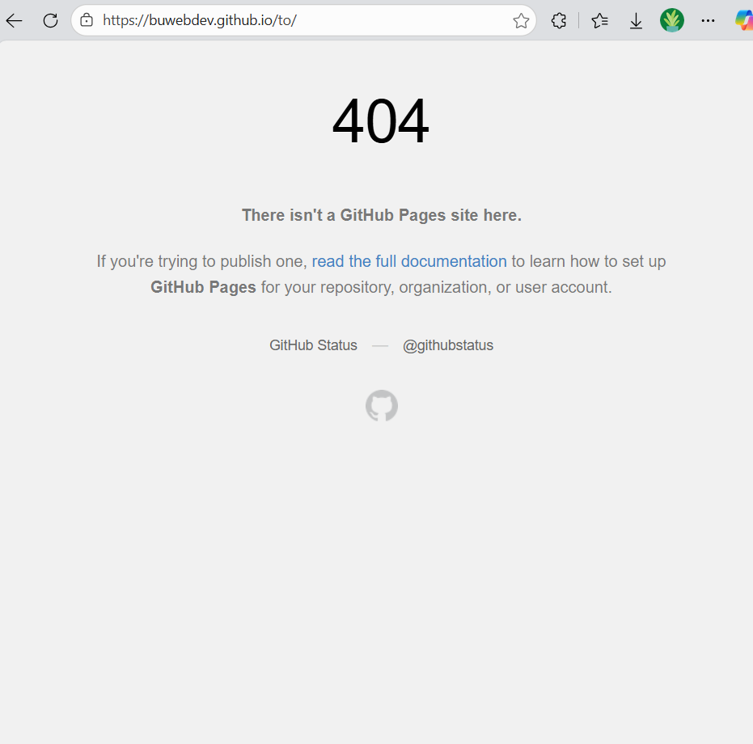
Comments | Navigating to an invalid URL resulted in a custom 404 page being displayed. The browser processed the request correctly and showed the expected error page instead of a default server error. This confirms proper error handling is implemented.

