Linux Commands Practical
Angad | Ubuntu terminal on Windows
This is a write-up of the commands I ran in my Linux terminal while practising file handling, text commands, zip, downloading with wget, file permissions and environment variables. I have kept my mistakes in on purpose. Most of what I learned came from the lines that threw an error, so it felt wrong to hide them.

Part 1: Files, folders and reading /etc/passwd
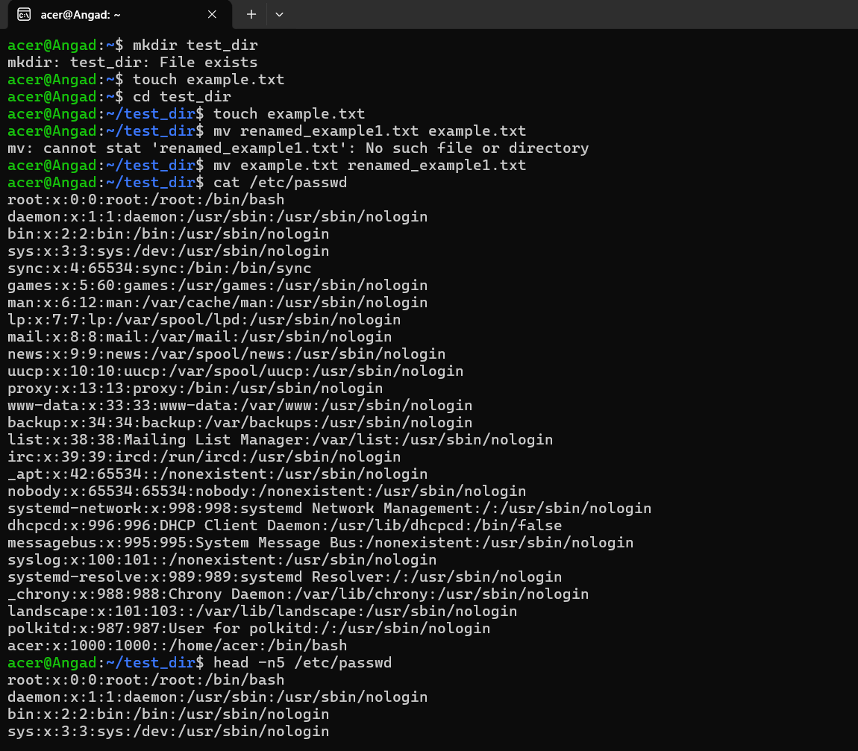
Screenshot 1

What I ran
mkdir test_dir tries to create a folder. It told me the folder already exists, so nothing was created. That was fine, I just carried on and used the existing one.
touch example.txt makes an empty file (or only updates the timestamp if the file is already there). I ran it once in my home folder and then again after cd test_dir, so there was a copy in both places.
mv moves or renames. mv example.txt renamed_example1.txt renamed my file. cat /etc/passwd printed the whole user account list, head -n5 showed only the first five lines of it.

My mistake here
I typed mv renamed_example1.txt example.txt first, which is backwards. mv always wants the old name first and the new name second. Since renamed_example1.txt did not exist yet, Linux said "No such file or directory". After I swapped them, the command worked.

Part 2: tail, grep and installing zip
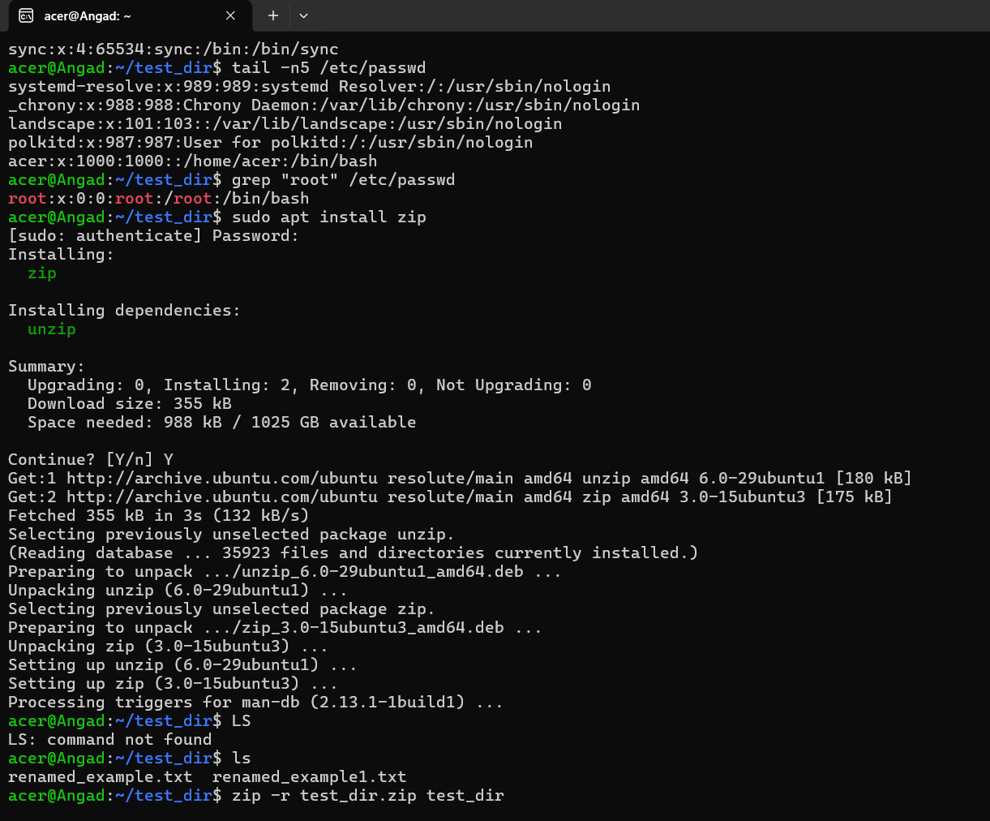
Screenshot 2

What I ran
tail -n5 /etc/passwd is the opposite of head, it shows the last five lines. My own user acer is at the very bottom. grep "root" /etc/passwd searches for a word inside a file and prints only the matching lines, with the match highlighted in red.
sudo apt install zip installed the zip tool (and unzip along with it). It asked for my password and then a Y/n confirmation. After that I ran ls and saw both text files in the folder.

My mistakes here
- I typed LS in capital letters and got "command not found". Linux is case sensitive, so only ls works.
- I ran zip -r test_dir.zip test_dir while I was already inside test_dir. There is no test_dir inside test_dir, so zip had nothing to add. The warning "zip file empty" is in the top of the next screenshot.

Part 3: zip, unzip, wget, chmod and export
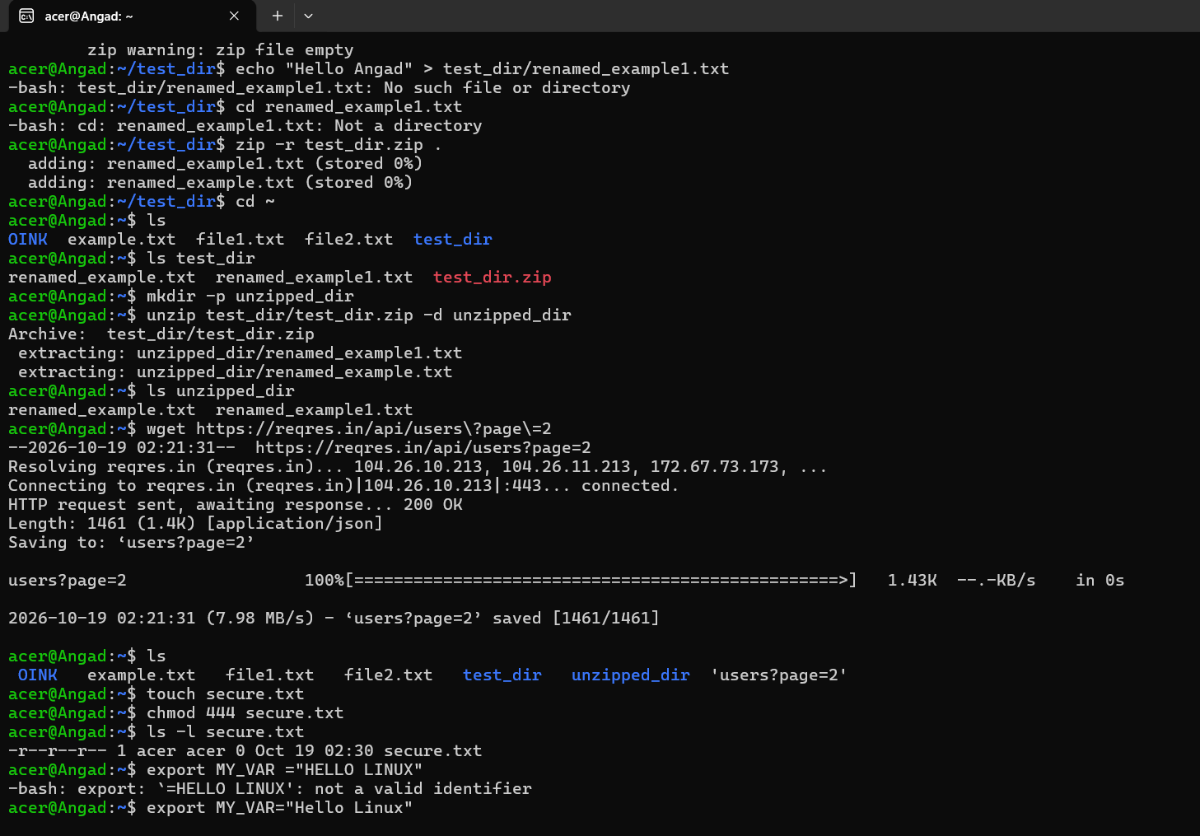
Screenshot 3

The zip and unzip part
I tried echo "Hello Angad" > test_dir/renamed_example1.txt to put some text in the file, but again I was already inside test_dir so that path was wrong ("No such file or directory"). Then I tried cd renamed_example1.txt which also failed because it is a file, not a directory. Two small errors from not paying attention to where I was. pwd would have saved me.
The fix for zip was zip -r test_dir.zip .. The dot means "the current folder", so it added both files this time. I went back with cd ~, checked with ls test_dir (the zip file was there), made a new folder using mkdir -p unzipped_dir and extracted into it with unzip test_dir/test_dir.zip -d unzipped_dir. ls unzipped_dir confirmed both files came out fine.

wget
wget downloads a file from a link. I used it on a sample API link, and it came back "200 OK" and saved a 1.4 KB JSON file. The backslashes in my command are there so the shell treats ? and = as normal characters. Because of the question mark, the saved file has an odd name, users?page=2, which is why ls shows it in quotes.

chmod and export
touch secure.txt then chmod 444 secure.txt. The number 444 gives read-only permission to owner, group and others. ls -l proved it by showing -r--r--r--. Nobody can write to that file now, not even me, unless I change the permission back.
export creates an environment variable. My first try was export MY_VAR ="HELLO LINUX" with a space before the equals sign, and bash said "not a valid identifier". There must be no spaces around =. The second attempt, export MY_VAR="Hello Linux", went through.

Mistakes in one place
- mv with the names in the wrong order (old name goes first).
- LS instead of ls. Commands are case sensitive.
- Zipping test_dir from inside test_dir, which gave an empty zip.
- Using test_dir/... as a path and doing cd into a file while I was in the wrong place.
- A space before = in export.

What I take from this
Most of my errors came from not knowing which folder I was standing in. From now on I will run pwd and ls before anything that uses a path. The other lesson is to read the error message properly. Every one of them told me exactly what was wrong, I just had to slow down and read it.

