ABSTRACT:
The Railway Reservation System a software project that supports the railway track system services as per train schedules. The project is designed with a good GUI that allows monitoring and controlling various trains on the network. It has happened so many times that you have been waiting on railway station for someone to arrive and you don’t have any exact information about train timing and other stuff. The track management system operates on train schedules and lays appropriate tracks for trains to pass as per their decided route. The Train management software has been designed to support and maintain data for multiple trains on the rail network. The train schedules and routes are maintained in a database. Whenever the train passes on a track the further track cross or joins are managed accordingly as per the train route. Once the train passes the track is then configured for the next scheduled train to pass.
INTRODUCTION:
It has happened so many times that you have been waiting on railway station for someone to arrive and you don’t have any exact information about train timing and other stuff. So here we present to you a project on Railway Tracking and Arrival Time Prediction. Using this system user’s can get the information about train timing, and is it on time or not, and other information. In this, system will track the train timing at what time train departed from a particular station and pass these timing details to other station’s system where it will display the timing according to train departed from previous station. If system will find any delay in train due to signal it will automatically update the train timing in next station and will be displayed to viewers.
In this system there is an admin module, who enters the detail about trains and its timing and these details will be passed through internet server and is fetched by the system on other stations, and there is other system that shows train information to the viewers on platform. Second system will get all the information of all trains but will automatically select the data that refers to particular station and shows that information on screen. For example if an admin at Mumbai station enter information about Delhi station Chennai station system will not be effected, but Delhi Station system will show the information about train. This system works like – when train is departed late from a station, admin will enter details about departure and its time, and this information goes in real time on internet server and retrieved on other system through internet server and shows the details on screen. Station masters on every station have a login wherein them may update train arrival time at their station when it arrives. This second System is installed on various locations on station for viewers to view the information. Admin will add information like train departed from station, expected arrival at destination, delay in the train schedule, etc. This project publishes real-time train schedule events to subscribing multiple client applications.

Advantages
- This system help commuter to know about train delays and timing.
- System will provide accurate details about the train.

Disadvantages
- If the train details entered by the admin is wrong so the system in next station will show wrong information
- If there is any network failure the whole system will not work properly.
SYSTEM ANALYSIS:
EXISTING SYSTEM:

The existing railway reservation system has many shortcoming associated with it. In the existing system railway used to set train reservation levels higher than seating capacity to compensate for passenger cancellation and no-shows accounting to overbooking in the agent frequently to do so thus wasting time and money for all. In the existing system integration of different railways on single platforms was not met. With the advent of the online reservation system these flaws can be overcome.
DISADVANTAGES OF EXISTING SYSTEM:
- High expensive
- Time taken procedures and methods
- No portability
- No user friendly
PROPOSED SYSTEM:
The new online reservation system maintains the database centrally giving the clients the information required from anywhere in the world whenever required. This system requires the use of API through which it interacts the data from a central database monitors all the data exchanges that are made at the client side to it and updates it automatically. Through online reservation system customer is able to book & purchase a ticket thus saving time money for the customer and an railway/agent. As the information is stored centrally the customer never loses his ticket as in the existing system.
ADVANTAGES OF THE PROPOSED SYSTEM:
- Significantly lower expenses.
- Time savings by not having to ship paper or to reenter data into a computer.
- Richer, more complete and more accurate data.
- Remote deployment to travelers; and in many cases
- The ability to use devices that you already own

SYSTEM SPECIFICATION:
Hardware Requirements:
- System : Pentium IV 2.4 GHz.
- Hard Disk : 40 GB.
- Floppy Drive : 1.44 Mb.
- Monitor : 15 VGA Color.
- Mouse : Logitech.
- Ram : 1 GB.
- Compatibility Mode : 2GB
Software Requirements:
- Operating system : Windows Xp, 7, 8.
- Coding Language : Java 1.6
- Tool Kit : Android 2.0 latest version
- IDE : Android Studio
- Running Device : Android Mobile 2.2 to 5.1(Latest Version)

MODULES:
- Administrator Module
- Passenger Login Module
- Passenger Registration Module
- Train Search Module
- Ticket Reservation Module
- Train Tracking Module
MODULE DESCRIPTION:
Administrator Login
The whole system is controlled by an administrator, administrator login into system by giving his authentication details such as username and password. After login into the system, he can see the trains currently available to the passengers. The train details are Train name, departure, destination, seat availability, and running days. And administrator can also add a new train into the databases.
Passenger Login
In this module, the user can login into the system by providing their credential, if a user is new to this application, and don’t have their credential details such as username and password; he can register as a new member in this system by registering.
Passenger Registration
If any user doesn’t have username and password to login into the system, then he can choose to register as a new member by choosing register option. He prompt to give his personal and contact information such as name, address, phone number, email id, and he can choose his own username and password. If registration is success then the user can login into the system, by username and password chosen by him/her.
Train Search
After successfully login into system, passenger can search the available trains by their requirements. The requirements may departure, destination, journey date. The list of available trains is shown to the user. Then user may select any train and make ticket reservation. If no train is available, then user may change the journey date, departure, or destination.
Ticket Reservation Module
If the journey date, destination and departure is match for a train then the passenger can select the particular train, after selecting the particular train, user will get the trains details and seat availability in each class, the classes will be AC, Sleeper and seater class. User can select any class, and input the number of seats to reserve, if the user selected seats not available then he prompt to give only select seat less than or equal to available seats. After selecting no. of seats, user can make payment, when he ready to pay, the details of reservation will be shown to the user such as class, number of seats, total amount. Then the user may confirm or cancel the payment. If he confirms the payment then only the ticket will be reserved for that passenger, otherwise it will be open to all.
Train Tracking
The passenger has the options to track the Trains in real time. Trains physical location will show in the map with the place currently train is travelling. Passenger can select particular train, and then train details such as previous station, next static, train started date and expected time to reach the next station are shown to the user. The route covered by the train is shown as a yellow line, and route to be covered will show as the dotted yellow line. The trains currently running on time will be shown in blue color, and trains currently running late will be shown in red color.

SYSTEM DESIGN:
SYSTEM ARCHITECTURE:
We strongly believe that the correct combination of latest information and communication technologies can provide an effective and feasible solution for the requirement of a reliable and accurate train tracking system to improve the efficiency and productivity of India Railways.
The solution we propose encompasses a powerful combination of mobile computing, Global System for Mobile Communication (WIRELESS), Global Positioning System (GPS), Geographical Information System (GIS) technologies and software to provide an intelligent train tracking and management system to improve the existing railway transport service. All these technologies are seamlessly integrated to build a robust, scalable architecture.

UML DIAGRAMS:
UML stands for Unified Modeling Language. UML is a standardized general-purpose modeling language in the field of object-oriented software engineering. The standard is managed, and was created by, the Object Management Group.
The goal is for UML to become a common language for creating models of object oriented computer software. In its current form UML is comprised of two major components: a Meta-model and a notation. In the future, some form of method or process may also be added to; or associated with, UML.
The Unified Modeling Language is a standard language for specifying, Visualization, Constructing and documenting the artifacts of software system, as well as for business modeling and other non-software systems.
The UML represents a collection of best engineering practices that have proven successful in the modeling of large and complex systems.
The UML is a very important part of developing objects oriented software and the software development process. The UML uses mostly graphical notations to express the design of software projects.

GOALS:
The Primary goals in the design of the UML are as follows:
- Provide users a ready-to-use, expressive visual modeling Language so that they can develop and exchange meaningful models.
- Provide extendibility and specialization mechanisms to extend the core concepts.
- Be independent of particular programming languages and development process.
- Provide a formal basis for understanding the modeling language.
- Encourage the growth of OO tools market.
- Support higher level development concepts such as collaborations, frameworks, patterns and components.
- Integrate best practices.

Use Case Diagram:
A use case diagram is a graph of actors, a set of use cases enclosed by a system boundary, communication (participation) associations between the actors and users and generalization among use cases. The use case model defines the outside (actors) and inside (use case) of the system’s behavior.
The following diagram depicts the use case diagram for the proposed system. The use case “Check classification patterns” represents that the user can obtain rules or classification patterns out of the original data set. This use case extends computation of information gain, because we make a division among tupelos based on the information gain computed for each attribute. The attribute with maximum information gain is selected as the split criterion.
The use case “Check privacy preservation” represents that the user can check the level of privacy on the data set. This use case extends generalization of data as level of privacy is directly related to the level of generalization.
Use Case:
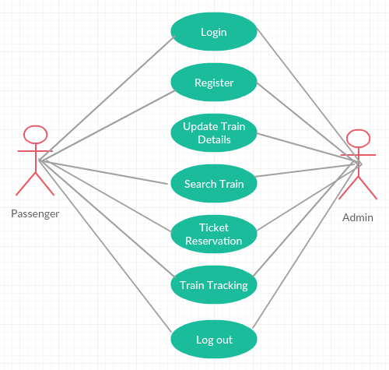
Sequence:
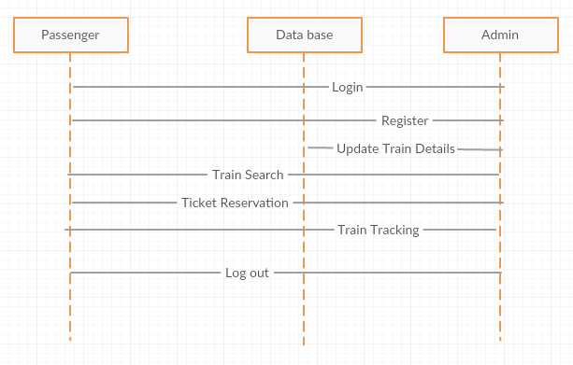
ER:
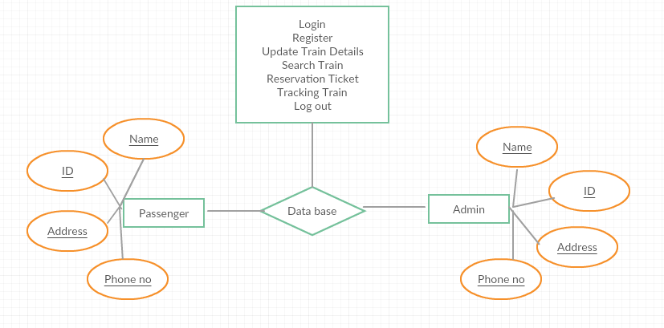
Activity:
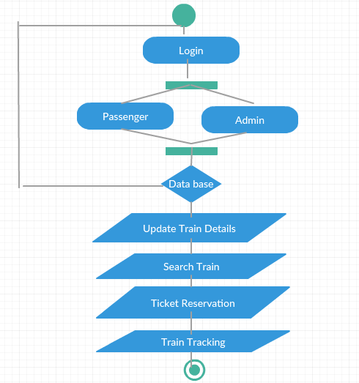
DFD:
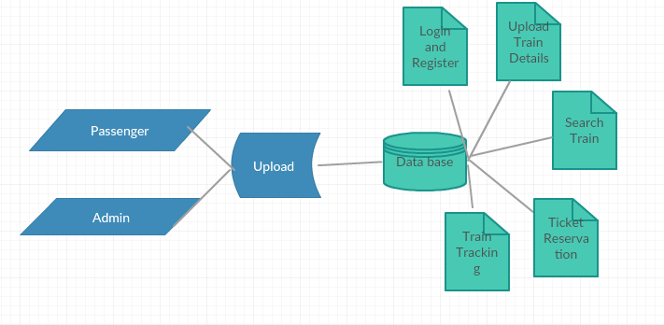
INPUT DESIGN:
The input design is the link between the information system and the user. It comprises the developing specification and procedures for data preparation and those steps are necessary to put transaction data in to a usable form for processing can be achieved by inspecting the computer to read data from a written or printed document or it can occur by having people keying the data directly into the system. The design of input focuses on controlling the amount of input required, controlling the errors, avoiding delay, avoiding extra steps and keeping the process simple. The input is designed in such a way so that it provides security and ease of use with retaining the privacy. Input Design considered the following things:
- What data should be given as input?
- How the data should be arranged or coded?
- The dialog to guide the operating personnel in providing input.
- Methods for preparing input validations and steps to follow when error occur.

OBJECTIVES:
1. Input Design is the process of converting a user-oriented description of the input into a computer-based system. This design is important to avoid errors in the data input process and show the correct direction to the management for getting correct information from the computerized system.
2. It is achieved by creating user-friendly screens for the data entry to handle large volume of data. The goal of designing input is to make data entry easier and to be free from errors. The data entry screen is designed in such a way that all the data manipulates can be performed. It also provides record viewing facilities.
3. When the data is entered it will check for its validity. Data can be entered with the help of screens. Appropriate messages are provided as when needed so that the user will not be in maize of instant. Thus the objective of input design is to create an input layout that is easy to follow
OUTPUT DESIGN:
A quality output is one, which meets the requirements of the end user and presents the information clearly. In any system results of processing are communicated to the users and to other system through outputs. In output design it is determined how the information is to be displaced for immediate need and also the hard copy output. It is the most important and direct source information to the user. Efficient and intelligent output design improves the system’s relationship to help user decision-making.
1. Designing computer output should proceed in an organized, well thought out manner; the right output must be developed while ensuring that each output element is designed so that people will find the system can use easily and effectively. When analysis design computer output, they should Identify the specific output that is needed to meet the requirements.
2. Select methods for presenting information.
3. Create document, report, or other formats that contain information produced by the system.

The output form of an information system should accomplish one or more of the following objectives.
- Convey information about past activities, current status or projections of the
- Future.
- Signal important events, opportunities, problems, or warnings.
- Trigger an action.
- Confirm an action.

SYSTEM ENVIRONMENTS
Android:
Android provides a rich application framework that allows you to build innovative apps and games for mobile devices in a Java language environment. The documents listed in the left navigation provide details about how to build apps using Android's various APIs. If you're new to Android development, it's important that you understand the following fundamental concepts about the Android app framework: Apps provide multiple entry points Android apps are built as a combination of distinct components that can be invoked individually. For instance, an individual activity provides a single screen for a user interface, and a service independently performs work in the background. From one component you can start another component using intent. You can even start a component in a different app, such as an activity in a maps app to show an address. This model provides multiple entry points for a single app and allows any app to behave as a user's "default" for an action that other apps may invoke.
Apps adapt to different devices
Android provides an adaptive app framework that allows you to provide unique resources for different device configurations. For example, you can create different XML layout files for different screen sizes and the system determines which layout to apply based on the current device's screen size. You can query the availability of device features at runtime if any app features require specific hardware such as a camera. If necessary, you can also declare features your app requires so app markets such as Google Play Store do not allow installation on devices that do not support that feature.
Application Fundamentals
Android apps are written in the Java programming language. The Android SDK tools compile your code—along with any data and resource files—into an APK: an Android package, which is an archive file with an .apk suffix. One APK file contains all the contents of an Android app and is the file that Android-powered devices use to install the app. Once installed on a device, each Android app lives in its own security sandbox: The Android operating system is a multi-user Linux system in which each app is a different user. By default, the system assigns each app a unique Linux user ID (the ID is used only by the system and is unknown to the app). The system sets permissions for all the files in an app so that only the user ID assigned to that app can access them. Each process has its own virtual machine (VM), so an app's code runs in isolation from other apps. By default, every app runs in its own Linux process. Android starts the process when any of the app's components need to be executed, then shuts down the process when it's no longer needed or when the system must recover memory for other apps.
App Components
App components are the essential building blocks of an Android app. Each component is a different point through which the system can enter your app. Not all components are actual entry points for the user and some depend on each other, but each one exists as its own entity and plays a specific role—each one is a unique building block that helps define your app's overall behavior. There are four different types of app components. Each type serves a distinct purpose and has a distinct lifecycle that defines how the component is created and destroyed. Here are the four types of app components:
Activities
An activity represents a single screen with a user interface. For example, an email app might have one activity that shows a list of new emails, another activity to compose an email, and another activity for reading emails. Although the activities work together to form a cohesive user experience in the email app, each one is independent of the others. As such, a different app can start any one of these activities (if the email app allows it). For example, a camera app can start the activity in the email app that composes new mail, in order for the user to share a picture. An activity is implemented as a subclass of Activity and you can learn more about it in the Activities developer guide.
Services
A Service is a component that runs in the background to perform long-running operations or to perform work for remote processes. A service does not provide a user interface. For example, a service might play music in the background while the user is in a different app, or it might fetch data over the network without blocking user interaction with an activity. Another component, such as an activity, can start the service and let it run or bind to it in order to interact with it. A service is implemented as a subclass of Service and you can learn more about it in the Services developer guide.
Content providers
A content provider manages a shared set of app data. You can store the data in the file system, an SQLite database, on the web, or any other persistent storage location your app can access. Through the content provider, other apps can query or even modify the data (if the content provider allows it). For example, the Android system provides a content provider that manages the user's contact information. As such, any app with the proper permissions can query part of the content provider (such asContactsContract.Data) to read and write information about a particular person. Content providers are also useful for reading and writing data that is private to your app and not shared. For example, the Note Pad sample app uses a content provider to save notes. A content provider is implemented as a subclass of Content Provider and must implement a standard set of APIs that enable other apps to perform transactions. For more information, see the Content Providers developer guide.
Broadcast receivers
A Broadcast receiver is a component that responds to system-wide broadcast announcements. Many broadcasts originate from the system—for example, a broadcast announcing that the screen has turned off, the battery is low, or a picture was captured. Apps can also initiate broadcasts—for example, to let other apps know that some data has been downloaded to the device and is available for them to use. Although broadcast receivers don't display a user interface, they may create a status bar notification to alert the user when a broadcast event occurs. More commonly, though, a broadcast receiver is just a "gateway" to other components and is intended to do a very minimal amount of work. For instance, it might initiate a service to perform some work based on the event. A broadcast receiver is implemented as a subclass of Broadcast Receiver and each broadcast is delivered as an Intent object. For more information, see the Broadcast Receiver class.
JAVA
Oracle has two products that implement Java Platform Standard Edition (Java SE) 7: Java SE Development Kit (JDK) 7 and Java SE Runtime Environment (JRE) 7.
JDK 7 is a superset of JRE 7, and contains everything that is in JRE 7, plus tools such as the compilers and debuggers necessary for developing applets and applications. JRE 7 provides the libraries, the Java Virtual Machine (JVM), and other components to run applets and applications written in the Java programming language. Note that the JRE includes components not required by the Java SE specification, including both standard and non-standard Java components.
Description of Java Conceptual Diagram
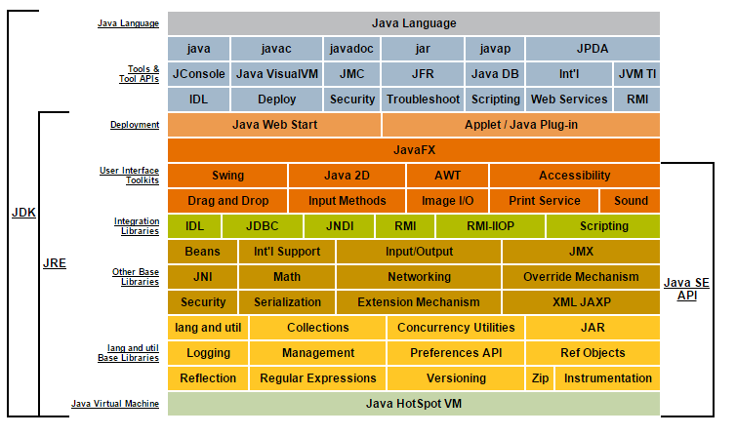
Overview
The ability to store and retrieve Java TM objects is essential to building all but the most transient applications. The key to storing and retrieving objects in a serialized form is representing the state of objects sufficient to reconstruct the object(s). Objects to be saved in the stream may support either the Serializable or the Externalizable interface. For Java TM objects, the serialized form must be able to identify and verify the Java TM class from which the contents of the object were saved and to restore the contents to a new instance. For serializable objects, the stream includes sufficient information to restore the fields in the stream to a compatible version of the class. For Externalizable objects, the class is solely responsible for the external format of its contents.
Objects to be stored and retrieved frequently refer to other objects. Those other objects must be stored and retrieved at the same time to maintain the relationships between the objects. When an object is stored, all of the objects that are reachable from that object are stored as well.
The goals for serializing Java TM objects are to:
Have a simple yet extensible mechanism.
Maintain the Java TM object type and safety properties in the serialized form.
Be extensible to support marshaling and unmarshaling as needed for remote objects.
Be extensible to support simple persistence of Java TM objects.
Require per class implementation only for customization.
Allow the object to define its external format.
Writing to an Object Stream
Writing objects and primitives to a stream is a straightforward process. For example:
First an OutputStream, in this case a FileOutputStream, is needed to receive the bytes. Then an ObjectOutputStream is created that writes to the FileOutputStream. Next, the string "Today" and a Date object are written to the stream. More generally, objects are written with the writeObject method and primitives are written to the stream with the methods of DataOutput.
The write Object method (see Section 2.3, "The write Object Method") serializes the specified object and traverses its references to other objects in the object graph recursively to create a complete serialized representation of the graph. Within a stream, the first reference to any object results in the object being serialized or externalized and the assignment of a handle for that object. Subsequent references to that object are encoded as the handle. Using object handles preserves sharing and circular references that occur naturally in object graphs. Subsequent references to an object use only the handle allowing a very compact representation.
Special handling is required for arrays, enum constants, and objects of type Class, ObjectStreamClass, and String. Other objects must implement either the Serializable or the Externalizable interface to be saved in or restored from a stream.
Primitive data types are written to the stream with the methods in the DataOutput interface, such as writeInt, writeFloat, or writeUTF. Individual bytes and arrays of bytes are written with the methods of OutputStream. Except for serializable fields, primitive data is written to the stream in block-data records, with each record prefixed by a marker and an indication of the number of bytes in the record.
ObjectOutputStream can be extended to customize the information about classes in the stream or to replace objects to be serialized. Refer to the annotateClass and replaceObject method descriptions for details.
Reading from an Object Stream
First an InputStream, in this case a FileInputStream, is needed as the source stream. Then an ObjectInputStream is created that reads from the InputStream. Next, the string "Today" and a Date object are read from the stream. Generally, objects are read with the readObject method and primitives are read from the stream with the methods of DataInput.
The read Object method deserializes the next object in the stream and traverses its references to other objects recursively to create the complete graph of objects serialized.
Primitive data types are read from the stream with the methods in the DataInput interface, such as readInt, readFloat, or readUTF. Individual bytes and arrays of bytes are read with the methods of InputStream. Except for serializable fields, primitive data is read from block-data records.
ObjectInputStream can be extended to utilize customized information in the stream about classes or to replace objects that have been deserialized. Refer to the resolveClass and resolveObject method descriptions for details.
Object Streams as Containers
Object Serialization produces and consumes a stream of bytes that contain one or more primitives and objects. The objects written to the stream, in turn, refer to other objects, which are also represented in the stream. Object Serialization produces just one stream format that encodes and stores the contained objects.
Each object that acts as a container implements an interface which allows primitives and objects to be stored in or retrieved from it. These interfaces are the ObjectOutput and ObjectInput interfaces which:
Provide a stream to write to and to read from
Handle requests to write primitive types and objects to the stream
Handle requests to read primitive types and objects from the stream
Each object which is to be stored in a stream must explicitly allow itself to be stored and must implement the protocols needed to save and restore its state. Object Serialization defines two such protocols. The protocols allow the container to ask the object to write and read its state.
To be stored in an Object Stream, each object must implement either the Serializable or the Externalizable interface:
For a Serializable class, Object Serialization can automatically save and restore fields of each class of an object and automatically handle classes that evolve by adding fields or supertypes. A serializable class can declare which of its fields are saved or restored, and write and read optional values and objects.
For an Externalizable class, Object Serialization delegates to the class complete control over its external format and how the state of the supertype(s) is saved and restored.
Defining Serializable Fields for a Class
The serializable fields of a class can be defined two different ways. Default serializable fields of a class are defined to be the non-transient and non-static fields. This default computation can be overridden by declaring a special field in the Serializable class, serialPersistentFields. This field must be initialized with an array of ObjectStreamField objects that list the names and types of the serializable fields. The modifiers for the field are required to be private, static, and final. If the field's value is null or is otherwise not an instance of ObjectStreamField[], or if the field does not have the required modifiers, then the behavior is as if the field were not declared at all.
For example, the following declaration duplicates the default behavior.
By using serialPersistentFields to define the Serializable fields for a class, there no longer is a limitation that a serializable field must be a field within the current definition of the Serializable class. The writeObject and readObject methods of the Serializable class can map the current implementation of the class to the serializable fields of the class using the interface that is described in Section 1.7, "Accessing Serializable Fields of a Class." Therefore, the fields for a Serializable class can change in a later release, as long as it maintains the mapping back to its Serializable fields that must remain compatible across release boundaries.
Note - There is, however, a limitation to the use of this mechanism to specify serializable fields for inner classes. Inner classes can only contain final static fields that are initialized to constants or expressions built up from constants. Consequently, it is not possible to set serialPersistentFields for an inner class (though it is possible to set it for static member classes). For other restrictions pertaining to serialization of inner class instances, see section Section 1.10, "The Serializable Interface".
Documenting Serializable Fields and Data for a Class
It is important to document the serializable state of a class to enable interoperability with alternative implementations of a Serializable class and to document class evolution. Documenting a serializable field gives one a final opportunity to review whether or not the field should be serializable. The serialization javadoc tags, @serial, @serialField, and @serialData, provide a way to document the serialized form for a Serializable class within the source code.
The @serial tag should be placed in the javadoc comment for a default serializable field. The syntax is as follows: @serial field-description The optional field-description describes the meaning of the field and its acceptable values. The field-description can span multiple lines. When a field is added after the initial release, a @since tag indicates the version the field was added. The field-description for @serial provides serialization-specific documentation and is appended to the javadoc comment for the field within the serialized form documentation.
The @serialField tag is used to document an ObjectStreamField component of a serialPersistentFields array. One of these tags should be used for each ObjectStreamField component. The syntax is as follows: @serialField field-name field-type field-description
The @serialData tag describes the sequences and types of data written or read. The tag describes the sequence and type of optional data written by writeObject or all data written by the Externalizable.writeExternal method. The syntax is as follows: @serialData data-description
The javadoc application recognizes the serialization javadoc tags and generates a specification for each Serializable and Externalizable class. See Section C.1, "Example Alternate Implementation of java.io.File" for an example that uses these tags.
When a class is declared Serializable, the serializable state of the object is defined by serializable fields (by name and type) plus optional data. Optional data can only be written explicitly by the writeObject method of a Serializable class. Optional data can be read by the Serializable class' readObject method or serialization will skip unread optional data.
When a class is declared Externalizable, the data that is written to the stream by the class itself defines the serialized state. The class must specify the order, types, and meaning of each datum that is written to the stream. The class must handle its own evolution, so that it can continue to read data written by and write data that can be read by previous versions. The class must coordinate with the superclass when saving and restoring data. The location of the superclasses data in the stream must be specified.
The designer of a Serializable class must ensure that the information saved for the class is appropriate for persistence and follows the serialization-specified rules for interoperability and evolution. Class evolution is explained in greater detail in Chapter 5, "Versioning of Serializable Objects."
Accessing Serializable Fields of a Class
Serialization provides two mechanisms for accessing the serializable fields in a stream:
The default mechanism requires no customization
The Serializable Fields API allows a class to explicitly access/set the serializable fields by name and type
The default mechanism is used automatically when reading or writing objects that implement the Serializable interface and do no further customization. The serializable fields are mapped to the corresponding fields of the class and values are either written to the stream from those fields or are read in and assigned respectively. If the class provides writeObject and readObject methods, the default mechanism can be invoked by calling defaultWriteObject and defaultReadObject. When the writeObject and readObject methods are implemented, the class has an opportunity to modify the serializable field values before they are written or after they are read.
When the default mechanism cannot be used, the serializable class can use the putFields method of ObjectOutputStream to put the values for the serializable fields into the stream. The writeFields method of ObjectOutputStream puts the values in the correct order, then writes them to the stream using the existing protocol for serialization. Correspondingly, the readFields method of ObjectInputStream reads the values from the stream and makes them available to the class by name in any order. See Section 2.2, "The ObjectOutputStream.PutField Class" and Section 3.2, "The Object Input Stream.GetField Class." for a detailed description of the Serializable Fields API.
The ObjectOutput Interface
The ObjectOutput interface provides an abstract, stream-based interface to object storage. It extends the DataOutput interface so those methods can be used for writing primitive data types. Objects that implement this interface can be used to store primitives and objects.
The writeObject method is used to write an object. The exceptions thrown reflect errors while accessing the object or its fields, or exceptions that occur in writing to storage. If any exception is thrown, the underlying storage may be corrupted. If this occurs, refer to the object that is implementing this interface for more information.
The ObjectInput Interface
The ObjectInput interface provides an abstract stream based interface to object retrieval. It extends the DataInput interface so those methods for reading primitive data types are accessible
The readObject method is used to read and return an object. The exceptions thrown reflect errors while accessing the objects or its fields or exceptions that occur in reading from the storage. If any exception is thrown, the underlying storage may be corrupted. If this occurs, refer to the object implementing this interface for additional information.
The Serializable Interface
Object Serialization produces a stream with information about the JavaTM classes for the objects which are being saved. For serializable objects, sufficient information is kept to restore those objects even if a different (but compatible) version of the implementation of the class is present. The Serializable interface is defined to identify classes which implement the serializable protocol:
A Serializable class must do the following:
- Implement the java.io.Serializable interface
- Identify the fields that should be serializable
(Use the serialPersistentFields member to explicitly declare them serializable or use the transient keyword to denote nonserializable fields.)
- Have access to the no-arg constructor of its first nonserializable superclass
The class can optionally define the following methods:
- A writeObject method to control what information is saved or to append additional information to the stream
- A readObject method either to read the information written by the corresponding writeObject method or to update the state of the object after it has been restored
- A writeReplace method to allow a class to nominate a replacement object to be written to the stream
- A readResolve method to allow a class to designate a replacement object for the object just read from the stream
ObjectOutputStream and ObjectInputStream allow the serializable classes on which they operate to evolve (allow changes to the classes that are compatible with the earlier versions of the classes). See Section 5.5, "Compatible JavaTM Type Evolution" for information about the mechanism which is used to allow compatible changes.
Note - Serialization of inner classes (i.e., nested classes that are not static member classes), including local and anonymous classes, is strongly discouraged for several reasons. Because inner classes declared in non-static contexts contain implicit non-transient references to enclosing class instances, serializing such an inner class instance will result in serialization of its associated outer class instance as well. Synthetic fields generated by javac (or other JavaTM compilers) to implement inner classes are implementation dependent and may vary between compilers; differences in such fields can disrupt compatibility as well as result in conflicting default serialVersionUID values. The names assigned to local and anonymous inner classes are also implementation dependent and may differ between compilers. Since inner classes cannot declare static members other than compile-time constant fields, they cannot use the serialPersistentFields mechanism to designate serializable fields. Finally, because inner classes associated with outer instances do not have zero-argument constructors (constructors of such inner classes implicitly accept the enclosing instance as a prepended parameter), they cannot implement Externalizable. None of the issues listed above, however, apply to static member classes.
The Externalizable Interface
For Externalizable objects, only the identity of the class of the object is saved by the container; the class must save and restore the contents. The Externalizable interface is defined as follows:
- The class of an Externalizable object must do the following:
- Implement the java.io.Externalizable interface
- Implement a writeExternal method to save the state of the object
- (It must explicitly coordinate with its supertype to save its state.)
- Implement a readExternal method to read the data written by the writeExternal method from the stream and restore the state of the object
- (It must explicitly coordinate with the supertype to save its state.)
Have the writeExternal and readExternal methods be solely responsible for the format, if an externally defined format is written
Note - The writeExternal and readExternal methods are public and raise the risk that a client may be able to write or read information in the object other than by using its methods and fields. These methods must be used only when the information held by the object is not sensitive or when exposing it does not present a security risk.
Have a public no-arg constructor
Note - Inner classes associated with enclosing instances cannot have no-arg constructors, since constructors of such classes implicitly accept the enclosing instance as a prepended parameter. Consequently the Externalizable interface mechanism cannot be used for inner classes and they should implement the Serializable interface, if they must be serialized. Several limitations exist for serializable inner classes as well, however; see Section 1.10, "The Serializable Interface", for a full enumeration.
An Externalizable class can optionally define the following methods:
- A writeReplace method to allow a class to nominate a replacement object to be written to the stream
- A readResolve method to allow a class to designate a replacement object for the object just read from the stream
Serialization of Enum Constants
Enum constants are serialized differently than ordinary serializable or externalizable objects. The serialized form of an enum constant consists solely of its name; field values of the constant are not present in the form. To serialize an enum constant, ObjectOutputStream writes the value returned by the enum constant's name method. To deserialize an enum constant, ObjectInputStream reads the constant name from the stream; the deserialized constant is then obtained by calling the java.lang.Enum.valueOf method, passing the constant's enum type along with the received constant name as arguments. Like other serializable or externalizable objects, enum constants can function as the targets of back references appearing subsequently in the serialization stream.
The process by which enum constants are serialized cannot be customized: any class-specific writeObject, readObject, readObjectNoData, writeReplace, and readResolve methods defined by enum types are ignored during serialization and deserialization. Similarly, any serialPersistentFields or serialVersionUID field declarations are also ignored--all enum types have a fixed serialVersionUID of 0L. Documenting serializable fields and data for enum types is unnecessary, since there is no variation in the type of data sent.
Protecting Sensitive Information
When developing a class that provides controlled access to resources, care must be taken to protect sensitive information and functions. During deserialization, the private state of the object is restored. For example, a file descriptor contains a handle that provides access to an operating system resource. Being able to forge a file descriptor would allow some forms of illegal access, since restoring state is done from a stream. Therefore, the serializing runtime must take the conservative approach and not trust the stream to contain only valid representations of objects. To avoid compromising a class, the sensitive state of an object must not be restored from the stream, or it must be reverified by the class. Several techniques are available to protect sensitive data in classes.
The easiest technique is to mark fields that contain sensitive data as private transient. Transient fields are not persistent and will not be saved by any persistence mechanism. Marking the field will prevent the state from appearing in the stream and from being restored during deserialization. Since writing and reading (of private fields) cannot be superseded outside of the class, the transient fields of the class are safe.
Particularly sensitive classes should not be serialized at all. To accomplish this, the object should not implement either the Serializable or the Externalizable interface.
Some classes may find it beneficial to allow writing and reading but specifically handle and revalidate the state as it is deserialized. The class should implement writeObject and readObject methods to save and restore only the appropriate state. If access should be denied, throwing a NotSerializableException will prevent further access.
SQL:
Introduction to Oracle SQL
Structured Query Language (SQL) is the set of statements with which all programs and users access data in an Oracle database. Application programs and Oracle tools often allow users access to the database without using SQL directly, but these applications in turn must use SQL when executing the user's request. This chapter provides background information on SQL as used by most database systems.
History of SQL
Dr. E. F. Codd published the paper, "A Relational Model of Data for Large Shared Data Banks", in June 1970 in the Association of Computer Machinery (ACM) journal,Communications of the ACM. Codd's model is now accepted as the definitive model for relational database management systems (RDBMS). The language, Structured English Query Language (SEQUEL) was developed by IBM Corporation, Inc., to use Codd's model. SEQUEL later became SQL (still pronounced "sequel"). In 1979, Relational Software, Inc. (now Oracle) introduced the first commercially available implementation of SQL. Today, SQL is accepted as the standard RDBMS language.
SQL Standards
Oracle strives to comply with industry-accepted standards and participates actively in SQL standards committees. Industry-accepted committees are the American National Standards Institute (ANSI) and the International Organization for Standardization (ISO), which is affiliated with the International Electrotechnical Commission (IEC). Both ANSI and the ISO/IEC have accepted SQL as the standard language for relational databases. When a new SQL standard is simultaneously published by these organizations, the names of the standards conform to conventions used by the organization, but the standards are technically identical.
The latest SQL standard was adopted in July 2003 and is often called SQL:2003. The formal names of this standard are:
ANSI/ISO/IEC 9075:2003, "Database Language SQL", Parts 1 ("SQL/Framework"), 2 ("SQL/Foundation"), 3 ("SQL/CLI"), 4 ("SQL/PSM"), 9 ("SQL/MED"), 10 ("SQL/OLB"), 11 ("SQL/Schemata"), 13 ("SQL/JRT") and 14 ("SQL/XML")
ISO/IEC 9075:2003, "Database Language SQL", Parts 1 ("SQL/Framework"), 2 ("SQL/Foundation"), 3 ("SQL/CLI"), 4 ("SQL/PSM"), 9 ("SQL/MED"), 10 ("SQL/OLB"), 11 ("SQL/Schemata"), 13 ("SQL/JRT") and 14 ("SQL/XML")
How SQL Works
The strengths of SQL provide benefits for all types of users, including application programmers, database administrators, managers, and end users. Technically speaking, SQL is a data sublanguage. The purpose of SQL is to provide an interface to a relational database such as Oracle Database, and all SQL statements are instructions to the database. In this SQL differs from general-purpose programming languages like C and BASIC. Among the features of SQL are the following:
- It processes sets of data as groups rather than as individual units.
- It provides automatic navigation to the data.
It uses statements that are complex and powerful individually, and that therefore stand alone. Flow-control statements were not part of SQL originally, but they are found in the recently accepted optional part of SQL, ISO/IEC 9075-5: 1996. Flow-control statements are commonly known as "persistent stored modules" (PSM), and the PL/SQL extension to Oracle SQL is similar to PSM.
SQL lets you work with data at the logical level. You need to be concerned with the implementation details only when you want to manipulate the data. For example, to retrieve a set of rows from a table, you define a condition used to filter the rows. All rows satisfying the condition are retrieved in a single step and can be passed as a unit to the user, to another SQL statement, or to an application. You need not deal with the rows one by one, nor do you have to worry about how they are physically stored or retrieved. All SQL statements use the optimizer, a part of Oracle Database that determines the most efficient means of accessing the specified data. Oracle also provides techniques that you can use to make the optimizer perform its job better.
- SQL provides statements for a variety of tasks, including:
- Querying data
- Inserting, updating, and deleting rows in a table
- Creating, replacing, altering, and dropping objects
- Controlling access to the database and its objects
- Guaranteeing database consistency and integrity
- SQL unifies all of the preceding tasks in one consistent language.
Common Language for All Relational Databases
All major relational database management systems support SQL, so you can transfer all skills you have gained with SQL from one database to another. In addition, all programs written in SQL are portable. They can often be moved from one database to another with very little modification.
Recent Enhancements
The Oracle Database SQL engine is the underpinning of all Oracle Database applications. Oracle SQL continually evolves to meet the growing demands of database applications and to support emerging computing architectures, APIs, and network protocols.
In addition to traditional structured data, SQL is capable of storing, retrieving, and processing more complex data:
Object types, collection types, and REF types provide support for complex structured data. A number of standard-compliant multiset operators are now supported for the nested table collection type.
Large objects (LOBs) provide support for both character and binary unstructured data. A single LOB can reach a size of 8 to 128 terabytes, depending on database block size.
The XMLType datatype provides support for semi structured XML data.
Native support of standards-based capabilities includes the following features:
Native regular expression support lets you perform pattern searches on and manipulate loosely formatted, free-form text within the database.
Native floating-point datatypes based on the IEEE754 standard improve the floating-point processing common in XML and Java standards and reduce the storage space required for numeric data.
Built-in SQL aggregate and analytic functions facilitate access to and manipulation of data in data warehouses and data marts.
Ongoing enhancements in Oracle SQL will continue to provide comprehensive support for the development of versatile, scalable, high-performance database applications.
Lexical Conventions
The following lexical conventions for issuing SQL statements apply specifically to the Oracle Database implementation of SQL, but are generally acceptable in other SQL implementations.
When you issue a SQL statement, you can include one or more tabs, carriage returns, spaces, or comments anywhere a space occurs within the definition of the statement. Thus, Oracle Database evaluates the following two statements in the same manner:
Case is insignificant in reserved words, keywords, identifiers and parameters. However, case is significant in text literals and quoted namesTools Support
Oracle provides a number of utilities to facilitate your SQL development process:
SQL*Plus is an interactive and batch query tool that is installed with every Oracle Database server or client installation. It has a command-line user interface and a web-based user interface called iSQL*Plus.
Oracle JDeveloper is a multiple-platform integrated development environment supporting the complete lifecycle of development for Java, Web services, and SQL. It provides a graphical interface for executing and tuning SQL statements and a visual schema diagrammer (database modeler). It also supports editing, compiling, and debugging PL/SQL applications.
Oracle HTML DB is a hosted environment for developing and deploying database-related Web applications. SQL Workshop is a component of Oracle HTML DB that lets you view and manage database objects from a Web browser. SQL Workshop offers quick access to a SQL command processor and a SQL script repository.
The Oracle Call Interface and Oracle precompilers let you embed standard SQL statements within a procedure programming language.
The Oracle Call Interface (OCI) lets you embed SQL statements in C programs.
The Oracle precompilers, Pro*C/C++ and Pro*COBOL, interpret embedded SQL statements and translate them into statements that can be understood by C/C++ and COBOL compilers, respectively.
Most (but not all) Oracle tools also support all features of Oracle SQL. This reference describes the complete functionality of SQL. If the Oracle tool that you are using does not support this complete functionality, then you can find a discussion of the restrictions in the manual describing the tool, such as SQL*Plus User's Guide and Reference.
Basic Elements of Oracle SQL
This chapter contains reference information on the basic elements of Oracle SQL. These elements are the simplest building blocks of SQL statements. Therefore, before using the statements described in familiarize yourself with the concepts covered in this chapter.
Datatypes
Each value manipulated by Oracle Database has a datatype. The datatype of a value associates a fixed set of properties with the value. These properties cause Oracle to treat values of one datatype differently from values of another. For example, you can add values of NUMBER datatype, but not values of RAW datatype.
When you create a table or cluster, you must specify a datatype for each of its columns. When you create a procedure or stored function, you must specify a datatype for each of its arguments. These datatypes define the domain of values that each column can contain or each argument can have. For example, DATE columns cannot accept the value February 29 (except for a leap year) or the values 2 or 'SHOE'. Each value subsequently placed in a column assumes the datatype of the column. For example, if you insert '01-JAN-98' into a DATE column, then Oracle treats the '01-JAN-98' character string as a DATE value after verifying that it translates to a valid date.
Oracle Database provides a number of built-in datatypes as well as several categories for user-defined types that can be used as datatypes. The syntax of Oracle datatypes appears in the diagrams that follow. The text of this section is divided into the following sections:
A datatype is either scalar or nonscalar. A scalar type contains an atomic value, whereas a nonscalar (sometimes called a "collection") contains a set of values. A large object (LOB) is a special form of scalar datatype representing a large scalar value of binary or character data. LOBs are subject to some restrictions that do not affect other scalar types because of their size. Those restrictions are documented in the context of the relevant SQL syntax.
Oracle Built-in Datatypes
The table that follows summarizes Oracle built-in datatypes. Please refer to the syntax in the preceding sections for the syntactic elements. The codes listed for the datatypes are used internally by Oracle Database. The datatype code of a column or object attribute is returned by the DUMP function.
CHAR Data type
The CHAR datatype specifies a fixed-length character string. Oracle ensures that all values stored in a CHAR column have the length specified by size. If you insert a value that is shorter than the column length, then Oracle blank-pads the value to column length. If you try to insert a value that is too long for the column, then Oracle returns an error.
The default length for a CHAR column is 1 byte and the maximum allowed is 2000 bytes. A 1-byte string can be inserted into a CHAR(10) column, but the string is blank-padded to 10 bytes before it is stored.
When you create a table with a CHAR column, by default you supply the column length in bytes. The BYTE qualifier is the same as the default. If you use the CHAR qualifier, for example CHAR(10 CHAR), then you supply the column length in characters. A character is technically a code point of the database character set. Its size can range from 1 byte to 4 bytes, depending on the database character set. The BYTE and CHAR qualifiers override the semantics specified by the NLS_LENGTH_SEMANTICS parameter, which has a default of byte semantics. For performance reasons, Oracle recommends that you use the NLS_LENGTH_SEMANTICS parameter to set length semantics and that you use the BYTE andCHAR qualifiers only when necessary to override the parameter.
NCHAR Datatype
The NCHAR datatype is a Unicode-only datatype. When you create a table with an NCHAR column, you define the column length in characters. You define the national character set when you create your database.
The maximum length of a column is determined by the national character set definition. Width specifications of character datatype NCHAR refer to the number of characters. The maximum column size allowed is 2000 bytes.
If you insert a value that is shorter than the column length, then Oracle blank-pads the value to column length. You cannot insert a CHAR value into an NCHAR column, nor can you insert an NCHAR value into a CHAR column.
The following example compares the translated_description column of the pm.product_descriptions table with a national character set string:
NVARCHAR2 Datatype
The NVARCHAR2 datatype is a Unicode-only datatype. When you create a table with an NVARCHAR2 column, you supply the maximum number of characters it can hold. Oracle subsequently stores each value in the column exactly as you specify it, provided the value does not exceed the maximum length of the column.
The maximum length of the column is determined by the national character set definition. Width specifications of character datatype NVARCHAR2 refer to the number of characters. The maximum column size allowed is 4000 bytes. Please refer to Oracle Database Globalization Support Guide for information on Unicode datatype support.
VARCHAR2 Datatype
The VARCHAR2 datatype specifies a variable-length character string. When you create a VARCHAR2 column, you supply the maximum number of bytes or characters of data that it can hold. Oracle subsequently stores each value in the column exactly as you specify it, provided the value does not exceed the column's maximum length of the column. If you try to insert a value that exceeds the specified length, then Oracle returns an error.
You must specify a maximum length for a VARCHAR2 column. This maximum must be at least 1 byte, although the actual string stored is permitted to be a zero-length string (''). You can use the CHAR qualifier, for example VARCHAR2(10 CHAR), to give the maximum length in characters instead of bytes. A character is technically a code point of the database character set. CHAR and BYTE qualifiers override the setting of the NLS_LENGTH_SEMANTICS parameter, which has a default of bytes. For performance reasons, Oracle recommends that you use the NLS_LENGTH_SEMANTICS parameter to set length semantics and that you use the BYTE and CHAR qualifiers only when necessary to override the parameter. The maximum length of VARCHAR2 data is 4000 bytes. Oracle compares VARCHAR2 values using nonpadded comparison semantics.
To ensure proper data conversion between databases with different character sets, you must ensure that VARCHAR2 data consists of well-formed strings. See Oracle Database Globalization Support Guide for more information on character set support.
VARCHAR Datatype
Do not use the VARCHAR datatype. Use the VARCHAR2 datatype instead. Although the VARCHAR datatype is currently synonymous with VARCHAR2, the VARCHAR datatype is scheduled to be redefined as a separate datatype used for variable-length character strings compared with different comparison semantics.
Numeric Datatypes
The Oracle Database numeric datatypes store positive and negative fixed and floating-point numbers, zero, infinity, and values that are the undefined result of an operation (that is, is "not a number" or NAN). For information on specifying numeric datatypes as literalsNUMBER Datatype
The NUMBER datatype stores zero as well as positive and negative fixed numbers with absolute values from 1.0 x 10⁻¹³⁰ to (but not including) 1.0 x 10¹²⁶. If you specify an arithmetic expression whose value has an absolute value greater than or equal to 1.0 x 10¹²⁶, then Oracle returns an error. Each NUMBER value requires from 1 to 22 bytes.
Specify a fixed-point number using the following form:
where:
p is the precision, or the total number of significant decimal digits, where the most significant digit is the left-most nonzero digit, and the least significant digit is the right-most known digit. Oracle guarantees the portability of numbers with precision of up to 20 base-100 digits, which is equivalent to 39 or 40 decimal digits depending on the position of the decimal point.
s is the scale, or the number of digits from the decimal point to the least significant digit. The scale can range from -84 to 127.
Positive scale is the number of significant digits to the right of the decimal point to and including the least significant digit.
Negative scale is the number of significant digits to the left of the decimal point, to but not including the least significant digit. For negative scale the least significant digit is on the left side of the decimal point, because the actual data is rounded to the specified number of places to the left of the decimal point. For example, a specification of (10,-2) means to round to hundreds.
Scale can be greater than precision, most commonly when e notation is used. When scale is greater than precision, the precision specifies the maximum number of significant digits to the right of the decimal point. For example, a column defined as NUMBER(4,5) requires a zero for the first digit after the decimal point and rounds all values past the fifth digit after the decimal point.
It is good practice to specify the scale and precision of a fixed-point number column for extra integrity checking on input. Specifying scale and precision does not force all values to a fixed length. If a value exceeds the precision, then Oracle returns an error. If a value exceeds the scale, then Oracle rounds it.
This represents a fixed-point number with precision p and scale 0 and is equivalent to NUMBER(p,0). The absence of precision and scale designators specifies the maximum range and precision for an Oracle number.
Floating-Point Numbers
Floating-point numbers can have a decimal point anywhere from the first to the last digit or can have no decimal point at all. An exponent may optionally be used following the number to increase the range (for example, 1.777 e⁻²⁰). A scale value is not applicable to floating-point numbers, because the number of digits that can appear after the decimal point is not restricted.
Binary floating-point numbers differ from NUMBER in the way the values are stored internally by Oracle Database. Values are stored using decimal precision for NUMBER. All literals that are within the range and precision supported by NUMBER are stored exactly as NUMBER. Literals are stored exactly because literals are expressed using decimal precision (the digits 0 through 9). Binary floating-point numbers are stored using binary precision (the digits 0 and 1). Such a storage scheme cannot represent all values using decimal precision exactly. Frequently, the error that occurs when converting a value from decimal to binary precision is undone when the value is converted back from binary to decimal precision. The literal 0.1 is such an example.
Oracle Database provides two numeric datatypes exclusively for floating-point numbers:
BINARY_FLOAT
BINARY_FLOAT is a 32-bit, single-precision floating-point number datatype. Each BINARY_FLOAT value requires 5 bytes, including a length byte.
BINARY_DOUBLE
BINARY_DOUBLE is a 64-bit, double-precision floating-point number datatype. Each BINARY_DOUBLE value requires 9 bytes, including a length byte.
In a NUMBER column, floating point numbers have decimal precision. In a BINARY_FLOAT or BINARY_DOUBLE column, floating-point numbers have binary precision. The binary floating-point numbers support the special values infinity and NaN (not a number).

SYSTEM STUDY
FEASIBILITY STUDY:
The feasibility of the project is analyzed in this phase and business proposal is put forth with a very general plan for the project and some cost estimates. During system analysis the feasibility study of the proposed system is to be carried out. This is to ensure that the proposed system is not a burden to the company. For feasibility analysis, some understanding of the major requirements for the system is essential.
Three key considerations involved in the feasibility analysis are
- ECONOMICAL FEASIBILITY
- TECHNICAL FEASIBILITY
- SOCIAL FEASIBILITY
ECONOMICAL FEASIBILITY:
This study is carried out to check the economic impact that the system will have on the organization. The amount of fund that the company can pour into the research and development of the system is limited. The expenditures must be justified. Thus the developed system as well within the budget and this was achieved because most of the technologies used are freely available. Only the customized products had to be purchased.
TECHNICAL FEASIBILITY:

This study is carried out to check the technical feasibility, that is, the technical requirements of the system. Any system developed must not have a high demand on the available technical resources. This will lead to high demands on the available technical resources. This will lead to high demands being placed on the client. The developed system must have a modest requirement, as only minimal or null changes are required for implementing this system.
SOCIAL FEASIBILITY:
The aspect of study is to check the level of acceptance of the system by the user. This includes the process of training the user to use the system efficiently. The user must not feel threatened by the system, instead must accept it as a necessity. The level of acceptance by the users solely depends on the methods that are employed to educate the user about the system and to make him familiar with it. His level of confidence must be raised so that he is also able to make some constructive criticism, which is welcomed, as he is the final user of the system.

CODING AND SCREEN
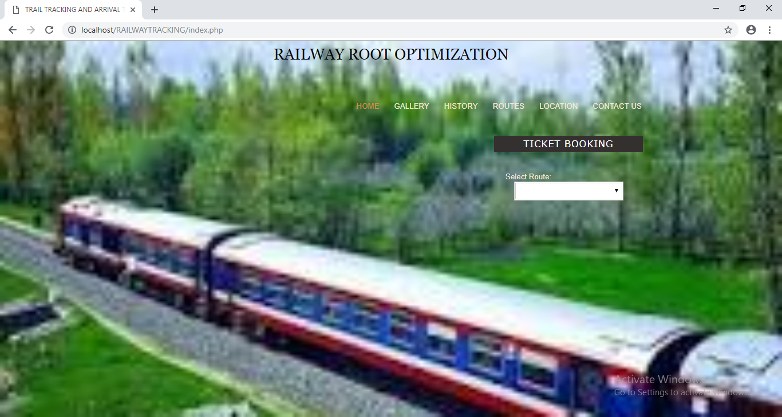

<?php
//Start session
session_start();

//Unset the variables stored in session
unset($_SESSION['SESS_MEMBER_ID']);
?>
<!DOCTYPE html PUBLIC "-//W3C//DTD XHTML 1.0 Strict//EN" "http://www.w3.org/TR/xhtml1/DTD/xhtml1-strict.dtd">
<html xmlns="http://www.w3.org/1999/xhtml">
<head>
<style>
body{background-image:url(./images/train.jpg);background-size:cover;}
</style>
<!-- Start WOWSlider.com HEAD section --> <!-- add to the <head> of your page -->
<link rel="stylesheet" type="text/css" href="engine1/style.css" />
<script type="text/javascript" src="engine1/jquery.js"></script>
<!-- End WOWSlider.com HEAD section -->

<meta http-equiv="Content-Type" content="text/html; charset=UTF-8" />
<title>TRAIL TRACKING AND ARRIVAL TIME</title>
<link rel="stylesheet" type="text/css" href="css/style.css" />
<link rel="icon" type="image/png" href="xres/images/favicon.png" />
<!--[if IE 6]><style type="text/css"> * html img { behavior: url("xres/iepngfix.htc") }</style><![endif]-->
<script type="text/javascript" src="xres/js/saslideshow.js"></script>
<script type="text/javascript" src="xres/js/slideshow.js"></script>
<script src="js/jquery-1.5.min.js" type="text/javascript" charset="utf-8"></script>
<script src="vallenato/vallenato.js" type="text/javascript" charset="utf-8"></script>
<link rel="stylesheet" href="vallenato/vallenato.css" type="text/css" media="screen" charset="utf-8">

<script type="text/javascript">
$("#slideshow > div:gt(0)").hide();

setInterval(function() {
$('#slideshow > div:first')
.fadeOut(1000)
.next()
.fadeIn(1000)
.end()
.appendTo('#slideshow');
}, 3000);
</script>
<!--sa calendar-->
<script type="text/javascript" src="js/datepicker.js"></script>
<link href="css/demo.css" rel="stylesheet" type="text/css" />
<link href="css/datepicker.css" rel="stylesheet" type="text/css" />
<script type="text/javascript">
//<![CDATA[

/*
A "Reservation Date" example using two datePickers
--------------------------------------------------

* Functionality

1. When the page loads:
- We clear the value of the two inputs (to clear any values cached by the browser)
- We set an "onchange" event handler on the startDate input to call the setReservationDates function
2. When a start date is selected
- We set the low range of the endDate datePicker to be the start date the user has just selected
- If the endDate input already has a date stipulated and the date falls before the new start date then we clear the input's value

* Caveats (aren't there always)

- This demo has been written for dates that have NOT been split across three inputs

*/

function makeTwoChars(inp) {
return String(inp).length < 2 ? "0" + inp : inp;
}

function initialiseInputs() {
// Clear any old values from the inputs (that might be cached by the browser after a page reload)
document.getElementById("sd").value = "";
document.getElementById("ed").value = "";

// Add the onchange event handler to the start date input
datePickerController.addEvent(document.getElementById("sd"), "change", setReservationDates);
}

var initAttempts = 0;

function setReservationDates(e) {
// Internet Explorer will not have created the datePickers yet so we poll the datePickerController Object using a setTimeout
// until they become available (a maximum of ten times in case something has gone horribly wrong)

try {
var sd = datePickerController.getDatePicker("sd");
var ed = datePickerController.getDatePicker("ed");
} catch (err) {
if(initAttempts++ < 10) setTimeout("setReservationDates()", 50);
return;
}

// Check the value of the input is a date of the correct format
var dt = datePickerController.dateFormat(this.value, sd.format.charAt(0) == "m");

// If the input's value cannot be parsed as a valid date then return
if(dt == 0) return;

// At this stage we have a valid YYYYMMDD date

// Grab the value set within the endDate input and parse it using the dateFormat method
// N.B: The second parameter to the dateFormat function, if TRUE, tells the function to favour the m-d-y date format
var edv = datePickerController.dateFormat(document.getElementById("ed").value, ed.format.charAt(0) == "m");

// Set the low range of the second datePicker to be the date parsed from the first
ed.setRangeLow( dt );

// If theres a value already present within the end date input and it's smaller than the start date
// then clear the end date value
if(edv < dt) {
document.getElementById("ed").value = "";
}
}

function removeInputEvents() {
// Remove the onchange event handler set within the function initialiseInputs
datePickerController.removeEvent(document.getElementById("sd"), "change", setReservationDates);
}

datePickerController.addEvent(window, 'load', initialiseInputs);
datePickerController.addEvent(window, 'unload', removeInputEvents);

//]]>
</script>

</head>

<body>
<h1>RAILWAY ROOT OPTIMIZATION</h1>
<div id="wrapper">
<div id="header">
<ul id="mainnav">
<li class="current"><a href="index.php">Home</a></li>
<li><a href="gallery.php">Gallery</a></li>
<li><a href="history.php">History</a></li>
<li><a href="routes.php">Routes</a></li>
<li><a href="location.php">location</a></li>
<li><a href="contact.php">Contact Us</a></li>
</ul>
</div>
<div id="content">
<div id="rotator">

<div id="logo" style="left: 600px; height: auto; top: 23px; width: 260px; position: absolute; z-index:4;">

<h2 class="accordion-header" style="height: 18px; margin-bottom: 15px; color: rgb(255, 255, 255); background: none repeat scroll 0px 0px rgb(53, 48, 48);">Ticket Booking</h2>
<div class="accordion-content" style="margin-bottom: 15px;">
<form action="selectset.php" method="post" style="margin-bottom:none;">
<span style="margin-right: 11px;">Select Route:
<select name="route" style="width: 191px; margin-left: 15px; border: 3px double #CCCCCC; padding:5px 10px;"/>
<?php
include('db.php');
$result = mysql_query("SELECT * FROM route");
while($row = mysql_fetch_array($result))
{
echo '<option value="'.$row['id'].'">';
echo $row['route'].' :'.$row['type'].' :'.$row['time'];
echo '</option>';
}
?>
</select>
</span><br>
<span style="margin-right: 11px;">Date:
<input type="text" class="w8em format-d-m-y highlight-days-67 range-low-today" name="date" id="sd" value="" maxlength="10" readonly="readonly" style="width: 165px; margin-left: 15px; border: 3px double #CCCCCC; padding:5px 10px;"/>
</span><br>
<span style="margin-right: 11px;">No. of Passenger:
<select name="qty" style="width: 191px; margin-left: 15px; border: 3px double #CCCCCC; padding:5px 10px;">
<option>1</option>
<option>2</option>
<option>3</option>
<option>4</option>
<option>5</option>
<option>6</option>
<option>7</option>
<option>8</option>
<option>9</option>
</select>
</span><br><br>
<input type="submit" id="submit" value="Next" style="height: 34px; margin-left: 15px; width: 191px; padding: 5px; border: 3px double rgb(204, 204, 204);" />
</form>
</div>
<h2 class="accordion-header" style="height: 18px; margin-bottom: 15px; color: rgb(255, 255, 255); background: none repeat scroll 0px 0px rgb(53, 48, 48);">Admin Login</h2>
<div class="accordion-content" style="margin-bottom: 15px;">
<form action="login.php" method="post" style="margin-bottom:none;">
<span style="margin-right: 11px;">Username: <input type="text" name="username" style="width: 165px; margin-left: 15px; border: 3px double #CCCCCC; padding:5px 10px;"/></span><br>
<span style="margin-right: 11px;">Password: <input type="password" name="password" style="width: 165px; margin-left: 15px; border: 3px double #CCCCCC; padding:5px 10px;"/></span><br><br>
<input type="submit" id="submit" class="medium gray button" value="Login" style="height: 34px; margin-left: 15px; width: 191px; padding: 5px; border: 3px double rgb(204, 204, 204);" />
</form>
</div>
</div>
</div>

</div>

<div id="footer">
<h4>+91 ......... &bull; <a href="contact-us.php">............</a></h4>
<p>Hours of Operation&nbsp;&nbsp;&bull;&nbsp;&nbsp;Mon - Sun: 10:00 am - 12:00 am</p>
<a href="index.php"></a>
<p>&copy; Copyright Reserved by ..........<br /></p>
</div>
</div>

<script type="text/javascript" src="engine1/wowslider.js"></script>
<script type="text/javascript" src="engine1/script.js"></script>
<!-- End WOWSlider.com BODY section -->
</body>
</html>
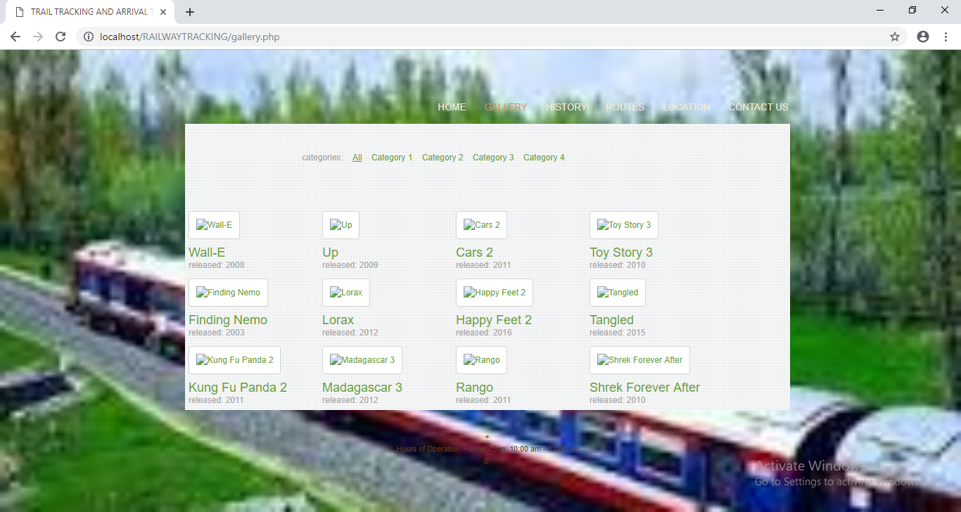
<!DOCTYPE html PUBLIC "-//W3C//DTD XHTML 1.0 Strict//EN" "http://www.w3.org/TR/xhtml1/DTD/xhtml1-strict.dtd">
<html xmlns="http://www.w3.org/1999/xhtml">
<head>
<meta http-equiv="Content-Type" content="text/html; charset=UTF-8" />
<title>TRAIL TRACKING AND ARRIVAL TIME</title>
<link rel="stylesheet" type="text/css" href="css/style.css" />
<link rel="icon" type="image/png" href="xres/images/favicon.png" />
<link type="text/css" href="css/styles.css" rel="stylesheet" media="all" />
<script type="text/javascript" src="js/sagallery.js"></script>
<script src="js/jquery.quicksand.js" type="text/javascript"></script>
<script src="js/jquery.easing.js" type="text/javascript"></script>
<script src="js/script.js" type="text/javascript"></script>
<script src="js/jquery.prettyPhoto.js" type="text/javascript"></script>
<link href="css/prettyPhoto.css" rel="stylesheet" type="text/css" />
</head>

<body>
<div id="wrapper">
<div id="header">
<ul id="mainnav">
<li><a href="index.php">Home</a></li>
<li class="current"><a href="gallery.php">Gallery</a></li>
<li><a href="history.php">History</a></li>
<li><a href="routes.php">Routes</a></li>
<li><a href="location.php">location</a></li>
<li><a href="contact.php">Contact Us</a></li>
</ul>
</div>
<div id="content">
<div id="gallerycontainer">
<ul class="portfolio-categ filter">
<li>categories:</li>
<li class="all active"><a href="#">All</a></li>
<li class="cat-item-1"><a href="#" title="Category 1">Category 1</a></li>
<li class="cat-item-2"><a href="#" title="Category 2">Category 2</a></li>
<li class="cat-item-3"><a href="#" title="Category 3">Category 3</a></li>
<li class="cat-item-4"><a href="#" title="Category 4">Category 4</a></li>
</ul>
<ul class="portfolio-area" style="width: 860px;">

<li class="portfolio-item2" data-id="id-0" data-type="cat-item-4">
<div>
<span class="image-block">
<a class="image-zoom" href="images/big/pic1.jpg" rel="prettyPhoto[gallery]" title="Wall-E"><img width="225" height="140" src="images/thumbs/p1.jpg" alt="Wall-E" title="Wall-E" />
</a>
</span>
<div class="home-portfolio-text">
<h2 class="post-title-portfolio"><a href="#" rel="bookmark" title="Wall-E">Wall-E</a></h2>
<p class="post-subtitle-portfolio">released: 2008</p>
</div>

</div>
</li>

<li class="portfolio-item2" data-id="id-1" data-type="cat-item-2">
<div>
<span class="image-block">
<a class="image-zoom" href="images/big/pic2.jpg" rel="prettyPhoto[gallery]" title="Up"><img width="225" height="140" src="images/thumbs/p2.jpg" alt="Up" title="Up" />
</a>
</span>
<div class="home-portfolio-text">
<h2 class="post-title-portfolio"><a href="#" rel="bookmark" title="Up">Up</a></h2>
<p class="post-subtitle-portfolio">released: 2009</p>
</div>

</div>
</li>

<li class="portfolio-item2" data-id="id-2" data-type="cat-item-1">
<div>
<span class="image-block">
<a class="image-zoom" href="images/big/pic3.jpg" rel="prettyPhoto[gallery]" title="Cars 2"><img width="225" height="140" src="images/thumbs/p3.jpg" alt="Cars 2" title="Cars 2" />
</a>
</span>
<div class="home-portfolio-text">
<h2 class="post-title-portfolio"><a href="#" rel="bookmark" title="Cars 2">Cars 2</a></h2>
<p class="post-subtitle-portfolio">released: 2011</p>
</div>

</div>
</li>

<li class="portfolio-item2" data-id="id-3" data-type="cat-item-4">
<div>
<span class="image-block">
<a class="image-zoom" href="images/big/pic4.jpg" rel="prettyPhoto[gallery]" title="Toy Story 3"><img width="225" height="140" src="images/thumbs/p4.jpg" alt="Toy Story 3" title="Toy Story 3" />
</a>
</span>
<div class="home-portfolio-text">
<h2 class="post-title-portfolio"><a href="#" rel="bookmark" title="Toy Story 3">Toy Story 3</a></h2>
<p class="post-subtitle-portfolio">released: 2010</p>
</div>

</div>
</li>

<li class="portfolio-item2" data-id="id-4" data-type="cat-item-3">
<div>
<span class="image-block">
<a class="image-zoom" href="images/big/pic5.jpg" rel="prettyPhoto[gallery]" title="Finding Nemo"><img width="225" height="140" src="images/thumbs/p5.jpg" alt="Finding Nemo" title="Finding Nemo" />
</a>
</span>
<div class="home-portfolio-text">
<h2 class="post-title-portfolio"><a href="#" rel="bookmark" title="Finding Nemo">Finding Nemo</a></h2>
<p class="post-subtitle-portfolio">released: 2003</p>
</div>

</div>
</li>

<li class="portfolio-item2" data-id="id-5" data-type="cat-item-2">
<div>
<span class="image-block">
<a class="image-zoom" href="images/big/pic6.jpg" rel="prettyPhoto[gallery]" title="Lorax"><img width="225" height="140" src="images/thumbs/p6.jpg" alt="Lorax" title="Lorax" />
</a>
</span>
<div class="home-portfolio-text">
<h2 class="post-title-portfolio"><a href="#" rel="bookmark" title="Lorax">Lorax</a></h2>
<p class="post-subtitle-portfolio">released: 2012</p>
</div>

</div>
</li>

<li class="portfolio-item2" data-id="id-6" data-type="cat-item-1">
<div>
<span class="image-block">
<a class="image-zoom" href="images/big/pic7.jpg" rel="prettyPhoto[gallery]" title="Happy Feet 2"><img width="225" height="140" src="images/thumbs/p7.jpg" alt="Happy Feet 2" title="Happy Feet 2" />
</a>
</span>
<div class="home-portfolio-text">
<h2 class="post-title-portfolio"><a href="#" rel="bookmark" title="Happy Feet 2">Happy Feet 2</a></h2>
<p class="post-subtitle-portfolio">released: 2016</p>
</div>

</div>
</li>

<li class="portfolio-item2" data-id="id-7" data-type="cat-item-1">
<div>
<span class="image-block">
<a class="image-zoom" href="images/big/pic8.jpg" rel="prettyPhoto[gallery]" title="Tangled"><img width="225" height="140" src="images/thumbs/p8.jpg" alt="Tangled" title="Tangled" />
</a>
</span>
<div class="home-portfolio-text">
<h2 class="post-title-portfolio"><a href="#" rel="bookmark" title="Tangled">Tangled</a></h2>
<p class="post-subtitle-portfolio">released: 2015</p>
</div>

</div>
</li>

<li class="portfolio-item2" data-id="id-8" data-type="cat-item-1">
<div>
<span class="image-block">
<a class="image-zoom" href="images/big/pic9.jpg" rel="prettyPhoto[gallery]" title="Kung Fu Panda 2"><img width="225" height="140" src="images/thumbs/p9.jpg" alt="Kung Fu Panda 2" title="Kung Fu Panda 2" />
</a>
</span>
<div class="home-portfolio-text">
<h2 class="post-title-portfolio"><a href="#" rel="bookmark" title="Kung Fu Panda 2">Kung Fu Panda 2</a></h2>
<p class="post-subtitle-portfolio">released: 2011</p>
</div>

</div>
</li>

<li class="portfolio-item2" data-id="id-9" data-type="cat-item-2">
<div>
<span class="image-block">
<a class="image-zoom" href="images/big/pic10.jpg" rel="prettyPhoto[gallery]" title="Madagascar 3"><img width="225" height="140" src="images/thumbs/p10.jpg" alt="Madagascar 3" title="Madagascar 3" />
</a>
</span>
<div class="home-portfolio-text">
<h2 class="post-title-portfolio"><a href="#" rel="bookmark" title="Madagascar 3">Madagascar 3</a></h2>
<p class="post-subtitle-portfolio">released: 2012</p>
</div>

</div>
</li>

<li class="portfolio-item2" data-id="id-10" data-type="cat-item-3">
<div>
<span class="image-block">
<a class="image-zoom" href="images/big/pic11.jpg" rel="prettyPhoto[gallery]" title="Rango"><img width="225" height="140" src="images/thumbs/p11.jpg" alt="Rango" title="Rango" />
</a>
</span>
<div class="home-portfolio-text">
<h2 class="post-title-portfolio"><a href="#" rel="bookmark" title="Rango">Rango</a></h2>
<p class="post-subtitle-portfolio">released: 2011</p>
</div>

</div>
</li>

<li class="portfolio-item2" data-id="id-11" data-type="cat-item-4">
<div>
<span class="image-block">
<a class="image-zoom" href="images/big/pic12.jpg" rel="prettyPhoto[gallery]" title="Shrek Forever After"><img width="225" height="140" src="images/thumbs/p12.jpg" alt="Shrek Forever After" title="Shrek Forever After" />
</a>
</span>
<div class="home-portfolio-text">
<h2 class="post-title-portfolio"><a href="#" rel="bookmark" title="Shrek Forever After">Shrek Forever After</a></h2>
<p class="post-subtitle-portfolio">released: 2010</p>
</div>

</div>
</li>

<div class="column-clear"></div>
</ul>
<div class="clearfix"></div>
</div>
</div>

<div id="footer">
<h4> &bull; <a href="contact-us.php"></a></h4>
<p>Hours of Operation&nbsp;&nbsp;&bull;&nbsp;&nbsp;Mon - Sun: 10:00 am - 12:00 am</p>
<a href="index.php"></a>
<p>&copy; <br /></p>
</div>
</div>
</body>
</html>
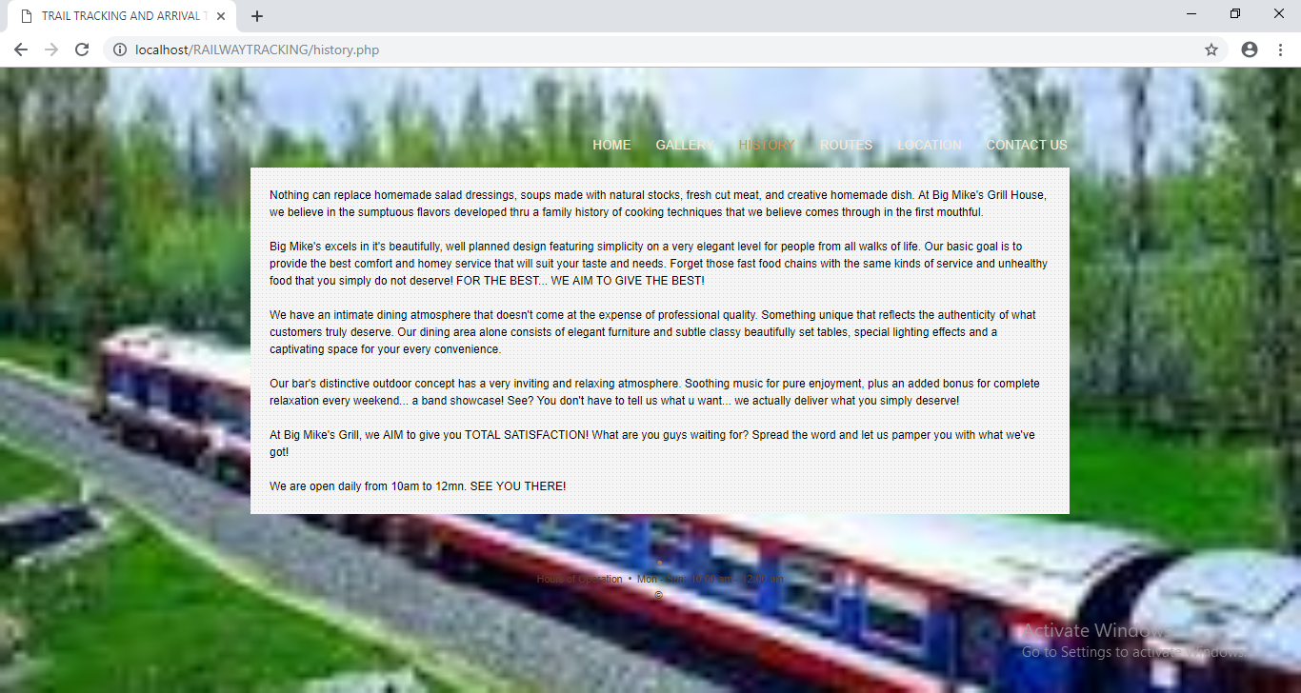
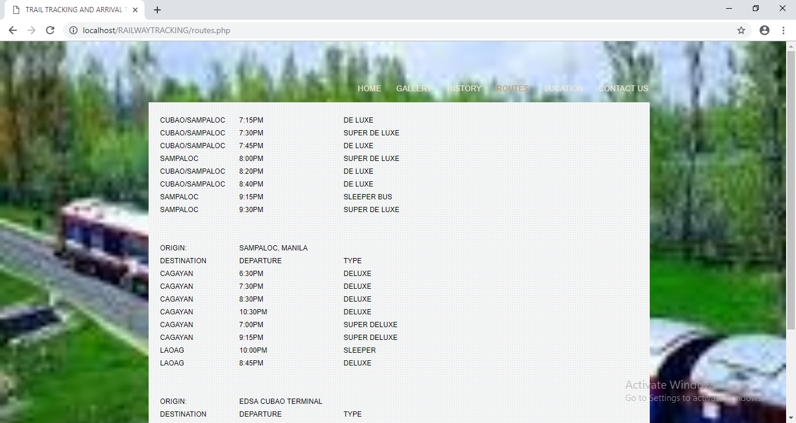
<!DOCTYPE html PUBLIC "-//W3C//DTD XHTML 1.0 Strict//EN" "http://www.w3.org/TR/xhtml1/DTD/xhtml1-strict.dtd">
<html xmlns="http://www.w3.org/1999/xhtml">
<head>
<meta http-equiv="Content-Type" content="text/html; charset=UTF-8" />
<title>TRAIL TRACKING AND ARRIVAL TIME</title>
<link rel="stylesheet" type="text/css" href="css/style.css" />
<link rel="icon" type="image/png" href="xres/images/favicon.png" />
<link type="text/css" href="css/styles.css" rel="stylesheet" media="all" />
</head>

<body>
<div id="wrapper">
<div id="header">

<ul id="mainnav">
<li><a href="index.php">Home</a></li>
<li><a href="gallery.php">Gallery</a></li>
<li><a href="history.php">History</a></li>
<li><a href="routes.php">Routes</a></li>
<li><a href="location.php">location</a></li>
<li class="current"><a href="contact.php">Contact Us</a></li>
</ul>
</div>
<div id="content">
<div id="gallerycontainer">
<div class="portfolio-area" style="margin:0 auto; padding:20px 20px 20px 20px; width:620px;">
<div id="contactleft">

</div><br>
<div id="contactright">
<h3>Message Form</h3>
<form class="validate" action="messageexec.php" method="POST">
<p>
<label for="name" class="required label">Name:</label><br>
<input id="name" class="contactform" type="text" name="name" />
</p>
<p>
<label for="email" class="required label">Email:</label><br>
<input id="email" class="contactform" placeholder="Example: " type="text" name="email" />
</p>
<p>
<label for="subject" class="required label">Subject:</label><br>
<input id="subject" class="contactform" type="text" name="subject" />
</p>
<p>
<label id="message-label" for="message" class="required label">Message:</label><br>
<textarea id="message" class="contactform" name="message" cols="28" rows="3"></textarea>
</p>
<p>
<label></label>
<input class="contactform" id="submit-button" type="submit" name="Submit" value="Submit" style="height: 35px;" />
</p>
</form>
</div>
<div class="column-clear"></div>
</div>
<div class="clearfix"></div>
</div>
</div>

<div id="footer">
<h4> &bull; <a href="contact-us.php"></a></h4>
<p>Hours of Operation&nbsp;&nbsp;&bull;&nbsp;&nbsp;Mon - Sun: 10:00 am - 12:00 am</p>
<a href="index.php"></a>
<p>&copy; Copyright <br /></p>
</div>

</div>
</body>
</html>
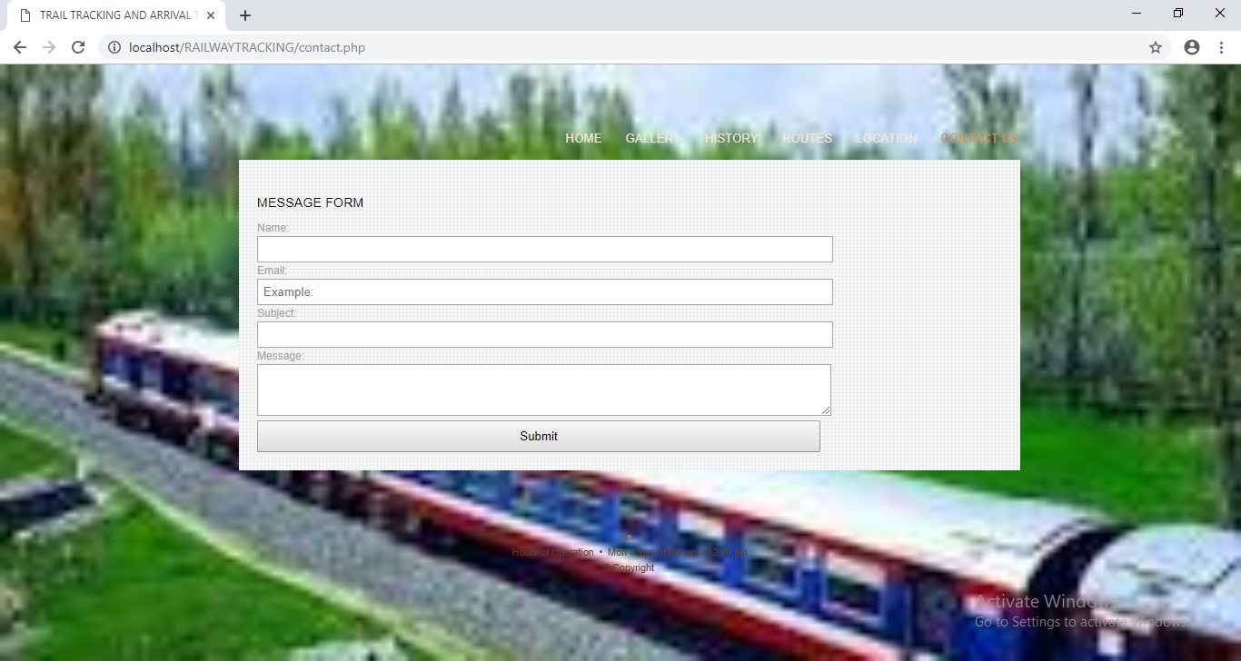
<!DOCTYPE html PUBLIC "-//W3C//DTD XHTML 1.0 Strict//EN" "http://www.w3.org/TR/xhtml1/DTD/xhtml1-strict.dtd">
<html xmlns="http://www.w3.org/1999/xhtml">
<head>
<meta http-equiv="Content-Type" content="text/html; charset=UTF-8" />
<title>TRAIL TRACKING AND ARRIVAL TIME</title>
<link rel="stylesheet" type="text/css" href="css/style.css" />
<link rel="icon" type="image/png" href="xres/images/favicon.png" />
<link type="text/css" href="css/styles.css" rel="stylesheet" media="all" />
</head>

<body>
<div id="wrapper">
<div id="header">

<ul id="mainnav">
<li><a href="index.php">Home</a></li>
<li><a href="gallery.php">Gallery</a></li>
<li><a href="history.php">History</a></li>
<li><a href="routes.php">Routes</a></li>
<li><a href="location.php">location</a></li>
<li class="current"><a href="contact.php">Contact Us</a></li>
</ul>
</div>
<div id="content">
<div id="gallerycontainer">
<div class="portfolio-area" style="margin:0 auto; padding:20px 20px 20px 20px; width:620px;">
<div id="contactleft">

</div><br>
<div id="contactright">
<h3>Message Form</h3>
<form class="validate" action="messageexec.php" method="POST">
<p>
<label for="name" class="required label">Name:</label><br>
<input id="name" class="contactform" type="text" name="name" />
</p>
<p>
<label for="email" class="required label">Email:</label><br>
<input id="email" class="contactform" placeholder="Example: " type="text" name="email" />
</p>
<p>
<label for="subject" class="required label">Subject:</label><br>
<input id="subject" class="contactform" type="text" name="subject" />
</p>
<p>
<label id="message-label" for="message" class="required label">Message:</label><br>
<textarea id="message" class="contactform" name="message" cols="28" rows="3"></textarea>
</p>
<p>
<label></label>
<input class="contactform" id="submit-button" type="submit" name="Submit" value="Submit" style="height: 35px;" />
</p>
</form>
</div>
<div class="column-clear"></div>
</div>
<div class="clearfix"></div>
</div>
</div>

<div id="footer">
<h4> &bull; <a href="contact-us.php"></a></h4>
<p>Hours of Operation&nbsp;&nbsp;&bull;&nbsp;&nbsp;Mon - Sun: 10:00 am - 12:00 am</p>
<a href="index.php"></a>
<p>&copy; Copyright <br /></p>
</div>

</div>
</body>
</html>

STYLE.CSS
@charset "UTF-8";

/* ======== reset ============================================================== */

* {margin:0;padding:0;}

img, a {
border:none;
outline:none;
}
li {margin:0;padding:0;}
body {
background-image:url(../images/download.jpg);background-size:cover;
font:smaller Arial, Helvetica, sans-serif;
line-height:1.3em;
color:#f6e8d2;
}
/* ======== layout ============================================================== */
#wrapper {
width:960px;
margin:0 auto;
padding: 0 0 14px 0;
overflow:hidden;
}
#header {
float:left;
width:960px;
}
img.logo {
position:absolute;
top:5px;
z-index:99;
}

/* ======== navigation ============================================================== */
#mainnav {
float:right;
list-style-type:none;
display:inline;
margin:68px 30px 0 0;
font-weight:lighter;
overflow:hidden;
}
#mainnav li {
display:inline;
padding:0 !important;
font-size:100%;
}
#mainnav li a {
float:left;
text-transform:uppercase;
color:#f6e8d2;
text-decoration:none;
padding:5px 12px 5px 12px !important;
margin: 0 0 0 2px;
}
#mainnav li a:hover {
background: transparent url(../images/nav-bg.png) repeat-x top left;
color:#d0934d;
}
#mainnav li.current a:link {
background: transparent url(../images/nav-bg.png) repeat-x top left;
color:#d0934d;
}
#mainnav li.current a:visited {
background: transparent url(../images/nav-bg.png) repeat-x top left;
color:#d0934d;
}

* html #mainnav li a {
float:left;
background:#644322;
text-transform:uppercase;
color:#f6e8d2;
text-decoration:none;
padding:5px 12px 5px 12px !important;
margin: 0 0 0 2px;
}
* html #mainnav li a:hover {
background: #493119;
color:#d0934d;
}

* html #mainnav li a:hover {
background: #493119;
color:#d0934d;
}
* html #mainnav li.current a:link {
background: #493119;
color:#d0934d;
}
* html #mainnav li.current a:visited {
background: #493119;
color:#d0934d;
}

/* ======== sub navigation ============================================================== */
#subnavwrap {
float:left;
padding:0 0 20px 0;
z-index:99;
}
#subnav {
float:left;
list-style-type:none;
display:inline;
margin:14px 0 0 0 !important;
padding: 0 0 0 8px !important;
font-weight:lighter;
overflow:hidden;
background:#150e06;
width:380px;
}
#subnav li {
display:inline;
padding:0 !important;
font-size:100%;
}
#subnav li a {
float:left;
background:none;
color:#996633;
text-decoration:none;
padding:5px 12px 5px 12px !important;
margin: 0 0 0 2px;
}
#subnav li a:hover {
background:#25180c;
color:#d0934d;
}
#subnav li.current a:link {
background:#25180c;
color:#d0934d;
}
#subnav li.current a:visited {
background:#25180c;
color:#d0934d;
}
img#subgraphic {
float:right;
border:1px solid #362411;
margin:-15px 0 0 0;
padding:0;
}
* html img#subgraphic {
float:right;
border:1px solid #362411;
margin:0 0 0 0;
padding:0;
}

/* ======== content ============================================================== */
#content {
float:left;
background: transparent url(../images/slideshow-bg.png) repeat-x top left;
width:860px;
min-height:377px;
padding:10px;
margin:0 0 20px 50px;
}
* html #content {
float:left;
background:#493119 url(../images/slideshow-bg.gif) repeat-x top left;
width:860px;
overflow:auto;
padding:10px 10px 2px 10px !important;
margin:0 0 20px 25px;
}
/* rotator in-page placement */
div#rotator {
position:relative;
height:345px;
}
/* rotator css */
div#rotator ul li {
z-index:3;
float:left;
list-style: none;
position:absolute;
}
/* rotator image style */
div#rotator ul li.show {
z-index:2;
}
* html div#rotator {
margin:0 0 43px 0;
}
#featured {
float:left;
background:#0B0703;
width:870px;
min-height:109px;
overflow:auto;
margin:0 0 20px 50px;
padding:10px 0 0 10px;
}
* html #featured {
float:left;
background:#0c0501;
width:870px;
height:109px;
overflow:auto;
margin:0 0 20px 25px;
padding:10px 0 0 10px;
}
#featured #items {
float:left;
width:744px;
font-size:90%;
}
#featured .item {
float:left;
width:370px;
min-height:100px;
}

/*
#featured a, #featured a:link {
color:#613e23;
text-decoration:none;
}
#featured a:hover {
color:#ac7940;
}
#featured .item img {
float:left;
padding-right:14px;
border-right:1px solid #362411;
margin-right:14px;
}

#featured .item h3 {
font-size:120%;
color:#f6e8d2;
margin:0 0 10px 0;
text-transform:uppercase;
}
#featured .item h3 a {
color:#f6e8d2;
}
#featured .item p strong {
color:#ac7940;
font-style:italic;
font-size:110%;
}
#featured .item p {
color:#362411;
}
#featured .item p a:hover strong{
color:#f6e8d2;
}
#featured .item p a:hover {
color:#AC7940;
}
*/

#featured a, #featured a:link {
color:#ac7940;
text-decoration:none;
}
#featured a:hover {
color:#613e23;
}
#featured .item img {
float:left;
padding-right:14px;
border-right:1px solid #362411;
margin-right:14px;
}

#featured .item h3 {
font-size:120%;
color:#f6e8d2;
margin:0 0 10px 0;
text-transform:uppercase;
}
#featured .item h3 a {
color:#f6e8d2;
}
#featured .item p strong {
color:#f6e8d2;
font-style:italic;
font-size:110%;
}
#featured .item p {
color:#ac7940;
}
#featured .item p a:hover strong{
color:#ac7940;
}
#featured .item p a:hover {
color:#4d2f1b;
}

#featured #wedding img {
float:right;
border:1px solid #362411;
margin:0 10px 0 0 ;
}

/* ======== footer ============================================================== */
#footer {
float:left;
width:880px;
padding:0 0 0 50px;
color:#613e23;
font-size:80%;
text-align:center;
}
#footer h4 {
width:880px;
text-align:center;
color:#ac7940;
letter-spacing:1px;
text-transform:uppercase;
font-weight:lighter;
font-size:170%
}
#footer a, #footer a:link {
color:#613e23;
text-decoration:none;
}
#footer a:hover {
color:#ac7940;
}
#footer h4 a, #footer h4 a:link {
color:#ac7940;
}
#footer h4 a:hover {
color:#613e23;
}
#footer img {
margin:18px 0 4px;
}

/* ======== subpage ============================================================== */
#leftside {
float:left;
width:196px;
margin:0;
padding:0;
background:none;
}
#maincontent {
float:right;
width:664px;
min-height:510px;
padding:20px 0 0 0;
background:#0b0703;
}
#maincontent h1{
font-weight:normal;
font-style:italic;
font-size:160%;
margin:0 0 0 0;
padding:0 0 0 20px;
text-transform:uppercase;
color:#AC7940;
}
#maincontent h2 {
font-size:120%;
color:#f6e8d2;
margin:20px 0 20px 0;
text-transform:uppercase;
}
#maincontent h3 {
font-size:120%;
color:#f6e8d2;
margin:0 0 20px 0;
text-transform:uppercase;
}
#maincontent p strong {
color:#f6e8d2;
font-style:italic;
font-size:110%;
}
#maincontent p {
margin:0 0 13px 0;
color:#ac7940;
}
#maincontent p a {
color:#ac7940;
text-decoration:none;
}
#maincontent p a:hover strong{
color:#ac7940;
}
#maincontent p a:hover {
color:#4d2f1b;
}

/*
#maincontent p strong {
color:#ac7940;
font-style:italic;
font-size:110%;
}
#maincontent p {
margin:0 0 13px 0;
color:#4d2f1b;
}
#maincontent p a {
color:#4d2f1b;
text-decoration:none;
}
#maincontent p a:hover strong{
color:#f6e8d2;
}
#maincontent p a:hover {
color:#AC7940;
} */

#contentarea {
float:left;
width:475px;
padding:0 0 0 0;
}
#cms {
float:left;
padding: 0 0 0 20px;
width:455px;
}
#rightside {
float:right;
width:140px;
border-left:1px solid #4d2f1b;
padding:0 18px 0 15px;
font-weight:lighter;
font-size:90%;
}
#rightside img {
margin:0 0 6px 0;
}
#packages {
list-style-type:none;
color:#AC7940;
padding:0 0 10px 0;
}
#packages li{
padding:0 0 12px 20px;
}
#packages strong{
color:#F6E8D2;
font-style:italic;
}

#gallerycontainer{
position:relative;
height:auto;
background: url("../images/bkg-pat.png") repeat scroll 0 0 #F5F5F5;
color: #A5A5A5;
font: 12px/1.5em Arial,Helvetica,sans-serif,"Arial Narrow";
}
.clearfix{
clear:both;
}

SYSTEM TESTING
Testing Plan:
Software testing is a critical element of software quality assurance and represents the ultimate review of specification, design and coding. In fact, testing is the one step in the software engineering process that could be viewed as destructive rather than constructive.
A strategy for software testing integrates software test case design methods into a well-planned series of steps that result in the successful construction of software. Testing is the set of activities that can be planned in advance and conducted systematically. The underlying motivation of program testing is to affirm software quality with methods that can economically and effectively apply to both strategic to both large and small-scale systems.

STRATEGIC APPROACH TO SOFTWARE TESTING
The software engineering process can be viewed as a spiral. Initially system engineering defines the role of software and leads to software requirement analysis where the information domain, functions, behavior, performance, constraints and validation criteria for software are established. Moving inward along the spiral, we come to design and finally to coding. To develop computer software we spiral in along streamlines that decrease the level of abstraction on each turn.

A strategy for software testing may also be viewed in the context of the spiral. Unit testing begins at the vertex of the spiral and concentrates on each unit of the software as implemented in source code. Testing progress by moving outward along the spiral to integration testing, where the focus is on the design and the construction of the software architecture. Talking another turn on outward on the spiral we encounter validation testing where requirements established as part of software requirements analysis are validated against the software that has been constructed. Finally we arrive at system testing, where the software and other system elements are tested as a whole.

Types of Testing:
- Unit Testing
Unit testing focuses verification effort on the smallest unit of software design, the module. The unit testing we have is white box oriented and some modules the steps are conducted in parallel.

- White Box Testing
This type of testing ensures that
- All independent paths have been exercised at least once
- All logical decisions have been exercised on their true and false sides
- All loops are executed at their boundaries and within their operational bounds
- All internal data structures have been exercised to assure their validity.

- Conditional Testing
In this part of the testing each of the conditions were tested to both true and false aspects. And all the resulting paths were tested. So that each path that may be generate on particular condition is traced to uncover any possible errors.
- Hybrid Testing
Hybrid testing examines class operation at an algorithmic granularity but only examines public methods and variables. From the standard point of the application, hybrid testing qualifies as white box testing since the classes being tested may not be exposed to the application. From the class level, hybrid testing qualifies as black box testing since private methods and variables are not exposed and how the results are produced is never called into question.
Test Report & Analysis
Compilation Test:
It was a good idea to do our stress testing early on, because it gives us time to fix some of unexpected deadlocks and stability problems that only occurred when components were exposed to very high transaction volumes.
Execution Test:
This Program was successfully loaded and executed. Because of good programming there were no execution errors
Output Test:
The Successful output screens are placed in the output screen section.

TEST CASE DESIGN:
Any engineering product can be tested in one of two ways:
1.White Box Testing: This testing is also called as glass box testing. In this testing, by knowing the specified function that a product has been designed to perform test can be conducted that demonstrates each function is fully operation at the same time searching for errors in each function. It is a test case design method that uses the control structure of the procedural design to derive test cases. Basis path testing is a white box testing.
Basic Path Testing:
- Flow graph notation
- Cyclomatic Complexity
- Deriving test cases
- Graph matrices

Control Structure Testing:
- Condition testing
- Data flow testing
- Loop testing

2.Black Box Testing: In this testing by knowing the internal operation of a product, tests can be conducted to ensure that “ all gears mesh”, that is the internal operation performs according to specification and all internal components have been adequately exercised. It fundamentally focuses on the functional requirements of the software.

The steps involved in black box test case design are:
- Graph based testing methods
- Equivalence partitioning
- Boundary value analysis
- Comparison testing

SOFTWARE TESTING STRATEGIES:
A software testing strategy provides a road map for the software developer. Testing is a set of activities that can be planned in advance and conducted systematically. For this reason a template for software testing a set of steps into which we can place specific test case design methods should be defined for software engineering process. Any software testing strategy should have the following characteristics:

- Testing begins at the module level and works “outward” toward the integration of the entire computer based system.
- Different testing techniques are appropriate at different points in time.
- The developer of the software and an independent test group conducts testing.
- Testing and Debugging are different activities but debugging must be accommodated in any testing strategy.

Unit Testing: Unit testing focuses verification efforts in smallest unit of software design (module).

Unit test considerations
Unit test procedures:
- Integration Testing: Integration testing is a systematic technique for constructing the program structure while conducting tests to uncover errors associated with interfacing. There are two types of integration testing:
- Top-Down Integration: Top down integration is an incremental approach to construction of program structures. Modules are integrated by moving down wards throw the control hierarchy beginning with the main control module.
- Bottom-Up Integration: Bottom up integration as its name implies, begins construction and testing with automatic modules.
- Regression Testing: In this contest of an integration test strategy, regression testing is the re execution of some subset of test that have already been conducted to ensure that changes have not propagate unintended side effects.
VALIDATION TESTING:
At the culmination of integration testing, software is completely assembled as a package; interfacing errors have been uncovered and corrected, and a final series of software tests – validation testing – may begin. Validation can be fined in many ways, but a simple definition is that validation succeeds when software functions in a manner that can be reasonably expected by the customer.
Reasonable expectation is defined in the software requirement specification – a document that describes all user-visible attributes of the software. The specification contains a section titled “Validation Criteria”. Information contained in that section forms the basis for a validation testing approach.

VALIDATION TEST CRITERIA:
Software validation is achieved through a series of black-box tests that demonstrate conformity with requirement. A test plan outlines the classes of tests to be conducted, and a test procedure defines specific test cases that will be used in an attempt to uncover errors in conformity with requirements. Both the plan and procedure are designed to ensure that all functional requirements are satisfied; all performance requirements are achieved; documentation is correct and human-engineered; and other requirements are met.
After each validation test case has been conducted, one of two possible conditions exist: (1) The function or performance characteristics conform to specification and are accepted, or (2) a deviation from specification is uncovered and a deficiency list is created. Deviation or error discovered at this stage in a project can rarely be corrected prior to scheduled completion. It is often necessary to negotiate with the customer to establish a method for resolving deficiencies.

CONFIGURATION REVIEW:
An important element of the validation process is a configuration review. The intent of the review is to ensure that all elements of the software configuration have been properly developed, are catalogued, and have the necessary detail to support the maintenance phase of the software life cycle. The configuration review sometimes called an audit.

Alpha and Beta Testing:
It is virtually impossible for a software developer to foresee how the customer will really use a program. Instructions for use may be misinterpreted; strange combination of data may be regularly used; and output that seemed clear to the tester may be unintelligible to a user in the field.

When custom software is built for one customer, a series of acceptance tests are conducted to enable the customer to validate all requirements. Conducted by the end user rather than the system developer, an acceptance test can range from an informal “test drive” to a planned and systematically executed series of tests. In fact, acceptance testing can be conducted over a period of weeks or months, thereby uncovering cumulative errors that might degrade the system over time.

If software is developed as a product to be used by many customers, it is impractical to perform formal acceptance tests with each one. Most software product builders use a process called alpha and beta testing to uncover errors that only the end user seems able to find.
A customer conducts the alpha test at the developer’s site. The software is used in a natural setting with the developer “looking over the shoulder” of the user and recording errors and usage problems. Alpha tests are conducted in controlled environment.

The beta test is conducted at one or more customer sites by the end user of the software. Unlike alpha testing, the developer is generally not present. Therefore, the beta test is a “live” application of the software in an environment that cannot be controlled by the developer. The customer records all problems that are encountered during beta testing and reports these to the developer at regular intervals. As a result of problems reported during bets test, the software developer makes modification and then prepares for release of the software product to the entire customer base.

CONCLUSION
After seeing many advancements and changes in the location tracking technology, Indian Railways now has the ability to pin point the location and other attributes of an operational train in an economical accurate manner. Thus it is visible that to keep up with the today’s demand for information and to comply with the citizen centric governance, technological advancements is essential for a 3rd world country, as after all the deciding factors of a country’s success would be on the how collaborative and duplex the governance framework in terms of seamless information flow of accurate and timely information between governance ecosystem.

FEATURE OF PROJECT

- User friendly

- Can run on internet/intranet so many clients can be handled by this project so we will save the time

- In future any modification can be done smoothly

- There is a section feedback which solves the problem of user actually it is visible to all client and can send the problem difficulty to administrator and admin has facility to read the all feedback according to feedback he can reply and improve the site etc……..

SCOPE OF THE PROJECT
This is project is being develop in MySql Server 5.3 backend & PHP front-end this distributed application might be develop in j2ee & oracle also and other plate form also. this software might be more secure in future it here we can add new module we can update every things of this distributed application.
We can use this distributed application for another project work also similar to this after a little modification.

BIBLIOGRAPHY

- Rudraksh Batra, Charul Shukla, Anil Kumar Bansal,”PHP Black Book” , DreamTech Press
- An Introduction to Database Systems, Author’s name (Bipin C. Desai), Published by Galgotia Publications pvt. Ltd, 2002.
- System of software engineering, Author’s name (roger s. pressman), Published by McGraw-Hill, 2002.
- Software engineering, Author’s name (Bharat Bhushan Agrwal & Sumit Prakash), Published by Laxmi publication pvt. Ltd, 2000.
- Software Engineering A Practioner’s Approach, Author’s name (Roger S. Pressman), Published by McGraw-Hill, 2001.
- Analysis and Design of Information Systems, Author’s name(RAJARAMAN V.),Published by Prentice Hall of India (1991),New Delhi .
- Beginning asp.net 2.0 and databases ,Wrox publication
- Beginning asp.net 2.0 , Wrox publication

