Filtering Instagram hashtags through crowdtagging and the HITS algorithm

In this paper author is analyzing or filtering instagram hashtags given by crowds to detect whether hash tag is correct or not which is given by crowds. To identify correctness of tags author is using HIT algorithm. Now-a-days online social network users are posting messages with related pictures and the hash tags will be assigning to that picture. This related hash tags make other users to search that image easily.

Sometime some user’s assigns unrelated hash tags to images which make searching process difficult. To overcome from this issue author has introduce hash tags filtering technique using which we will filter hash tags to determine whether hash tag is relevant or irrelevant by matching content of both main hash tag and the annotator hash tags. If annotator assigns related hash tags then it will be relevant and supervisor will give good score to that annotator.

Using HIT algorithm we can determine whether that hash tags is used more frequently or not, if it’s less frequent or unrelated hash tag then we will consider as stop hash tag.

In this application we used same given in paper to execute existing and extension logic. Existing technique will analyze given tags and annotators tags to find out whether given hashtag is relevant or irrelevant by using HIT algorithm. Our extension algorithm is based on Deep Learning Convolution Neural Network which analyze input image and describe contents available in image and then check whether extracted content from image and annotator’s attribute are correct or not.

In paper only one image used so we are also using same image but our extension technique will extract content from any image but for existing technique in paper author has expose only image details so we used same image

Screen shots

Double click on ‘run.bat’ file to get below screen

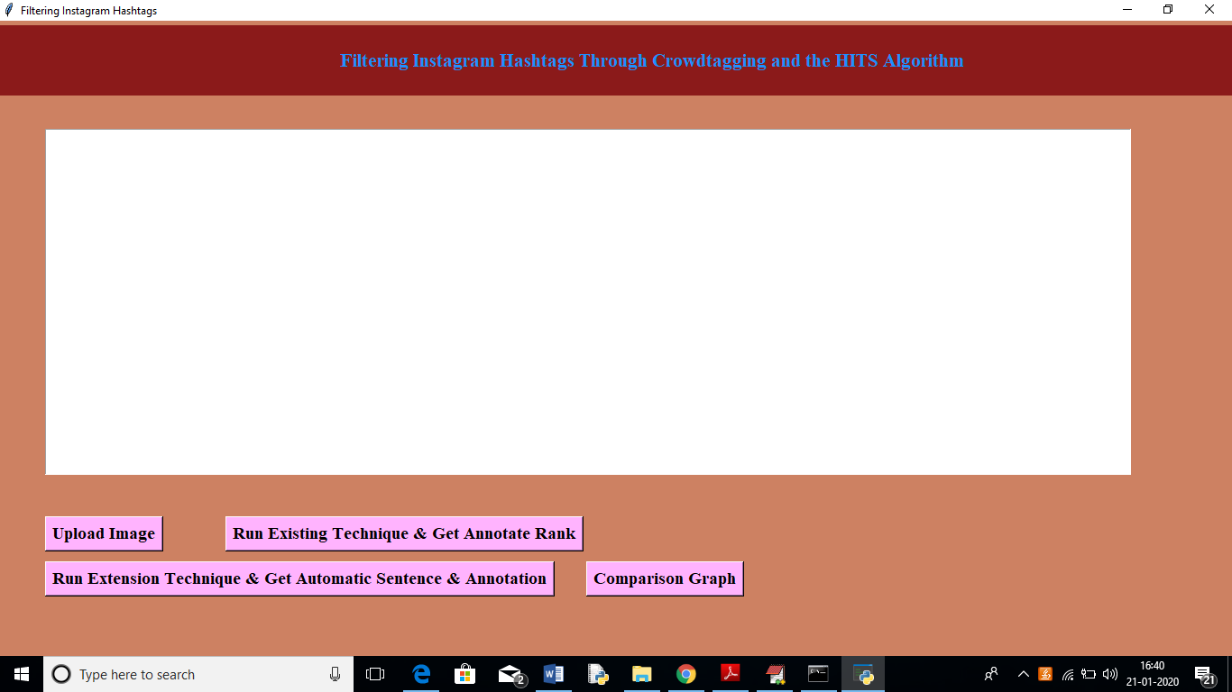

In above screen click on ‘Upload Image’ button to upload image

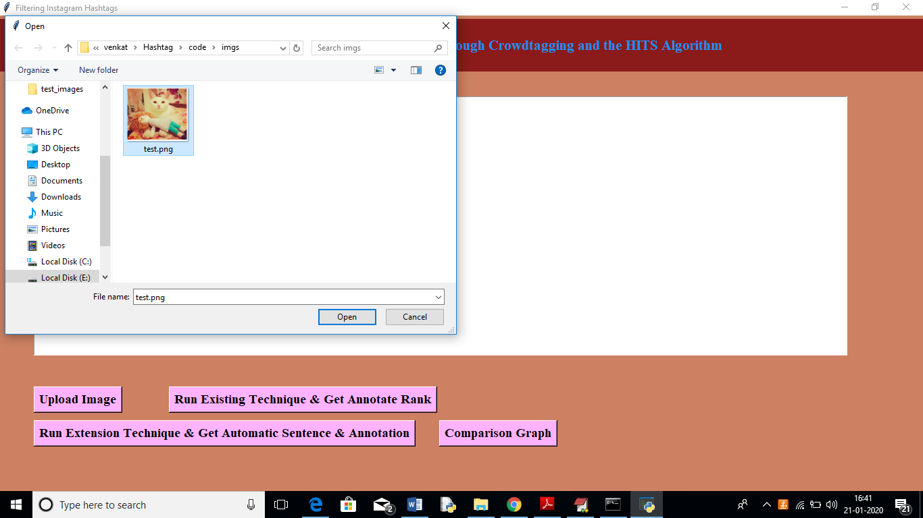

In above screen I am uploading one image and by seeing that image anybody can say that cat or kitten sitting on a bed with some stuff and our extension will describe same sentence or extract same data from image but existing technique just will check whether given hash tag and annotator tags are similar or relevant or not relevant. After uploading image will get below screen

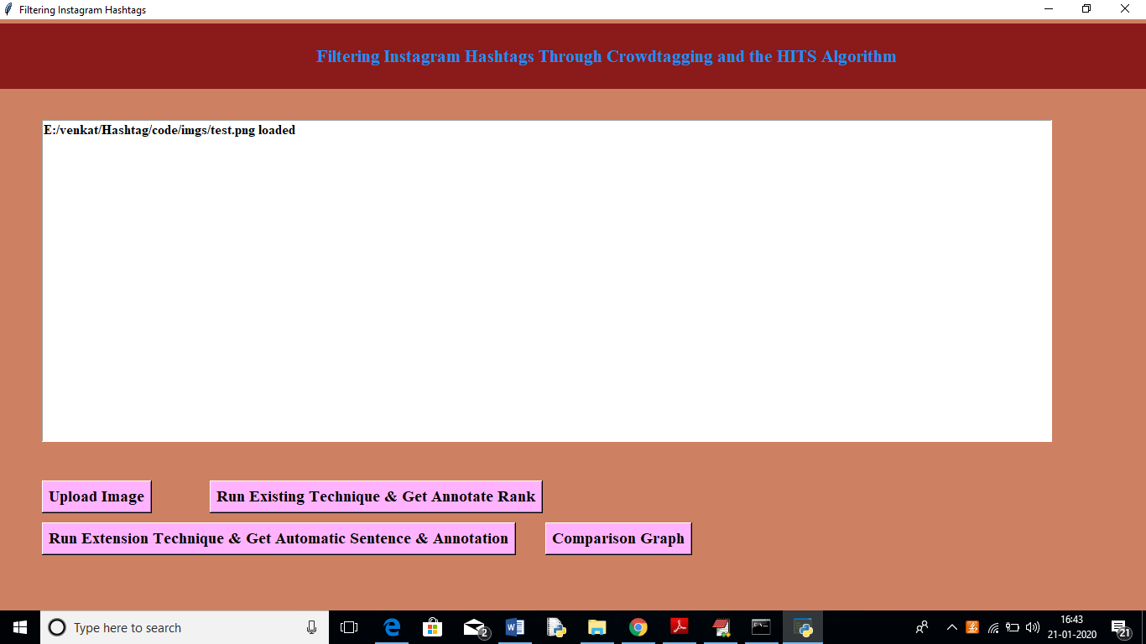

Now click on ‘Run Existing Technique & Get Annotation Rank’ button to get below screen

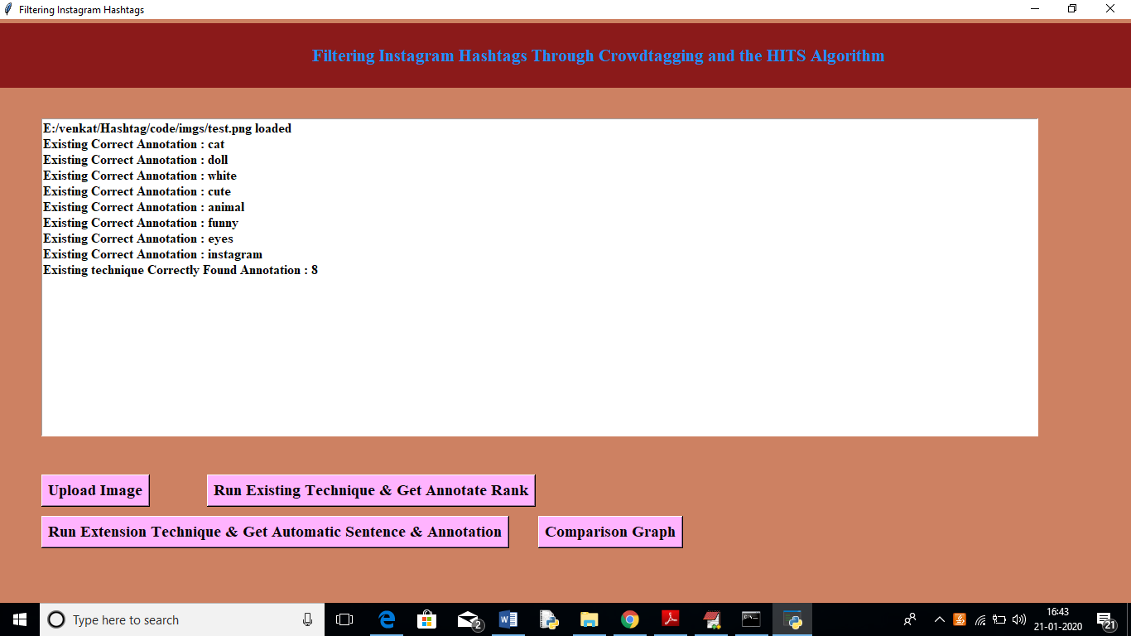

In above screen we can see from loaded images above annotations are correct as image contains cat, doll, cute etc. Existing technique able to extract 8 correct annotation from all annotated text. Now click on ‘Run Extension Technique & get Automatic Sentence & Annotation’ button to describe image in sentence and to check extracted words are matching with annotators words or not.

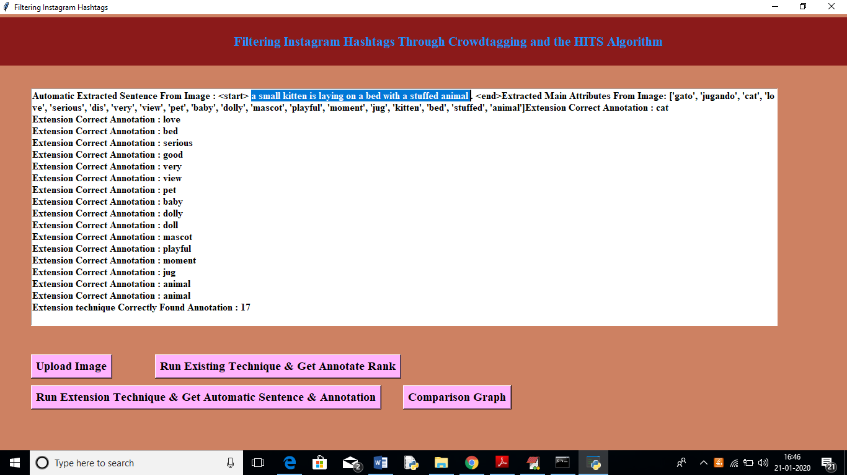

In above screen in selected text you can see our extension technique describing image in a sentence and then extracting words from image and compare with annotator’s tags to get relevant details. Extension technique able to extract 17 related annotations. Now click on ‘Comparison Graph’ button to get below graph

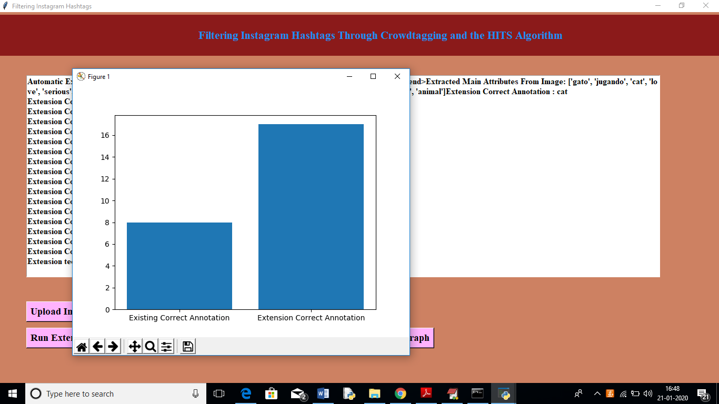

In above graph x-axis represents technique name and y-axis represents count of extracted matching annotations and we can see extension technique able to extract more related words compare to existing technique.

Note: existing technique can able to check with only one image as author given only one image details in paper and what other images he has used that information is not available. But extension technique can work with any image. See another image example

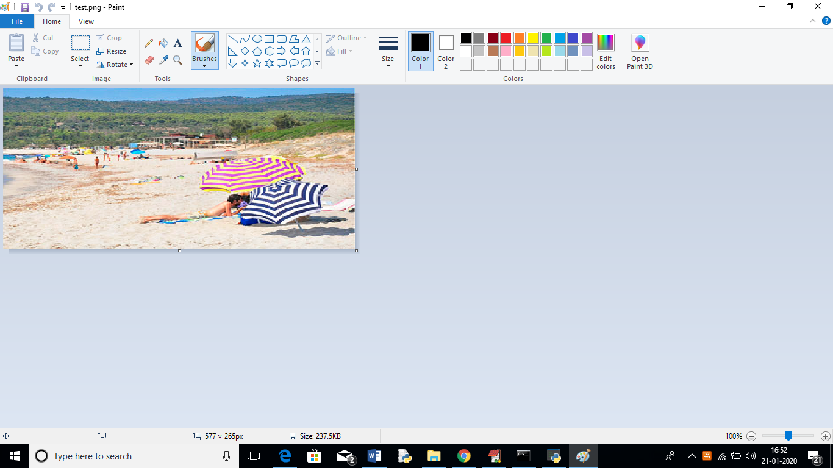

In above image we can see peoples are on beach with umbrellas and extension technique can extract this information but cannot compare with existing technique as author not include this image in his annotation dataset

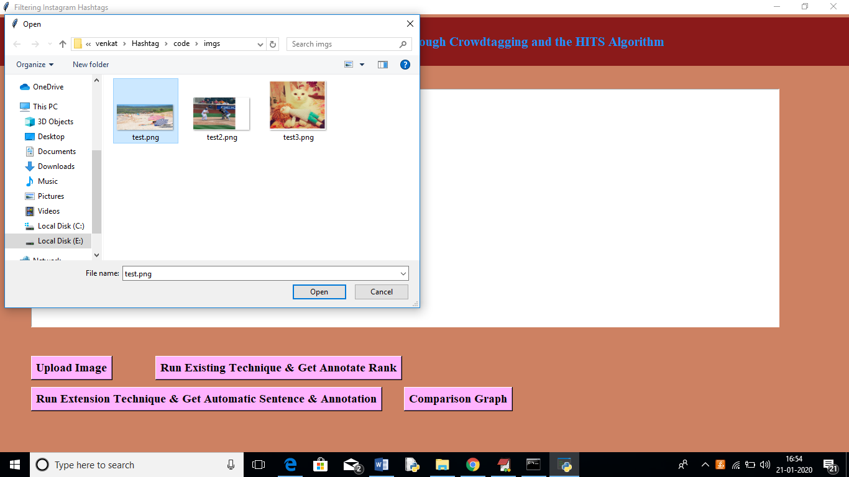

In above screen uploading same image and then click on ‘Run Extension Technique & get Automatic Sentence & Annotation’ button to get below results

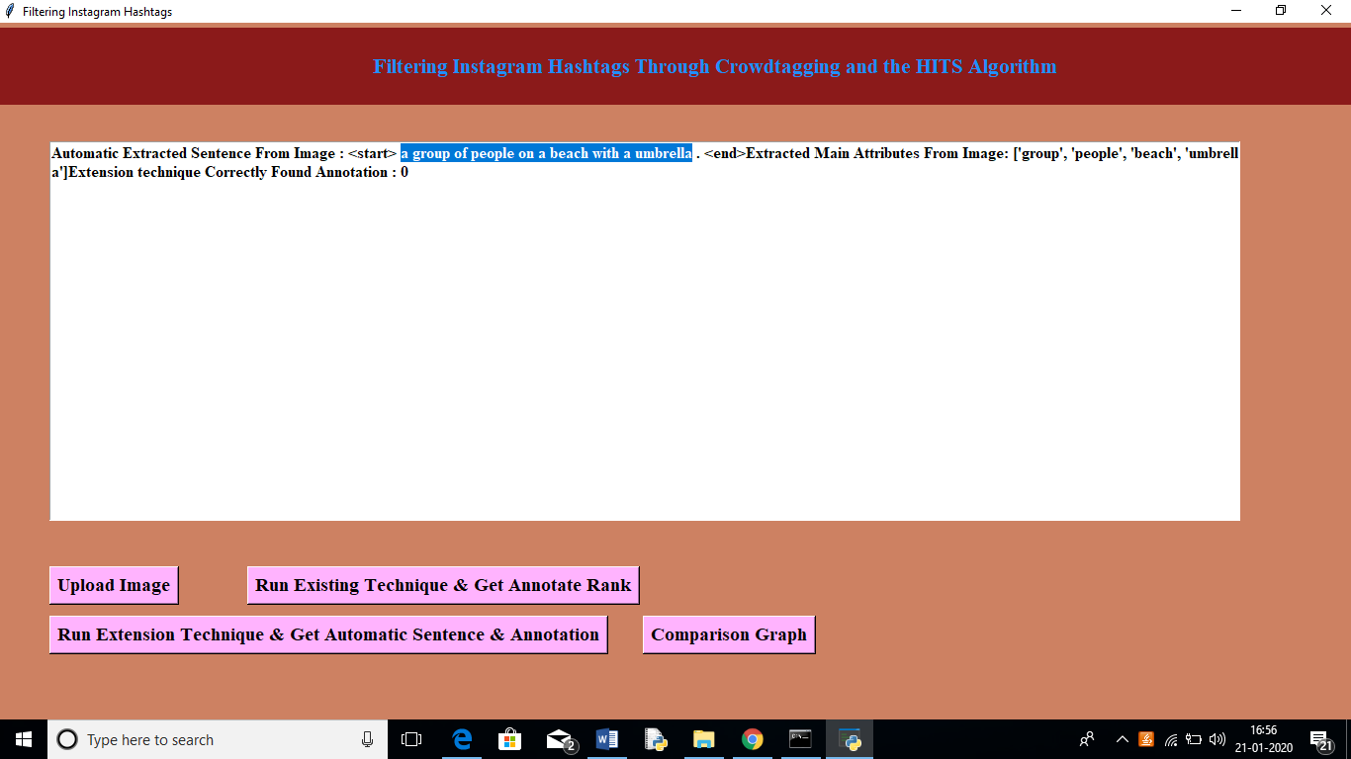

In above screen in selected text you can see sentence describing image and its related attributes or hashtag also displaying